PAN-021893 My Map Report:

Application map
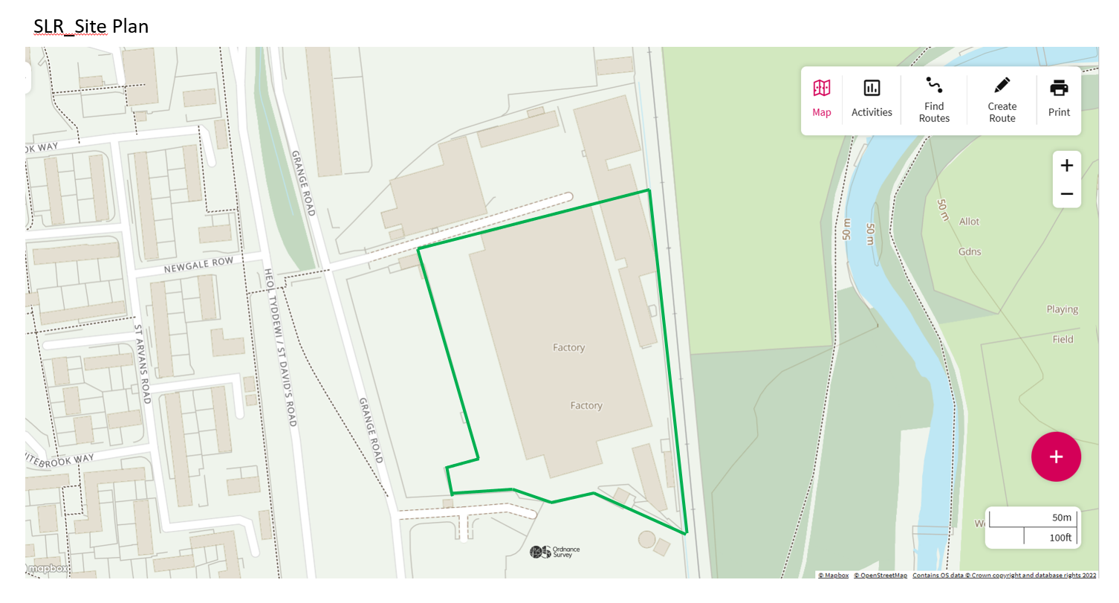

Site Boundary
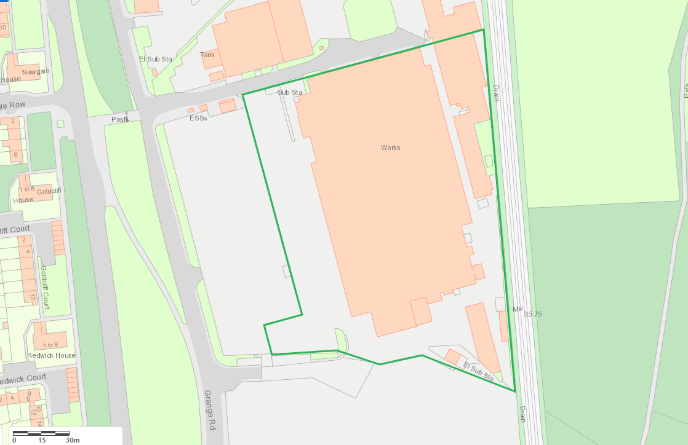

AQMA 0m
None
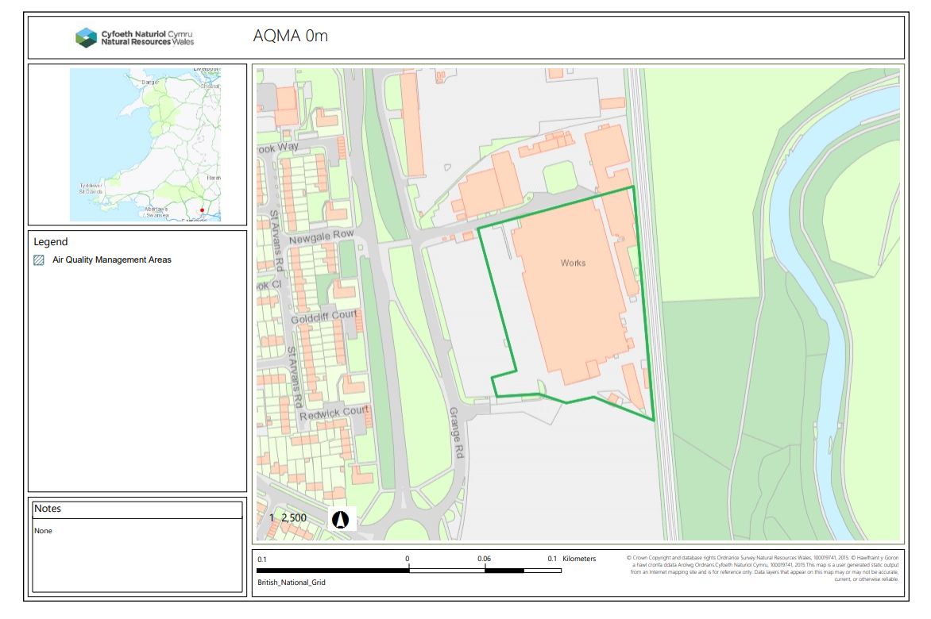
Any well, spring (or issue) or borehole used / not used for the supply of water for human consumption including from a private water supply or supplies within 50m.
None
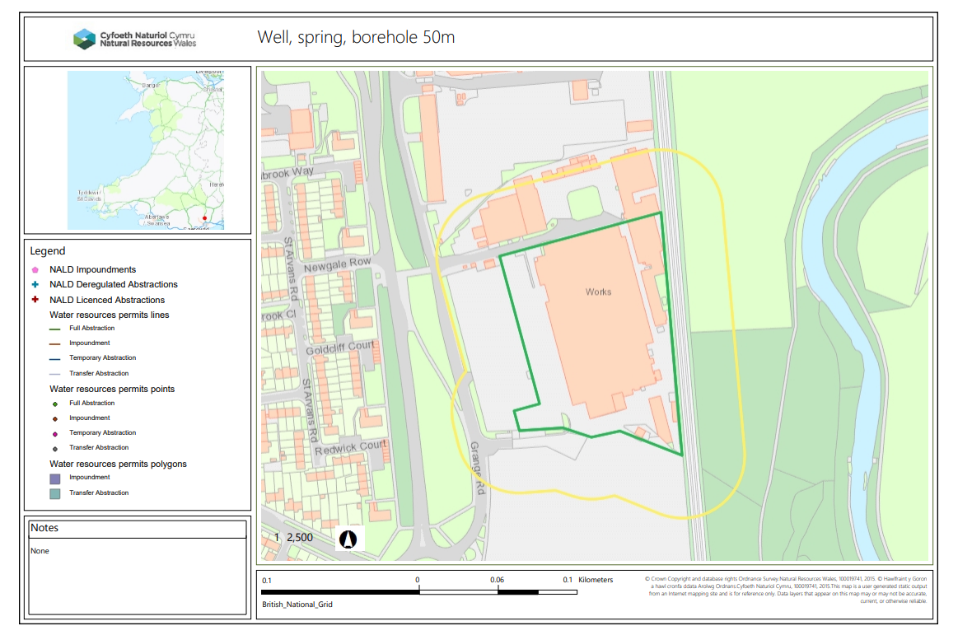
European designated sites- Natura 2000 (SPA, pSPA, SAC or cSAC) or Ramsar- or SSSI within 500m

None

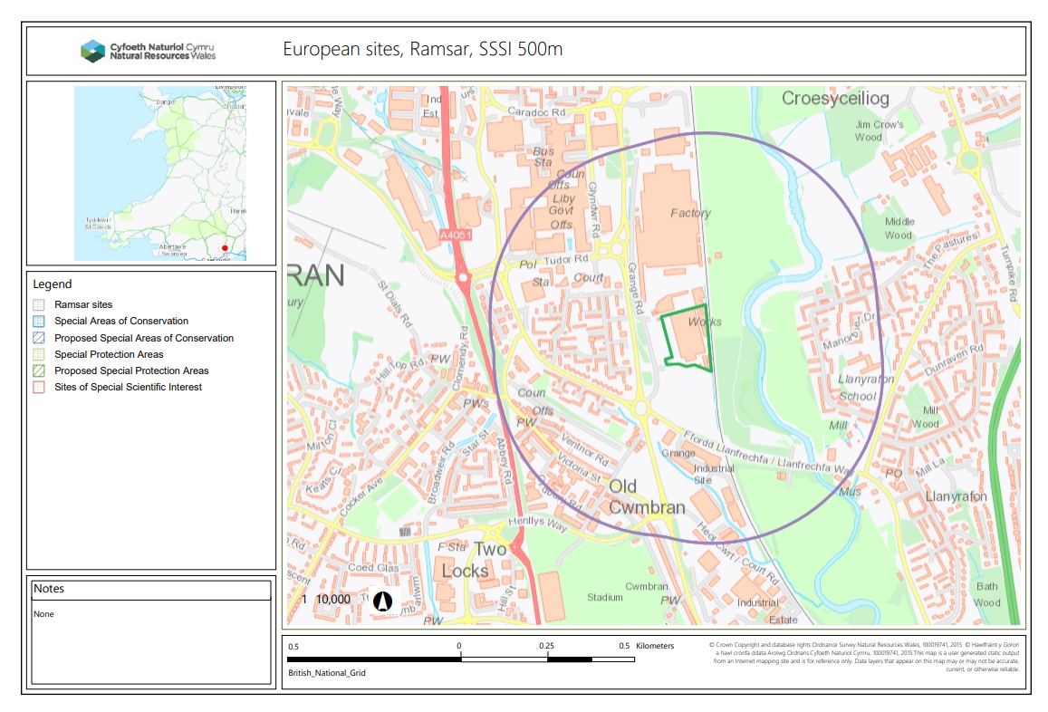

END

