PAN-022081 My Map Report:

- Application map
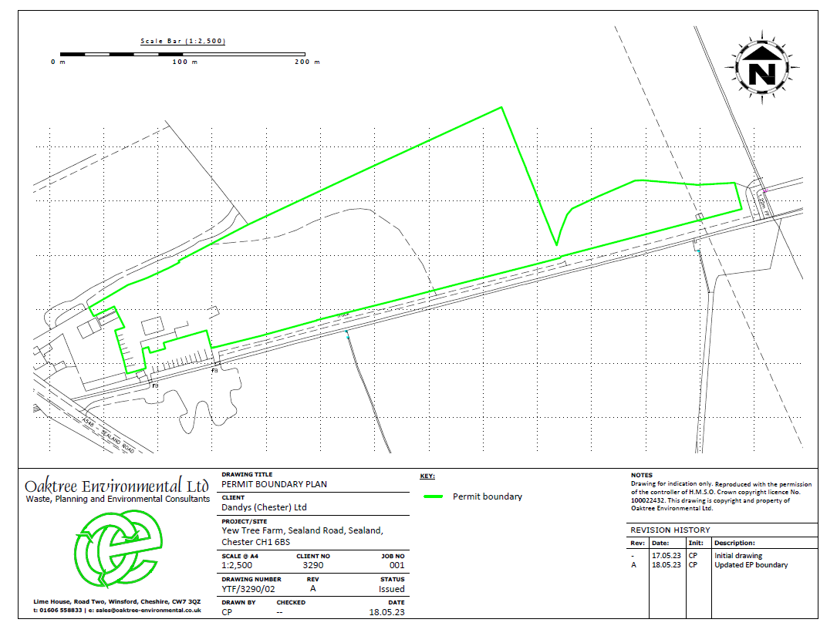

- Site Boundary for permit
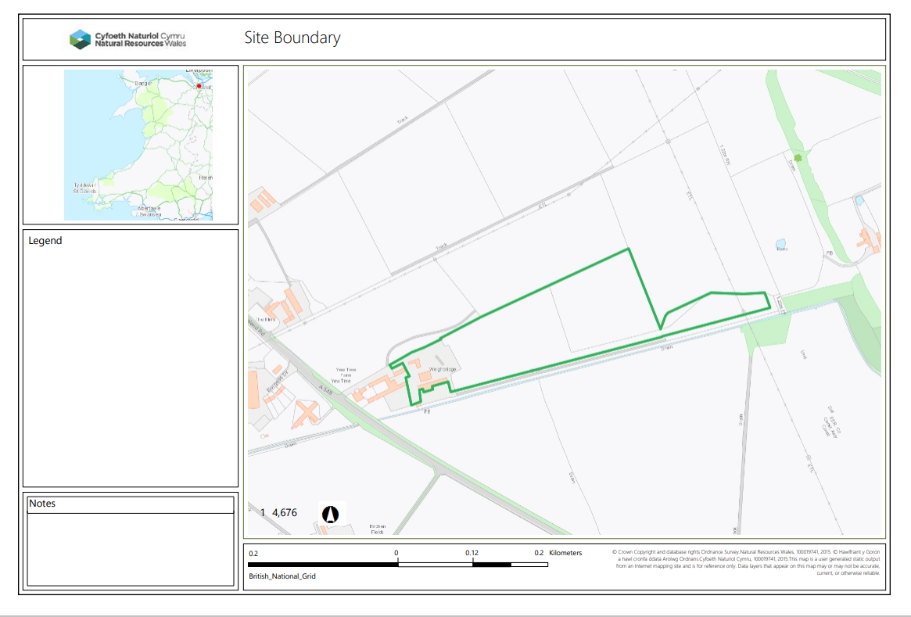
- Section 2.2.2 of permit – The activities shall not be carried out within:
- European designated sites- Natura 2000 (SPA, pSPA, SAC or cSAC) or Ramsar- or SSSI - 500m

None

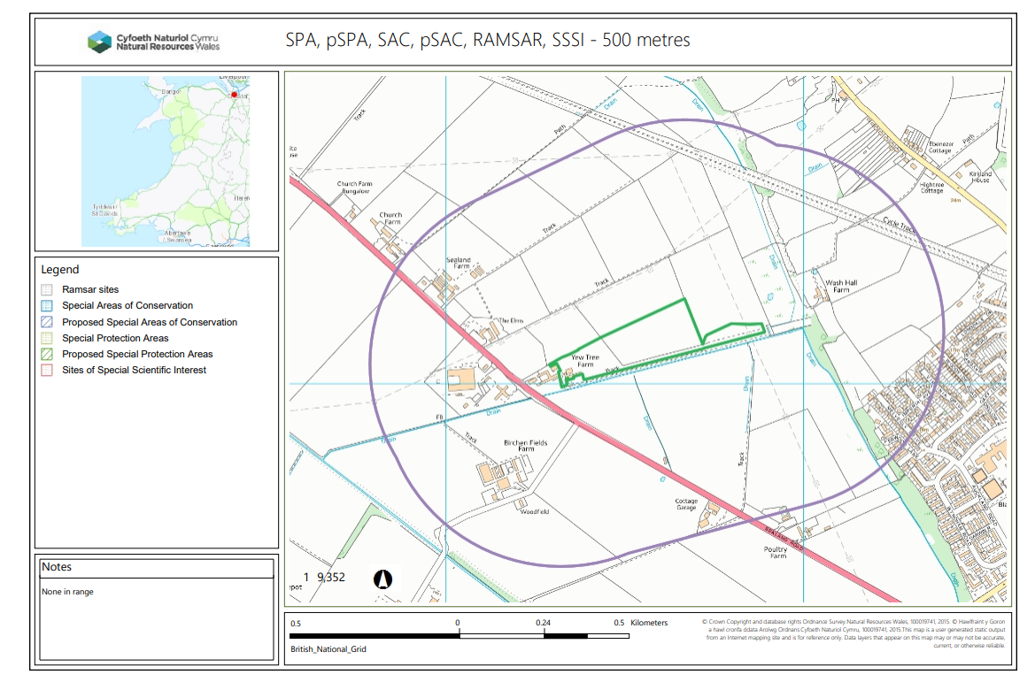

- Watercourse – 10m

None
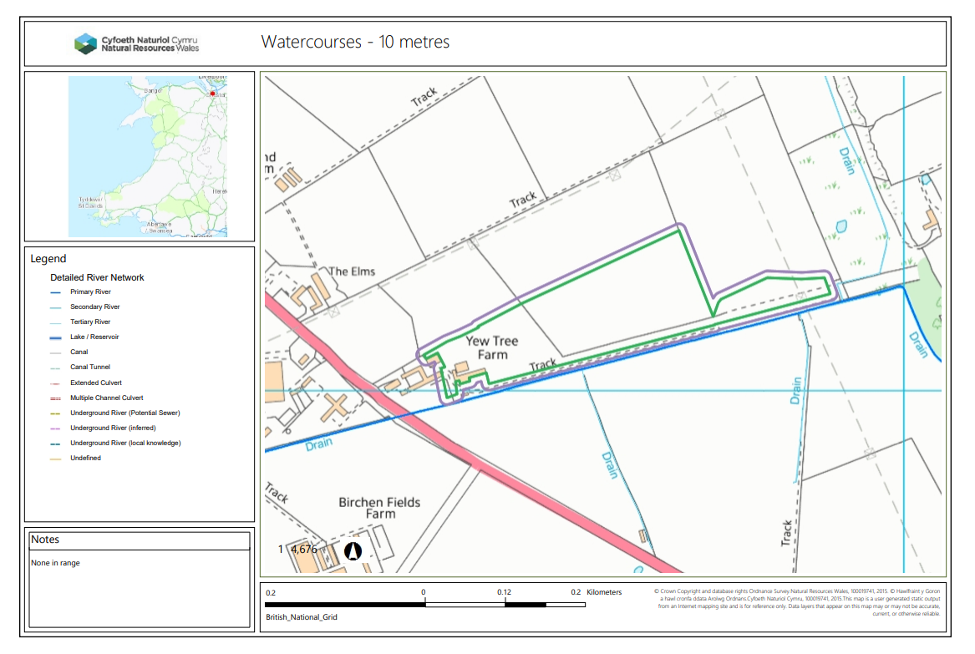
- Any well, spring (or issue) or borehole - 50m.

None
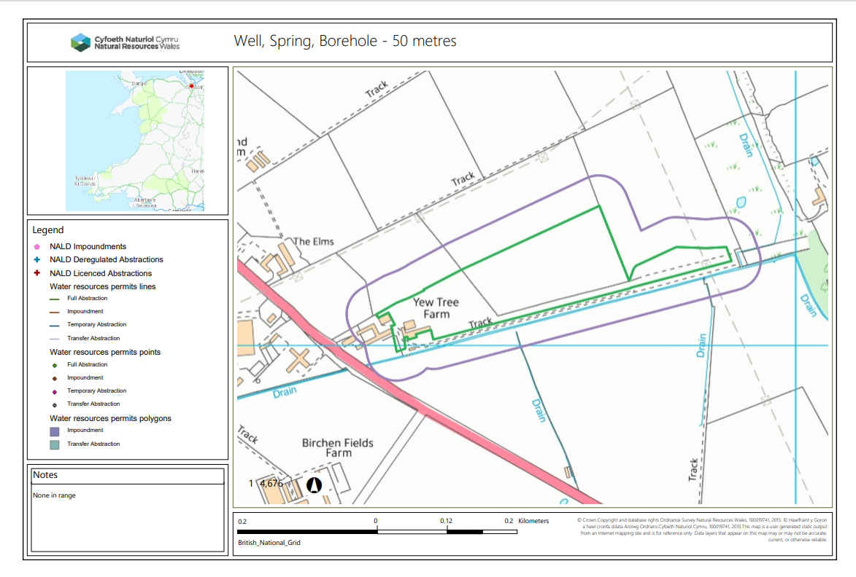

- AQMA – 0m
None
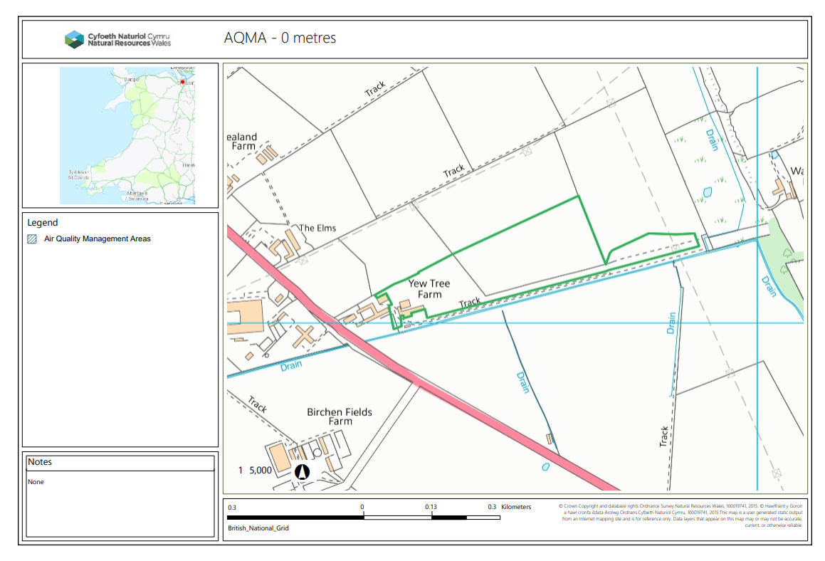
- Great Crested Newts – 250m
None
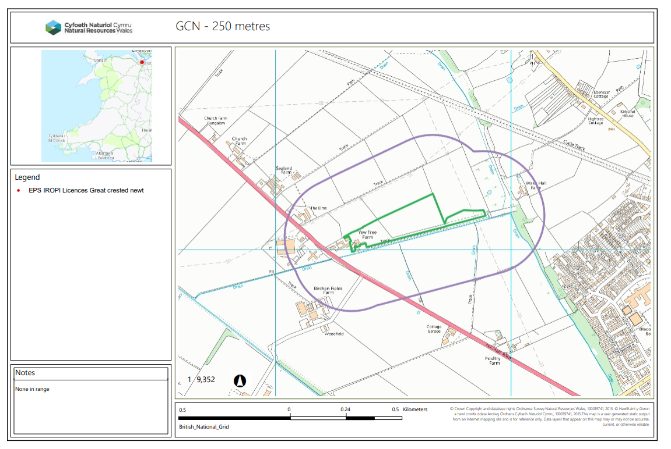

- BAP – 50m

None

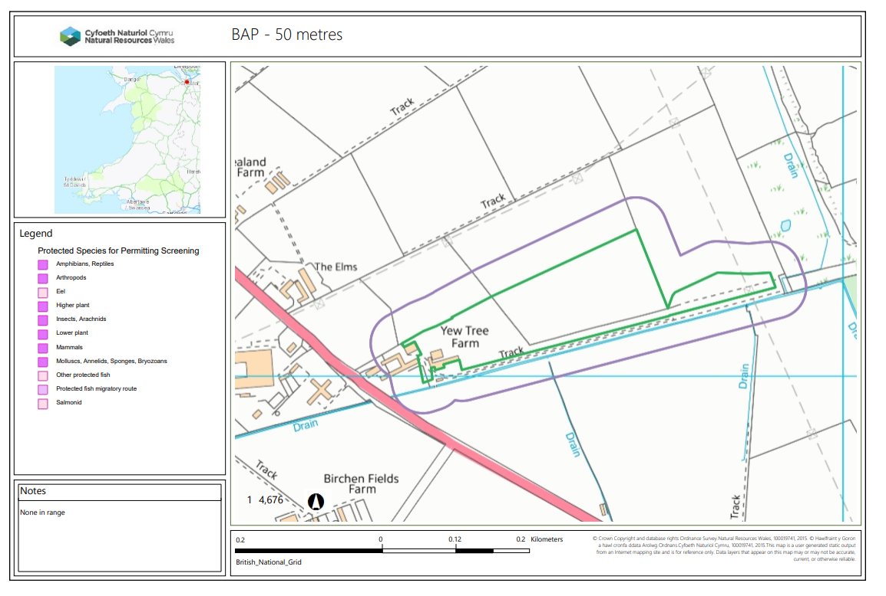

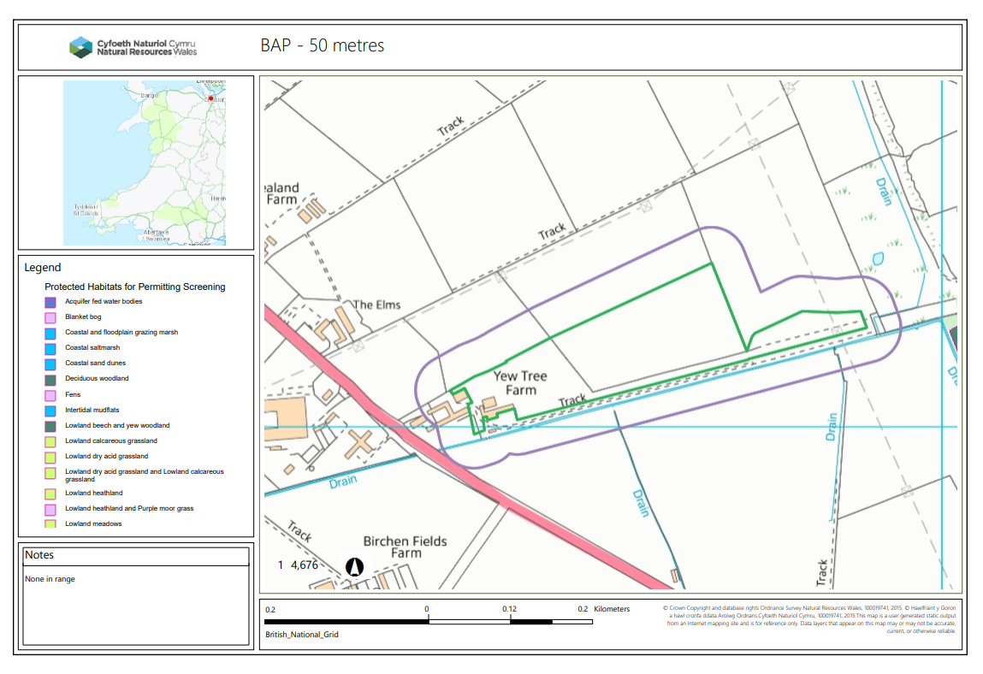

- National Nature Reserve, Local Nature Reserve, Local Wildlife Site, Ancient Woodland, Scheduled Ancient Monument – 50m

None

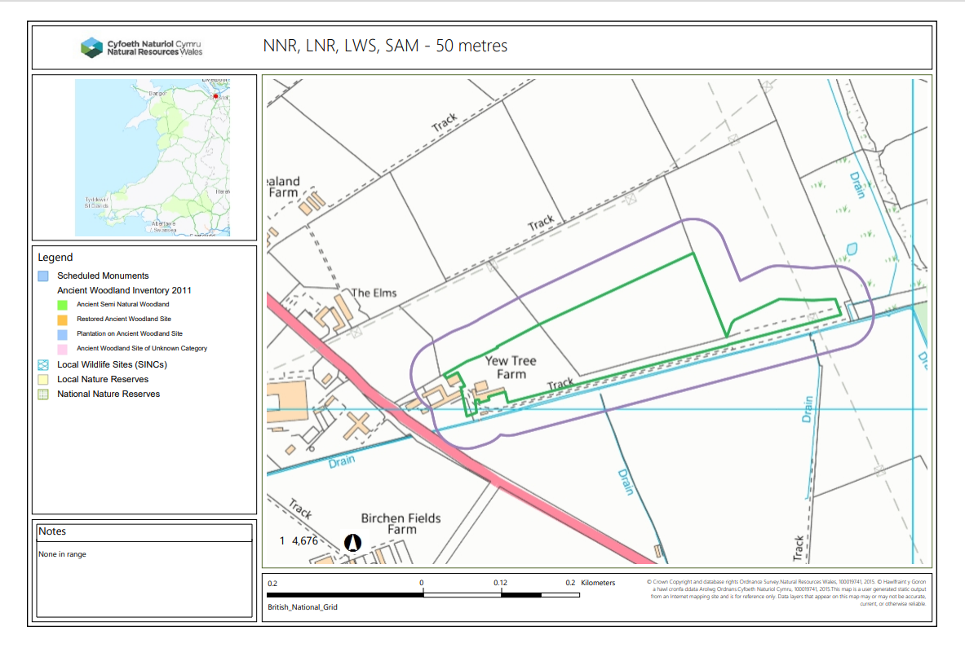
- Section 2.4.1 table 2.4 states When located within groundwater Source Protection Zones 1 or 2 the specified wastes below shall be stored and treated on an impermeable surface with a sealed drainage system.
When located outside groundwater Source Protection Zones 1 or 2 all permitted wastes shall be stored and treated on hard-standing or on an impermeable surface with sealed drainage system.
Groundwater Source Protection Zones

None

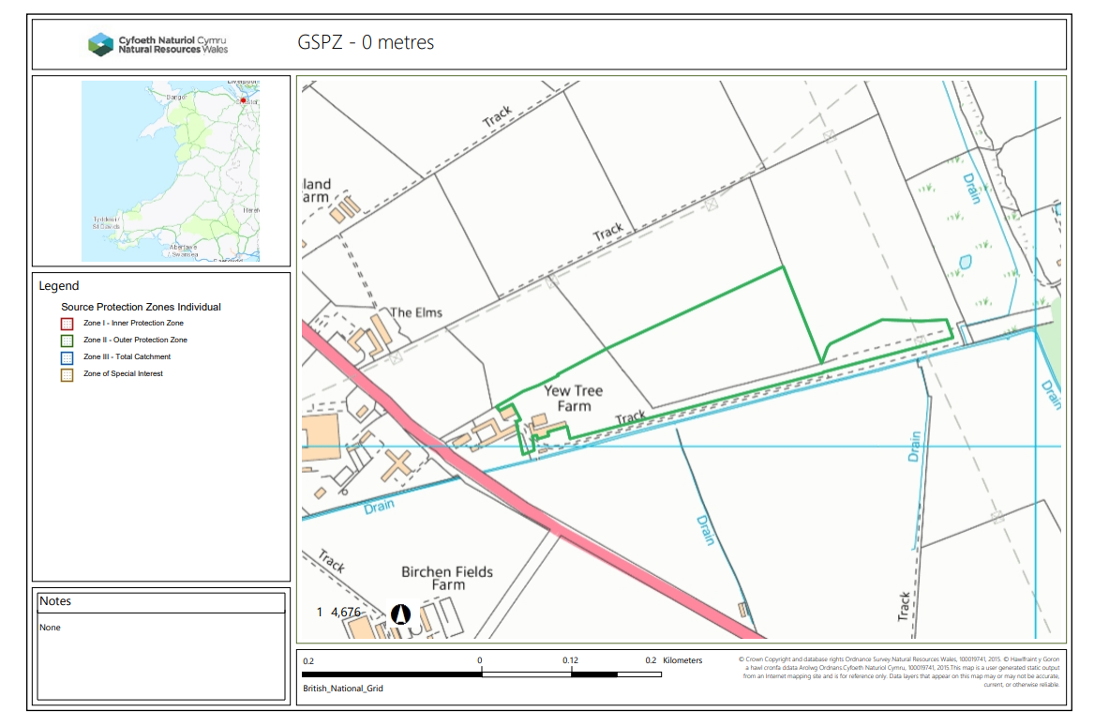

END

