Notice of variation with introductory note
Environmental Permitting (England & Wales) Regulations 2016

Derwent Renewable Power Limited
Argoed Farm AD Facility
Argoed
Trefeglyws
Caersws
Powys
SY17 5QT

Variation application number
EPR/AB3090CC/V001

Permit number

EPR/AB3090CC

Argoed Farm AD Facility

Permit number EPR/AB3090CC

Introductory note

This introductory note does not form a part of the notice

The following notice gives notice of the variation of an environmental permit.

This variation extends the site boundary and amends the registered office address.

The schedules specify the changes made to the original permit.

The status log of a permit sets out the permitting history, including any changes to the permit reference number.

Status log of the permit
Description | Date | Comments
Permit determined  EPR/AB3090CC | 08/12/15 | Permit issued to Derwent Renewable Power Limited.
Application  EPR/AB3090CC/V001 | Duly made  04/07/23 | Application to extend site boundary and amend company registered office address.
Variation determined EPR/AB3090CC | 12/07/23 | Varied permit issued.

End of introductory note

Notice of variation
Environmental Permitting (England and Wales) Regulations 2016

The Natural Resources Body for Wales (“Natural Resources Wales”) in exercise of its powers under regulation 20 of the Environmental Permitting (England and Wales) Regulations 2016 varies

Permit number

EPR/AB3090CC/V001

issued to:

Derwent Renewable Power Limited (“the operator”)

whose registered office is

Argoed

Trefeglyws

Caersws

Powys

SY17 5QT

company registration number 09714157

to operate a regulated facility at

Argoed Farm AD Facility

Argoed

Trefeglyws

Caersws

Powys

SY17 5QT

to the extent set out in the schedules.

The notice shall take effect from 12/07/2023

Name | Date
Huw Davies | 12/07/2023

Authorised on behalf of Natural Resources Wales

Schedule 1 – conditions to be deleted

None

Schedule 2 – conditions to be amended

None

Schedule 3 – conditions to be added

None

Schedule 4 – amended plan

Amended plan attached

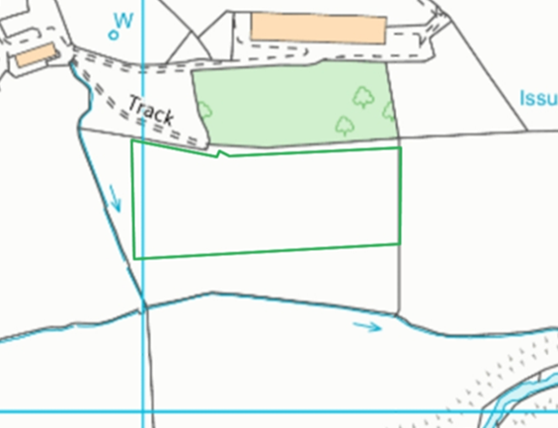

(© Crown Copyright and database right 2015. Ordnance Survey licence number 100019741.)

