Permit with introductory note
The Environmental Permitting (England & Wales) Regulations 2016

Mr Jeremy Alderwick

East Trewent Farm
Freshwater East
Pembroke
SA71 5LR

Permit number

EPR/CB3990ZG

Package Treatment Plant and Infiltration system serving East Trewent Farm

Permit Number EPR/CB3990ZG

Introductory note

This introductory note does not form a part of the permit

The main features of the permit are as follows.

This permit regulates discharges of secondary treated sewage effluent, a maximum of 4.35m³, from East Trewent Farm and holiday cottage complex. Effluent is to discharge to ground from a package treatment system via an infiltration system. The discharge is domestic in nature.

Site comprises of; 3x 2 bedrooms, 1x 3 bedroom, 2x 1 bedroom, and 1x 4 bedroom cottages.

The status log of the permit sets out the permitting history, including any changes to the permit reference number.

Status log of the permit
Description | Date | Comments
Application EPR/CB3990ZG/A001 | Duly made 23/03/2023 | Application for discharge of secondary treated sewage effluent.
Permit determined | 21/07/2023 | Permit issued to Mr Jeremy Alderwick

End of introductory note

Permit
The Environmental Permitting (England and Wales) Regulations 2016

Permit number

EPR/CB3990ZG

The Natural Resources Body for Wales (“Natural Resources Wales”) hereby authorises, under regulation 13 of the Environmental Permitting (England and Wales) Regulations 2016

Mr Jeremy Alderwick (“the operator”),

of

East Trewent Farm

Freshwater East

Pembroke

SA71 5LR

to operate a groundwater activity at

East Trewent Farm

Freshwater East

Pembroke

SA71 5LR

to the extent authorised by and subject to the conditions of this permit.

Name | Date
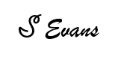 | 21/07/2023

Authorised on behalf of Natural Resources Wales

Conditions

Management

General management

The operator shall manage and operate the activities:

in accordance with a written management system that identifies and minimises risks of pollution, including those arising from operations, maintenance, accidents, incidents, non-conformances and those drawn to the attention of the operator as a result of complaints; and

using sufficient competent persons and resources.

Records demonstrating compliance with condition 1.1.1 shall be maintained.

Any person having duties that are or may be affected by the matters set out in this permit shall have convenient access to a copy of it kept at or near the place where those duties are carried out.

2 Operations
2.1 Permitted activities

2.1.1 The operator is only authorised to carry out the activities specified in schedule 1 table S1.1 (the “activities”).

2.2 The site
2.2.1 The activities shall not extend beyond the site, being the land shown edged in green and the discharge shall be made at the point marked on the site plan at schedule 7 to this permit and as listed in table S3.2 (discharge points).

2.3 Operating techniques

2.3.1 The infiltration system specified in table S1.1 shall be constructed to comply with the following:

no part of the infiltration system constructed shall be more than [2] metres below ground level;

no part of the infiltration system shall be less than [1.2] metres above the highest predicted annual groundwater level;

the infiltration system shall not connect to any land drainage system;

the infiltration system shall not be situated within [10] metres of any watercourse (including any ditch that runs dry for part of the year), or any other surface water;

the infiltration system shall not be situated within [50] metres of a well or borehole used for water supply.

3 Emissions and monitoring

3.1 Emissions to water, air or land

3.1.1 There shall be no point source emissions to water, air or land except from the sources and emission points listed in schedule 3 tables S3.1, S3.2 and S3.3.

3.1.2 The limits given in schedule 3 shall not be exceeded.

Emissions of substances not controlled by emission limits
3.2.1 For the activity referenced in schedule 1, table S1.1 the operator shall take appropriate measures as far as is reasonably practicable:
      - to prevent the input of hazardous substances to groundwater; and
      - where a non-hazardous pollutant is not controlled by an emission limit, to limit the input of such non-hazardous pollutants to groundwater so as to ensure that inputs do not cause pollution of groundwater.

3.3 Monitoring

3.3.1 Permanent means of access shall be provided to enable sampling/monitoring to be carried out in relation to the emission points specified in schedule 3 tables S3.1, S3.2 and S3.3 unless otherwise agreed in writing by Natural Resources Wales.

4 Information

4.1 Records

All records required to be made by this permit shall:

be legible;

be made as soon as reasonably practicable;

if amended, be amended in such a way that the original and any subsequent amendments remain legible, or are capable of retrieval; and

be retained, unless otherwise agreed in writing by Natural Resources Wales, for at least 6 years from the date when the records were made.
4.1.2 The operator shall keep on site all records, plans and the management system required to be maintained by this permit, unless otherwise agreed in writing by Natural Resources Wales.

4.2 Reporting

4.2.1 The operator shall send all reports and notifications required by the permit to Natural Resources Wales using the contact details supplied in writing by Natural Resources Wales.

4.3 Notifications

4.3.1 Natural Resources Wales shall be notified without delay following the detection of:

any malfunction, breakdown or failure of equipment or techniques, accident, or emission of a substance not controlled by an emission limit which has caused, is causing or may cause significant pollution;

the breach of a limit specified in the permit; or

any significant adverse environmental effects.

(d) any emergency discharge that has occurred.

4.3.2 Any information provided under condition 4.3.1 shall be confirmed by sending the information listed in schedule 5 to this permit within the time period specified in that schedule.

4.3.3 Where Natural Resources Wales has requested in writing that it shall be notified when the operator is to undertake monitoring and/or spot sampling, the operator shall inform Natural Resources Wales when the relevant monitoring and/or spot sampling is to take place. The operator shall provide this information to Natural Resources Wales at least 14 days before the date the monitoring is to be undertaken.

4.3.4 Natural Resources Wales shall be notified within 14 days of the occurrence of the following matters, except where such disclosure is prohibited by Stock Exchange rules:

Where the operator is a registered company:

any change in the operator’s trading name, registered name or registered office address; and

(b) any steps taken with a view to the operator going into administration, entering into a company voluntary arrangement or being wound up.

Where the operator is a corporate body other than a registered company:

any change in the operator’s name or address; and

any steps taken with a view to the dissolution of the operator.

4.3.5 Where the operator proposes to make a change in the nature or functioning, or an extension of the activities, which may have consequences for the environment and the change is not otherwise the subject of an application for approval under the Regulations or this permit:

Natural Resources Wales shall be notified at least 14 days before making the change; and

(b) the notification shall contain a description of the proposed change in operation.

4.4 Interpretation

4.4.1 In this permit the expressions listed in schedule 6 shall have the meaning given in that schedule.

4.4.2 In this permit references to reports and notifications mean written reports and notifications, except where reference is made to notification being made “without delay”, in which case it may be provided by telephone.

Schedule 1 – Operations

Table S1.1 Activities
Description of activity | Limits of specified activity
Groundwater activity: discharge into land of secondary treated sewage effluent | Via an infiltration system centred on NGR SS 00928 97437

Schedule 2 - Waste types, raw materials and fuels

Wastes are not accepted as part of the permitted activities and there are no restrictions on raw materials or fuels under this schedule.

Schedule 3 – Emissions and monitoring

Table S3.1 Point Source emissions to water (other than sewer) and land – emission limits and monitoring requirements
Emission point ref. & location | Parameter | Limit (incl. unit) | Reference  Period | Monitoring frequency | Compliance statistic
Outflow from sewage treatment plant prior to discharge into drainage field | Maximum daily flow | 4.35 m³/day | Total daily volume | N/A | Maximum
 | Visible oil or grease | No significant trace present | Instantaneous (spot sample) | N/A | No significant trace

Table S3.2 Discharge points
Effluent Name | Discharge Point | Discharge point NGR | Receiving Environment
Secondary treated sewage effluent | Outlet 1 | SS 00928 97437 | Groundwater via an infiltration system

Table S3.3 Monitoring points
Effluent(s) and discharge point(s) | Monitoring type | Monitoring point NGR | Monitoring point reference
Secondary treated sewage effluent via outlet 1 | Effluent sample point | SS 00928 97437 | Sampling Chamber

Schedule 4 - Reporting

There is no reporting under this schedule.

Schedule 5 - Notification

These pages outline the information that the operator must provide.

Units of measurement used in information supplied under Part A and B requirements shall be appropriate to the circumstances of the emission. Where appropriate, a comparison should be made of actual emissions and authorised emission limits.

If any information is considered commercially confidential, it should be separated from non-confidential information, supplied on a separate sheet and accompanied by an application for commercial confidentiality under the provisions of the EP Regulations.

Part A
Permit Number | EPR/CB3990ZG

Name of operator
Location of Facility | East Trewent Farm, Freshwater East, Pembroke, SA71 5LR

Time and date of the detection

(a) Notification requirements for any malfunction, breakdown or failure of equipment or techniques, accident, or emission of a substance not controlled by an emission limit which has caused, is causing or may cause significant pollution

To be notified within 24 hours of detection

Date and time of the event

Reference or description of the location of the event

Description of where any release into the environment took place

Substances(s) potentially released

Best estimate of the quantity or rate of release of substances

Measures taken, or intended to be taken, to stop any emission

Description of the failure or accident.

(b) Notification requirements for the breach of a limit

To be notified within 24 hours of detection unless otherwise specified below

Emission point reference/ source

Parameter(s)

Limit

Measured value and uncertainty

Date and time of monitoring

Measures taken, or intended to be taken, to stop the emission

Time periods for notification following detection of a breach of a limit
Parameter | Notification period

(c) Notification requirements for the detection of any significant adverse environmental effect

To be notified within 24 hours of detection

Description of where the effect on the environment was detected

Substances(s) detected

Concentrations of substances detected

Date of monitoring/sampling

Part B - to be submitted as soon as practicable

Any more accurate information on the matters for notification under Part A.

Measures taken, or intended to be taken, to prevent a recurrence of the incident

Measures taken, or intended to be taken, to rectify, limit or prevent any pollution of the environment which has been or may be caused by the emission

The dates of any unauthorised emissions from the facility in the preceding 24 months.

Name*

Post

Signature

Date

* authorised to sign on behalf of the operator

Schedule 6 - Interpretation
“accident” means an accident that may result in pollution.
“annually” means once every year.
“application” means the application for this permit, together with any additional information supplied by the operator as part of the application and any response to a notice served under Schedule 5 to the EP Regulations.
“emissions to land” includes emissions to groundwater.
“EP Regulations” means The Environmental Permitting (England and Wales) Regulations SI 2016 No.1154 and words and expressions used in this permit which are also used in the Regulations have the same meanings as in those Regulations.

“emissions of substances not controlled by emission limits” means emissions of substances to air, water or land from the activities, either from the emission points specified in schedule 3 or from other localised or diffuse sources, which are not controlled by an emission limit.
“groundwater” means all water, which is below the surface of the ground in the saturation zone and in direct contact with the ground or subsoil.
“Natural Resources Wales” means the Natural Resources Body for Wales established by article 3 of the Natural Resources Body for Wales (Establishment) Order 2012. The Natural Resources Body for Wales (Functions) Order 2013 transferred the relevant functions of the Countryside Council for Wales, and functions of the Environment Agency and the Forestry Commission in Wales to the Natural Resources Body for Wales.
“quarter” means a calendar year quarter commencing on 1 January, 1 April, 1 July or 1 October.

“year” means calendar year ending 31 December.

Schedule 7 - Site plan

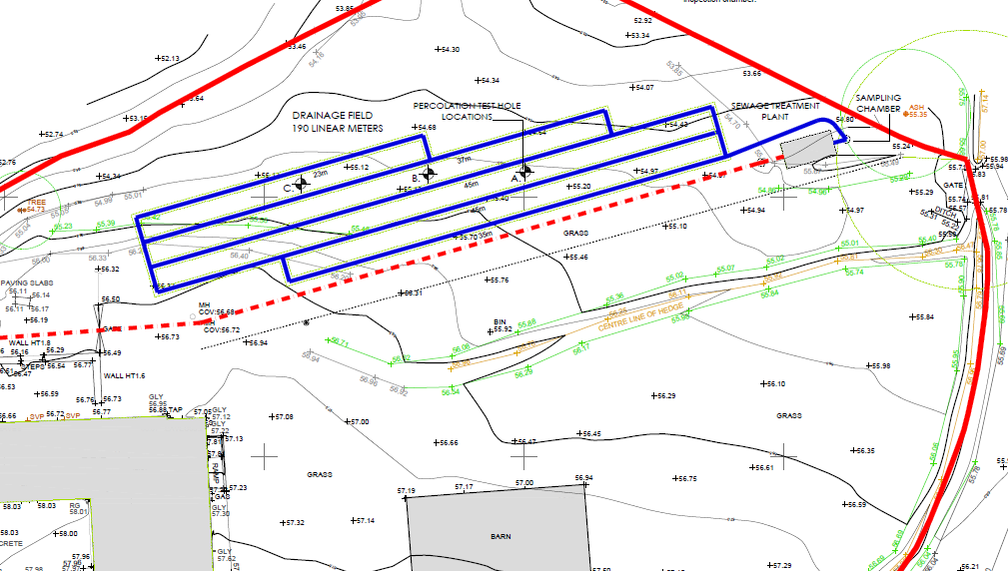

Site Boundary marked in Green

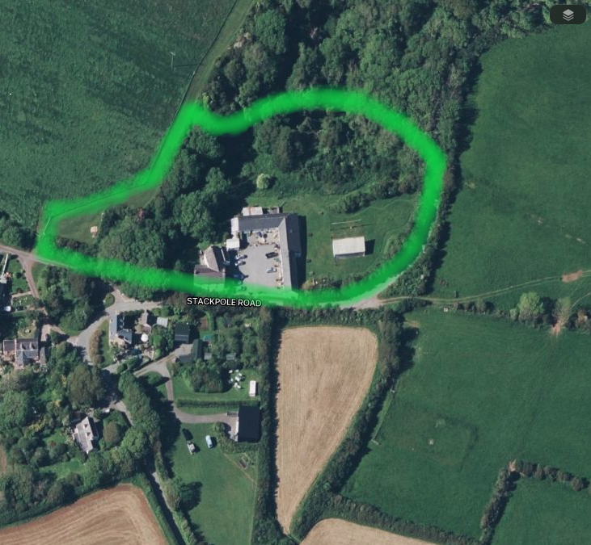
Sampling Chamber

© Crown Copyright and database right 2023. Ordnance Survey licence number 100019741.

END OF PERMIT

