Notice of variation with introductory note
Environmental Permitting (England & Wales) Regulations 2016

Airbus Operations Limited

Chester Road
Broughton
Chester
CH4 0DR

Permit number
EPR/BM3965IA/V008

Permit number

EPR/BM3965IA

Airbus Operations Limited

Permit number EPR/BM3965IA

Introductory note

This introductory note does not form a part of the notice

The following notice gives notice of the variation of an environmental permit.

The schedules specify the changes made to the original permit.

This variation is to authorise the installation of a new paint booth within the existing Final Single Aisle Wing Painting Facility on site (building number 160). The paint booths, carry out detailed painting of wing elements and the installation of the new booth will increase the production throughput of the Final Single Aisle Wing Painting Facility.

The new paint booth will be operated in the same manner as the existing Final Single Aisle Wing Paint Shop booths and will use the same compliant coating and solvent cleaning materials. The new booth will have a dedicated vent stack and will contribute to the site’s overall emission to air. The stack will release air containing particulate matter and volatile organic compounds as a result of the painting activities. Particulates shall be abated by in line filter bags, while releases of volatile organic compounds shall be controlled by the site’s compliance with their agreed Solvent Reduction Plan.

The status log of a permit sets out the permitting history, including any changes to the permit reference number.

Status log of the permit
Description | Date | Comments
Application BM3965IA | Duly Made 06/06/2002
Request for information | 18/09/2002 | Received 18/09/2002
Permit determined BM3965IA | 15/11/2002
Application BV0945 | 10/04/2003
Variation EPR/BV0945 issued | 27/07/2003
Variation application TP3737PJ | 09/07/2004
Additional information supplied | 13/07/2004
Additional information supplied | 02/08/2004
Additional information supplied | 18/10/2004
Additional information supplied | 12/05/2005
Variation TP3737PJ issued | 30/06/2005
Variation application NP3235MQ | 12/12/2006
Variation NP3235MQ issued | 26/01/2007
Variation application EPR/BM3965IA/V005 | Duly Made 11/11/2009
Variation EPR/BM3965IA/V005 issued | 03/08/2010
Variation application EPR/BM3965IA/V006 | Duly Made 27/03/2015
Variation EPR/BM3965IA/V006 issued | 02/09/2015
Application EPR/BM3965IA/V007  (variation and consolidation) | Duly made  07/06/2016 | Application to vary and update the permit to modern conditions.
Additional information received | 10/08/2016 | Updated site plan and plan of emission points to air
Variation determined  Consolidated Permit: EPR/BM3965IA | 05/09/2016 | Varied and consolidated permit issued in modern condition format. The following permits have been consolidated: EPR/BM3965IA and EPR/BP3937WE
Application for variation  PAN-002197  (EPR/BM3965IA/V008) | Duly Made 15/01/2018 | Application to install an additional paint booth on site with associated emission point
Variation  EPR/BM3965IA/V008 issued | 10/04/2018

End of introductory note

Notice of variation
Environmental Permitting (England and Wales) Regulations 2016

The Natural Resources Body for Wales (“Natural Resources Wales”) in exercise of its powers under regulation 20 of the Environmental Permitting (England and Wales) Regulations 2016 varies

Permit number

EPR/BM3965IA

issued to:

Airbus Operations Limited (“the operator”),

whose registered office is

Pegasus House

Aerospace Avenue

Filton

Bristol

BS34 7PA

company registration number

03468788

to operate part of an installation at

Chester Road

Broughton

Chester

CH4 0DR

to the extent set out in the schedules.

The notice shall take effect from DD/MM/YYYY

Signed | Date
[name of authorised person] | [DD/MM/YYYY]

Authorised on behalf of Natural Resources Wales

Schedule 1 – conditions to be deleted

None

Schedule 2 – conditions to be amended

The following conditions are amended as a result of the application made by the operator

Table S1.2 shall be amended to:

Table S1.2 Operating techniques
Description | Parts | Date Received
Application BS4243 | The response to questions 2.3 and given in pages 14 to 22 inclusive and within sections 2.3.1 to 2.3.12 of the Application | 06/06/02
Application BS4243 Response to Schedule 4 Part 1 Notice dated 11 Sept 2002 | Response to questions 3 and 4 | 12/09/02
Application BM3965IA | The response to section 2.1, 2.2 and 2.3 in the application | 04/12/06
Application BM3965IA Additional information from the Operator | Atmospheric Dispersion Modelling | 08/01/07
Application BM3965IA Additional information from the Operator | Re-submission of main text of the application, PPC04, PPC06 and Table 2.10.2 Surface Water Monitoring | 15/01/07
Application BM3965IA Additional information from the Operator | Atmospheric Dispersion Modelling for Onsite Receptors and Conversion of nitric oxide to nitrogen dioxide | 17/01/07
Application EPR/BM3965IA/V005 | Sections 3.12, 3.13, 3.17, 3.18, 3.19, 3.20, 3.21, 3.22, 3.23 (except 3.23.6 and 3.23.7) | 11/11/09
Application EPR/BM3965IA/V006 | Section 2 of application report “Application for a Variation to Environmental Permit Np. EPR/BM3965IA” | 27/03/15
Application EPR/BM3965IA/V007 | Sections 4, 5, 6 and 8 of 934592-RPT-1 Rev. B “Airbus Environmental Permit Variation Application, Permit EPR/BM3965IA” (June 2016) | 07/06/16
Application EPR/BM3965IA/V008 | ‘Permit variation application EPR/BM3964IA’ report and the associated Air Quality Impact Assessment (AQIA) report | 15/01/18

Table S1.3 shall be amended to:

Table S1.3 Improvement programme requirements
Reference | Requirement | Date
IC1 | The Operator shall continue with the programme to remove chromium from the production process. A summary report shall be submitted to Natural Resources Wales identifying progress towards this removal by the due date and then annually until completion. | 31/12/07 and then annually until chromium removed
IC2 | The Operator shall:  confirm the design capacity of the effluent treatment plant by stating the maximum rate at which it can operate expressed as tonnes of untreated effluent per day; and  provide the European Waste Catalogue (EWC) waste codes associated with untreated effluent being introduced into the effluent treatment plant.  The design capacity of the effluent treatment plant and the EWC codes for the untreated effluent shall be provided to Natural Resources Wales in the form of a written report. | 30/09/16
IC3 | The Operator shall submit to Natural Resources Wales an updated plan showing the location of all the emission points to sewer listed in table S3.3. | 31/10/16
IC4 | The Operator shall confirm the total maximum consumption capacity of the seven paint shops on site as a mass of organic solvents in both kg / hour and tonnes / year. The seven paint shops are: Haden Booth, Site 5, Interim Single Aisle, Binks, Stringer, West and Final Single Aisle. Confirmation of the total maximum consumption capacity shall be submitted in writing to Natural Resources Wales. | 31/12/16
IC5 | The Operator shall sample and analyse emissions from release points A184 and A185 for Particulate Matter in the form of PM10, when the preparation and combo booths serving these emission points are operational. The sampling and analysis exercise shall be designed to ensure that a representative sample is obtained and shall be conducted in accordance with the requirements of the Natural Resources Wales guidance document M1 “Sampling Requirements for Stack Emission monitoring” and BS EN 13284-1.  The analysis results shall be converted into long and short term process contributions (PC) using detailed air dispersion modelling software. The detailed air dispersion modelling shall show the PCs as a percentage of both the 40 µg/m3 annual mean UK air quality objective and the 50 µg/m3 24-hour mean UK air quality objective for Particulate Matter. In addition, the calculated PCs shall be added to the existing long and short term backgrounds for particulate matter to derive the Predicted Environmental Concentration (PEC) at all nearby human sensitive receptors and as a maximum on the modelling grid. The air dispersion modelling shall also show the PECs as a percentage of the long and short term air quality objectives for particulate matter in order to demonstrate the likelihood of exceedance of either as result of the operation of the new booths.  The results of the sampling and analysis exercise and air dispersion modelling study and conclusions shall be submitted in the form of a written report to Natural Resources Wales. | 31/03/17  Discharged  (11/01/218)
IC6 | The Operator shall provide the European Waste Catalogue (EWC) waste codes associated with chromate free untreated effluent being introduced into the effluent treatment plant. This information shall be provided when the installation’s surface treatment activities become chromate free operations.  The EWC codes for the chromate free untreated effluent shall be provided to Natural Resources Wales in the form of a written report. | 30/09/17

Table S3.1 shall be amended to:

Table S3.1 Point source emissions to air – emission limits and monitoring requirements
Emission point ref. & location (on PPC 04 E dated 9/8/16)) | Source | Parameter | Limit (including unit) | Reference period | Monitoring frequency | Monitoring standard or method
Chrome Anodising, TSA Anodising, and Effluent Treatment Plant
Large Component Manufacture (LCM)
A79, A81, A83 | Tanks 01, 02, 03, 04, 05, 08 and 11 on the LCM Treatment Line | n/a | n/a | n/a | n/a | n/a
A90 | LCM Effluent Treatment | n/a | n/a | n/a | n/a | n/a
A82 | Tank 9 | n/a | n/a | n/a | n/a | n/a
Stringer Manufacturing Centre (SMC)
A84 | Tanks 01, 02, 05, 08, 09, 10 and 13 on the SMC Treatment Line | n/a | n/a | n/a | n/a | n/a
A91 | SMC Effluent Treatment | n/a | n/a | n/a | n/a | n/a
Paint Shops
Haden Booth
A24, A26 | Oven, spray booth and paint mix | VOCs | n/a | n/a | Annually | Mass balance ^{Note 1}
Site 5
A27 – A34 | Prep booths, spray booths, detail booths, detail booth oven and paint mix | VOCs | n/a | n/a | Annually | Mass balance ^{Note 1}
Interim Single Aisle
A35 – A43  A35a – A42a | Booths and paint mix | VOCs | n/a | n/a | Annually | Mass balance ^{Note 1}
Binks
A44 | Spray booths, paint mix and oven | VOCs | n/a | n/a | Annually | Mass balance ^{Note 1}
Stringer
A55, A56 | Spray booth, paint mix and booth oven | VOCs | n/a | n/a | Annually | Mass balance ^{Note 1}
West
A58 – A60 | Paint shops and paint mix | VOCs | n/a | n/a | Annually | Mass balance ^{Note 1}
Final Single Aisle
A177 – A181, A184 – A185  A186 | Prep booth and paintshop | VOCs | n/a | n/a | Annually | Mass balance ^{Note 1}Mass balanceNote 1
Combustion Plant
A4 – A10, A12, A14 | Process / Space Heaters | n/a | n/a | n/a | n/a | n/a
A23 | Hanger 91 Boiler | n/a | n/a | n/a | n/a | n/a
A61 – A72 | A380 Autoclaves | n/a | n/a | n/a | n/a | n/a
A112 – A115 | Site 5 Burners | n/a | n/a | n/a | n/a | n/a
A119 | Haden Booth Burner | n/a | n/a | n/a | n/a | n/a
A99 – A111, A120 – A173, A182 | Combustion Plant <0.5MW Input | n/a | n/a | n/a | n/a | n/a
A175 | Final Single Aisle Boiler | n/a | n/a | n/a | n/a | n/a
CHP-A1 | Stringer Boiler 1 | Oxides of Nitrogen (as NOx) | 200 mg/m3 | 15 minute average | Annually | ISO10849
CHP-A2 | Stringer Boiler 2 | Oxides of Nitrogen (as NOx) | 200 mg/m3 | 15 minute average | Annually | ISO10849
CHP-A3 | Skin and Creep Boiler | Oxides of Nitrogen (as NOx) | 200 mg/m3 | 15 minute average | Annually | ISO10849
CHP-A4 | West Factory Boiler 1 | Oxides of Nitrogen (as NOx) | 200 mg/m3 | 15 minute average | Annually | ISO10849
CHP-A5 | West Factory Boiler 2 | Oxides of Nitrogen (as NOx) | 200 mg/m3 | 15 minute average | Annually | ISO10849
CHP-A6 | West Factory Boiler 3 | Oxides of Nitrogen (as NOx) | 200 mg/m3 | 15 minute average | Annually | ISO10849
CHP-A7 | West Factory Boiler 4 | Oxides of Nitrogen (as NOx) | 200 mg/m3 | 15 minute average | Annually | ISO10849
CHP-A8 | West Factory CHP 1 | Oxides of Nitrogen (as NOx) | 500 mg/m3 | 15 minute average | Annually | ISO10849
CHP-A9 | West Factory CHP 2 | Oxides of Nitrogen (as NOx) | 500 mg/m3 | 15 minute average | Annually | ISO10849
CHP-A10 | West Factory CHP 3 | Oxides of Nitrogen (as NOx) | 500 mg/m3 | 15 minute average | Annually | ISO10849
CHP-A11 | West Factory CHP 4 | Oxides of Nitrogen (as NOx) | 500 mg/m3 | 15 minute average | Annually | ISO10849
CHP-A12 | Stringer CHP 1 | Oxides of Nitrogen (as NOx) | 500 mg/m3 | 15 minute average | Annually | ISO10849
CHP-A13 | Stringer CHP 2 | Oxides of Nitrogen (as NOx) | 500 mg/m3 | 15 minute average | Annually | ISO10849
CHP-A14 | Skin and Creep CHP | Oxides of Nitrogen (as NOx) | 500 mg/m3 | 15 minute average | Annually | ISO10849
CHP-A15 | CHP D | Oxides of Nitrogen (as NOx) | 500 mg/m3 | 15 minute average | Annually | ISO10849
CHP-A16 | Boiler 1 D | Oxides of Nitrogen (as NOx) | 200 mg/m3 | 15 minute average | Annually | ISO10849
CHP-A17 | Boiler 2 D | Oxides of Nitrogen (as NOx) | 200 mg/m3 | 15 minute average | Annually | ISO10849
CHP-A18 | CHP E | Oxides of Nitrogen (as NOx) | 500 mg/m3 | 15 minute average | Annually | ISO10849
CHP-A19 | Boiler 1 E | Oxides of Nitrogen (as NOx) | 200 mg/m3 | 15 minute average | Annually | ISO10849
CHP-A20 | Boiler 2 E | Oxides of Nitrogen (as NOx) | 200 mg/m3 | 15 minute average | Annually | ISO10849
CHP-A21 | Boiler 3 E | Oxides of Nitrogen (as NOx) | 200 mg/m3 | 15 minute average | Annually | ISO10849

Schedule 3 – conditions to be added

None

Schedule 4 – amended plan

The site plans shall be amended to:
Site plan
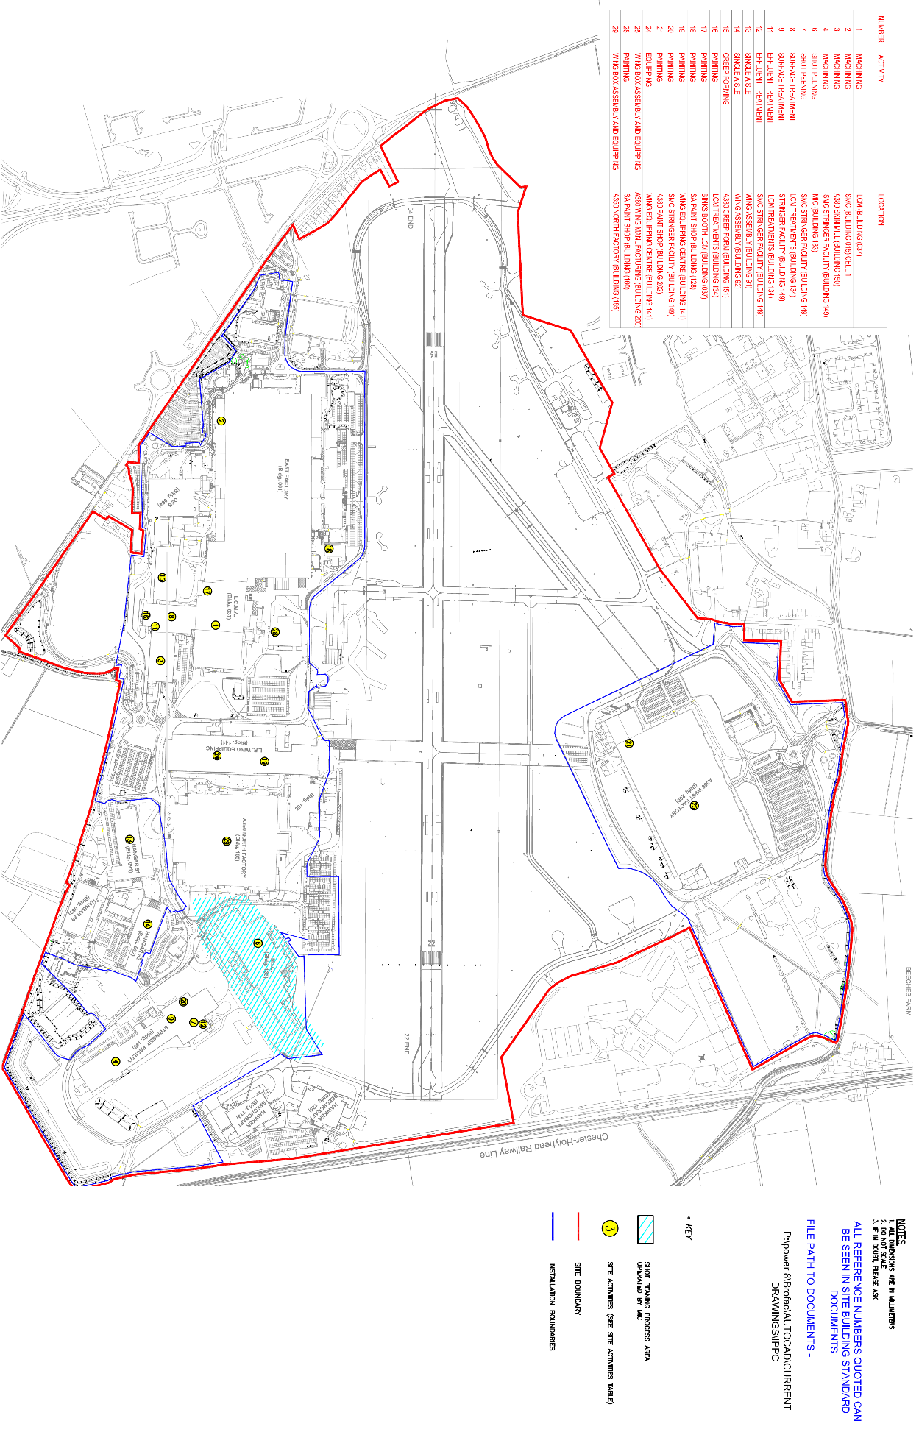

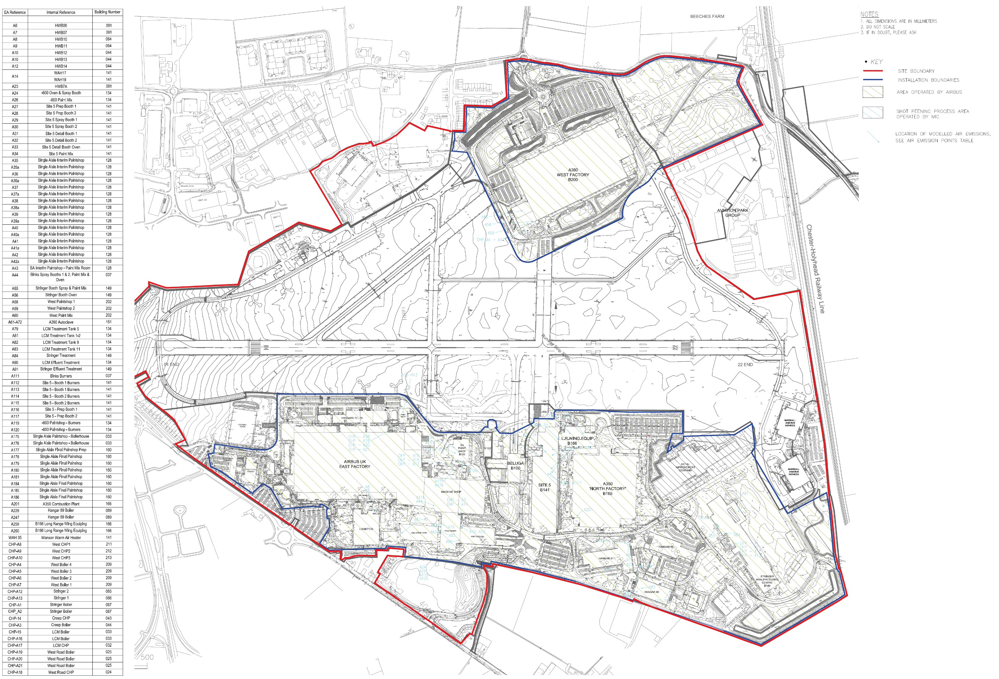
Emission Point Plan

