CRoW Appendix 4 (140_10_SD02)  CRoW Act 2000: Natural Resources Wales application for permission - Formal Notice |  | 
Natural Resources Wales Formal Notice.
Requirements of Section 28I of the Wildlife & Countryside Act 1981 as amended by the Countryside and Rights of Way Act (CRoW) 2000.
Duty in relation to granting any consent, licence or permit for activities likely to damage Sites of Special Scientific Interest (SSSI).
Guide to filling in this form for Natural Resources Wales staff:
To be completed by Permitting Officers for any applications for a permission which the Natural Resources Wales has considered under S28G duties to protect and enhance SSSIs. This applies to all proposed permissions within a SSSI, and to operations outside the SSSI boundary which are likely to damage its special features.
Refer to OI 140_10 ‘Applying the Countryside and Rights of Way (CRoW) Act 2000 to applications for permits with potential for impact on Sites of Special Scientific Interest (SSSI)’, including the flowchart in Appendix 2.
Pink italic text – drafting notes, to be deleted before completion/consultation.
Blue text – examples, to be replaced with permission-specific information.
Ensure you have completed all sections.
- Natural Resources Wales area/region/NPS hub: | Wales, Cardiff, Ty Cambria
- Name of SSSI: | Brynna a Wern Tarw (33WBK)
- Type of permission: | Environmental Permit
- Date for Natural Resources Wales permit determination: | 21/07/2023
- Predicted 28 day date for response from NRW conservation/ecology (under S28 I(4)): | N/A
- Natural Resources Wales reference no: | EPR/BS6149IQ/V011 (PAN-019896)
- National grid reference: | SS 96080 84010
- Description of proposal: | - The addition of a flue gas desulphurisation abatement plant on line 3 cupola and associated emission point A19 to allow the site to meet the BAT emission limit of 1400 mg/m³. The desulphurisation process consist of injecting sodium bicarbonate into the gas stream to remove the sulphur dioxide. The residual dust is collect by bag filters which are periodically emptied. This is an established best available technique for this sector.  - Expansion of the waste products accepted under Table S2.2 to include products manufactured outside the UK by Rockwool’s other sites operated by Rockfon.  - Addition of discharge point to sewer (S1) to reflect that the settlement tank has now been connected to sewer. Previously the water was discharge primarily to surface water (emission point w1). W1 will remain in the permit as discharge to surface water may occasionally occur in the event of an overflow but the emission limits will remain the same.  - Add an improvement condition for the operator to submit a plan for the reduction of the emissions of ammonia to air
- Is the proposed activity within (wholly or partially) the SSSI boundary? | No  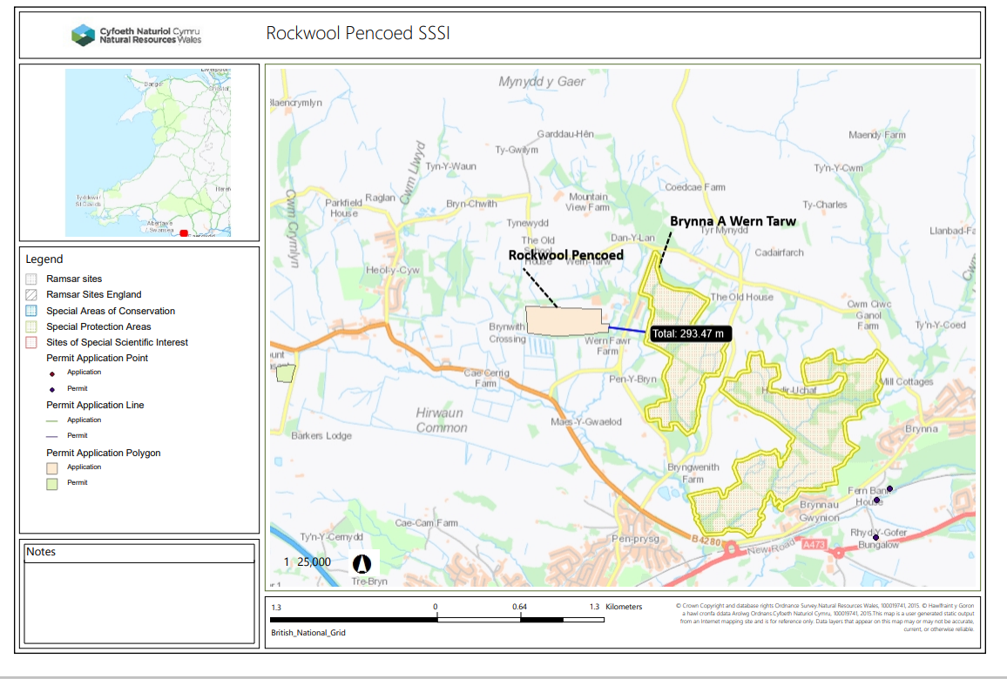  Site located approximately 290 meters from the installation
- Has there been any pre-application discussion or correspondence with NRW conservation/ecology | No
- What aspect(s) of the proposed permission may damage the features which are of special interest for the SSSI?
The following ‘Operations Requiring Consent’ (or other activities associated with the permission) that may cause damage) are relevant to the proposed permission.

Dumping, spreading or discharging of any materials: Through emissions to air. There are no impact pathways through emissions to surface water.

The following SSSI features and mechanisms of impact have been considered to assess the likelihood of damage:

We have concluded that there is no impact pathway from the proposal to cause damage to the feature of the SSSI for the following reasons

- Desulphurisation plant: the addition of the new desulphurisation plant will allow the site to reduce their emissions of sulphur dioxide allowing the emission limit to be reduced from 2200 mg/m³ (as agreed as part of improvement condition 18 on the 06/04/2023). As such the proposal will decrease the emissions of sulphur dioxide from the site. The desulphurisation plant will also be installed with bag that will capture the residual carbonate mixture. The permit already has requirement monitoring and emission limits for particulate matter.

- Cupola lines 1 and 2 will continue to have emission limited of 2200 mg/m³ as agreed in response improvement condition 18 on the 06/04/2023. Therefore, there is no change in the impact from emissions of sulphur dioxide from these lines.

- The use of waste produced by Rockfon in the process will not lead to any new emissions or lead to any increase risk of exceedance any existing emission limits

As a result of the above it has been concluded that the variation proposal will not lead to any increase in risk of impact from the site’s emissions to air to the Brynna a Wern Tarw SSSI.

- Decision
i) The proposed permission is not likely to damage any of the flora, fauna or geological or physiological features which are of special interest.

Natural Resources Wales is minded to:
Issue the permission

- Name and job title of Natural Resources Wales officer: | William Wallace  Senior Permitting Officer, Installation and RSR permitting
- Date form sent to NRW conservation/ecology | N/A-Filed for Audit
For Natural Resources Wales use only, once NRW conservation/ecology response received
- NRW conservation/ecology comment on assessment: | N/A-Filed for Audit
- Name and job title of NRW conservation/ecology officer:
- Date of receipt of NRW conservation/ecology response:

