MyMap and EMS Report for OPRA review
Proximity to Human Occupation
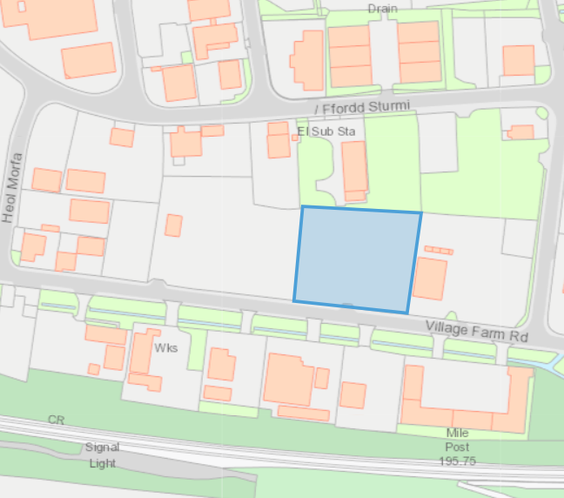

Direct run-offs
Section 1.3.2 of 2019 EMS:

Air Quality Management Zone
- none within 2km

Sensitivity of surface water
Nearest classified stretch is over 2km away

Assessment under wildlife, countryside or habitats legislation
SAC within 1km:
- Glaswelltiroedd Cefn Cribwr / Cefn Cribwr Grasslands SAC
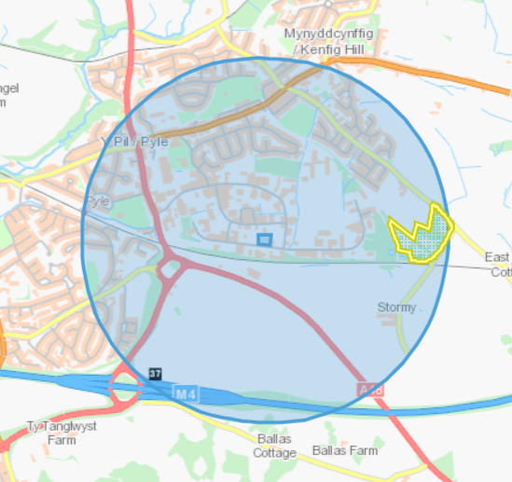

SSSI within 2km:
- Cynffig / Kenfig
- Penycastell, Cefn Cribwr
- Stormy Down
- Waun Cimla
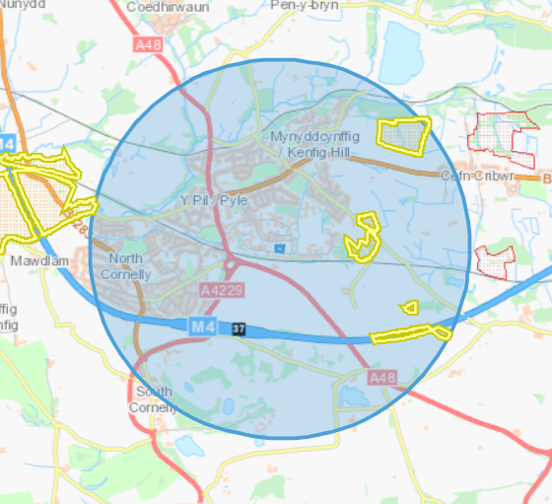

Groundwater/Aquifers
Aquifer Designation (Superficial)
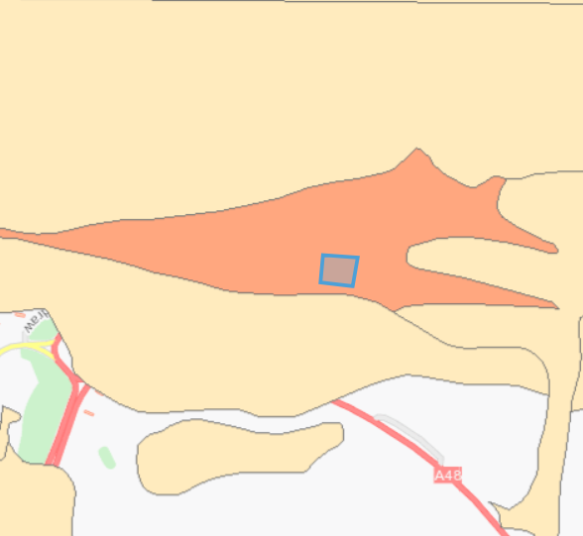
- no groundwater source protection zone

Aquifer Designation (Bedrock)
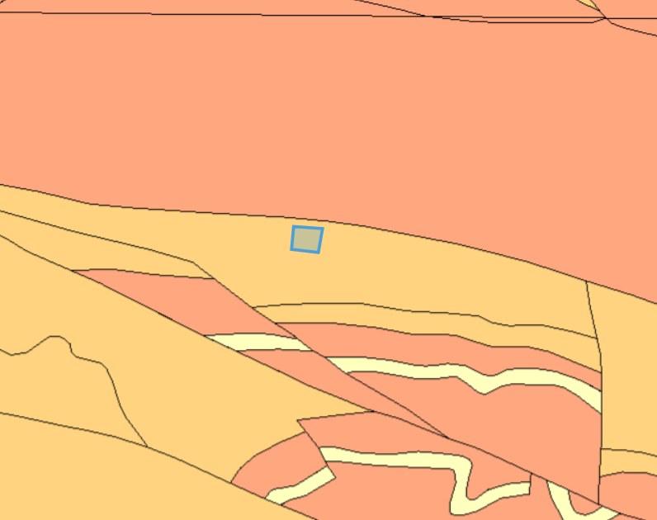
- no groundwater source protection zone

Flood Plain


