WQ Non-Point Source GW Activity
Risk Screening Report
Application Reference: PAN-008029
Date: 11th February 2020
Designated Site | Scientific Name | Common Name | Distance Criteria | Present
Source Protection Zone 1 |  |  | 0+
Groundwater Vulnerability Zones |  |  | within
LRC priority & protected species (point) | Austropotamobius pallipes | White-clawed Freshwater Crayfish | 30
LRC priority & protected species (point) | Coenagrion mercuriale | Southern Damselfly | 30
LRC priority & protected species (point) | Epidalea calamita | Natterjack Toad | 30
LRC priority & protected species (point) | Euphydryas aurinia form aurinia | Marsh Fritillary | 30
LRC priority & protected species (point) | Hydrochara caraboides | Lesser Silver Water Beetle | 30
LRC priority & protected species (point) | Lacerta agilis | Sand Lizard | 30
LRC priority & protected species (point) | Margaritifera margaritifera | Freshwater Pearl Mussel (CODE 1) | 30
LRC priority & protected species (point) | Myxas glutinosa | Glutinous Snail | 30
LRC priority & protected species (point) | Synaptus filiformis | Hairy Click Beetle | 30
LRC priority & protected species (point) | Trichomanes speciosum | Killarney Fern (CODE 3) | 30
LRC priority & protected species (point) | Triturus cristatus | Great Crested Newt (CODE 2) | 30
LRC priority & protected species (point) | Vertigo geyeri | Geyer's Whorl Snail | 30
LRC priority & protected species (point) | Vertigo moulinsiana | Desmoulin's Whorl Snail | 30
National Nature Reserves - Wales |  |  | 30
Local Nature Reserves - Wales |  |  | 30
Local Wildlife Sites |  |  | 30
Ancient Woodland - Wales |  |  | 30
Special Areas of Conservation - Wales | Afon Teifi |  | 1000
Special Protection Areas - Wales |  |  | 1000
Ramsar Sites - Wales |  |  | 1000
Sites of Special Scientific Interest - Wales | Afon Teifi |  | 1000

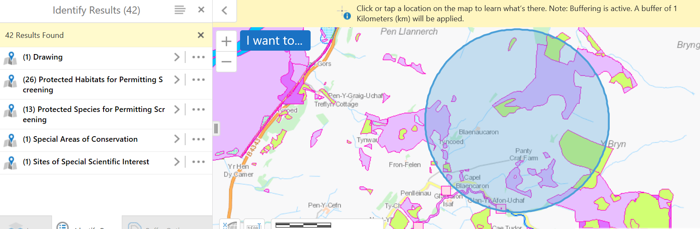

© Crown Copyright and database right 2020. Ordnance Survey licence number 100019741.

