Environmental Permitting: Natural Resources Wales variation request
You must have agreement from your Area Environment Manager and Permitting Service Cardiff (PSC) to carry out this variation. Use this form following the instructions in the OI How we determine an application or vary a permit. Attach any documents that relate to this request such as your letter to the operator about the variation and any emails approving the request.

Area officer | Jeremy Goddard | Contact phone number | 0300 065 4022

AEM approver | Huwel Manley | Date approved
WPCC approver |  | Date approved

Permit details
Permit number | GWSW0418
Operator name | Mr. David Kenneth Price
Facility name | -
Site address | Cwmcynwal  Hafod Bridge  Llanwrda  Carmarthenshire  SA19 8BS
Grid reference | SN 70541 35624
Region | South West
Area | Operations/Carmarthenshire NRM

Justification for variation

During a recent visit to inspect against the conditions of EPR permit GWSW0418 for the spreading of waste sheep dip to land, it was found that there are a number of errors within the permit. The permit has previously been varied and transferred, along the way some of the conditions have changed and are no longer environmentally protective. Jeremy Goddard has liaised with Stephanie Jenkins in the Permitting Centre regarding this matter. As the Environment Agency were at fault for these errors during a previous review and variation of the permit, Natural Resources Wales should make the relevant changes at no cost to the permit holder Mr. David Price.

The latest version of the permit stipulates:

2.3.7 The maximum volume of used / waste sheep dip (of working strength) before any dilution to assist safe spreading, shall not exceed 2 cubic metres per annum discharged to the land identified in schedule 7 and subject to the requirements of condition 2.3.8.

ISSUE: 2 cubic metres is way more waste than is produced from dipping at the site. Looking at the original groundwater authorisation the figures included are much closer to my observations out on site. Mr. Price confirmed that after dipping he has approximately 200 gallons of waste dip left in the bath. The original authorisation allowed the farm to spread 1.0 cubic metres per day (1,000 litres / 220 gallons) which is a similar volume as to what is actually being produced on site (see highlighted condition from the old permit below).

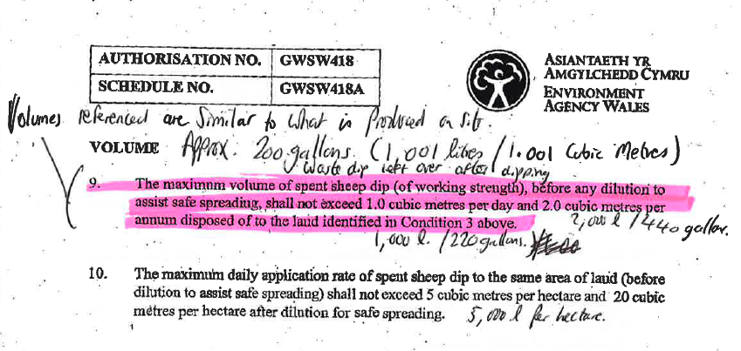

2.3.8 The maximum daily spreading rate of used / waste working strength sheep dip shall not exceed 5 cubic metres spread evenly on a minimum of 20 hectares of the land identified in schedule 7.

ISSUE: 20 hectares is way too large an area to spread the waste sheep dip over and is much larger than the plot identified in schedule 7 of the permit.

2.3.10 The discharge of used / waste sheep dip to the same individual area of land within the site identified in schedule 7 shall not be undertaken more frequently than once per year. A maximum of 2 discharges may be made per year within the site and where multiple discharges are permitted they shall be rotated within the site so as to be in accordance with the requirements of condition 2.3.8.

ISSUE: During the inspection Mr. Price stated that he currently dips once per year but the original and new permit allow him to dispose of waste dip twice per year; the new permit stipulating that it can’t be spread twice on the same area of land within the disposal plot. During the site visit it was evident that much of the disposal area identified in the new permit is not suitable for spreading as it is far too steep. I have highlighted the part of the plot that is suitable for spreading in pink (approximately 2 hectares) in the plan overleaf and have liaised with Stephanie Jenkins in permitting regarding whether the plot is of sufficient size to spread on twice, which she believes it is (see Hydraulic loading calculations overleaf).

As best practice I also advise that an additional condition (which is on most groundwater permits) requiring that the working strength waste sheep dip is further diluted to a 3:1 ratio (3 part slurry or water and one part dip) to further assist safe spreading.

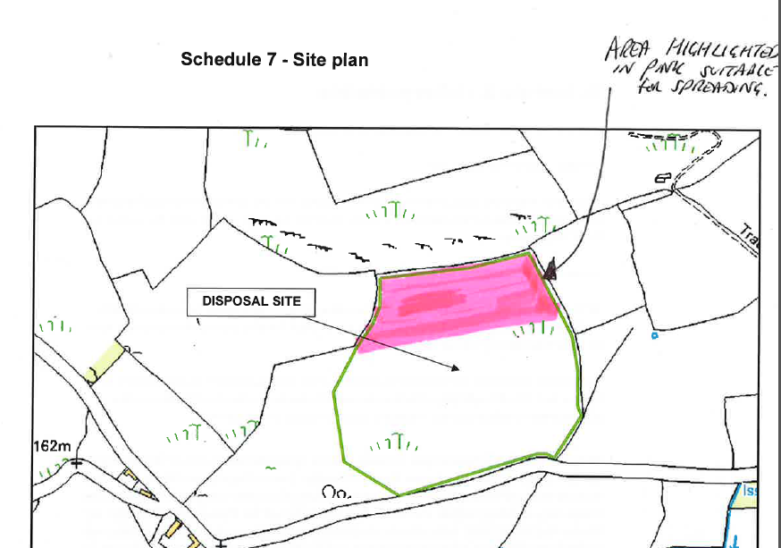

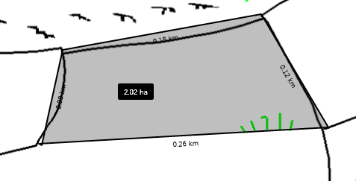

Hydraulic Loading

Minimum area (ha) = Daily loading (after dilution) mᶟ per day / Application rate (mᶟ/ha)

1mᶟ per day = working strength dip spread by a vacuum tanker (so requires dilution)

By 1 part dip : 3 part water/slurry
= 4mᶟ per day
/ 20 mᶟ (hydraulic loading for vacuum tanker)

= 0.2 hectares for one spread
Dipping twice a year at a rate of 1mᶟ per day would therefore require 0.4hectares

(Total amount of undiluted dip per annum = 2mᶟ. Total amount of diluted dip per annum = 8mᶟ.)

What date do you want the permit change to take effect from? | As soon as possible

Charging
What is the charge for this variation? | N/A
Justification if we are not charging the operator

As this was an Environment Agency error, no charge should be directed at the permit holders. Advice given from Permitting is that since this would be an admin variation and it was an error made by the Environment Agency, then no Form L is required.

Consultation
I have liaised with Stephanie Jenkins in the permitting Centre over this matter.

Operator competence
Will the variation affect technical competence? | No
Detail relevant convictions to date.

N/A

Details of any current enforcement.

N/A

Sites of high public interest and other issues

Are there any sensitivity issues with the application? For example site of high public interest, hostile site, habitats issues etc:

None known

Please supply details of interested parties, for example complainants

None known

Do you wish PSC to consult with the operator? | No

Desired outcome

An Environmentally protective and error free permit to be issued.
Contact telephone numbers:
Jeremy Goddard – Environment Officer 0300 065 4022
Stephanie Jenkins – Permitting Officer 0300 065 4551

For PSC use only

PSC assessment of request
Assessment

Request accepted? (note if charge applies but area does not want to charge we must have Form L or waiver) | yes | no
Permit Centre Manager authorisation | Date
If request rejected date Area Environment Manager notified | Date
If request accepted date Permit Receipt Centre instructed to place in permit tracking system | Date
Date invoice raised to operator and name of officer arranging this | Date  Officer

Variation work dates
Date operator sent letter about variation
Date request arrived in PRC
Date request referred to PSC
Date request arrived in PSC
Date draft variation notice sent to operator
Date of operator response (if any)
Date variation issued to operator and area updated

Date invoice raised to operator
Name of officer arranging invoice

