Mr David Davies  Nant-y-Ffrwd  Abergorlech  Carmarthenshire  SA32 7SY | Ein cyf/Our ref: GWSW3007  Dyddiad/Date: 23 July 2015

Dear Mr Davies

RE: SHEEP DIP DISPOSAL PERMIT GWSW3007

We recently wrote to you to enquire whether you were still using sheep dip and disposing of the spent dip to land in accordance with the conditions of your Environmental Permit. As you have indicated that you are still using dip (or we have not received a reply) we would like to arrange an inspection of the farm for Tuesday 15 September 2015 at 13:00. If this date and/or time is inconvenient please contact me on 0300 065 4022 to rearrange.

The focus of the visit will be:

1. Your Discharge records – what substances are used, how often is the discharge area used, volumes discharged, what spreading equipment is used etc.

2. Inspecting the Dipping Infrastructure and Discharge Area(s) – we’ll need to have access to the fields where the spent dip is spread.

3. Conducting a Pollution Prevention Assessment – associated with the correct use and storage of pesticides.

If you have any queries please don’t hesitate to contact me. In the meantime if I don’t hear from you I’ll see you on Tuesday 15 September.
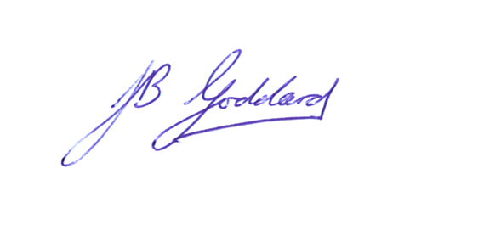
Yours sincerely

Jeremy Goddard
Swyddog Amgylchedd/Environment Officer
Tîm Rheoli Adnoddau Naturiol, Sir Gâr /
Natural Resource Management, Carmarthenshire

Ffôn/Tel 0300 065 4022
Ebost/Email jeremy.goddard@cyfoethnaturiolcymru.gov.uk

