Mr. Haydn Jones  Glangforiog  Llanybydder  Carmarthenshire  SA40 9SA | Ein cyf/Our ref: GWSW1785  Dyddiad/Date: 2 December 2015

Dear Mr. Jones

Environmental Permitting Regulations 2010
Sheep Disposal Permit (GWSW1785)

Permit Compliance Assessment

Thank you to you for meeting me at Glangforiog farm on 17 September 2015. At the time of the inspection, I found that your used/waste sheep dip disposal operations were generally compliant with the conditions of Environmental Permit GWSW1785. The disposal plot shown was the same as that notified in the farm’s permit and it appeared suitable for the disposal of used/waste sheep dip. It was found that your records of dipping and disposal of used/waste dip were good and satisfied the requirements of the permit.

I have enclosed a copy of the Management System template for the discharge of used or waste sheep dip to land. You have already utilised parts of this template to keep records required by your permit however you still need to develop an accident / incident plan. I have also enclosed a copy of your Environmental Permit for your records.

Pollution Prevention Guidance

Sheep Dipping Infrastructure: A general pollution prevention assessment was made of your dipping practices and farm infrastructure; it was found that you are using a mobile dip. All equipment should be checked thoroughly before use, for proper operation, signs of damage, corrosion or excessive wear. The Groundwater Protection Code states that dipping baths should have no drain holes and makes no distinction between static and mobile dipping baths. According to the code your bath should not have a drain hole as it does at the moment. Waste dip should be pumped out of the bath using a slurry vacuum tanker or similar. When in use the dipping infrastructure should be located more than 10 metres away from a surface watercourse so the mobile system should be sited appropriately.

You must ensure that the animals are kept within the draining pens for at least 10 minutes after dipping and then away from water (apart from a drinking trough) for at least 24 hours. You should find a suitable field where they can be held for at least this period of time before having any access to water.

Diesel Tank: It was found that the plastic diesel tank in the farm yard was not compliant with the requirements of the Water Resources (Control of Pollution) (Silage, Slurry and Agricultural Fuel Oil) (Wales) Regulations 2010 [known as ‘SSAFO’ Regulations]. The tank had no secondary containment as the valves and pipework came through the side of the tank. There however did not appear to be a problem with leakage and the tank appeared in a good state of repair with a locked valve. I have enclosed a booklet on the SSAFO Regulations for your information.

As discussed on site the oil storage part of the SSAFO Regulations are soon to be replaced by the The Control of Pollution (Oil Storage) (Wales) Regulations which is likely to become law this year. Under these regulations any oil storage container over 200 litres in capacity will need to have certain safety requirements including secondary containment as standard. Businesses will have between 2 and 4 years to ensure they have a tank compliant with the new regulations depending on their proximity to surface and groundwater.

Thank you again for your time showing me around the farm, if you require clarification on any issues contained within this letter please don’t hesitate to contact me.
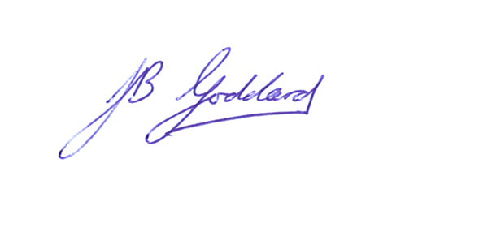
Yours sincerely

Jeremy Goddard
Swyddog Amgylchedd/Environment Officer
Tîm Rheoli Adnoddau Naturiol, Sir Gâr / Natural Resource Management, Carmarthenshire

Ffôn/Tel 0300 065 4022
Ebost/Email jeremy.goddard@cyfoethnaturiolcymru.gov.uk

