Permit
The Environmental Permitting (England & Wales) Regulations 2016

Dandy’s (Chester) Limited

Dandy’s Topsoil
Yew Tree Farm
Sealand Road
Sealand
Chester
CH1 6BS

Permit number

EPR/CB3882ZF

Permit
The Environmental Permitting (England and Wales) Regulations 2016
Permit number

EPR/CB3882ZF

The Natural Resources Body for Wales (“Natural Resources Wales”) authorises, under regulation 13 of the Environmental Permitting (England and Wales) Regulations 2016

Dandy’s (Chester) Limited (“the operator”),

whose registered office is

Yew Tree Farm Sealand Road

Sealand

Chester

CH1 6BS

company registration number 05033416

to operate waste operations at

Dandy’s Topsoil

Yew Tree Farm

Sealand Road

Sealand

Chester

CH1 6BS

to the extent authorised by and subject to the conditions of this permit.

Under regulation 27(2) of the Regulations, standard rules SR2010 No12 are conditions of this permit.

Name | Date
Huw Davies | 08/08/2023

Authorised on behalf of Natural Resources Wales

Schedule 1 - Site plan

This is the plan referred to in the standard rules SR2010 No12

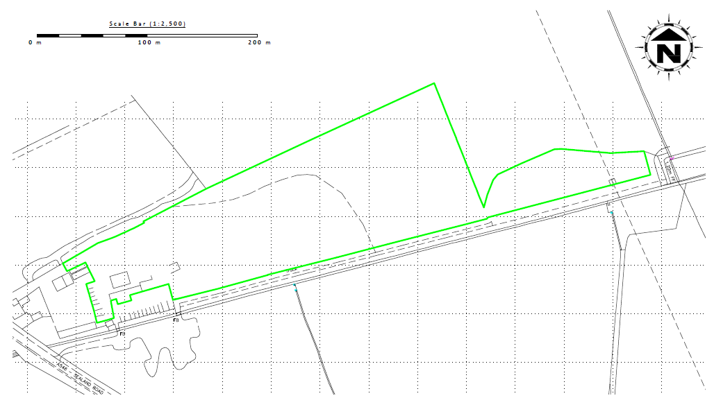

© Crown copyright licence No. 100022432.

END OF PERMIT

