CRoW Appendix 4 (140_10_SD02)  CRoW Act 2000: Natural Resources Wales application for permission - Formal Notice |  | 
Natural Resources Wales Formal Notice.
Requirements of Section 28I of the Wildlife & Countryside Act 1981 as amended by the Countryside and Rights of Way Act (CRoW) 2000.
Duty in relation to granting any consent, licence or permit for activities likely to damage Sites of Special Scientific Interest (SSSI).
- Natural Resources Wales area/region/NPS hub: | Permitting: Wales-wide Installations team  Protected Sites Advisors: Wrexham and Flintshire Environment Team
- Name of SSSI: | All within 2km screening of the installation:  ER1 DEE ESTUARY / ABER AFON DYFRDWY – 31WHJ (Wales) (0.3 km)  ER1 Dee Estuary – 1000595 (England) (1.5km)  ER2 River Dee and Bala Lake – 31WDW (1.5km)  ER6 Inner Marsh farm (31 WTC) (1.1km)  ER7 Shotton Lagoons and Reedbeds (31 WBU) (1km)
- Type of permission: | Environmental Permit - variation to increase site throughput
- Date for Natural Resources Wales permit determination: | 13/06/23, thereby requiring advertising of draft decision by 15/05/23
- Predicted 28 day date for response from NRW conservation/ecology (under S28 I(4)): | N/A – filed for audit only as “not likely to damage” conclusion
- Natural Resources Wales reference no: | PAN-018868 (EPR/AB3092CV/V007)  DMS: EPR-AB3092CV (sharepoint.com)  OPR: Public register - Customer Portal (naturalresources.wales)
- National grid reference: | Stack location: x331093.4, y371418.0  Parc Adfer Energy Recovery Facility, Deeside Industrial Park, Deeside, Flintshire, CH5 2LL
- Description of proposal: | Installation regulated under the Environmental Permitting Regulations 2016 – municipal waste incinerator. Variation to existing permit.  Application to increase the site capacity (tonnes per annum of incineration):  - from 200, 000 tonnes per annum  - to 232, 000 tonnes per annum  - increase of 32, 000 tonnes per annum (16%).  This increase in capacity is to be achieved entirely within the existing infrastructure and without modification to the plant. In effect, at commissioning, the facility was capped operationally at below its full technical capacity. Now the operator wishes to use the full technical capacity. This will result in increased flow of exhaust waste gas, but no other material changes to incineration as already permitted.  The facility has recently been through its periodic BAT/BREF permit review which has reduced emission limits for a number of air pollutants. Some pollutant emission rates will increase as a result of the proposed capacity increase variation. However compared to the existing “baseline”, the increase is in those cases less than would otherwise be expected as it is “offset” by the decrease in emission limits.
- Is the proposed activity within (wholly or partially) the SSSI boundary? | No – distance to SSSIs within 2km screening distance identified above Q2  Orientation map:  - added blue cross = approximate location of emission stack  - triangular area north (1.1km) = Inner marsh farm (continues to north across Wales-England border but not shown on this NRW sourced map)  - to the south east (thin red line, 1.5km) = River Dee and Bala Lake  - area to the west (1km) within grey shaded industrial estate = Shotton lagoons and reedbeds  - Remaining large area to the west and extensions to the north and south of the industrial estate = Dee Estuary (0.3km at nearest point) - also continues to north across Wales-England border, but not shown on this map)  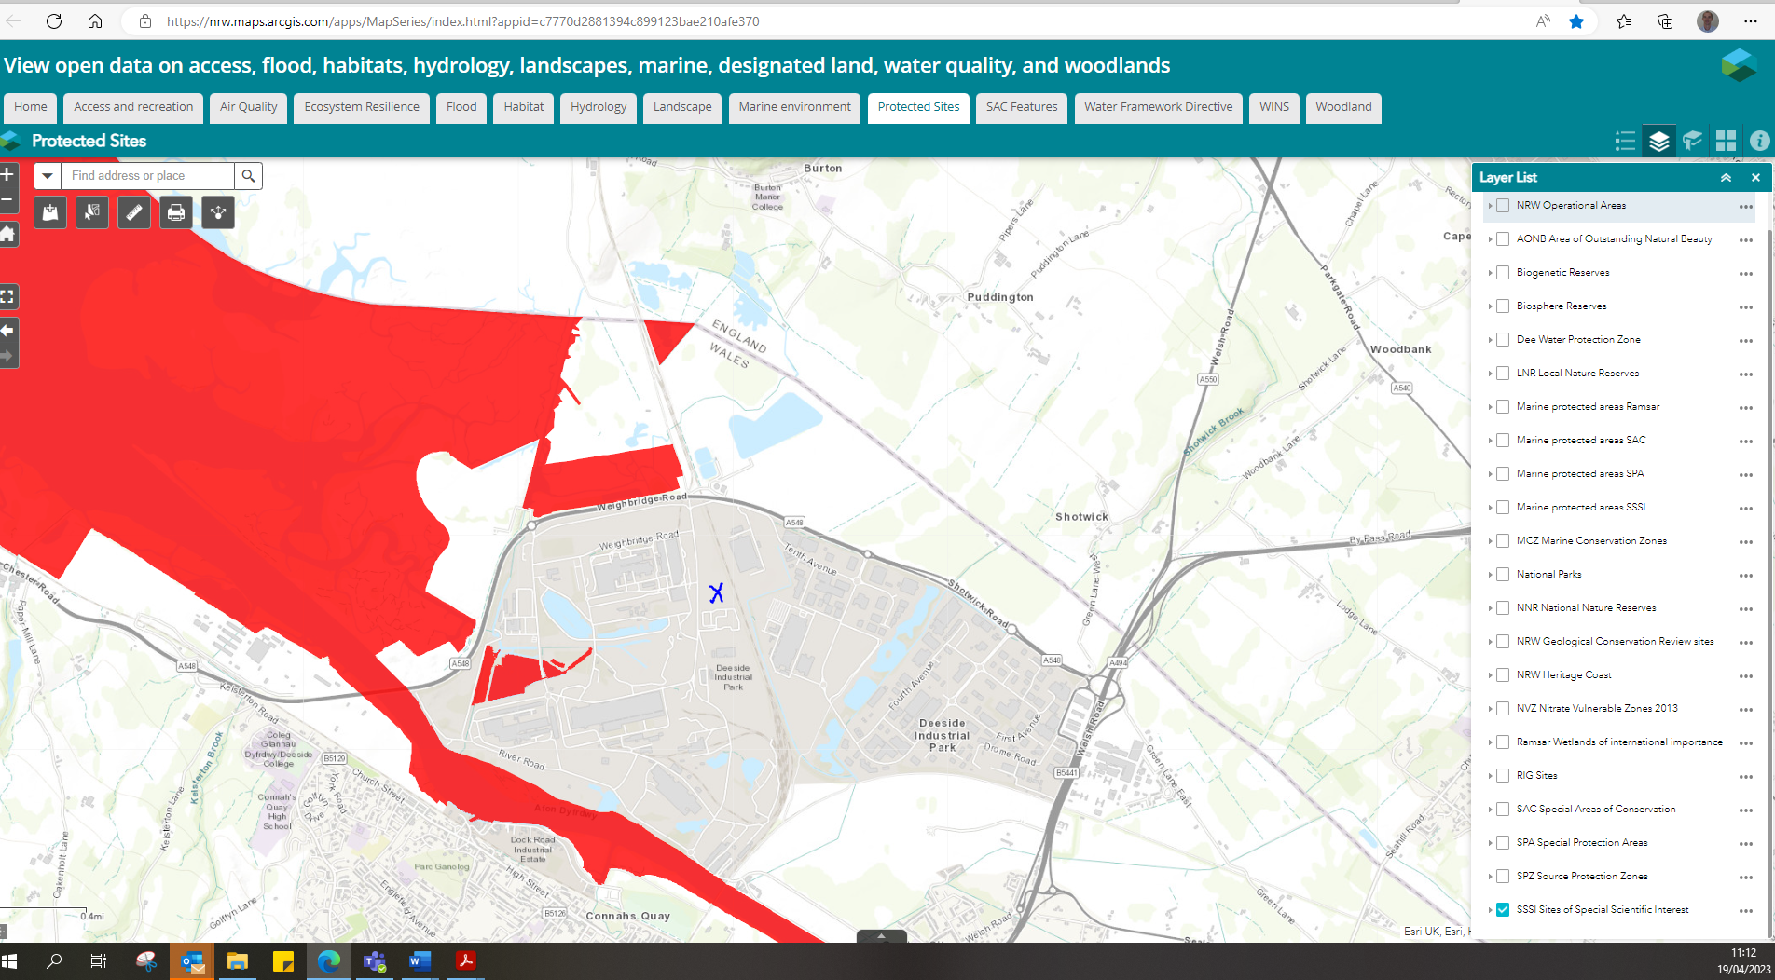
- Has there been any pre-application discussion or correspondence with NRW conservation/ecology | Yes - not specifically relating to the SSSI’s other than a few comments on the Shotton lagoons & reedbeds, but extensive discussions have occurred for the related HRA, and assessment of impact on SAC/SPA/Ramsar and SSSI sites. Therefore see DMS record for the Form 1 HRA for detail of these relevant discussions.
- What aspect(s) of the proposed permission may damage the features which are of special interest for the SSSI?
The following ‘Operations Requiring Consent’ (or other activities associated with the permission) that may cause damage) are relevant to the proposed permission.

Dumping, spreading or discharging of any [waste] materials (or equivalent as alternatively worded depending on specific SSSI citation)
i.e., the emission to air of relevant pollutants from the waste incineration process via the main exhaust stack and for which there is an associated Critical Level or Load (Cle/Clo) for ecological receptors (NOX as NO2 [annual and 24-h] , NH3 [annual], SO2 [annual], HF [weekly and 24-h], Nutrient N deposition [annual], acid deposition [annual]).

No other impact pathways are considered relevant, particularly noting summary above that there are no changes to site infrastructure or processes, it is a technical capacity increase within existing plant. Small changes to site operations e.g. increase in materials handling/movement /mobile plant is considered minor and without credible changed impact on SSSIs.

The following SSSI features and mechanisms of impact have been considered to assess the likelihood of damage:

All relevant protected features of the SSSI are protected by the assessment against site relevant critical levels (Cle) and critical loads (Clo) for aerial pollutants as listed above, using the tightest limit set by the most sensitive feature in the SSSI for screening, as documented on APIS. The process contribution (PC) from the expanded installation cannot automatically be considered insignificant in all cases using standard screening criteria, and for some pollutants (NH3, acid deposition) background pollutant levels exceed these standards. Therefore it has been necessary to identify the distribution of protected features and feature-specific critical levels and loads in some instances, as detailed below, in order to assess the likelihood of damage to the SSSIs.
- Decision

Assessment:
The applicant has undertaken detailed and precautionary dispersion modelling of air emissions impacts, i.e. considering the highest/worst impact possible for a number of variables as explained in their submission. This includes modelling with 5 years of meteorological data, and considering the highest modelled impact from different modelling “runs”. The modelling has been subject to detailed auditing by NRW experts, who are satisfied that the predictions within the applicant’s submitted report are suitable for use in permit determination.

Initial assessment is made on the very precautionary basis of the impact of the whole installation PC – i.e., the sum of existing incinerator impact plus that arising from the proposed capacity increase. This is in accordance with relevant permitting guidance but note that the impact from the proposed change is considerably smaller than the total site impact, the majority of which is already consented. If the PC at SSSI receptors is <1% of a long-term air quality standard, or <10% of a short-term air quality standard, then it is considered insignificant, hence not likely to damage the SSSI. This assessment is precautionary, being based on the most stringent Cle/Clo applicable to the protected site based on its features. It assumes that these features are present throughout the SSSI, and does not consider whether they are present at the point of maximum impact of the emitted pollutants

Where PC cannot be deemed insignificant, a subsequent screening test considers the Predicted Environmental Concentration (PEC), i.e., the concentration of pollutant from the proposed activity (PC) plus the background pollutant level from other sources. If with detailed modelling PEC is 100% of the critical level/load, it is considered that the proposed capacity increase is not likely to damage the SSSI, as the Cle / Clo is unlikely to be breached. This is also on the same precautionary basis of lowest Cle/Clo and without reference to feature specific limits or feature distribution.

Where this two-stage screening cannot conclude “not likely to damage” then further detailed assessment is made with reference to feature-specific Cle/Clo as recorded on APIS and the feature distribution in SSSI as confirmed by the protected sites advisors, rather than the lowest levels/loads applicable to the whole protected site.

This screening procedure is in accordance with permitting guidance “legacy EA OI 67-12 “Detailed assessment of the impact of aerial emissions from new or expanding IPPC regulated industry for impacts on nature conservation”. Guidance AQTAG 21” (2015) for determining likely significant effect is also relevant and gives similar advice, although it is primarily focused on National Site Network sites rather than SSSI’s

Results are summarised for individual pollutants as follows:
- For the following pollutants the increased capacity incinerator PC is insignificant , being ≤10% of the short-term Cle/Clo / ≤1% of the long-term Cle/Clo at all SSSI receptors, screening using the most stringent Cle/Clo applicable to each individual protected site based on designated features:
  - NOX 24h Cle of 75 µg/m3 (the highest modelled PC is 6.8% at ER1 for a short-term limit)
  - HF 24h Cle of 5 µg/m3 (the highest modelled PC is 2.9% at ER1 for a short-term limit)
  - HF weekly Cle of 0.5 µg/m3 (the highest modelled PC is 0.6% at ER1 for a short-term limit)
  - For annual acid deposition (Clo of 4.558 kg_{eq}/ha/yr for ER1, 4.538 kg_{eq}/ha/yr for ER6). The highest modelled PC is 0.72% at ER1 for a long-term limit

  - In the same way, the PC for further pollutants is insignificant (≤10%/1% as specified above) at selected SSSI receptors as follows:
    - ER2 River Dee and Bala lake – all remaining pollutants (NOX as NO2 [annual, 30 µg/m3] , NH3 [annual, 1 µg/m3], SO2 [annual, 10 µg/m3], Nutrient N deposition [annual, 10 kgN/ha/yr].
    - ER6 Dee Estuary: SO2 annual, 10 µg/m3], Nutrient N deposition [annual, 20 kgN/ha/yr] (noting the correct application of a N-dep Clo for ER6 SSSI of 20kgN/ha/yr, whereas in the SPA assessment of the same land area, a screening Clo of 8 kgN/ha/yr is applied, according to the citation/features of each.
    - ER7 – all remaining pollutants (NOX as NO2 [annual, 30 µg/m3], NH3 [annual, 1 µg/m3], [annual, 10 µg/m3], Nutrient N deposition [annual, 10 kgN/ha/yr].

    - Impact at ER1 and ER6 for pollutants not screened out above using the 1%/10% criteria continues below:

- For the following pollutants the expanded capacity incinerator is unlikely to damage the SSSI ER1 – Dee Estuary or ER6 – inner marsh farm. While the PEC’s cannot in all cases automatically be considered insignificant using the criteria above, the PEC is not expected to breach the Cle/Clo taking into account background pollution plus the revised incinerator PC:
  - For NOX annual Cle of 30 µg/m3, the modelled PEC is 42% of the ES at ER1, and 37% of the ES at ER6 (PC’s are also small, 1.7% and 1.2% of ES respectively)
  - For SO2 annual Cle of 10 µg/m3, the modelled PEC is 22% of the ES at ER1, (PC is also small, 1.15% of the ES)

- Two pollutants remain requiring further detailed consideration: NH3 at ER1 and ER6, and Nutrient Nitrogen Deposition at ER1
  - For NH3, ER1 and ER6 site-wide screening was undertaken by the applicant using the most stringent limit ammonia limit of 1 µg/m3. This is for the protection of lichens or bryophytes (including mosses, liverworts and hornwarts) – in this instance petalwort as listed on APIS for ER1. Protected sites advisors have confirmed that petalwort is not present near the installation (over 10km away). They have also confirmed that an ammonia level of 3 µg/m3 can be used for features including Atlantic salt meadows and estuaries which are present near the industrial installation and where APIS indicates a Clo of “1 or 3” for ER1. For ER6 screening the applicant had applied a level of 1 µg/m3, although the most sensitive feature on APIS indicates that 3 µg/m3 is appropriate. It has been confirmed that 3 µg/m3 is appropriate for ER6).
The application indicates in a diagram reproduced below the area where the NH3 PC exceeds 1% of Cle of 1 µg/m3 applicable to petalwort etc. At no point in the protected sites does the PC exceed 1% of the Cle of 3 µg/m3 applicable more generally in the SSSI. As it has been confirmed there are no highly ammonia sensitive features in the area indicated on the diagram where the PC exceeds 1% of a Cle of 1 µg/m3, and that 1% of the more general Cle of 3 µg/m3 is not exceeded in any location in the SSSI, the emission is unlikely to damage the SSSI ER1 or ER6.
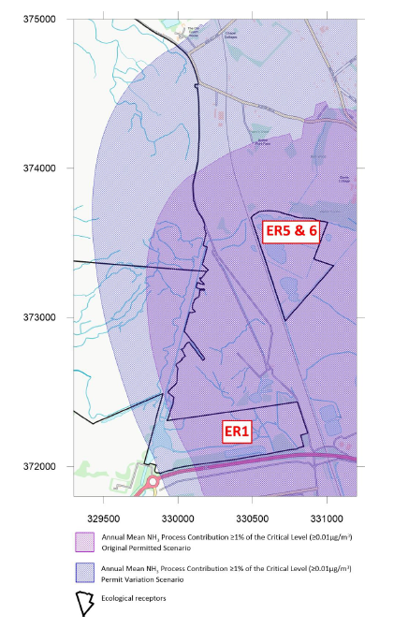
  - For Nitrogen deposition, a site-wide screening was undertaken for ER1 using the most stringent load indicated on APIS of 8 kgN/ha/yr. This is for the protection of feature “SSSI1459 Sterna hirundo via protection of the species’ broad habitat – costal stable dune grasslands, acid type” as shown on APIS. Protected sites advisors have confirmed that this habitat is not present near the installation for ER1. They have confirmed that a load of 20 kgN/ha/yr can be used for features including saltmarshes and estuaries that are present in the area (e.g. SSSI0058 Anas acuta). The application indicates the area where the industrial installation PC exceeds 1% of Clo of 8 kgN/ha/yr as shown below. At no point in the protected site does the PC exceed 1% of the more widely applied Clo of 20 kgN/ha/yr. As it has been confirmed there are no highly N-deposition sensitive features in the area indicated on the diagram that the PC exceeds 1% of a Clo of 8 kgN/ha/yr and the PC at no point exceeds 1% of the more widely applicable 20 kgN/ha/yr, the emission is unlikely to damage the SSSI ER1.

Although ER5/6 is shown on the diagram as potentially exceeding, it has already been outlined in screening above that PC is <1% of site-relevant critical load of 20 kgN/ha/yr and therefore unlikely to damage.
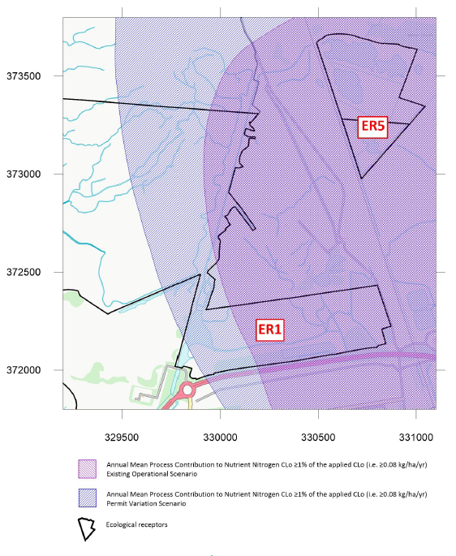
This information summarises the application, conversations with the protected sites advisors, and more detailed justification / information on the HRA “form 1” assessment. Refer to these sources if required, for further technical justification of the assessment and conclusion below.

Conclusion:

i) The proposed permission is not likely to damage any of the flora, fauna or geological or physiological features which are of special interest.

The only relevant potential effects are increased emissions of airborne pollutants. Compared with relevant critical levels / loads, it can be concluded after detailed stepwise assessment and with air dispersion modelling, that for all pollutants process contributions are <1% of the appropriate critical level/load. It was not possible to do this at site-wide level and using the most stringent levels/loads for the whole protected sites, but information on specific designated features, their location, and feature- appropriate levels and loads, after due consideration, this conclusion was robustly demonstrated.

Natural Resources Wales is minded to:

Issue the permission

- Name and job title of Natural Resources Wales officer: | Dr David Poole  Senior Specialist Permitting Officer
- Date form sent to NRW conservation/ecology | N/A, filed for information only as “not likely to damage”
For Natural Resources Wales use only, once NRW conservation/ecology response received
- NRW conservation/ecology comment on assessment: | Please delete as appropriate:  i) NRW conservation/ecology advise the operation can go ahead  ii) NRW conservation/ecology advise the operation can go ahead with conditions  iii) NRW conservation/ecology advise against permitting the operation  Please ensure that the NRW conservation/ecology response is attached to this Formal Notice.
- Name and job title of NRW conservation/ecology officer:
- Date of receipt of NRW conservation/ecology response:

