PAN-022531 My Map Report:

Application map
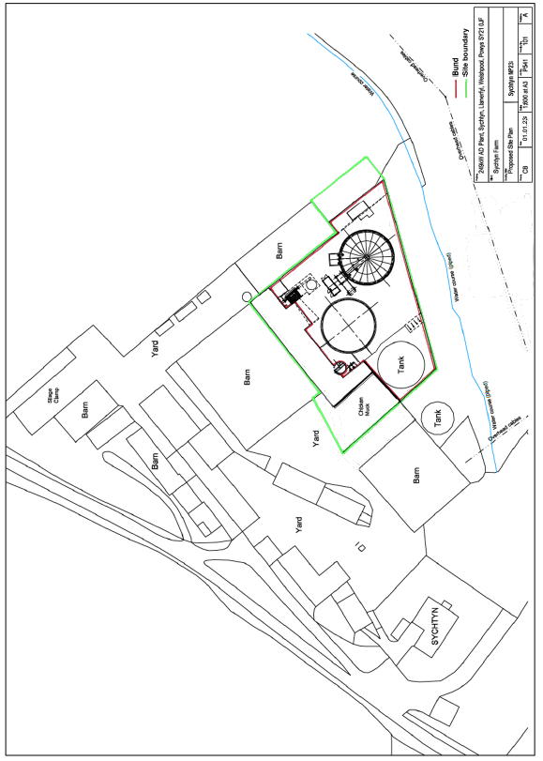
Site Boundary
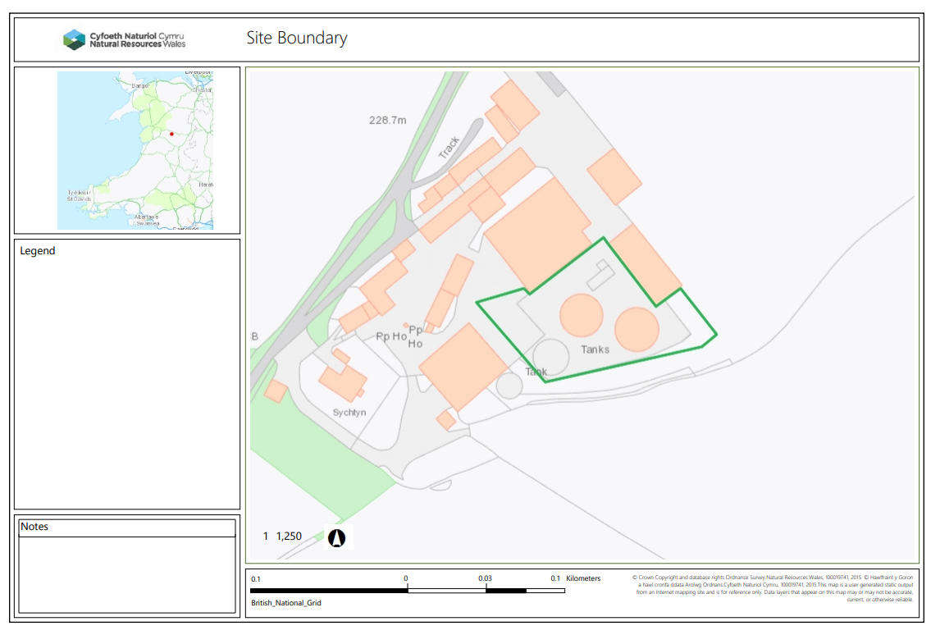

Watercourse within 10m
Watercourse lies south of site flowing W to E. Within 10m of existing and proposed boundary. Application states watercourse is 'piped' although this is not evident on MyMap. Confirm with local evidence that the watercourse is piped and physical distance RFI
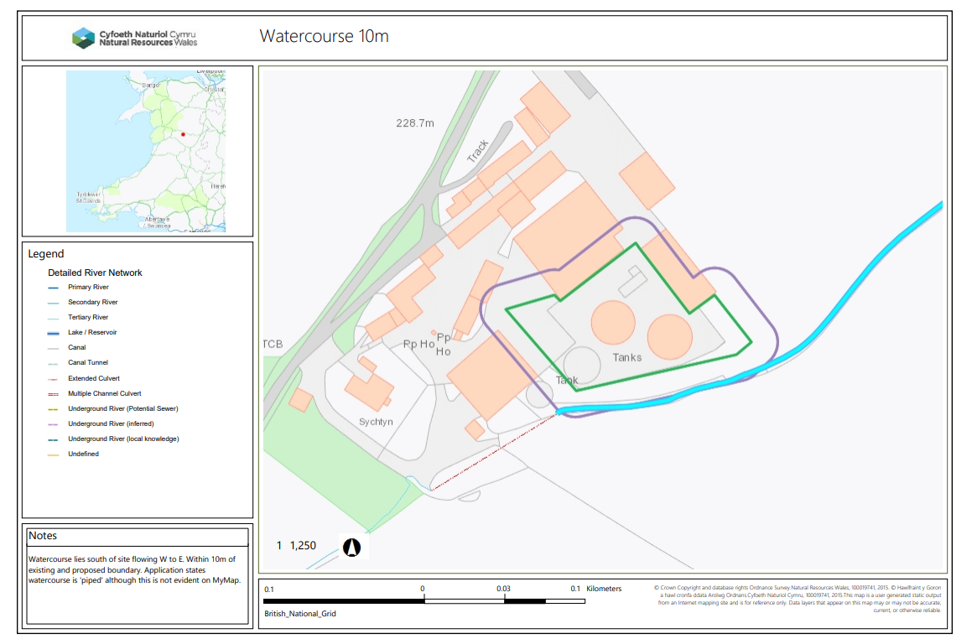
Groundwater source protection zone 1 within 0m
None
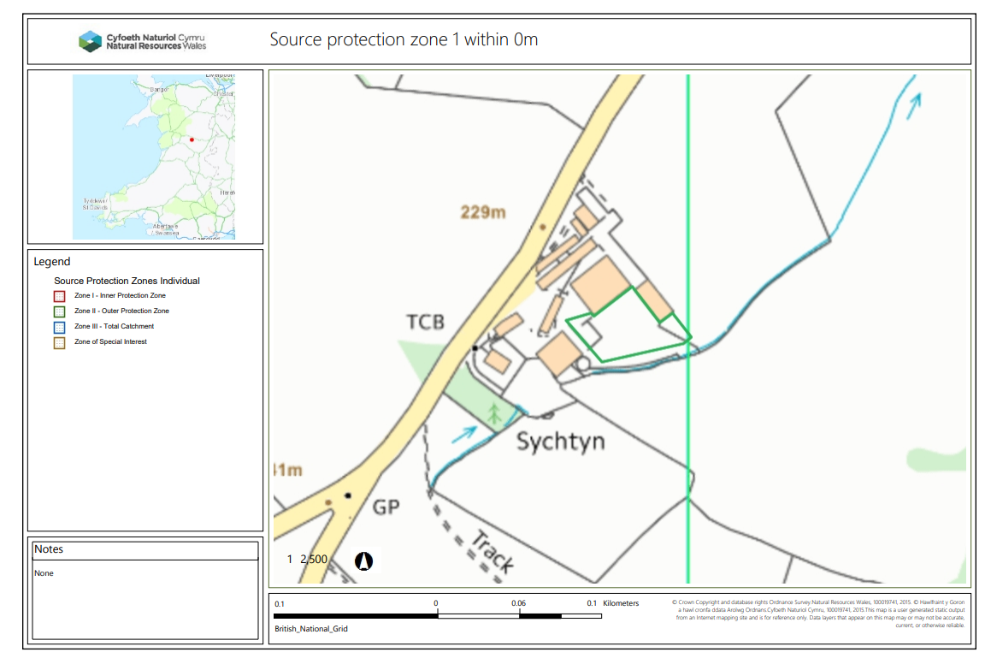
AQMA within 0m
None
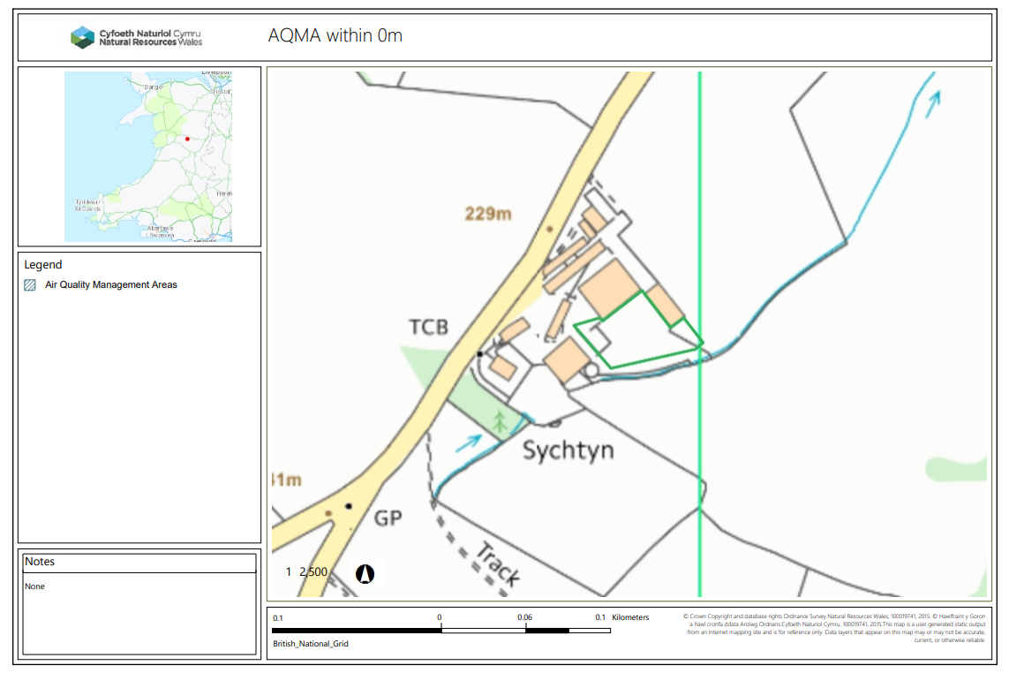
Any well, spring (or issue) or borehole used / not used for the supply of water for human consumption including from a private water supply or supplies within 50m.
None
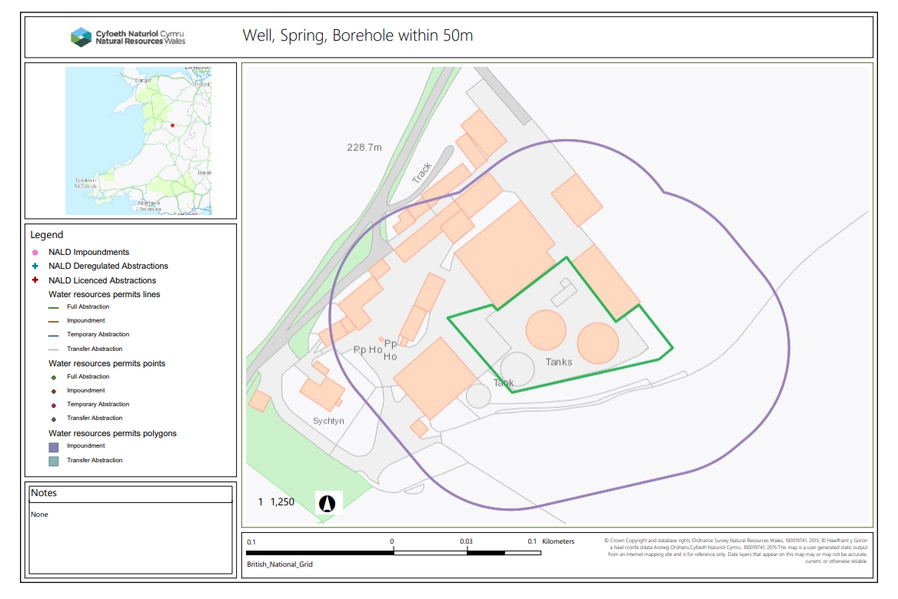
European designated sites- Natura 2000 (SPA, pSPA, SAC or cSAC) or Ramsar- or SSSI within 200m

None
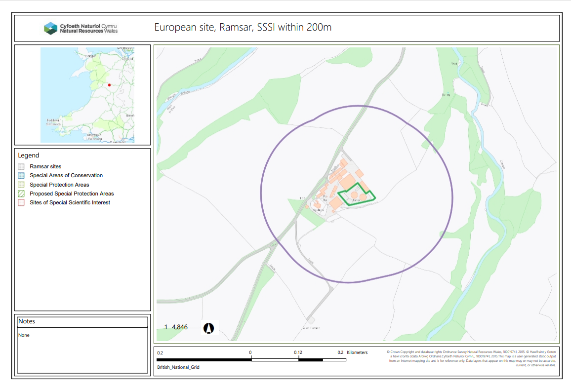
Nearest sensitive receptor in cases where the stack does not have an “effective” stack height of 3 metres or more, or the stack is less than 7 metres in height. 200m
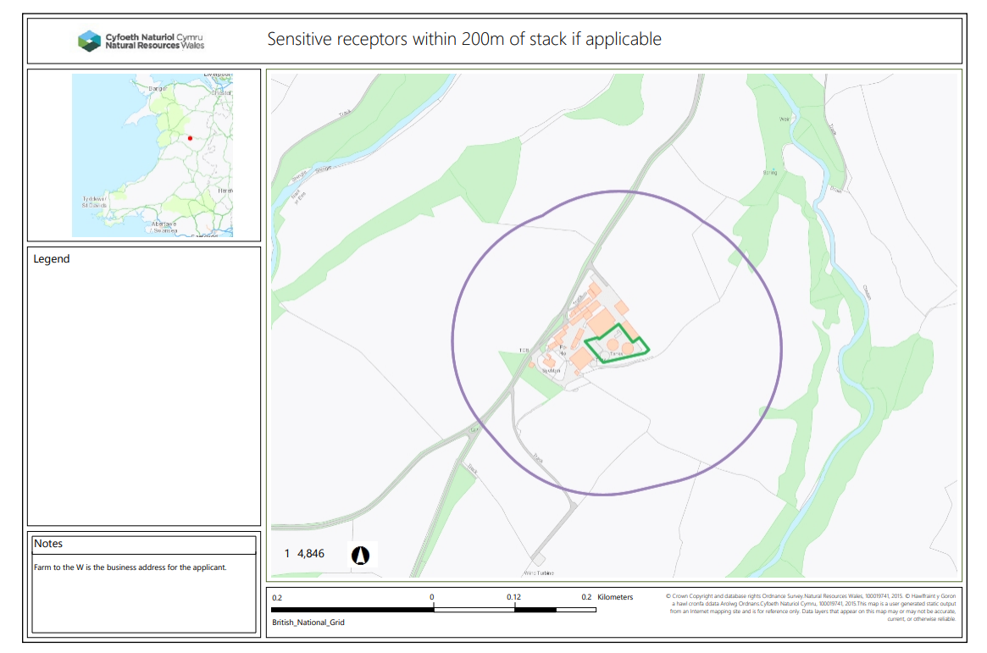
END

