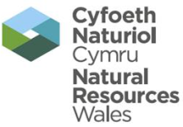 | EPR Compliance Assessment Report |  |  |  |  |  | Report ID: 06090
This form will report compliance with your permit as determined by an NRW officer
Site | Milford Haven Terminal |  |  |  |  | Permit Ref |  |  | KP3036AX
Operator/ Permit holder | Puma Energy (UK) Limited
Date | 19 January 2016 |  |  |  |  | Time in |  |  | 10:00 |  |  | Out | 14:00
What parts of the permit were assessed | Environment Management Systems (Maintenance ETP, Noise and Odour Management Plan)
Assessment | Audit | EPR Activity: | Installation | X |  |  | Waste Op |  |  | Water Discharge
Recipient’s name/position | Richard Livock – Environmental Engineer
Officer’s name | Gary Evans and Nick Jenkins |  |  |  | Date issued |  |  |  |  |  | 1 March 2016

Section 1 - Compliance Assessment Summary
This is based on the requirements of the permit under the Environmental Permitting Regulations. A detailed explanation and any action you may need to take are given in the “Detailed Assessment of Compliance” (section 3). This summary details where we believe any non-compliance with the permit has occurred, the relevant condition and how the non-compliance has been categorised using our Compliance Classification Scheme (CCS). CCS scores can be consolidated or suspended, where appropriate, to reflect the impact of some non-compliances more accurately. For more details of our CCS scheme, contact your local office.
Permit Conditions and Compliance Summary |  |  |  |  |  | Condition(s) breached
a) Permitted activities | 1. Specified by permit |  | A
b) Infrastructure | 1. Engineering for prevention & control of pollution |  | A
b) Infrastructure | 2. Closure & decommissioning |  | N
b) Infrastructure | 3. Site drainage engineering (clean & foul) |  | N
b) Infrastructure | 4. Containment of stored materials |  | N
b) Infrastructure | 5. Plant and equipment |  | N
c) General management | 1. Staff competency/ training |  | N
c) General management | 2. Management system & operating procedures |  | A
c) General management | 3. Materials acceptance |  | N
c) General management | 4. Storage handling, labelling, segregation |  | N
d) Incident management | 1. Site security |  | N
d) Incident management | 2. Accident, emergency & incident planning |  | N
e) Emissions | 1. Air |  | N
e) Emissions | 2. Land & Groundwater |  | NA
e) Emissions | 3. Surface water |  | NA
e) Emissions | 4. Sewer |  | NA
e) Emissions | 5. Waste |  | A
f) Amenity | 1. Odour |  | A
f) Amenity | 2. Noise |  | A
f) Amenity | 3. Dust/fibres/particulates |  | NA
f) Amenity | 4. Pests, birds & scavengers |  | NA
f) Amenity | 5. Deposits on road |  | NA
g) Monitoring and records, maintenance and reporting | 1. Monitoring of emissions & environment |  | A
g) Monitoring and records, maintenance and reporting | 2. Records of activity, site diary, journal & events |  | A
g) Monitoring and records, maintenance and reporting | 3. Maintenance records |  | A
g) Monitoring and records, maintenance and reporting | 4. Reporting & notification |  | N
h) Resource efficiency | 1. Efficient use of raw materials |  | N
h) Resource efficiency | 2. Energy |  | N
KEY: C1, C2, C3, C4 = CCS breach category ( * suspended scores are marked with an asterisk),
A = Assessed or assessed in part (no evidence of non-compliance), N = Not assessed, NA = Not Applicable
Number of breaches recorded |  | 0 |  | Total compliance score  (see section 5 for scoring scheme) |  |  | 0

If the Total No Breaches is greater than zero, then please see Section 3 for details of our proposed enforcement response

Section 2 – Compliance Assessment Report Detail
This section contains a report of our findings and will usually include information on:
- the part(s) of the permit that were assessed (e.g. maintenance, training, combustion plant, etc)  - where the type of assessment was ‘Data Review’ details of the report/results triggering the assessment  - any non-compliances identified  - any non-compliances with directly applicable legislation  - details of any multiple non-compliances | - information on the compliance score accrued inc. details of suspended or consolidated scores.  - details of advice given  - any other areas of concern  - all actions requested  - any examples of good practice.  - a reference to photos taken

Attendees
Duncan Armstrong – Global Head of Project Development and Sustainability (Puma)
Steve Kenyan – Milford Haven Terminal site manager (Puma)
Graham Moore – UK EHS Manager (Puma)
Adam Craxford – Maintenance Manager (Puma)
Richard Livock – Environmental Engineer (Puma)
Alistair Walgate – Process Engineer (Puma)
Gary Evans – PPC Technical Specialist (Natural Resources Wales)
Nick Jenkins – PPC Officer (Natural Resources Wales)
Agenda

- Overview of process
- Removal of process units
- Environment Management Systems
- Maintenance of Effluent Treatment System
- Noise complaints and investigation
- Best Available Techniques Reference (BRef) document

- Overview of the Process

Puma Energy (UK) Limited (“Puma”) now operate the former Murco refinery installation under permit reference FB3393NV as a Fuel Storage and Distribution Terminal. The operator currently have 48 tanks in service with 5 out of service for maintenance. The company have control over the LPG Spheres however the system is decommissioned and no plans in the short term to operate this part of the facility.

The company continues to export products via road and rail (Westerleigh, Theale and Bedworth) with a limited amount via jetty to date.

On site there have been some changes in relation to staff with introduction of a new SEQ Manager covering Puma UK Operations (Graham Moore). Rebecca Brazzell was the previous SEQ Manager at the Milford Haven site.

- Removal of Process Units

In relation to the Process dismantling, Murphy Oil Corporation (“Murphy”) is leasing the MHR (Milford Haven Refinery) Process area from Puma with Puma retaining the area within their permitted boundary. Parts of the facility will be sold and dismantled i.e. Cogen, North Process area and Hydrodesulphurisation Unit, with the remaining sections being demolished. The process area will be returned to a flat concrete slab. The dismantling operation will be overseen by Murphy (Des Thomas) with Puma ultimately responsible for the area under the Environmental Permitting Regulations. As result of this contracted work programme Puma will have to ensure that the work is incorporated into their own site management systems e.g. emergency response, waste management, noise management plans and odour management. This would also include any impact on the surface water release limits.

Contracts are currently being reviewed by Murphy in relation to the approved contractor with anticipation of the on-site work commencing in May 2016 and projected duration of 30 -54 months. NRW requested a plan of works.

- Environmental Management Systems (Noise and Odour Management Plans)

The majority of the operational procedures will remain unchanged, however the scale of Puma’s operations have reduced. This has resulted in a change to the procedures to remove aspects of the operation that were linked to the refinery process area. This would result in a reduced noise and odour inventory and a realignment of the source inventories for both.

Puma recognise its permitted responsibilities and will also be incorporating the dismantling and demolition work within their control procedures to minimise the impact on the environment. Noise source inventories have been provided to the contractor - Byco.

As outlined above these plans need to incorporate all on site activities, including the partial site closure.

Puma also advised that although they are conscious that daytime work on the dismantling would be the preferred option, they are not discounting the operation to continue through the night.

- Maintenance of the Effluent Treatment Facility

Since the facility has stopped refining, the effluent load has reduced significantly, resulting in no permit breaches and potential improvement in final effluent quality. The company has a maintenance programme for the effluent treatment process (lagoons), however this was based on the refinery operating and the increased effluent loads. The company needs to review their maintenance plans for this process to produce a revised program, for example de slugging activities.

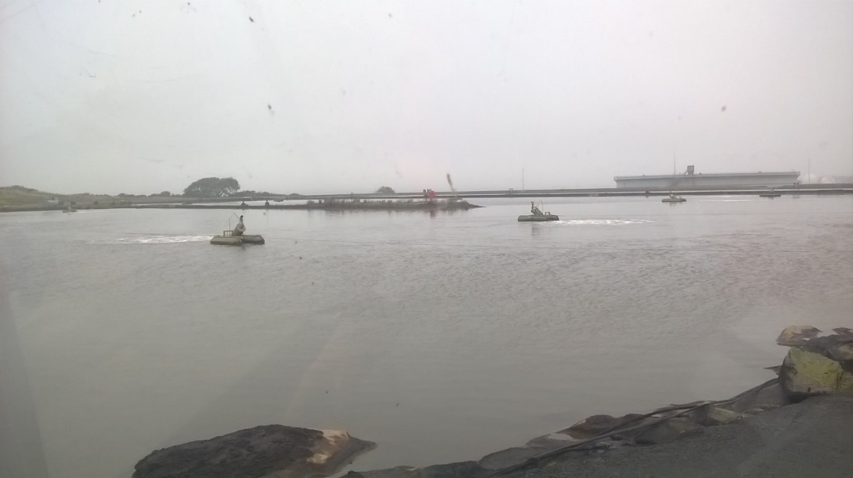

During the visit, the lagoons were inspected and as shown above the aeration continues to operate to maintain the treatment of effluent. At the time of inspection one of the aerators was out for maintenance. This process is now one of the key environmental aspects for the facility as it has the potential to discharge effluent into Milford Haven along with potential odour if the sludge levels aren’t managed appropriately. Puma advised that the last sludge survey was undertaken February 2013 and the next survey is planned for the first half of 2016. A maintenance plan will be developed after the scheme.

- Noise complaints and investigation

18 and 21 January 2016, NRW and Port Health were informed of a noise complaint which described a low frequency sound “like huge diesel engine or lorry parked outside house with engine running.” The report came from south of the Puma installation and although not specific to the installation, the complainant was also aware that a tanker was on the jetty at South Hook LNG facility and therefore could not be discounted from the investigation.

The sound sources currently onsite are limited and due to the proximity of the complainant and the neasrest sound source i.e. the aerators, NRW requested Puma to provide evidence that these items of plant are not likely to be impacting upon the complainant and to provide an assessment to substantiate their argument.

8 February 2016, Puma submitted the required information based on a desktop study using manufacturer’s specification of the aerator i.e. 11kW Spiral Aerators by TUV Rheinland (although this was not validated by NRW). Puma based their calculation of sound pressure level (SpL) at the closest boundary (approx 200m south of the centre of the berm of the middle lagoon) and at the complaint location (approximately 450m south of the berm). Whereas previously Puma has operated up to 12 aerators, as of 28 January it has reduced this number by half.

To enable a quick assessment of the SpL, the following equations will used to firstly calculate the total SpL of the 6 aerators (1) and secondly the SpL at the two offiste locations (2 and 3):

- $SpL=10\log{(\left({10}^{7.7}\right)*6)}$
- ${SpL}_{2}={SpL}_{1}-20\log\left(\frac{200}{1}\right)$
- ${SpL}_{2}={SpL}_{1}-20log⁡(\frac{450}{1})$

Using equation (1) 6 identical aerators operating will produce a cumulative SpL of 84.8dB(A) at 1 metre. Therefore using equations (2) and (3) at 200m and at 450m respectively, the SpL excluding any other attenuation i.e. weather, ground, air absorption, barriers etc would be 38.8dB(A) at 200m and 31.7dB(A) at 450m.

This assessment does not consider the effects of tonality and although the sound levels could considered low at the receptor, tones can be considered more disturbing than broadband sound. When undertkaing a BS4142 assessment, the tonality of a sound must be considered either subjectively or objectively. In September 2014, NRW undertook an analysis of the aerators at three locations around the lagoons but no low frequency tones (10Hz to 160Hz) were present but a middle frequency tone (300Hz) was identified.

- Best Available Techniques Reference (Bref) document
The current process of fuel storage and distribution is not listed as an activity under the Industrial Emissions Directive but the requirement is that Puma apply the guidance within the relevant Bref to their operations i.e. Refining of mineral oil and gas. We discussed how this will be carried out and whether the requirement will be in the form of a Regulation 60 notice or a letter. Inevitably there will be complaince issues if the notice is not actioned within the relevant timescale. NRW are considering issuing the operator with a letter as the current operation is outside the scope of the IED, but is covered under EPR.

NRW will provide Puma with a copy of an assessment from it’s public register that will outline how the similar assessments have been made at other regualted sites. We would expect the operator to undertake a cost benefit analysis of the proposed technology in the Bref against current operations.

[End]

 | EPR Compliance Assessment Report |  | Report ID: 06069
This form will report non-compliance with your permit as determined by an NRW officer
Site | Milford Haven Terminal | Permit |  | KP3036AX
Operator/ Permit | Puma Energy Limited | Date |  | 19 January 2016

Section 3- Enforcement Response | Only one of the boxes below should be ticked
You must take immediate action to rectify any non-compliance and prevent repetition.
Non-compliance with your permit conditions constitutes an offence and can result in criminal prosecutions and/or suspension or revocation of a permit. Please read the detailed assessment in Section 2 and the steps you need to take in Section 4 below.
Other than the provision of advice and guidance, at present we do not intend to take further enforcement action in respect of the non-compliance identified above. This does not preclude us from taking enforcement action if further relevant information comes to light or advice isn’t followed.
In respect of the above non-compliance you have been issued with a warning. At present we do not intend to take further enforcement action. This does not preclude us from taking additional enforcement action if further relevant information comes to light or offences continue.
We will now consider what enforcement action is appropriate and notify you, referencing this form.

Section 4- Action(s)
Where a non - compliance has been detected and an enforcement response has been selected above, this section summarises the steps you need to take to return to compliance and also provides timescales for this to be done.
Criteria Ref. | CCS Category | Action Required/Advised | Due Date
See Section 1 above
NA

Section 5 - Compliance notes for the Operator |  |  |  | Section 6 – General Information
To ensure you correct actual or potential non-compliance we may  advise on corrective actions verbally or in writing  require you to take specific actions in writing  issue a notice  require you to review your procedures or management system  change some of the conditions of your permit  decide to undertake a full review of your permit |  |  |  | Data protection notice  The information on this form will be processed by Natural Resources Wales (NRW) to fulfill its regulatory and monitoring functions and to maintain the relevant public register(s). NRW may also use and/or disclose it in connection with:  offering/providing you with its literature/services relating to environmental matters  consulting with the public, public bodies and other organisations (e.g. Health and Safety Executive, local authorities) on environmental issues  carrying out statistical analysis, research and development on environmental issues  providing public register information to enquirers  investigating possible breaches of environmental law and taking any resulting action  preventing breaches of environmental law  assessing customer service satisfaction and improving its service  Freedom of Information Act/Environmental Information Regulations request.  NRW may pass it on to its agents/representatives to do these things on its behalf. You should ensure that any persons named on this form are informed of the contents of this data protection notice.
Any breach of a permit condition is an offence and we may take legal action against you.

We will normally provide advice and guidance to assist you to come back into compliance either after an offence is committed or where we consider that an offence is likely to be committed. This is without prejudice to any other enforcement response that we consider may be required.
Enforcement action can include the issue of a formal caution, prosecution, the service of a notice and or suspension or revocation of the permit.
See our Enforcement and Civil Sanctions guidance for further information
This report does not relieve the site operator of the responsibility to
ensure you comply with the conditions of the permit at all times and prevent pollution of the environment
ensure you comply with other legislative provisions which may apply.
Non-compliance scores and categories |  |  |  | Disclosure of information  NRW will provide a copy of this report to the public register(s). However, if you consider that any information contained in this report should not be released to the public register(s) on the grounds of commercial confidentiality, you must write to your local area office within twenty working days of receipt of this form indicating which information it concerns and why it should not be released, giving your reasons in full.
CCS category | Description | Score
C1 | A non-compliance which could have a major environmental effect | 60
C2 | A non-compliance which could have a significant environmental effect | 31
C3 | A non-compliance which could have a minor environmental effect | 4 |  | Customer charter  What can I do if I disagree with this compliance assessment report?  If you are unable to resolve the issue with your site officer, you should firstly discuss the matter with the officer’s line managers. If you wish to raise your dispute further through our official Complaints and Commendations procedure, phone our general enquiry number 0300 065 3000 (Mon to Fri 08.00–18.00) and ask for the Customer Contact team or send an email to enquiries@naturalresourceswales.gov.uk If you are still dissatisfied you can make a complaint to the Public Services Ombudsman for Wales. For advice on how to complain to the Ombudsman phone their helpline on (0845) 601 0987.
C4 | A non-compliance which has no potential environmental effect | 0.1
Operational Risk Appraisal (Opra) - Compliance assessment findings may affect your Opra score and/or your charges. This score influences the resource we use to assess permit compliance.

