PAN-022525 MyMap Report
Field outlines:
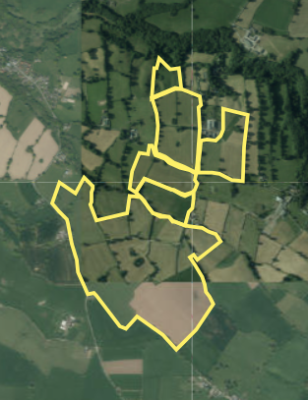
Public rights of way
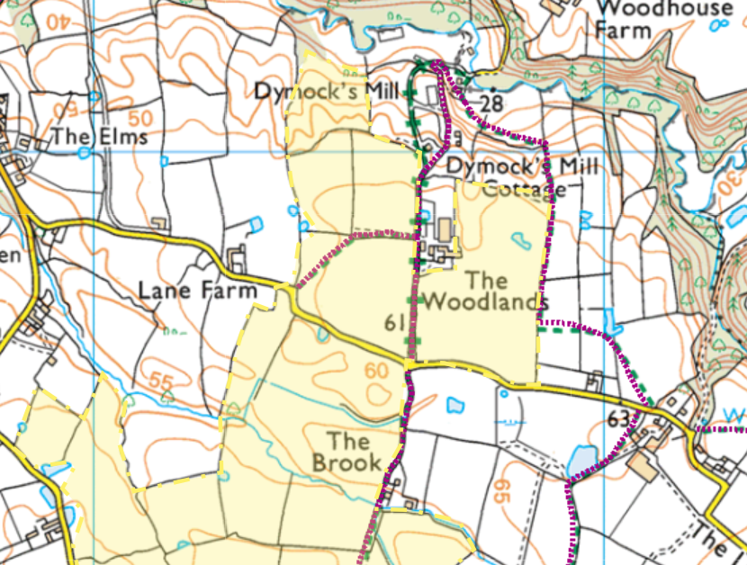
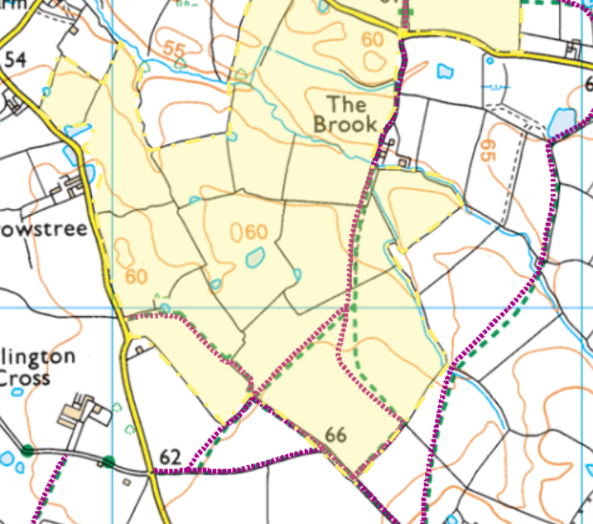

Slope
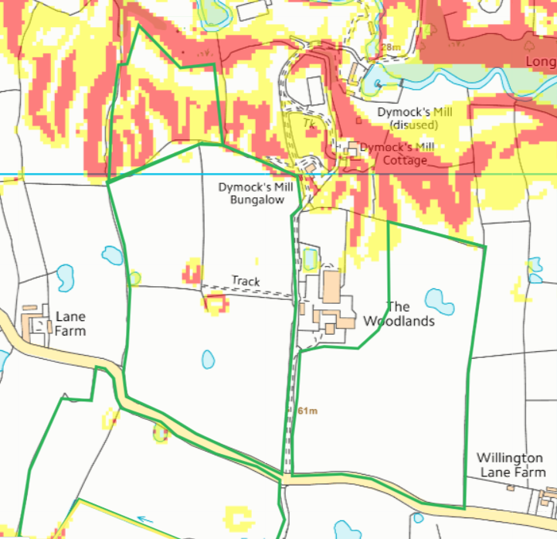
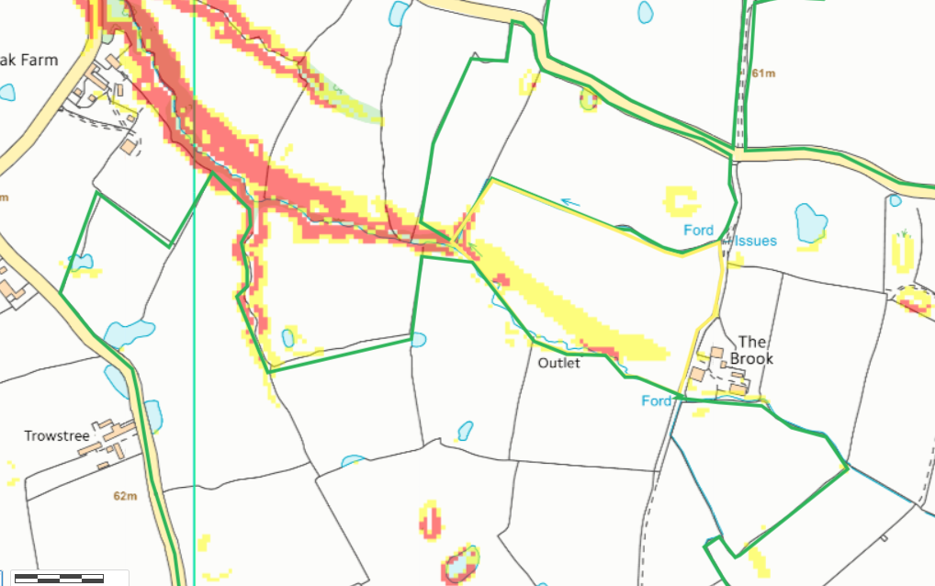
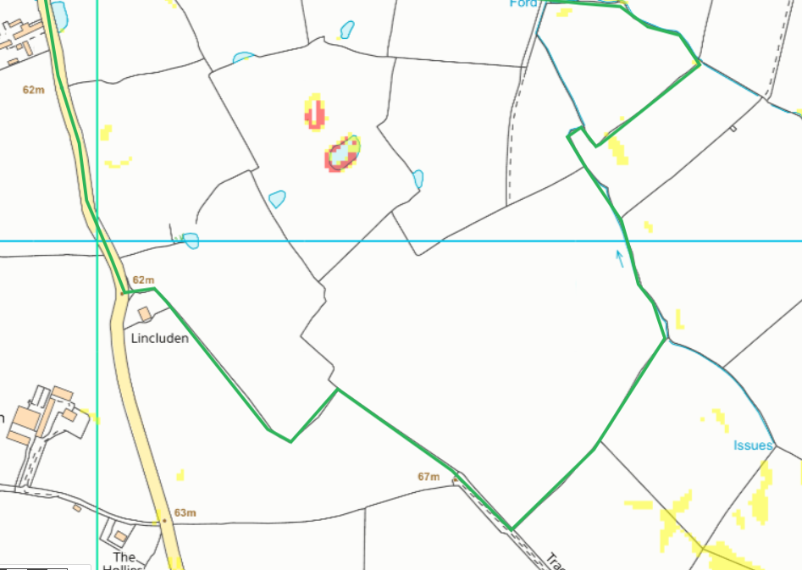
Surface water
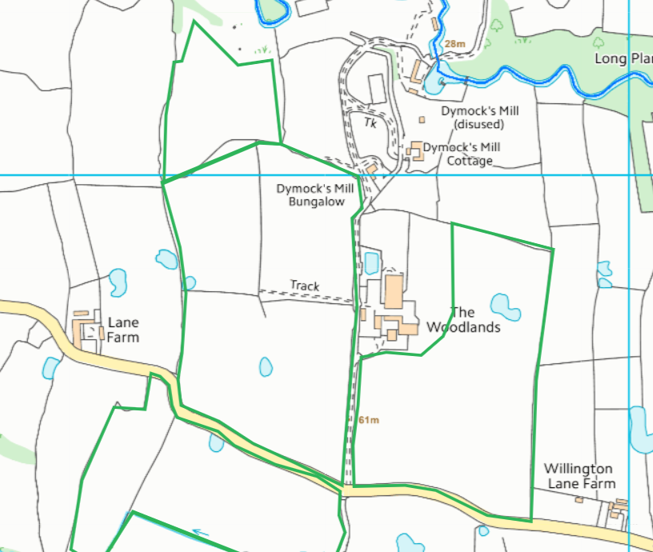
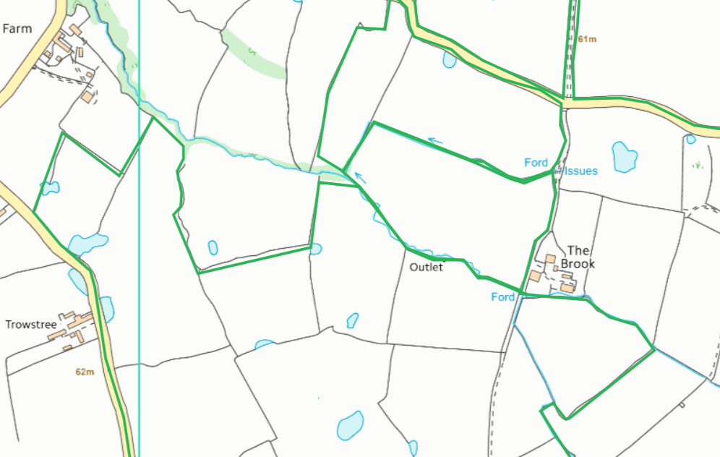
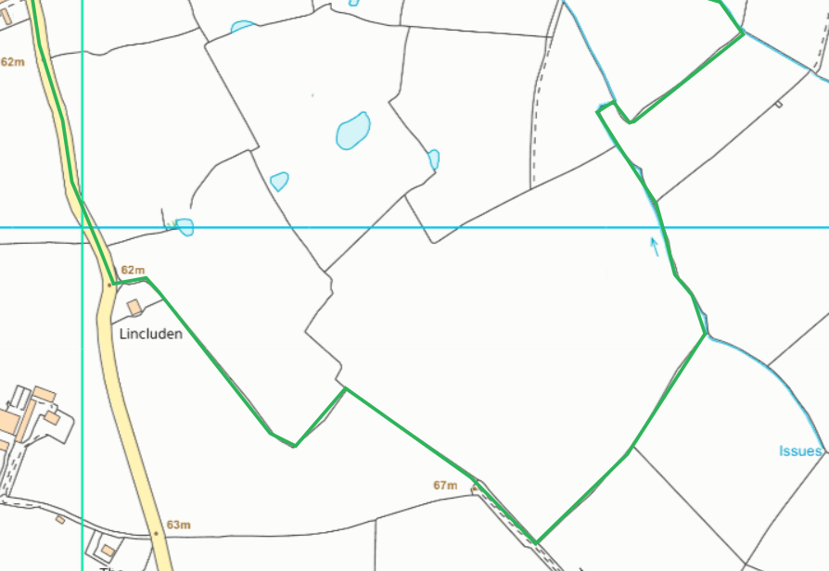

SSSI
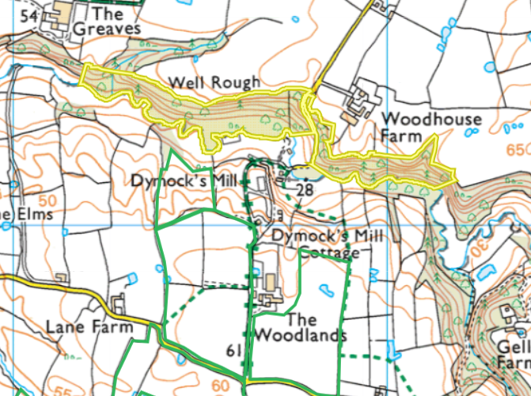
- Well Rough & Long Plantation SSSI
No SAC, SPA or Ramsar within 500 meters of the spreading/storage locations

Local Wildlife site
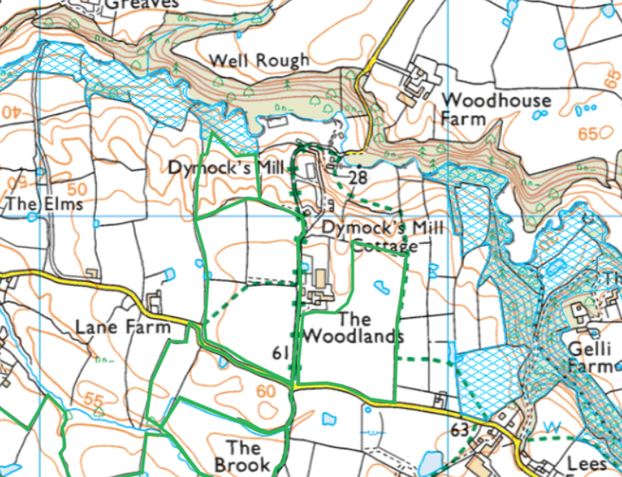
Tallarn Green Meadows to the north of field 3
Black Wood, Kidruffin Wood and The Gelli to the east of field 4

Ancient woodlands
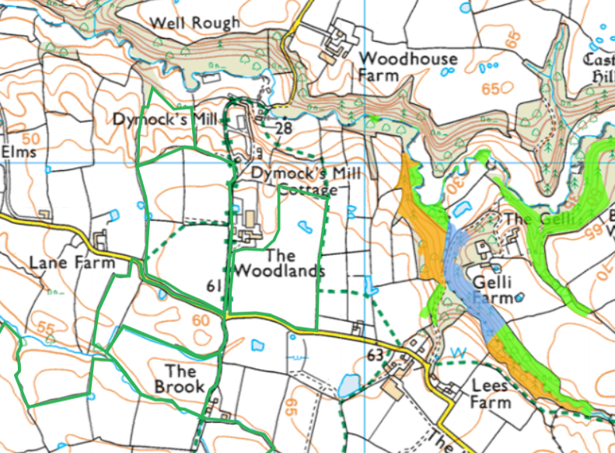

Protected habitats
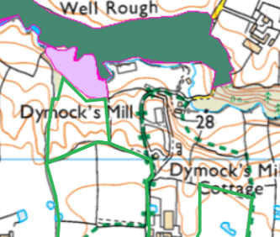
- Purple moor grass and rush pastures to the north for field 3

Protected species
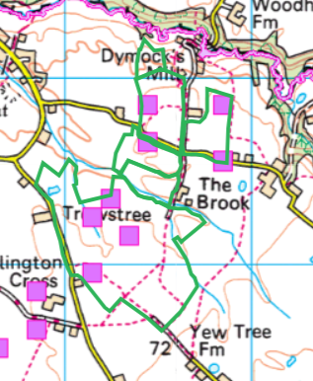
- Newts in most fields
- European Eel migratory route in Wych Brook to the north of field 3

Flood risk


