PAN-020249 MyMap report
Nearest residential receptors
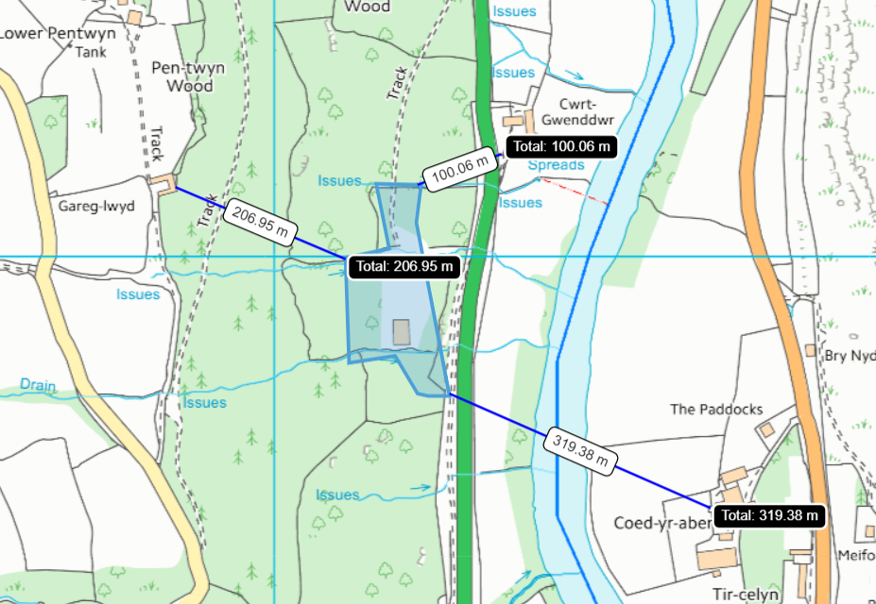

SSSI
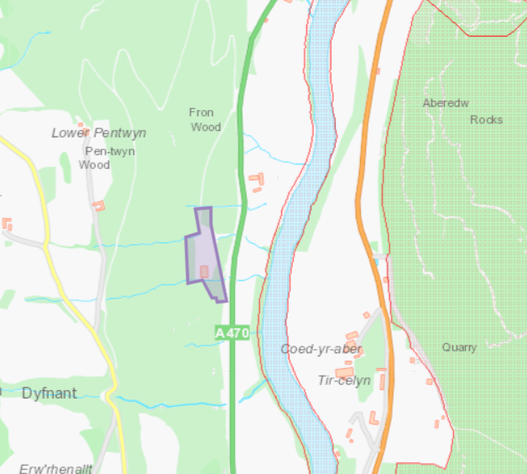
- River Wye (Upper Wye) / Afon Gwy (Gwy Uchaf) SSSI approx. 96 meters
- Llandeilo, Rhulen and Llanbedr Hills SSSI approx 415 meters

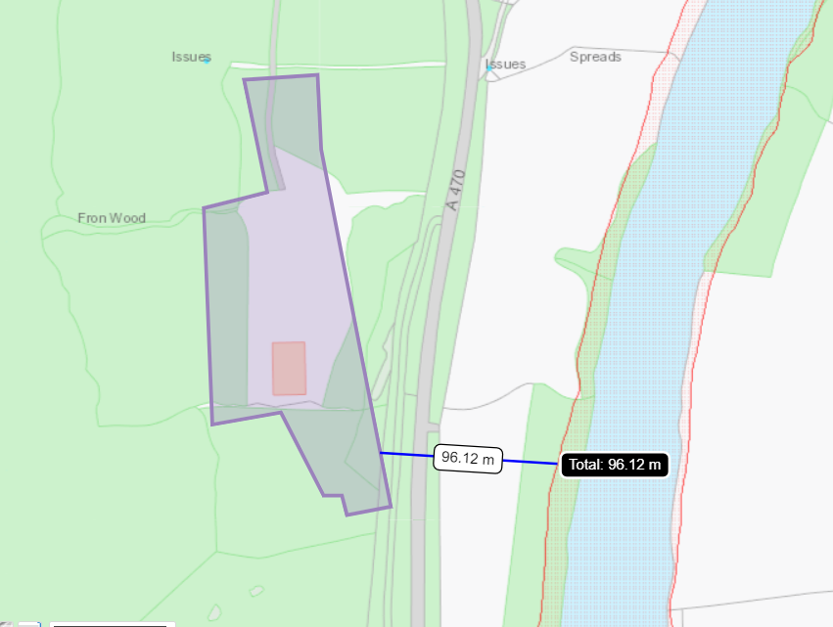
- River Wye (Upper Wye) / Afon Gwy (Gwy Uchaf) SSSI approx. 96 meters (85 meters at closest ppoint- see SAC map for reference)

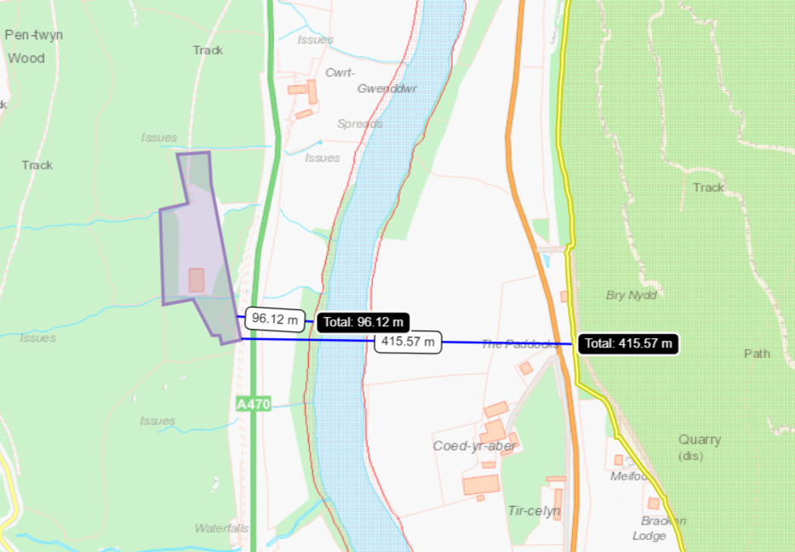
- Llandeilo, Rhulen and Llanbedr Hills SSSI approx 415 meters
SAC
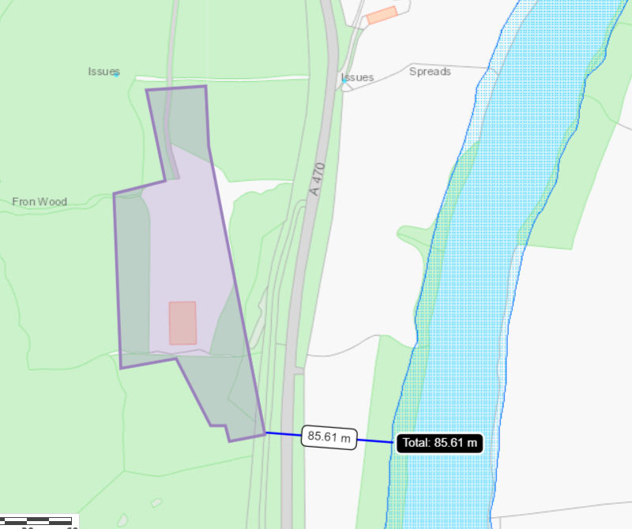
- River Wye / Afon Gwy (Wales) SAC approx. 85 meters away

Ancient woodland
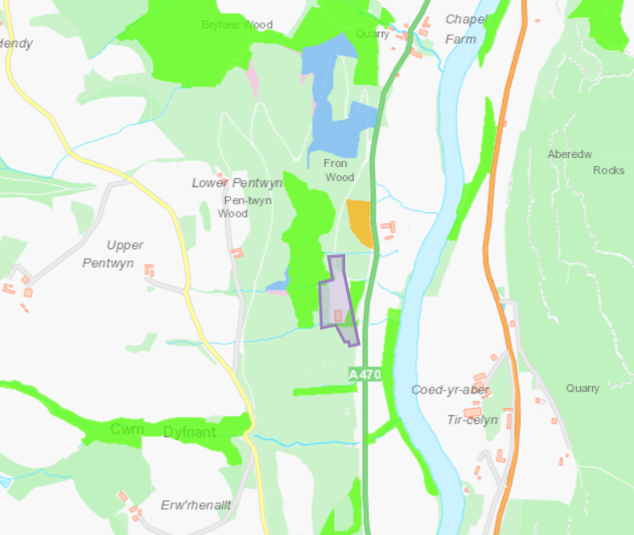
Within 500 meters:
- 13341 Ancient Semi Natural Woodland
- 13342 Ancient Semi Natural Woodland
- 13339 Ancient Semi Natural Woodland
- 13340 Ancient Semi Natural Woodland
- 20073 Ancient Semi Natural Woodland
- 20074 Ancient Semi Natural Woodland
- 20136 Ancient Semi Natural Woodland
- 20131 Ancient Semi Natural Woodland
- 23509 Restored Ancient Woodland Site
- 40752 Plantation on Ancient Woodland Site
- 40424 Plantation on Ancient Woodland Site
- 42301 Plantation on Ancient Woodland Site
- 42306 Plantation on Ancient Woodland Site
- 42307 Plantation on Ancient Woodland Site
- 48665 Ancient Woodland Site of Unknown Category
- 48659 Ancient Woodland Site of Unknown Category
- 48045 Ancient Woodland Site of Unknown Category
Flood risk
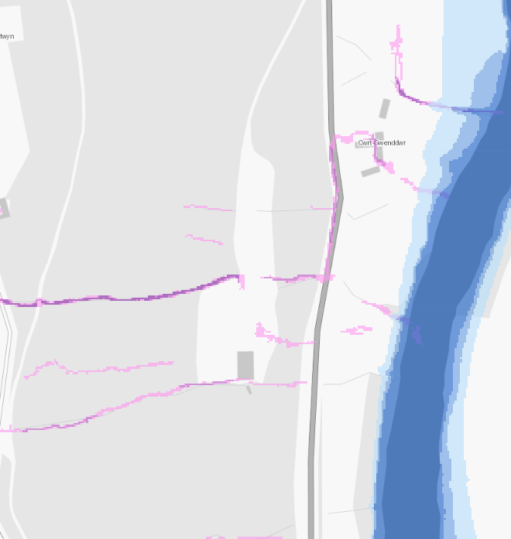
- flood risk from surface water and small watercourses along the southern (downslope) end of the site and through the culverted stream to the north of the site

Protected Habitats for Permitting Screening
Within 500 meters:
- Lowland dry acid grassland and Lowland calcareous grassland
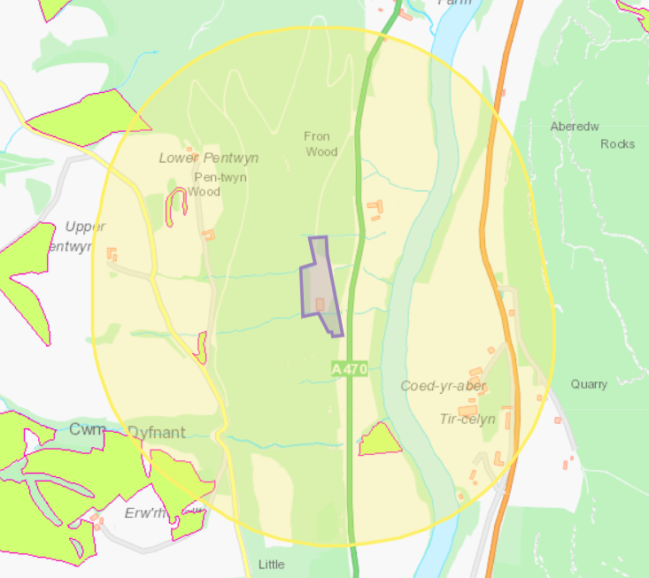

Protected Species for Permitting Screening
Within 500 meters:
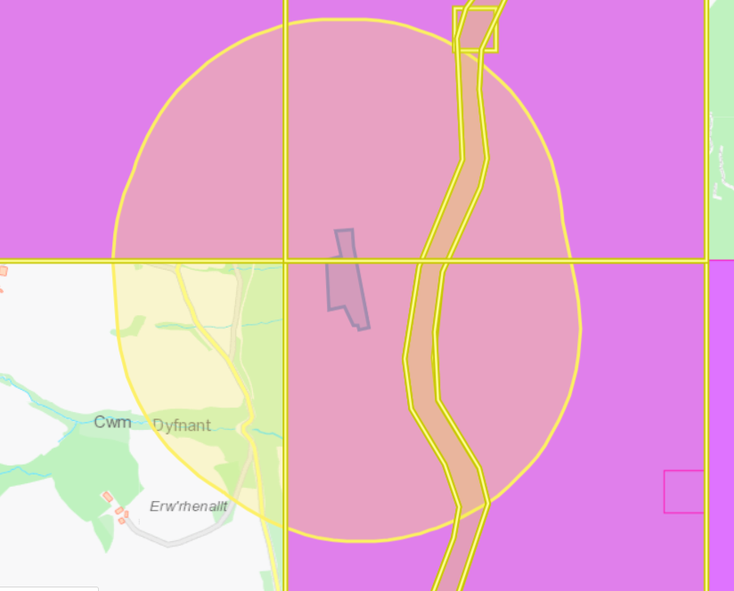
Within 500 meters:
- River Lamprey migratory route
- Atlantic Salmon migratory route
- Twaite Shad migratory route
- Unidentified Shad migratory route
- European Eel migratory route
- Bullhead
- Threatened Lichen
- Threatened Bryophyte

Section 7:
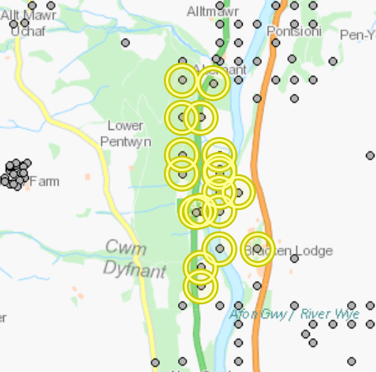
within 500 meters:
- Birds: Lesser Spotted Woodpecker
- Butterflies and Moths: Blood-vein, Broom Moth , Buff Ermine , Small Phoenix, White Ermine
- Mammals: Eurasian Red Squirrel, European Otter, Hazel Dormouse, Noctule Bat, Pine Marten, Soprano Pipistrelle, West European Hedgehog

Aquifer (superficial)
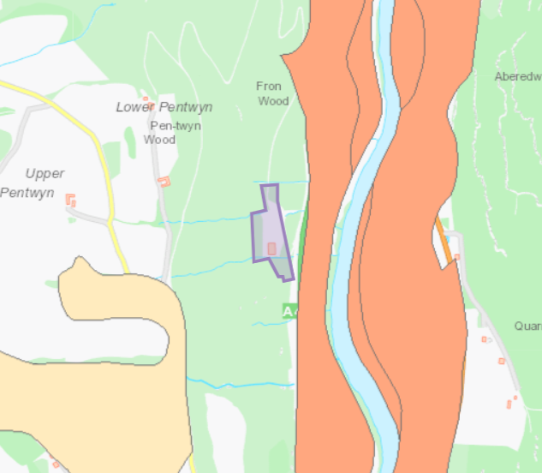

Aquifer (bedrock)
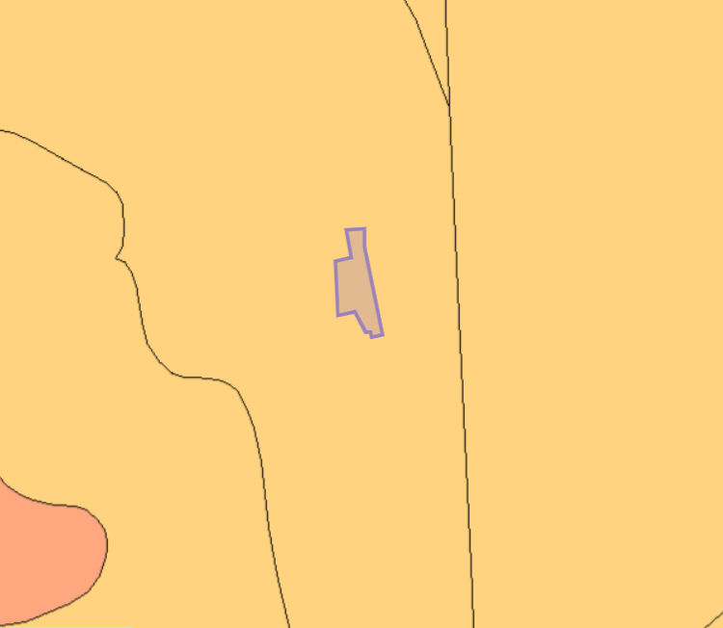

Watercourses


