BP0253601 Stackpole STW SPS Plan

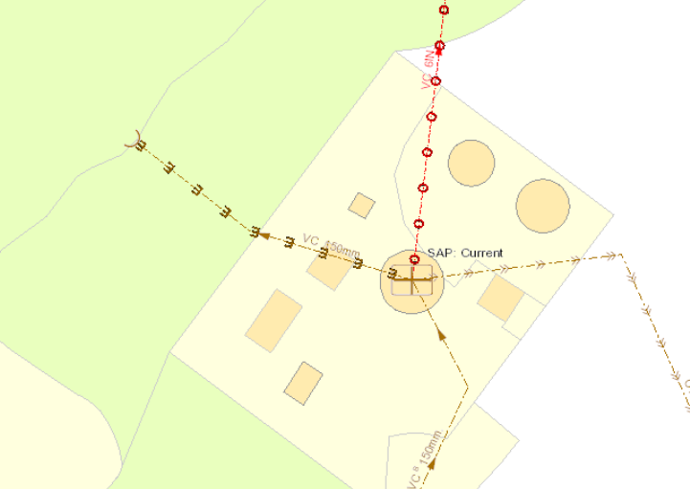
Discharge point
Sample Point
EDM Monitoring Point

