CRoW Appendix 4 (140_10_SD02)  CRoW Act 2000: Natural Resources Wales application for permission - Formal Notice  FOR INFORMATION ONLY |  | 
Natural Resources Wales Formal Notice.
Requirements of Section 28I of the Wildlife & Countryside Act 1981 as amended by the Countryside and Rights of Way Act (CRoW) 2000.
Duty in relation to granting any consent, licence or permit for activities likely to damage Sites of Special Scientific Interest (SSSI).
Guide to filling in this form for Natural Resources Wales staff:
To be completed by Permitting Officers for any applications for a permission which the Natural Resources Wales has considered under S28G duties to protect and enhance SSSIs. This applies to all proposed permissions within a SSSI, and to operations outside the SSSI boundary which are likely to damage its special features.
Refer to OI 140_10 ‘Applying the Countryside and Rights of Way (CRoW) Act 2000 to applications for permits with potential for impact on Sites of Special Scientific Interest (SSSI)’, including the flowchart in Appendix 2.
Pink italic text – drafting notes, to be deleted before completion/consultation.
Blue text – examples, to be replaced with permission-specific information.
Ensure you have completed all sections.
- Natural Resources Wales area/region/NPS hub: | South Central
- Name of SSSI: | Severn Estuary SSSI
- Type of permission: | Environmental Permit
- Date for Natural Resources Wales permit determination: | 18/08/2023
- Predicted 28 day date for response from NRW conservation/ecology (under S28 I(4)): | NA
- Natural Resources Wales reference no: | PAN-020942
- National grid reference: | ST 20312 74837
- Description of proposal: | 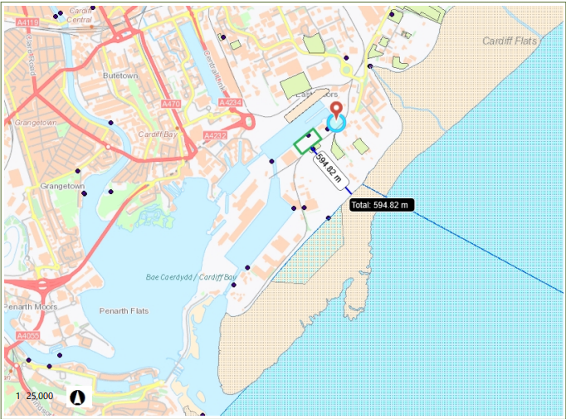  The site is currently permitted for the storage and bulking up of Refuse Derived Fuels (RDF) and Treated and Untreated wood for transfer off site via shipping vessel. The site is permitted to discharge rainfall dependant run-off from areas of the site associated with waste storage into the Roath Dock waters via an interceptor.  The application is to allow the operator to store an additional type of waste on site. This proposed waste is 10 02 10 Mill Scales.  Mill Scales is an absolutely non hazardous waste code as per the WM3 Guidance on the classification and assessment of Waste the operator provided a Safety Data Sheet for Mill Scale (Ferrous Metal) as part of their application which also confirms that the Mill Scale is non-hazardous as well as non-soluble in water.  This means the main risks introduced to the site by adding this waste to the permitted waste codes are:  - An increase of dust emissions leaving the site boundary  - An increase in suspended solids within the rainfall dependant run-off.
- Is the proposed activity within (wholly or partially) the SSSI boundary? | No, the site boundary of the proposed activity is approximately 600m metres north west of the SSSI boundary.
- Has there been any pre-application discussion or correspondence with NRW conservation/ecology | NO.
- What aspect(s) of the proposed permission may damage the features which are of special interest for the SSSI?
The following ‘Operations Requiring Consent’ (or other activities associated with the permission) that may cause damage) are relevant to the proposed permission.

7. Dumping, spreading or discharging of any materials.

22. Storage of materials

The following SSSI features and mechanisms of impact have been considered to assess the likelihood of damage:

Terrestrial invertebrate biology affected by deposit of airborne particulate matter released from the activity and marine invertebrate biology affected by suspended solids in run-off water entering surface water drains / ditches.
- Decision
The proposed permission is not likely to damage any of the flora, fauna or geological or physiological features which are of special interest.

The Specific Material – Mill Scale

The Mill Scale material is inherently non-hazardous (being classified as Absolutely Non-Hazardous by our WM3 guidance). The Safety Data Sheet provided by the applicant supports this and also confirms that Mill Scale is non-soluble in water.

The material is also considered to be dense and unlikely to raise as a result of the limited proposed site operations.

As a result of the above, the impact of Mill Scale is limited to the potential additional suspended solids impacting the various features of the Severn Estuary.

Discharge of Suspended Solids

The site currently (and will continue to) have a impermeable surface with sealed drainage system with an interceptor which all rainfall dependant run-off goes through prior to discharge into the dock waters. This is standard control that would be expected of most site where they are discharging directly to the environment (irrespective of the presence of a European protected site) it is a measure put in place to protect the environment general not specifically mitigate any impacts to the Severn Estuary SSSI.

The purpose of the interceptor is to remove suspended solids from the run-off waters prior to the discharge into the dock waters. The operator has provided details of how this interceptor will be inspected and maintained to ensure it is working effectively. These procedures are included in the operators permit as operating techniques which are effectively permit conditions and must therefore be followed.

As a result of these specific assessments all potential pathways are removed due standard controls, or physical characteristics of the proposal/designated site.

The proposed permission is therefore not likely to damage the SSSI features via the discharge of contaminated materials as the only risk posed form the additional mill scale material is an increase of suspended solids which will be controlled via an interceptor.

Deposition of Fugitive Dust Emissions

The site will be limited to 6,000 Tonnes of Mill Scale on site at anyone time and an annual throughput of 30,000T. With the exception of loading and unloading operations (and handling) no other treatment of the material is proposed. There should therefore be limited agitation of the Mill Scale and as a result limited suspension/resuspension of dust particulates will occur which would to generate a fugitive dust emission form the site boundary.

It is understood that Mill Scale is a dense material and therefore it is likely that any fugitive emissions that do occur would be deposited closer to the site then for less dense materials such as those already permitted (RDF, Treated and Untreated Wood). Due to the distance between the site and Severn Estuary SAC, SAP and RAMSAR emission

The operator has provided a Dust Emission Management Plan with the aim of reducing the any emissions of dust from site (mainly required due to the proximity of human receptors to the site boundary) this includes dust control measures such as:

- Dampening down stockpiles
- Reduced drop heights
- Sheeted vehicles
- Dust suppression
- Maintaining good housekeeping standards

The proposed permission is therefore not likely to damage the SSSI features via deposit of airborne particulate matter due to control measures and visual monitoring identified within the ‘How to comply with your environmental permit’ guidance and the operators Environmental Risk Assessment and dust management plan.

Natural Resources Wales is minded to:
Issue the permission

- Name and job title of Natural Resources Wales officer: | Matthew Fryer  Permitting Officer
- Date form sent to NRW conservation/ecology | N/A
For Natural Resources Wales use only, once NRW conservation/ecology response received
- NRW conservation/ecology comment on assessment: | N/A
- Name and job title of NRW conservation/ecology officer: | N/A
- Date of receipt of NRW conservation/ecology response: | N/A

