CRoW Appendix 4 (140_10_SD02)  CRoW Act 2000: Natural Resources Wales application for permission - Formal Notice |  | 
Natural Resources Wales Formal Notice.
Requirements of Section 28I of the Wildlife & Countryside Act 1981 as amended by the Countryside and Rights of Way Act (CRoW) 2000.
Duty in relation to granting any consent, licence or permit for activities likely to damage Sites of Special Scientific Interest (SSSI).
- Natural Resources Wales area/region/NPS hub: | NRW Permitting Service
- Name of SSSI: | Blorenge SSSI approx. 875 meters from the proposed site  Siambre Ddu SSSI- approx. 1,912 meters from the proposed site
- Type of permission: | Bespoke Environmental Permit under the Environmental Permitting Regulations 2016
- Date for Natural Resources Wales permit determination: | 27/06/2023
- Predicted 28 day date for response from NRW conservation/ecology (under S28 I(4)): | n/a saved for information only
- Natural Resources Wales reference no: | PAN-019748
- National grid reference: | SO 24473 09469
- Description of proposal: | The application by Recovery Blaenavon Ltd is for a non-hazardous waste physical treatment facility on the Kays and Kears Industrial Estate, Blaenavon. The Non-hazardous material is plastic, which will be processed at a maximum rate of 52 tonnes per day and not exceeding 20,000 tonnes per year. The materials will be delivered to the site by truck and fed into a waste reception area by forklift. The material will be stored here until it can be fed into a heating area and the resulting plastic granulate material will be loaded into transport vehicles for delivery to the customer.  The site is adjacent to a number of existing industrial buildings upon level ground with direct access to the estate roadway. There are two sites of special scientific interest, one 877 m away and one 1.9 km away. The site is considered to be at high risk of flooding from surface water and small watercourses. The site is surrounded by housing to the southeast and northwest, with the nearest residential area is 550m away.  The site is approximately 875 meters away from the nearest SSSI (Blorenge) and approximately 1,912 meters away from the next nearest SSSI (Siambre Ddu). See maps at the end of this document.  The site is on a groundwater source protection zone 1, however the SSSI would not be affected by this site due to the hydrological profile of the area. for the same reasons surface water has not been assessed within this document.  Potential issues which may affect the SSSIs are dust, noise, litter and fire. Odour is not deemed a risk for this site, nor are pests due to the type of waste that is proposed to be accepted- waste pre-acceptance and acceptance procedures have been reviewed and will be incorporated into the permit to ensure relevant procedures are complied with.  Dust/litter  Waste is accepted onto site is pre-sorted and pre-baled. It would not typically be a dusty waste.  Baled plastic, in its largest form is processed inside the building only.  All shredding is undertaken inside the building within a sealed unit that houses both dust and acoustic abatement technology.  A dust extraction unit is sealed and integral to the processing plant.  The roller shutter doors are closed when not in use.  The waste storage is external but on concrete. The processing and product storage areas comprise engineered concrete surfacing and are inside the buildings.  If on-site conditions become dusty, a water hose will be used on the site access road and the external working areas, where required. In the unlikely event of the adjacent public highway become muddy, a road sweeper will be hired as needed. The Site boundary is inspected daily for any dust or particulates escaping the site.  The types of waste to be accepted can be associated with litter. The material arrives baled and tied to prevent the bale from losing integrity and contents.  Noise  The application includes a Nosie Impact Assessment and a Noise Management Plan. These were assessed as part of the determination, and incorporated into the permit to ensure compliance.  Fire  The application includes a Fire Prevention and Mitigation Plan. It was assessed as part of the determination, and incorporated into the permit to ensure compliance.
- Is the proposed activity within (wholly or partially) the SSSI boundary? | No
- Has there been any pre-application discussion or correspondence with NRW conservation/ecology | No
- What aspect(s) of the proposed permission may damage the features which are of special interest for the SSSI?
The following ‘Operations Requiring Consent’ (or other activities associated with the permission) that may cause damage) are relevant to the proposed permission.
- None for either Blorenge SSSI or Siambre Ddu SSSI given proposed activities and distances between propped site and SSSIs.

The following SSSI features and mechanisms of impact have been considered to assess the likelihood of damage:
- Aerial- dust and noise.
- Decision
The proposed permission is not likely to damage any of the flora, fauna or geological or physiological features which are of special interest.
- No pathway for features to be affected due to the proposed mitigation methods which have been incorporated into the permit where relevant.

Natural Resources Wales is minded to issue the permission
- Name and job title of Natural Resources Wales officer: | Louise Bailey  Permitting Officer
- Date form sent to NRW conservation/ecology | n/a saved for information only

Site boundary as per application

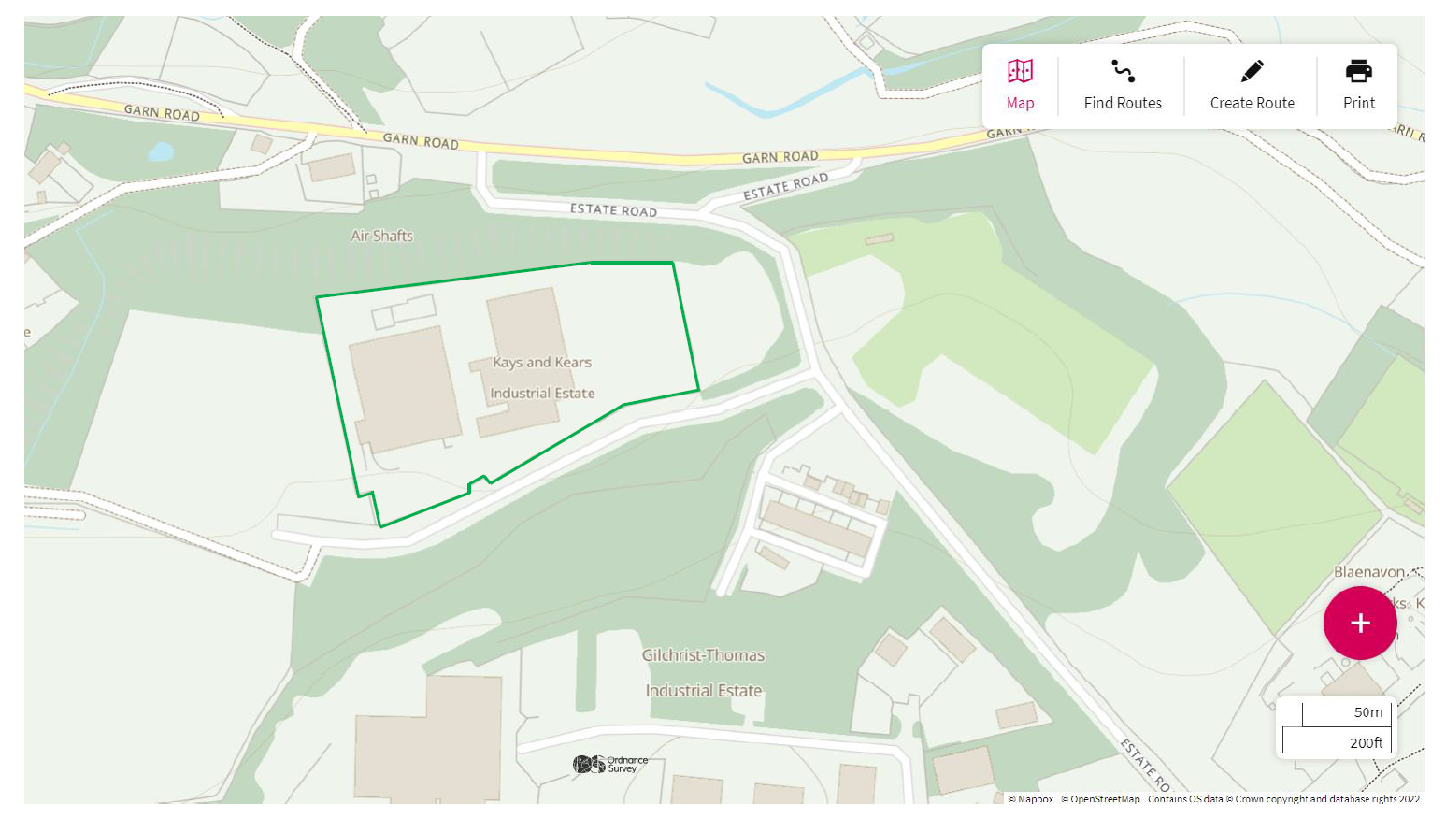

SSSI within 2km of the site

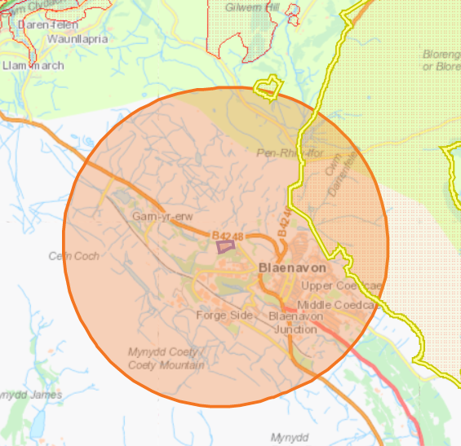

Blorenge SSSI approx. 875 m 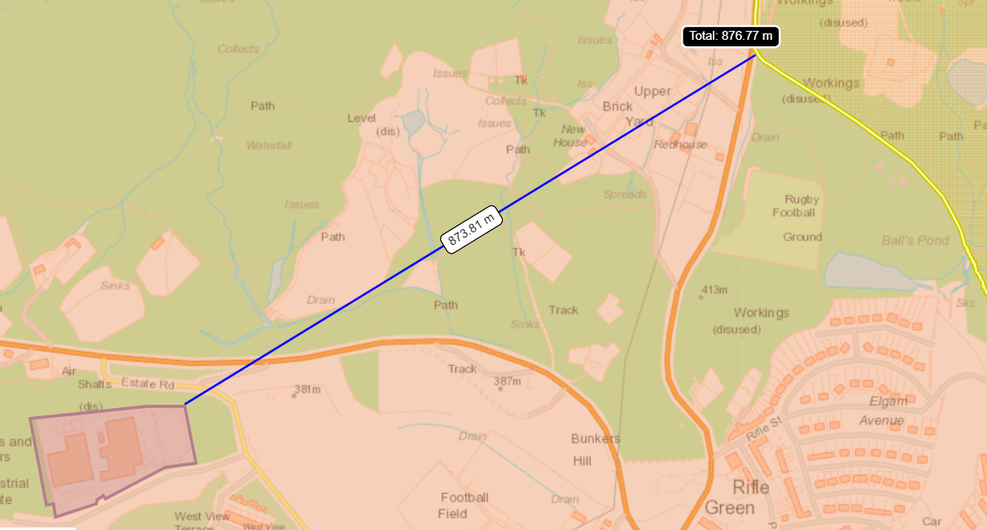

Siambre Ddu SSSI- approx. 1,912 meters


