PAN-022503 Mymap report
Rights of way map
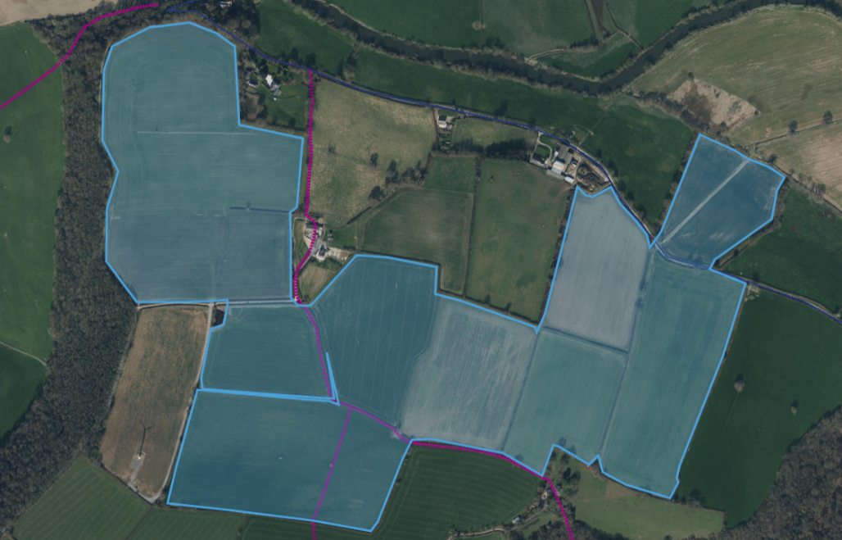
All tracks marked on provided documents.
Slope map
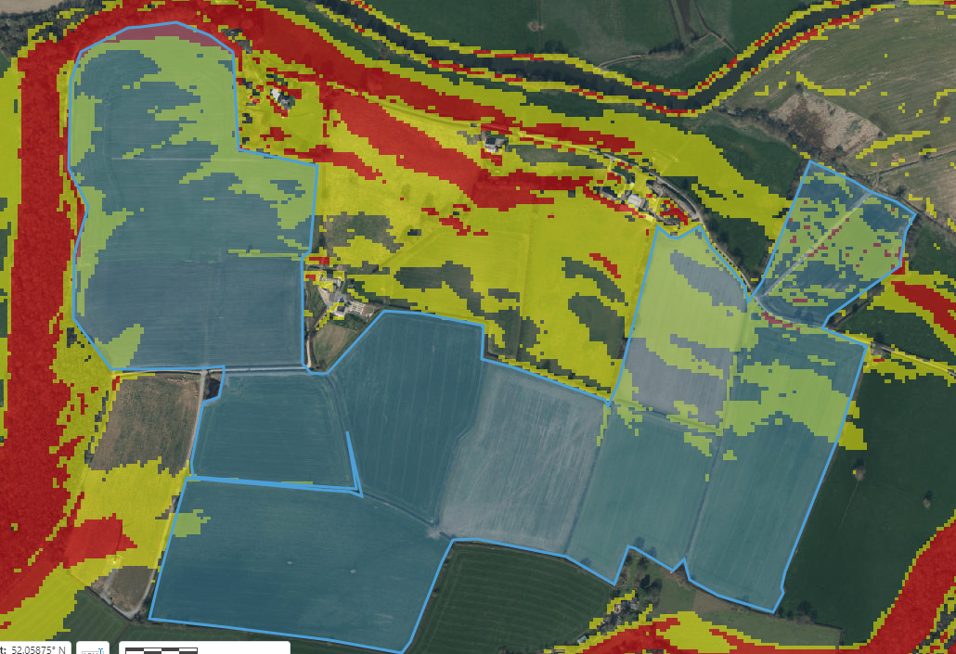
CASTELL MALG 9 field on the top right contains water courses at its north end a 20m buffer zone has been placed around this course. Several fields contain slopes between 7-12 degrees, with small areas of 12+ degrees. Slope mitigation has been provided via a request for information, 20m buffer zones around water course, low trajectory spread methods and relatively low spread rates. Spread method is dribble bar and soil incorporation.
Mymap assessment
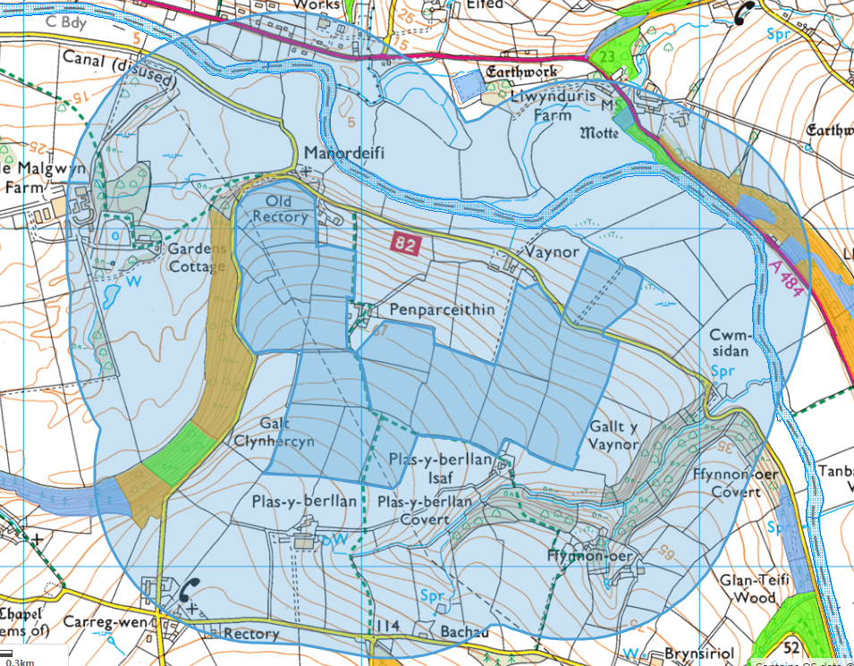
No issues to note
Habitat and Species
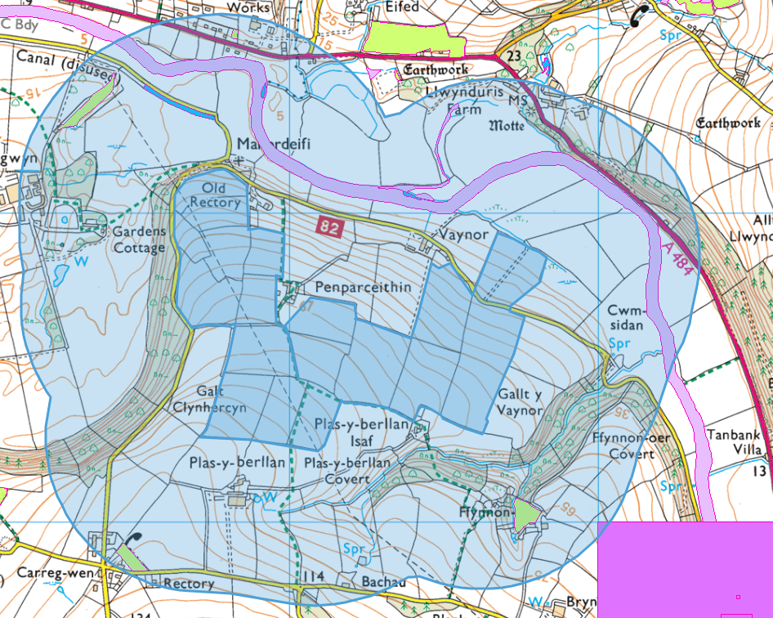
Water courses in field CM9 drain into the SSSI/SAC Afon Teifi, field is also sloped towards the SSSI and water course which drains into the Afon Teifi, which also contain protected species.
SSSI Map
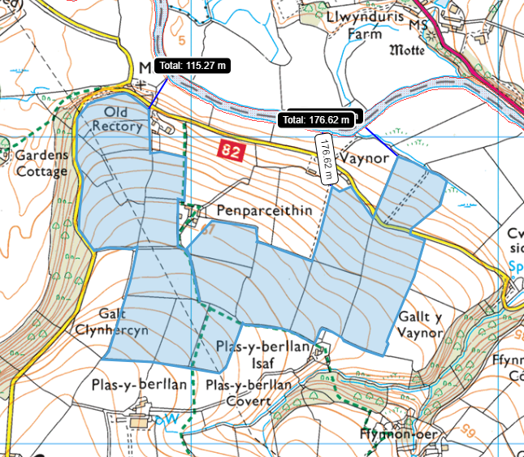
Water courses in field CM9 drain into the SSSI Afon Teifi, field is also sloped towards the SSSI and water course which drains into the Afon Teifi, which also contain protected species.
SAC Map
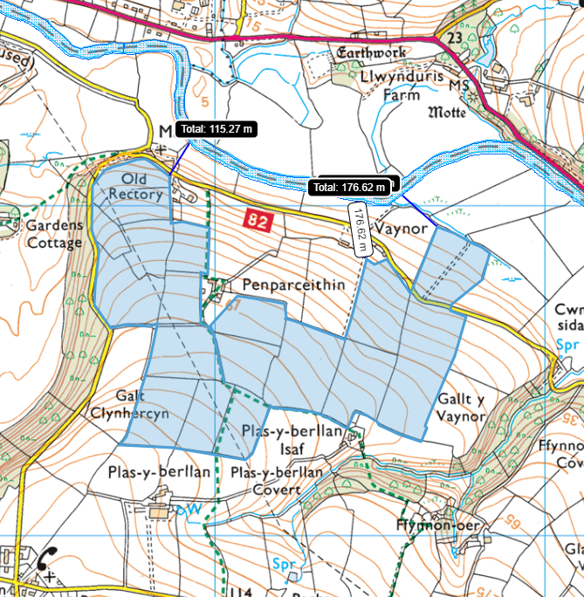
Water courses in field CM9 drain into the SAC Afon Teifi, field is also sloped towards the SSSI and water course which drains into the Afon Teifi, which also contain protected species.

