CRoW Appendix 4 (140_10_SD02)  CRoW Act 2000: Natural Resources Wales application for permission - Formal Notice |  | 
Natural Resources Wales Formal Notice.
Requirements of Section 28I of the Wildlife & Countryside Act 1981 as amended by the Countryside and Rights of Way Act (CRoW) 2000.
Duty in relation to granting any consent, licence or permit for activities likely to damage Sites of Special Scientific Interest (SSSI).
Guide to filling in this form for Natural Resources Wales staff:
To be completed by Permitting Officers for any applications for a permission which the Natural Resources Wales has considered under S28G duties to protect and enhance SSSIs. This applies to all proposed permissions within a SSSI, and to operations outside the SSSI boundary which are likely to damage its special features.
Refer to OI 140_10 ‘Applying the Countryside and Rights of Way (CRoW) Act 2000 to applications for permits with potential for impact on Sites of Special Scientific Interest (SSSI)’, including the flowchart in Appendix 2.
Pink italic text – drafting notes, to be deleted before completion/consultation.
Blue text – examples, to be replaced with permission-specific information.
Ensure you have completed all sections.
- Natural Resources Wales area/region/NPS hub: | Northwest Wales
- Name of SSSI: | Migneint-Arenig-Dduallt SSSI
- Type of permission: | Landspreading deployment under standard rules permit SR2010 No4
- Date for Natural Resources Wales permit determination: | 31/08/2023
- Predicted 28 day date for response from NRW conservation/ecology (under S28 I(4)): | 30/08/2023
- Natural Resources Wales reference no: | PAN-022455
- National grid reference: | Farm location: SH 81623 45994  Fields:  1 1 SH 82096 46327  2 2 SH 81870 46143  3 3 SH 82069 46550  4 4 SH 81853 46334  5 7 SH 81123 45900  6 8 SH 80865 45607  7 20 SH 82392 46972  8 21 SH 82484 46849  9 22 SH 82659 47067  Storage:  1 SH 81649 46016  Migneint-Arenig-Dduallt SSSI grid reference: SH820 410
- Description of proposal: | A land spreading application to spread a total of 8 waste streams for the waste codes 19 09 02 & 02 07 02 at Blaen Y Coed Farm, Betws-y-Coed.Wastes are to be spread on grass fields. The application rate ranges from 90-250 tonnes per ha, with a total tonnage to spread 6,950 tonnes.  NOTE: In the request for information 1 dated 28/07/2023 the applicant has been told to remove one waste stream ‘Aberfalls’ (EWC 02 07 02) from the deployment due to the waste having a p.H of 3.5 which is considered acidic. The spreading of this acidic waste would likely cause the grass to experience stunt in growth and therefore not meet the requirements of agricultural benefit. For full details see the request for information on the DMS.  The waste will be spread over 27.8 ha hectares of land within the listed fields at Blaen Y Coed Farm The wastes may be stored in a lagoon or spread on delivery. The wastes will be spread via dribble bar which is an appropriate application method for the waste types.  Targeted periods of spreading on grass fields include early spring 2024 (late February – May), after cutting of silage, and prior to grazing through summer and autumn 2023.  No more than 50t/ha of waste will be spread on a field in any 3-week period in accordance with CoGAP, and no more than 250t/ha will be spread within any 12-month period.  The wastes may be applied separately or in combination. If the wastes are applied in combination the total combined amount applied will not exceed 250t/ha, the total nitrogen loading will be less than 250kg/ha, and the amount of available nitrogen and total or available phosphate and potash (whichever is appropriate) will not exceed the fertiliser recommendation or the amount removed in crop offtake, whichever is the greater.  Fields 1 and 2 have soil pH below 6, therefore no alum based sludge will be spread on these field as per TGN 8.01.  The landspreading activity will comply with CoGAP.
- Is the proposed activity within (wholly or partially) the SSSI boundary? | NO  All fields are located within 500 meters screening distance of the Migneint-Arenig-Dduallt SSSI. Below is a table detailing the distance the fields are from the SSSI (at the closest point).  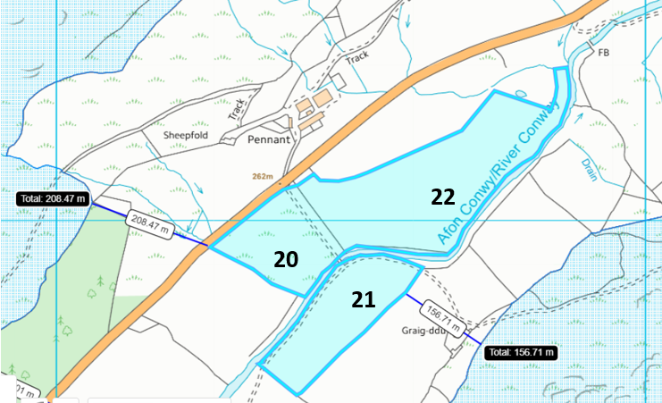  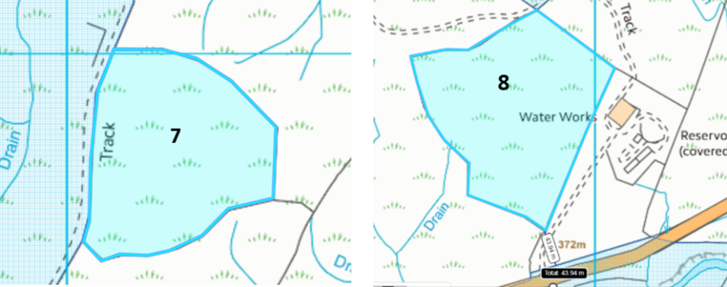  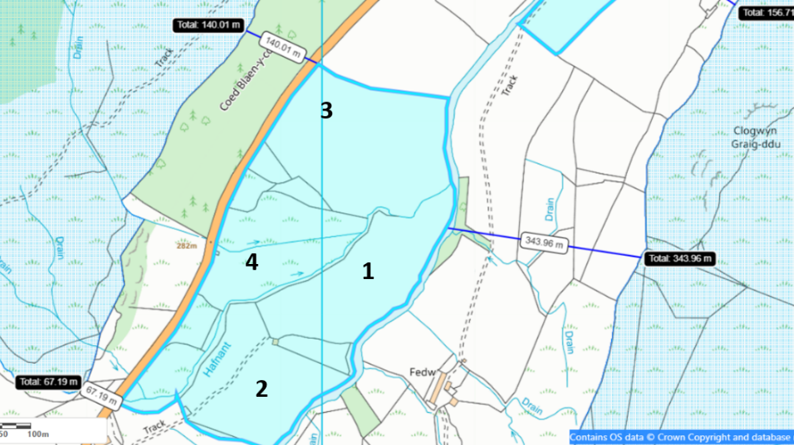  Fields 1, 2, 3, 20, 21 & 22 border the Afon Conwy and was assessed as a potential impact pathway. Although these fields have an 20 meter no spread buffer zone to mitigate the risk of potential runoff of the wastes from entering the water course. The fields are also located downstream of where the river passes through the Migneint-Arenig-Dduallt SSSI meaning there is no impact pathway for wastes to enter the SSSI. (see elevation profile at the bottom of the appendix 4).  Fields 4, 7 & 8 are located near the SSSI.
  Field reference | Distance from SSSI (meters)
  1 | 231
  2 | 163
  3 | 140
  4 | 67
  7 | Borders SSSI
  8 | 44
  20 | 209
  21 | 157
  22 | 170
- Has there been any pre-application discussion or correspondence with NRW conservation/ecology | NO
- What aspect(s) of the proposed permission may damage the features which are of special interest for the SSSI?

The following ‘Operations Requiring Consent’ (or other activities associated with the permission) that may cause damage) are relevant to the proposed permission.

5. Application of manure, slurry, silage liquor, fertilisers, and lime.

7 Dumping, spreading, or discharging of any materials.

22. Storage of materials.

26. Use of vehicles or craft in a way likely to damage the features of special interest.

The following SSSI features, and mechanisms of impact have been considered to assess the likelihood of damage:

Habitats

- Blanket bog
- Dry heath
- Wet heath
- Upland broad-leaved woodland and scrub
- Lakes (nutrient-poor and brown, peaty lakes)
- Flush and spring
- A mixture of associated habitats including: grassland and rush pasture, swamp, cliffledge communities, vegetated scree, rock crevice communities, boulders, scree, rivers,
- streams and bracken.

Plants

- Nationally scarce plants (marsh clubmoss, tall bog-sedge, rock stonecrop and eyebright)
- and regionally rare or threatened flowering plants (mountain everlasting, northern
- bedstraw, dwarf willow, few-flowered sedge, water sedge and stiff sedge)
- An assemblage of mosses and liverworts which are nationally rare, nationally scarce
- and/or Atlantic species
- The nationally rare liverwort, Welsh notchwort

Birds

- The upland breeding bird assemblage
- Hen harrier
- Merlin
- Peregrine

Insects and other invertebrates

- The upland invertebrate assemblage
- The locally uncommon large heath butterfly
- The nationally rare ground beetle Trechus rivularis
- The nationally scarce weevil Anthonomus conspersus
- The nationally rare fungus gnat Brevicornu kingi

Geological features

- Manganese mineralization in mine spoil and rock outcrops at Mwyngloddfa Mynydd Nodol

- Ordovician (Arenig) sedimentary and volcanic rocks exposed in disused quarries, natural
- outcrops and stream sections at Amnodd-wen & Ffilltergerig

The main impact concern would be nutrification via runoff or nutrient leaching into the fields closest to the SSSI i.e. field 7. An increase in nutrient content has the potential to cause algal blooms and other atypical species to outcompete protected and designated species within the SSSI.

- Decision
i) The proposed permission is not likely to damage any of the flora, fauna or geological or physiological features which are of special interest.

- Field 7 that borders the SSSI contains an 20 meter no spread buffer zone that mitigates the risk of surface runoff and/or leachate containing nutrients and/or PTEs (Al and Fe) into the SSSI.

- Fields 1, 2, 3, 4, 8, 20, 21 & 22 that contain water issues or border the Afon Conwy contain a 20 meter no spread buffer zone that mitigates the risk of surface runoff and/or leachate containing nutrients and/or PTEs (Al and Fe) into the SSSI.

- Fields 2, 3, 4 and 8 have implemented no spread buffer zones in areas which contain moderately (7-12º) and highly sloping land (12+º). The no spread buffer zone mitigates the risk of surface runoff containing nutrients and/or PTEs (Al and Fe) into the SSSI/ watercourses.

- Wastes will be spread via dribble bar. This application method is appropriate for the waste types and apply the wastes directly to the ground to reduce the risk of surface runoff.

- No alum rich sludges will be spread on fields with a pH of less than 6 as per TGN 8.01 page 131. This includes fields closest to the SSSI (fields 3, 4, 7, & 8 ) so there is a lower risk of Al and Fe entering the SSSI and causing detriment to the SSSI.

- The operator will avoid the land spreading activity at sensitive times i.e., the breeding season. This will include 15th March to 15th August for fields close to the SSSI (fields 7 & 8).

- Spreading will only be undertaken when weather conditions are suitable within restrictions outlined in CoGAP and any relevant closed periods.

- Machinery operations will take account of soil conditions, slopes etc.

- Liquid spreading machinery will be turned off and lifted away from soil prior to turning at the end of each run.

- Machinery will be checked daily when in use, regularly serviced and spreading equipment calibrated. Umbilical hoses will be regularly checked for damage to prevent leaks.

- Machinery turns will not be executed in the buffer strips.

- Waste deliveries to field/stores will be supervised.

- All spillages will be reported immediately to the NRW.

Natural Resources Wales is minded to: Issue the permission
- Name and job title of Natural Resources Wales officer: | Owen Clee  Permitting Officer
- Date form sent to NRW conservation/ecology | 02/08/2023
For Natural Resources Wales use only, once NRW conservation/ecology response received
- NRW conservation/ecology comment on assessment: | Please delete as appropriate:  i) NRW conservation/ecology advise the operation can go ahead  ii) NRW conservation/ecology advise the operation can go ahead with conditions  iii) NRW conservation/ecology advise against permitting the operation  Please ensure that the NRW conservation/ecology response is attached to this Formal Notice.
- Name and job title of NRW conservation/ecology officer:
- Date of receipt of NRW conservation/ecology response:



