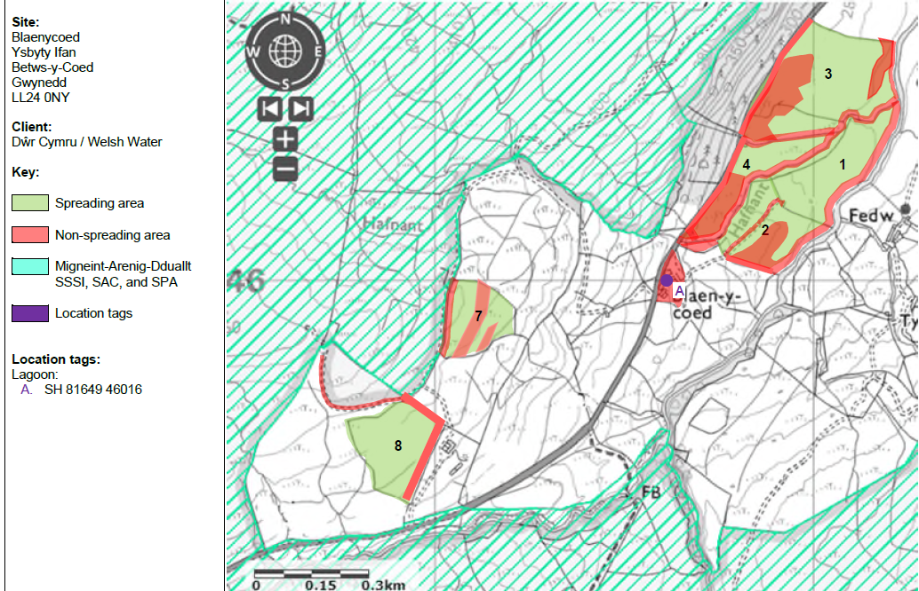
Proposed spreading map
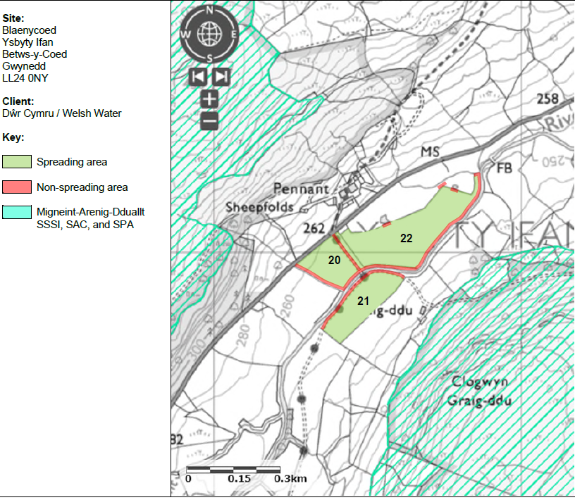

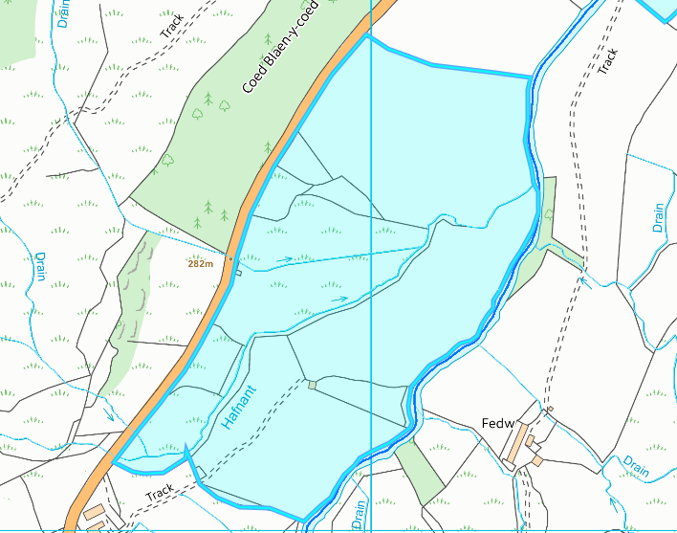
Detailed river network:
2
1
4
3
rwth
[Grab your reader’s attention with a great quote from the document or use this space to emphasize a key point. To place this text box anywhere on the page, just drag it.]
Field 1,2,3 and 4 border a water issue that runs along the middle boundary of the fields. There is a 10 no spread zone in place to prevent nutrients entering the issue / river.

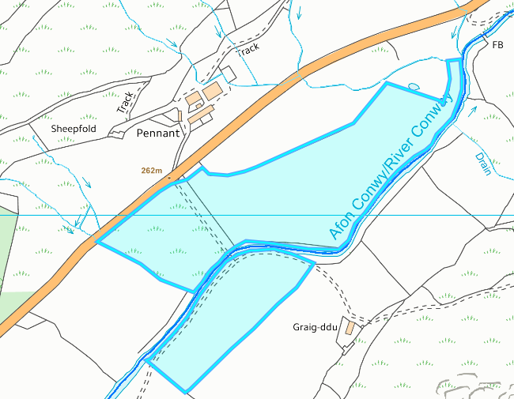
21
20
22
Field 20, 21 and 22 border the Afon Conwy. There is a 10 metre no spread zone in place to prevent nutrients entering the river.

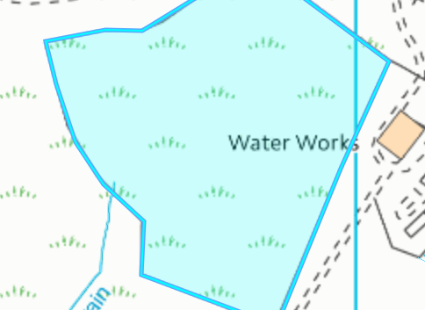
Field 8 contains a land drain. The border of the field is buffered by a no spread buffer zone which includes the area to which the land drain occupies. No action needed.
8
3

Groundwater protection zones (source)

None in range.

Wells, springs or boreholes used for the supply of water for human consumption including from a private water supply or supplies
None in range.

any springs wells or boreholes not used to supply water for domestic or food production purposes within 50m

None in range.

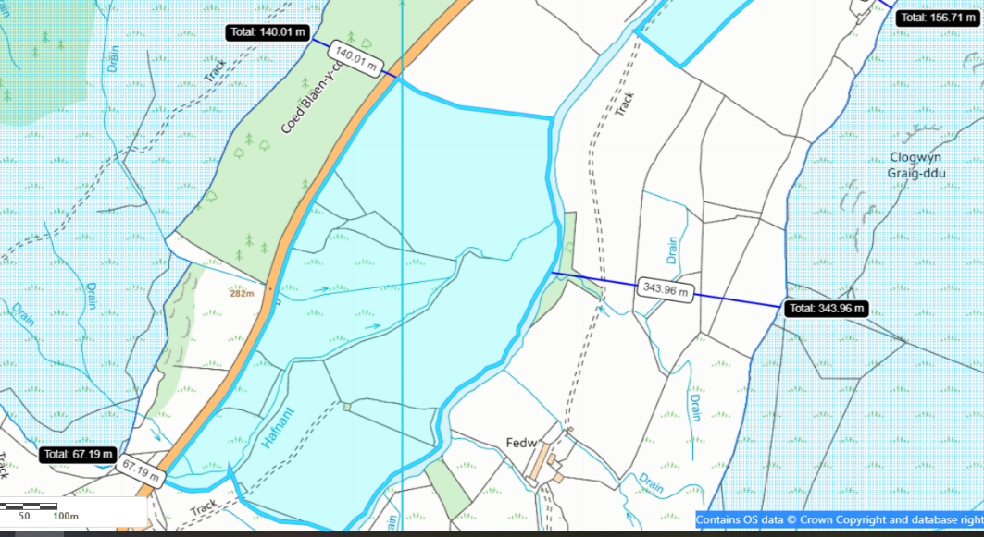
European designated sites- Natura 2000 (SPA, pSPA, SAC or cSAC) or Ramsar- or SSSI within 500m
Field 3 is located 140 meters at its closest point to the Migneint-Arenig-Dduallt SAC , SSSI & SPA.
Field 2 is located 163 meters at its closest point to the Migneint-Arenig-Dduallt SAC , SSSI & SPA.
Field 1 is located 231 meters at its closest point to the Migneint-Arenig-Dduallt SAC , SSSI & SPA.
Field 4 is located 67 meters at its closest point to the Migneint-Arenig-Dduallt SAC , SSSI & SPA.

2
1
4

3
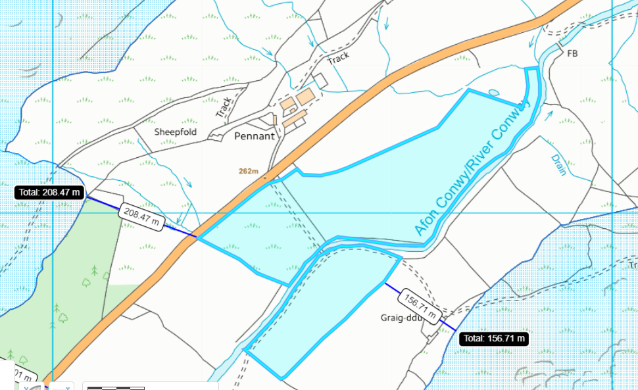
22
20
21
Field 20 is located 209 meters at its closest point to the Migneint-Arenig-Dduallt SAC , SSSI & SPA.
Field 21 is located 157 meters at its closest point to the Migneint-Arenig-Dduallt SAC , SSSI & SPA.
Field 22 is located 170 meters at its closest point to the Migneint-Arenig-Dduallt SAC , SSSI & SPA.

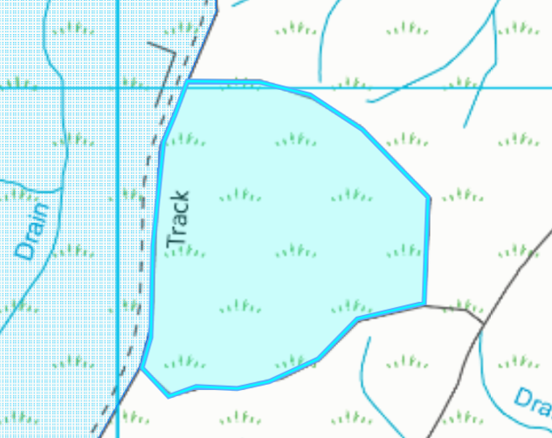
Field 7 borders the Migneint-Arenig-Dduallt SAC , SSSI & SPA

7

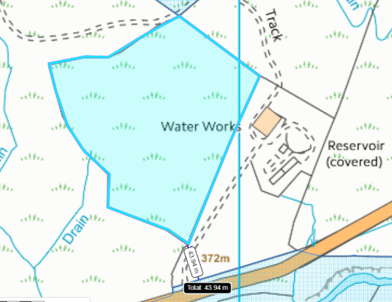
8
Field 8 borders the Migneint-Arenig-Dduallt SAC , SSSI & SPA

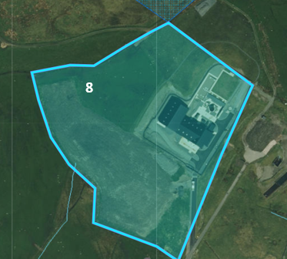
Field 8 aerial imagery suggests the field is agricultural improved and does not contain the habit. Although the spreading area does contain a building (Walters engineers LTD) and road. This area of land will be requested to be removed from the deployment.

- Scheduled Ancient Monument- None in range.

- Local Nature Reserve- None in range.

- National Nature Reserve- None in range.

- Ancient Woodlands-
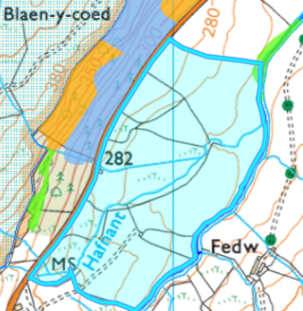
Field 3 borders an ancient woodland: Plantation on Ancient Woodland & Restored Ancient Woodland. The border of field 3 contains a 10 meter no spread buffer zone to prevent nutrients entering the site.
3

- Local Wildlife Sites (SINC)- None in range.

- National Park- All landspreading fields lie within the Snowdonia national park.

- Groundwater Safeguard Zone- None in range.

- ANOBs - None in range.

- Hedges- Nothing of concern.

- Ditches- See slope assessment

Slope Map
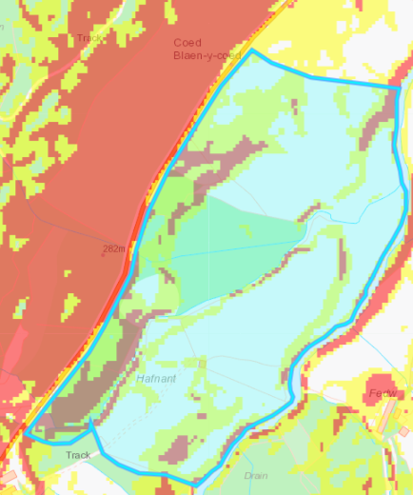
Fields 2, 3 and 4 contain highly & moderately sloping land. These areas of land implement a no spread buffer zone to mitigate the risk of surface runoff and/or leachate.
Field 1 contains highly & moderately sloping land that have been buffered in the request for information 1.

3
4
1
2

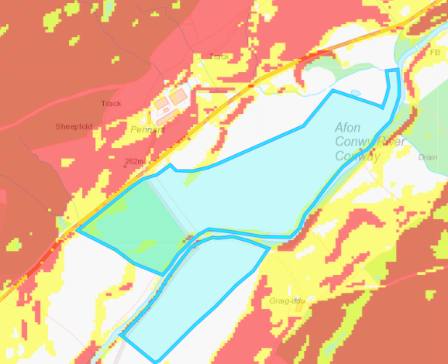
Field 20 contain small amounts of highly and moderately sloping land that have been buffered in the request for information 1.

21
22
20

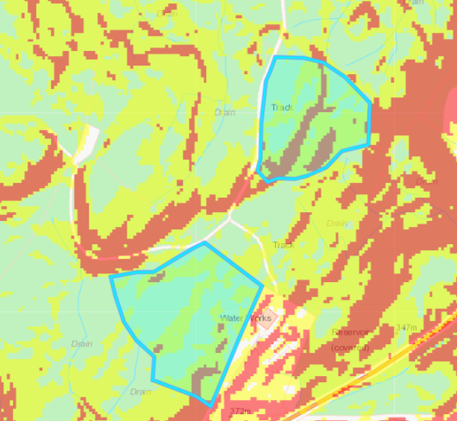
Field 7 contains highly & moderately sloping land. These areas of land implement a no spread buffer zone to mitigate the risk of surface runoff and/or leachate.

Field 8 contains highly & moderately sloping land that have been buffered in the request for information 1.

8
7

