CRoW Appendix 4 (140_10_SD02)  CRoW Act 2000: Natural Resources Wales application for permission - Formal Notice |  | 
Natural Resources Wales Formal Notice.
Requirements of Section 28I of the Wildlife & Countryside Act 1981 as amended by the Countryside and Rights of Way Act (CRoW) 2000.
Duty in relation to granting any consent, licence or permit for activities likely to damage Sites of Special Scientific Interest (SSSI).
Guide to filling in this form for Natural Resources Wales staff:
To be completed by Permitting Officers for any applications for a permission which the Natural Resources Wales has considered under S28G duties to protect and enhance SSSIs. This applies to all proposed permissions within a SSSI, and to operations outside the SSSI boundary which are likely to damage its special features.
Refer to OI 140_10 ‘Applying the Countryside and Rights of Way (CRoW) Act 2000 to applications for permits with potential for impact on Sites of Special Scientific Interest (SSSI)’, including the flowchart in Appendix 2.
Pink italic text – drafting notes, to be deleted before completion/consultation.
Blue text – examples, to be replaced with permission-specific information.
Ensure you have completed all sections.
- Natural Resources Wales area/region/NPS hub: | North East Wales
- Name of SSSI: | Afon Dyfrdwy (River Dee) SSSI
- Type of permission: | Bespoke mobile plant permit for landspreading or reclamation, restoration or improvement of land
- Date for Natural Resources Wales permit determination: | 11/09/2023
- Predicted 28 day date for response from NRW conservation/ecology (under S28 I(4)): | 08/09/2023
- Natural Resources Wales reference no: | PAN-022693
- National grid reference: | Farm location: SJ 36167 44303  Fields: Fields:  1 ID05 SJ 3682 5073  2 ID06 SJ 3712 5068  3 ID07 SJ 3688 5060  4 ER10 SJ 3598 4165  5 ER11 SJ 3584 4158  6 MF08 SJ 3502 4427  7 MF10 SJ 3558 4419  8 MF11 SJ 3531 4402  9 MF12 SJ 3562 4395  10 ID02 SJ 3685 5088  11 ID03 SJ 3170 5084  12 ID04 SJ 3662 5063  Storage:  SJ 35430 44530
- Description of proposal: | A bespoke land spreading application to spread a one stream (EWC 06 02 05* at Manor Farm, Wrexham. Wastes are to be spread on grass and maize fields. The application rate ranges from 3-13 tonnes per ha, with a total tonnage to spread 356 tonnes. The purpose of the deployment is to lime the fields which are significantly below the cropping Optimum where the field p.H currently ranges from 5.9-4.8.  The waste will be spread over 50 ha hectares of land within the listed fields at Manor Farm. The wastes will be stored in a temporary field heap. The wastes will be spread via rear discharge spreader which is an appropriate application method for the waste type.  The lime is a solid granular waste that is most appropriate for spreading between cropping onto post-harvest stubble in Autumn or cultivated ground in the Spring prior to sowing of Spring crops. Spreading on grass pasture will be limited to autumn following sileage offtake (1 or 2 crop with aftermath grazing). As the grass will be dormant, this will mitigate the effects of lime conductivity and limit the potential for leaf scorch. Following application, a full 30-day (full grass rotation) stand-off period for any grazing livestock will be maintained. Spreading will be scheduled to avoid dawn and dusk to minimise ecological disturbance.  For lime applications >7t/ha on grassland (permanent pasture) applications will be split, so no more than 7t/ha is spread at any one time.  The landspreading activity will comply with CoGAP.
- Is the proposed activity within (wholly or partially) the SSSI boundary? | NO  ER10, ER11, MF10, MF11 and MF12 are located within 500 meters screening distance of the River Dee SSSI. Below is a table detailing the distance the fields are from the SSSI (at the closest point).  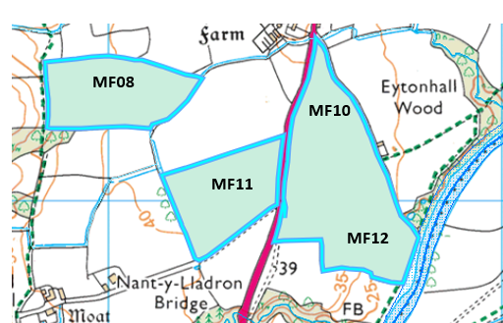  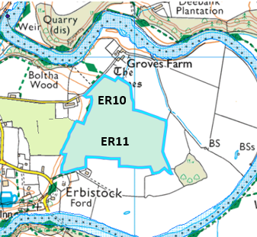  Fields ID02 to ID07 are not located within 500 meters of a SSSI and have been screened out.  No potential impact pathway was identified for fields ER10, ER11, MF10 and MF11. Considering the fields are located 372-183 meters away from the SSSI it is highly unlikely the spreading of a small amount of liming waste could reach the SSSI and cause detriment to the site.  As Field MF12 does border the River Dee SSSI this field will be considered further in the Appendix 4 form.
  Field reference | Distance from SSSI (meters)
  ER10 | 183
  ER11 | 221
  MF10 | 185
  MF11 | 372
  MF12 | Borders the SSSI
- Has there been any pre-application discussion or correspondence with NRW conservation/ecology | NO
- What aspect(s) of the proposed permission may damage the features which are of special interest for the SSSI?
The following ‘Operations Requiring Consent’ (or other activities associated with the permission) that may cause damage) are relevant to the proposed permission.

7. Dumping, spreading or discharging of any materials.

22. Storage of materials.

26. Use of vehicles, vessels or craft.

The following SSSI features and mechanisms of impact have been considered to assess the likelihood of damage:

Fish

- Salmon
- Bullhead
- Brook lamprey
- River lamprey
- Sea lamprey

Mammals

- Otter

Plants

- Floating water plantain
- Vascular plants (slender hare’s-ear, sea barley, and hard-grass)

Invertebrates

- Aquatic and shingle dwelling invertebrates:
- club-tailed dragonfly
- The stonefly
- Isogenus nubecula
- The weevil Baris lepidii

Geological features

- Natural exposures of Upper Carboniferous rocks at Dee Bridge.

- Fluvial landforms and processes related to the development of the River
Dee near Rhewl, and between Holt and Worthenbury.

Habitats

- Four river habitat types
- Saltmarsh transition habitats

As Field MF 12 borders the River Dee SSSI the main impact pathway the lime may travel to the SSSI is through airborne dust emissions due the powdery nature of the waste. The method of application (rear discharger spreader) is likely to produce some level of dust to be emitted as the waste is to be applied to the fields.

Due to the close proximity field MF12 to the SSSI surface runoff and/or leachate was considered as a potential minor impact pathway. The main being dust.
- Decision
i) The proposed permission is not likely to damage any of the flora, fauna or geological or physiological features which are of special interest.

- Field MF 12 that borders the SSSI contains an 20 meter no spread buffer zone. This buffer zone will allow potential dust emissions from spreading wastes via rear discharger spreader to disperse in the air and settling before reaching the SSSI. The buffer zone also mitigates the risk of surface runoff and/or leachate of the wastes to reach the SSSI.

- The application rate of the Lostock lime in field MF 12 is 9 tonnes per ha. This is a very small application rate which means dust emissions will be minimal. The small application rate also means surface runoff and leachate risk is low due to the soil effectively up taking the lime.

- Field MF 12 does contain minimal areas of land moderately sloping at (7-12º). Although the surface runoff and/or leachate risk has been determined as low due to the waste being a stackable solid. In additional as the application rate is very low the Lostock lime will be up taken by the receiving soils reducing the risk of surface runoff and/or leachate.

- The Lostock lime will be spread when the ground and weather conditions are suitable (i.e.. avoiding frosty, moisture laden or dry and cracked conditions) with little to no wind. Optimum conditions for spreading are a following light dew with nil wind. This mitigates the risk of potential dust emissions as any potential dust is likely to settle on field MF12.

- Spreading will only be undertaken when weather conditions are suitable within restrictions outlined in CoGAP

- Wastes will be spread via rear discharge spreader. This application method is appropriate for the waste type.

- Machinery operations will take account of soil conditions, slopes etc.

- Machinery will be checked daily when in use, regularly serviced and spreading equipment calibrated.

- Machinery turns will not be executed in the buffer strips.

- Waste deliveries to field/stores will be supervised.

- All spillages will be reported immediately to the NRW.

Natural Resources Wales is minded to: Issue the permission

- Name and job title of Natural Resources Wales officer: | Owen Clee  Permitting Officer
- Date form sent to NRW conservation/ecology | 10/08/2023
For Natural Resources Wales use only, once NRW conservation/ecology response received
- NRW conservation/ecology comment on assessment: | i) NRW conservation/ecology advise the operation can go ahead
- Name and job title of NRW conservation/ecology officer: | Refer to the environmental team consultation response for signature on the DMS.
- Date of receipt of NRW conservation/ecology response: | 01/09/2023

