PAN-022693 My Map Report:

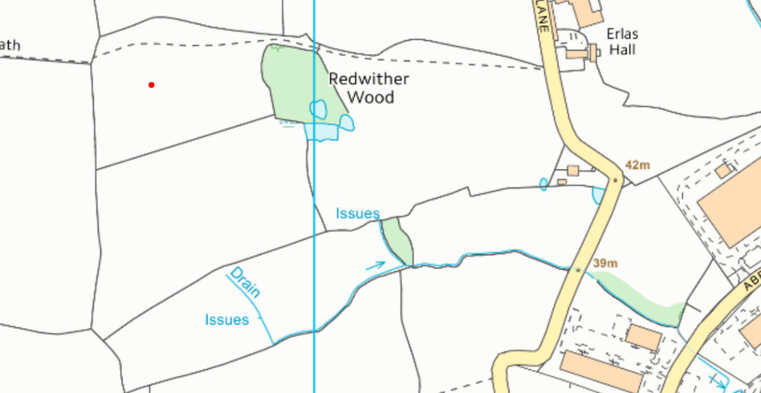
Detailed river network:
ID07
ID06
Field ID05 contains a pond. There is 10 metre implemented no spread buffer zone to mitigate the risk of the lime waste from entering the pond.
ID06 and ID07 contain water issues. There is 10 metre implemented no spread buffer zone to mitigate the risk of lime waste from entering the water.
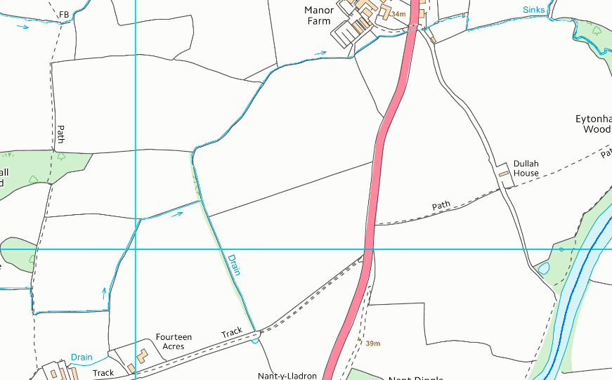
Groundwater protection zones (source)
MF10
MF11
MF12
MF08
Fields MF08, MF10 & MF11 contain a water issue that is hydrologically connected to the River Dee. There is 10 metre implemented no spread buffer zone to mitigate the risk of the lime waste from entering the issue /river. MF 12 borders the River Dee, the is a 20 metre no spread buffer zone in place.
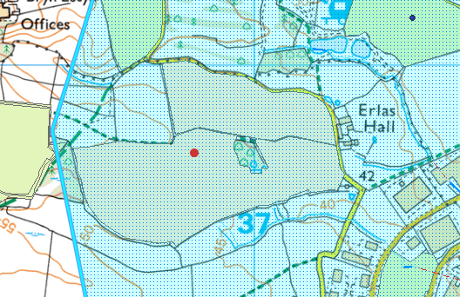
ID06
ID07
ID05
ID04
ID03
ID02
Fields ID02, ID03, ID04, ID05, ID06, ID06 AND ID07 lie within a source protection zone: DCWW Bretton/gorstella/pulford & Meadow Food (number 3).
Wells, springs or boreholes used for the supply of water for human consumption including from a private water supply or supplies
None in range.
any springs wells or boreholes not used to supply water for domestic or food production purposes within 50m

None in range.
European designated sites- Natura 2000 (SPA, pSPA, SAC or cSAC) or Ramsar- or SSSI within 500m
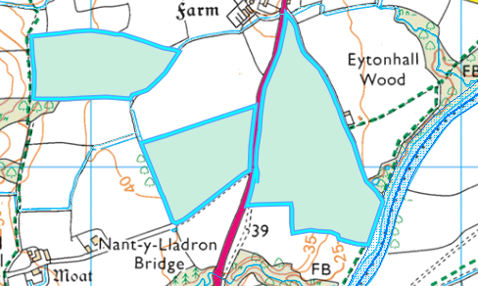
MF10
MF12
MF08
Other protected sites:
MF11
Fields MF08, MF10, MF11 and MF12 (borders) are located within screening distance to the Afon Dyfrdwy (River Dee) SSSI & the River Dee and Bala Lake / Afon Dyfrdwy a Llyn Tegid (Wales) SAC x2

Field ER10 is located 190 metres from the Afon Dyfrdwy (River Dee) SSSI & River Dee and Bala Lake / Afon Dyfrdwy a Llyn Tegid (Wales) SAC x2.
Field ER11 is located 219 metres from the SSSI and SAC

River Dee and Bala Lake / Afon Dyfrdwy a Llyn Tegid (Wales) SAC x2

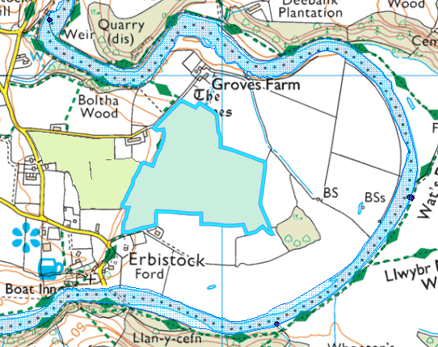
ER11
ER10

- Local Nature Reserve- None in range.

- National Nature Reserve - None in range.

- Ancient Woodlands-
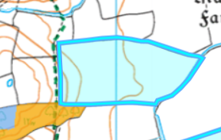
MF08
An ancient woodland is borders Field MF08. There is a 10 metre implemented no spread buffer zone to mitigate the risk of the lime waste from entering the habitat.

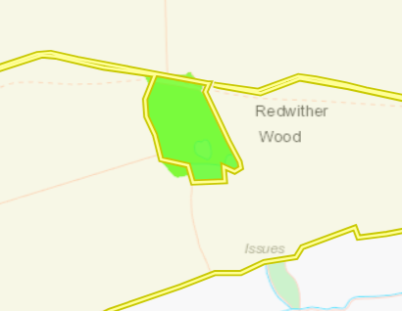
ID05
An Ancient Semi Natural Woodland is located in field ID05. There is a 10 metre implemented no spread buffer zone to mitigate the risk of the lime waste from entering the woodland.

- National Park- None in range.

- Groundwater Safeguard Zone- None in range.

- ANOBs - None in range.

- Hedges- Nothing of concern.

- Ditches- See slope assessment below.

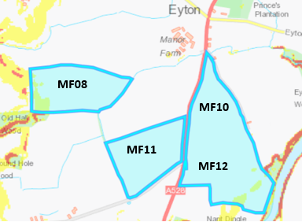
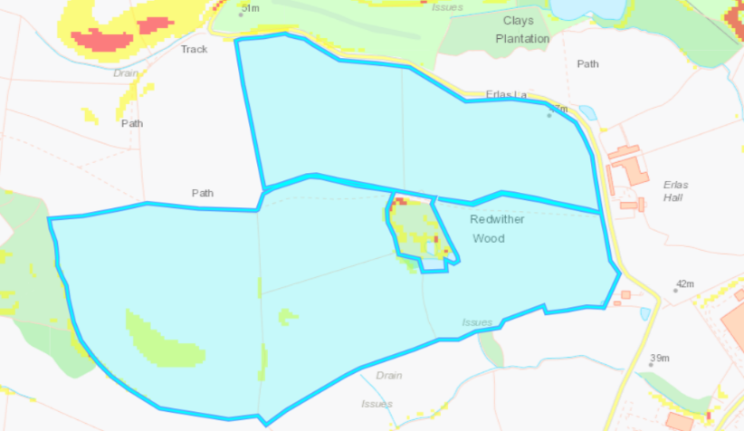
Slope Map
Field ID04 contains some moderately sloping land (7-12º). The runoff risk has been determined as low for the following reasons:
- The moderately sloping land is contained to the spreading field.
- The waste is a stackable solid meaning the runoff risk is low.
- The application rate is very low, ranging from 3-13 t/ha.
- The waste will be applied via rear discharger spreader which is an approperate method for the waste type.
The rest of the fields are flat to gently sloping (0-7º) and do not pose a surface runoff risk.
ID06
ID07
ID05
ID04
ID03
ID02

Field MF 08 contains some moderately sloping land (7-12º). The runoff risk has been determined as low for the reasons listed above.
The rest of the fields are flat to gently sloping (0-7º) and do not pose a surface runoff risk.

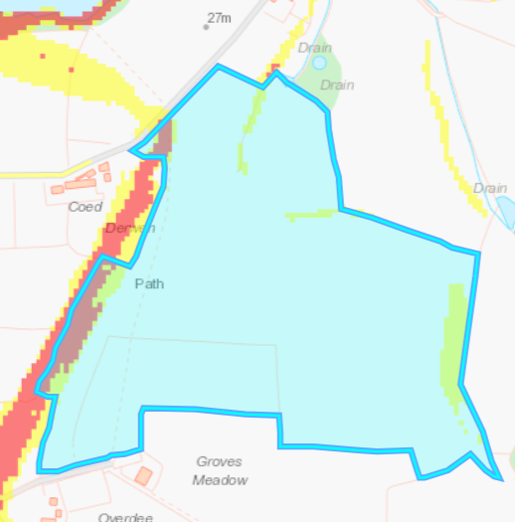
Fields ER10 and E11 contain some areas that are highly sloping 12º. The runoff risk has been determined as low for the reasons listed above.
ER11
ER10

