Surface water courses
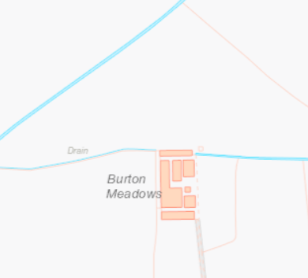

Historic monuments within 1km
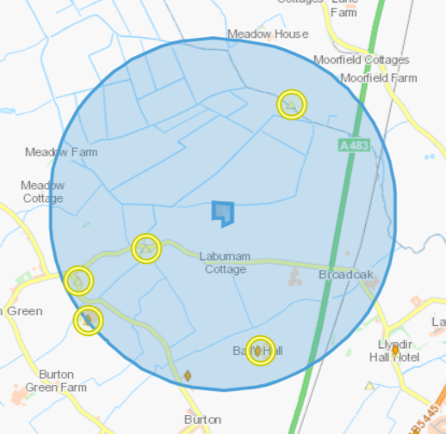
BURTON HALL- SJ35005824
BALL'S HALL- SJ36065805
GOLDEN GROVE INN, BURTON- SJ35365868
HOLY WELL, BURTON- SJ36255957
ENGLISH PRESBYTERIAN CHURCH (BURTON), BURTON HALL ROAD- SJ34945848

Listed buildings within 1km
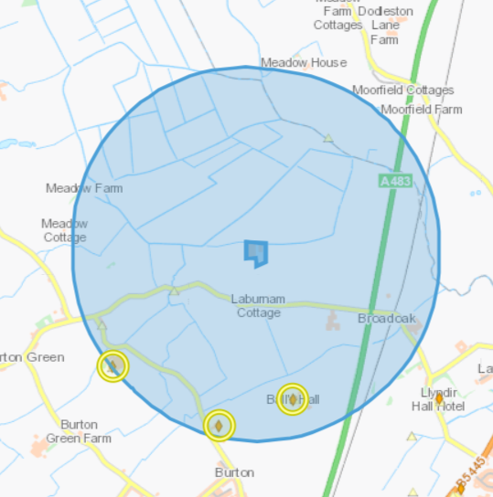
Left- Burton Hall- Located amidst open agricultural land to the south of Burton Hall Road with a northern aspect. Reached by a private track coming off the south side of Burton Hall Road.
Middle Ivy Cottage (formerly known as Ravensbourne Cottages)- Located at the end of a lane off the east side of Burton Hall Road between Ravensbourne and Burton House with open farm land to the east.
Right- Ball's Hall- Set amidst open farmland 1 km north-east of Burton Road. Reached by a private track which leaves Burton Road at its junction with Rosemary Lane and Burton Hall Road to traverse an open field

SPZ 3- DCWW Bretton/gorstella/pulford & Meadow Food
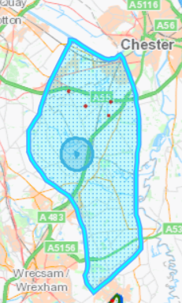

Aquifer Designation (Bedrock) 

Aquifer Designation (Superficial)
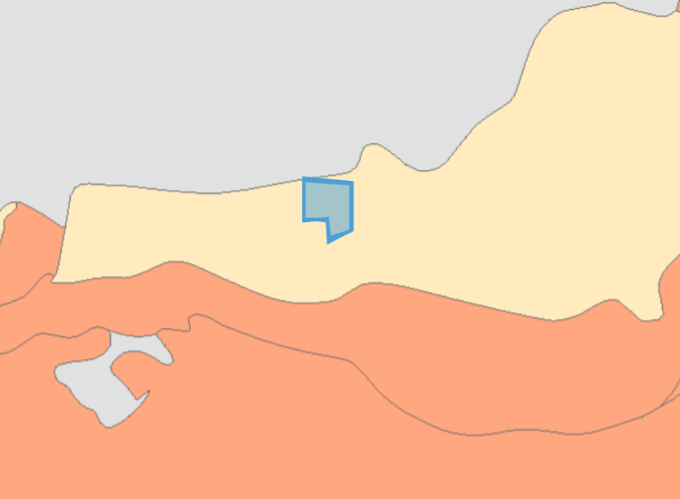

Protected Habitiats
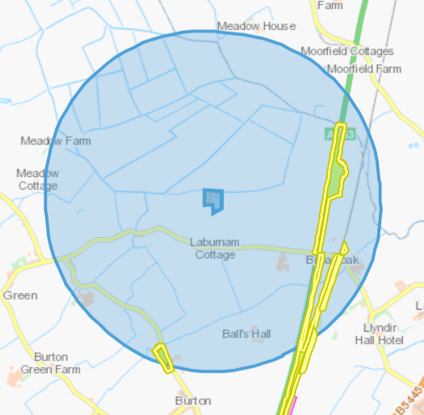
Lowland dry acid grassland and Lowland calcareous grassland

Protected species
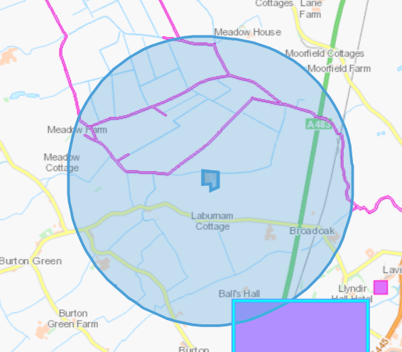
European Eel migratory route
Threatened Bryophyte

Section 7 species
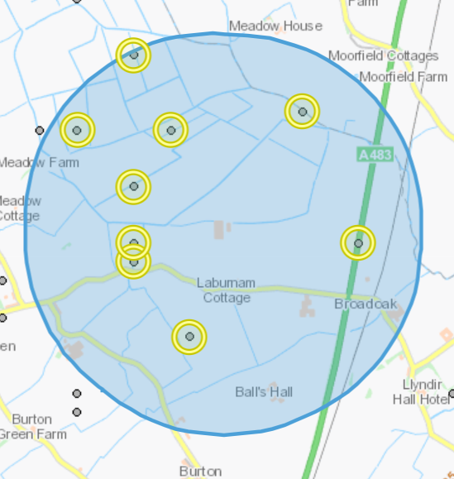
Mammals- European Otter and Brown Hare
Birds- Dunnock, Lapwing, Eurasian Skylark, Golden Plover

Flooding


