PAN-022175 Mymap report
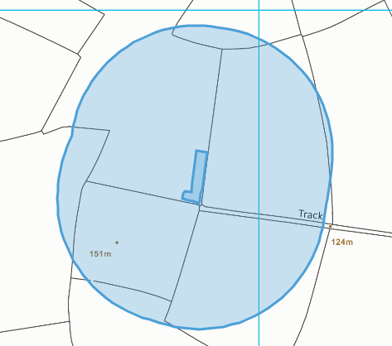
SRP for SR2010 No17- Storage of wastes to be used in land treatment. (Storage of waste prior to use)
The permitted activities must not be carried out within:
• 200 metres of a European Site1, Ramsar Site or a Site of Special Scientific Interest (SSSI);
• 200 meters from any off-site building used by the public, including dwelling houses.
• Groundwater Source Protection Zone 1; or
• if a Source Protection Zone has not been defined then within 50 metres of any well spring or borehole used for the supply of water for human consumption including from a private water supply or supplies.
There are no source protection zones, ground water source protection zones within 200m of the site
There are no SSSI, SAC, SPA or Ramsar sites within 200m of the application site.
There are no springs, wells, boreholes, or issues within 50m of the site.
There are no off-site building used by the public, including houses within 200m of the site.


