PAN-020465 MyMap report

Proximity of Human occupation
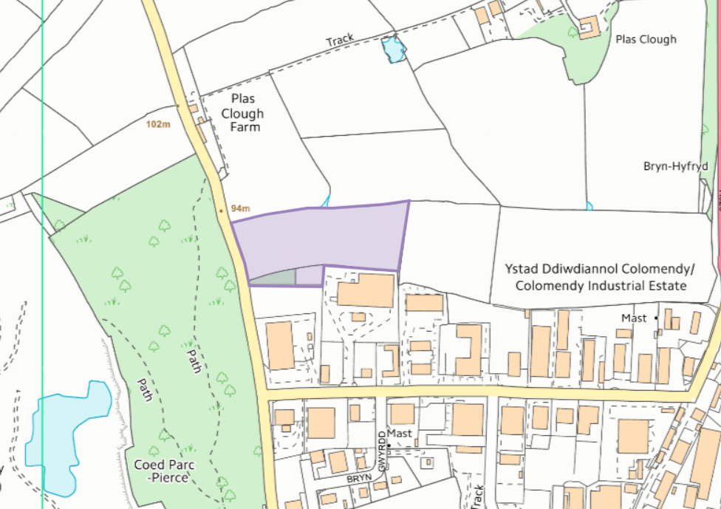

Assessment under wildlife, countryside or habitats legislation
SSSI within 2km:
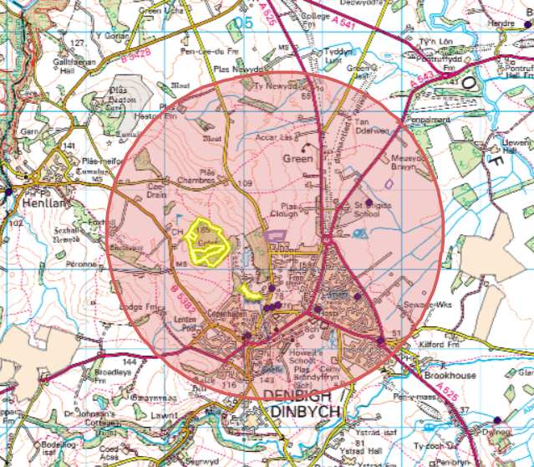

Crest Mawr Wood SSSI approx. 490 meters from the site:
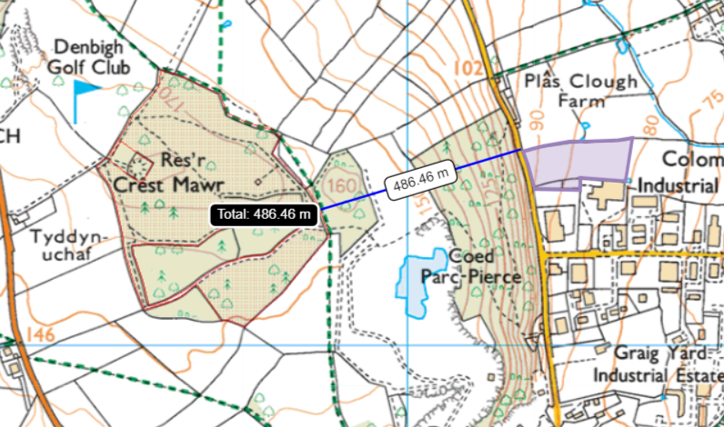

Graig Quarry SSSI Approx 660 meters from the site:
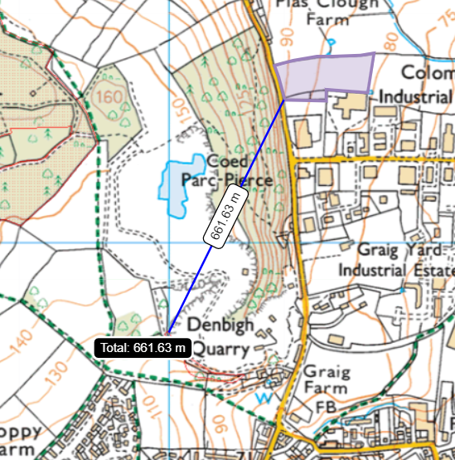

No SAC, SPA, Ramsar within 1km of the site

Groundwater/Aquifers
- Aquifer Designation (Superficial)
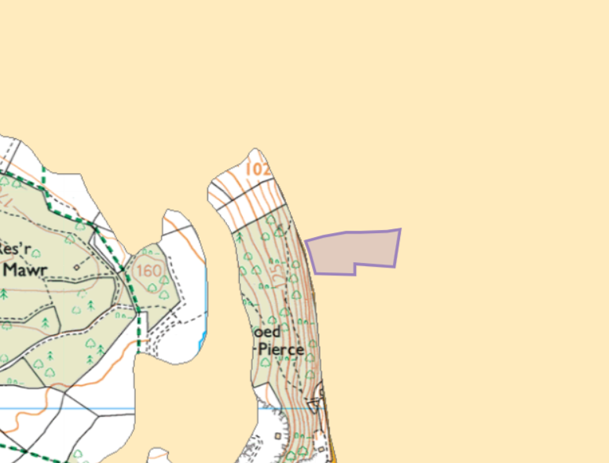
Site is not in groundwater source protection zone

- Aquifer Designation (Bedrock)
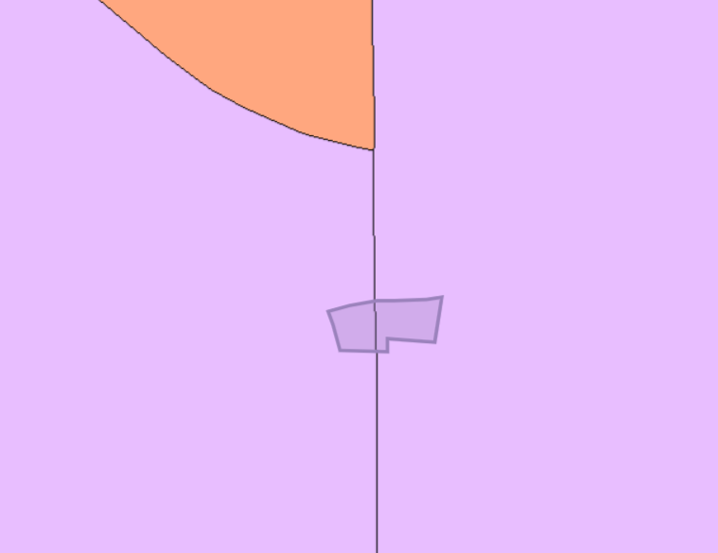
Site is not in groundwater source protection zone

Sensitivity of surface water
- Surface water
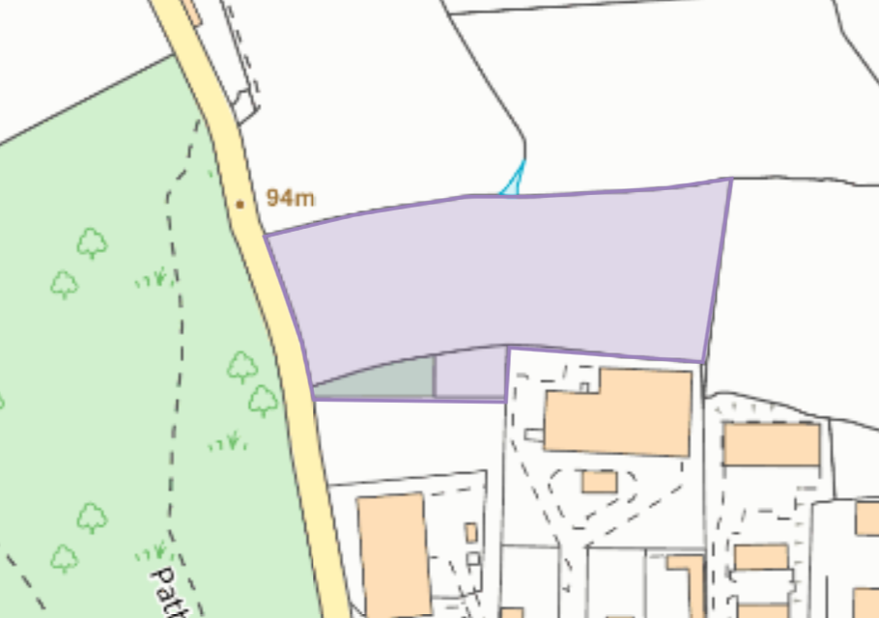

Flood Plain
- Low flood risk from surface water & small watercourses
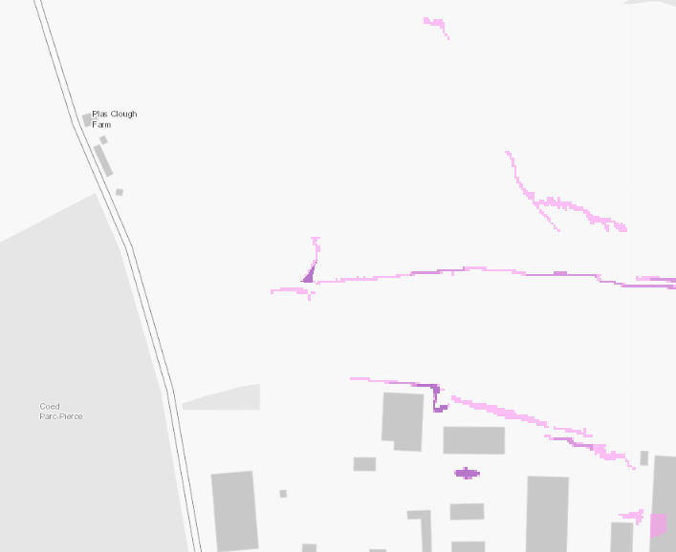

Ancient woodland:
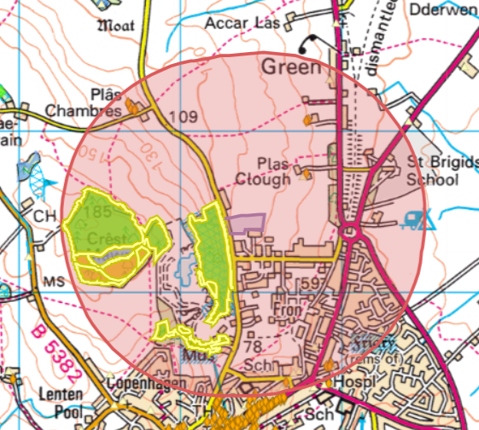
- Ancient Semi Natural Woodland
- Restored Ancient Woodland Site
- Plantation on Ancient Woodland Site
Historic monuments
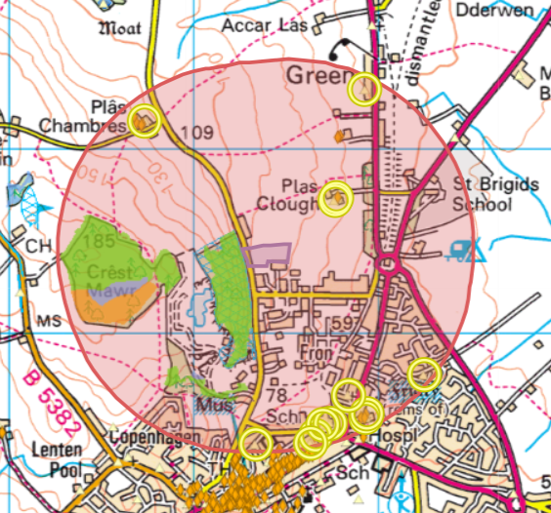
Nearest is PLAS CLOUGH, GARDEN- Gardens, Parks and Urban Spaces- COUNTRY HOUSE GARDEN

- ABBEY COTTAGE
- DENBIGH, CARMELITE FRIARY; WHITE FRIARY
- DR. PIERCE MEMORIAL HALL;THEATR TWM O'R NANT, DENBIGH
- DENBIGH RAILWAY STATION
- MISSION CHURCH, GREEN
- DENBIGH STATION; GOODS SHED
- PLAS CLOUGH, GARDEN
- FRON, Y, CHAPEL (WELSH CALVINISTIC METHODIST), ALBERT RD./MOLD RD., DENBIGH
- PLAS CLOUGH
- PLYMOUTH BRETHREN (ENGLISH MEETING HOUSE), POST OFFICE LANE, DENBIGH
- PLAS-YN-GREEN/BRIGIDINE CONVENT, GARDEN
- SALISBURY HOUSE STABLES & COACH-HOUSE
- PLAS CHAMBRES

Listed buildings
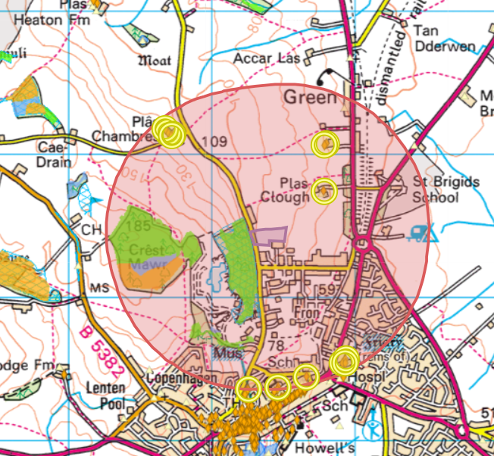
Nearest is Plas Clough House

- Abbey House
- Agricultural Range at Tan-y-Parc
- Plas Clough
- Denbigh Friary
- Secondary House at Plas Chambres
- Theatr Twm O'r Nant, including forecourt walls and railings
- Garden Wall adjacent to Tan-y-Fron
- Tan-y-Parc
- Abbey Cottage
- Plas Chambres, including adjoining forecourt and garden walls
- Agricultural Complex at Plas Chambres
- Carthouse at Plas Chambres, including adjoining orchard walls

Scheduled monument
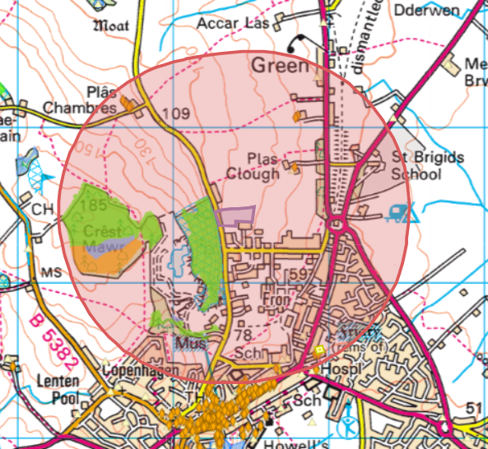
Denbigh Friary in centre of Denbigh

Local wildlife site
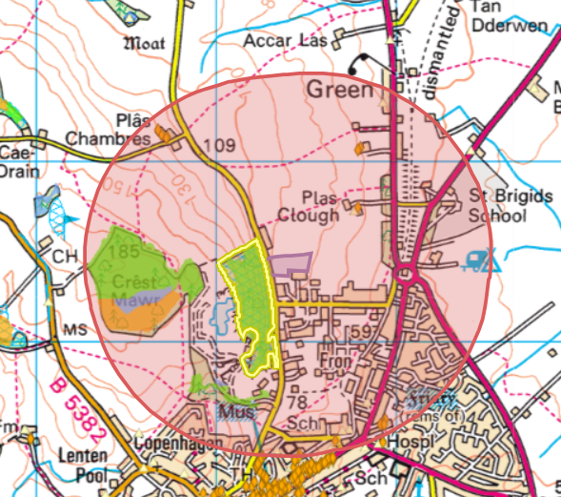
- Coed Parc-Pierce- Broadleaved woodland, with Alder, Ash and Beech communities. It is a limestone woodland just to the north of Denbigh Quarry also on site of ancient woodland.

Protected habitats


