CRoW Appendix 4 (140_10_SD02)  CRoW Act 2000: Natural Resources Wales application for permission - Formal Notice |  | 
Natural Resources Wales Formal Notice.
Requirements of Section 28I of the Wildlife & Countryside Act 1981 as amended by the Countryside and Rights of Way Act (CRoW) 2000.
Duty in relation to granting any consent, licence or permit for activities likely to damage Sites of Special Scientific Interest (SSSI).
- Natural Resources Wales area/region/NPS hub: | North East
- Name of SSSI: | Crest Mawr Wood SSSI approx. 490 meters from the site  Graig Quarry SSSI Approx 660 meters from the site
- Type of permission: | Tier 3 bespoke waste permit under Environmental Permitting Regulations 2016 for a hazardous and non-hazardous household, commercial, industrial waste transfer station.
- Date for Natural Resources Wales permit determination: | 04/01/2024
- Predicted 28 day date for response from NRW conservation/ecology (under S28 I(4)): | n/a saved form information only
- Natural Resources Wales reference no: | PAN-020465
- National grid reference: | SJ 05395 67429
- Description of proposal: | Application is for a hazardous and non-hazardous household, commercial, industrial waste transfer station, to accept up to 55,000 tonnes per annum of waste.  Non-hazardous waste will be subject to treatments of sorting and/or separation, screening, compaction, baling and bulking up. Waste electronic and electrical equipment, waste batteries and/or accumulators and hazardous waste will only be bulked up for onward transport.  All waste is stored on impermeable surfacing in bays or containers, with a sealed drainage system which will prevent waste from washing off site. There will be a maintenance regime in place for the drainage on site as per Section 8 of the EMS.  The wastes with the highest risks will be stored indoors or in sealed containers.  Crest Mawr Wood SSSI approx. 490 meters to the west of the site, and Graig Quarry SSSI Approx 660 meters south west from the site. These are shown on the plans at the end of the document.  The site is not hydrologically linked to either of the designated sites.  Noise will be managed in line with DCC.012 Noise Management Plan.  The fixed plant (balers and sorting line) will be located in the enclosed WTS shed, along with bays in which vehicles will tip waste into. Noise from other activities will be intermittent.  Pests will be manged in line with DCC.013 Pest Management Plan.  Household food waste will be stored in a sealed container and adult hygiene products stored within a dedicated bay in a building and both will be transferred offsite. As a result, any odours will be fully contained and the risk of attracting flies/vermin minimised. Site will also employ housekeeping procedures.
Fire risk (including management of combustion products in the event of a fire) will be manged in line with DCC.005 Fire Prevention and Mitigation Plan (FPMP).

Dust (and litter) will be managed in line with DCC.014 Dust Management Plan.
A Dust & Odour Management System (Mist-Air System) covers the main and secondary building to control any issued with dust with a water mist. Site will also employ housekeeping procedures. Waste that is stored externally is not easily windblown. i.e. glass and bales or is in covered bays, i.e. road sweepings.
Daily checks are made within and around the site for litter which may escape during the waste handling and processing operations within and around the waste transfer building. Any vehicle leaving the site will be checked to ensure that they are clear of loose material and that waste is secure. Where necessary, vehicles will be cleaned before leaving site. If mud, or debris is deposited onto public areas, by accident or neglect, that material will be cleaned as soon as practicable and cause of mud/debris escape investigated, and corrective measure activated to avoid future occurrences.

Odour will be managed in line with DCC.011 Odour Management Plan v3.0
Waste will be assessed at point of collection; excessively odorous or non-compliant waste will not be brought to site. Any load received which is overly odorous will be quarantined and removed from site.
Potentially odorous wastes include food waste, adult hygiene products, residual (black bag) waste and garden (green) waste (if decomposition occurs):
- Food waste will be collected in stillage RRVs in separate dedicated food pods. On arrival at the site, the food pods will be removed from the RRV and immediately tipped into the fully sealed food skips inside the secondary building. These food skips will remain closed when they are not in use and will be washed at least weekly as will the food pods on the RRVs. No food waste will be tipped on the floor and food waste will be on site for a maximum of 3 days.
- AHPs will be collected in bags and will be deposited within a sealed container located in the designated bay within the WTS building following collection and will remain on site for no longer than 5 days. The waste will remain in the bags during storage. The container will be washed down at least weekly.
- residual waste will be removed daily
- Garden waste will be collected within 3 days of being received
Site has a Dust & Odour Management System (Mist-Air System) that covers the main and secondary building.

Relevant supporting documents/operating procedures will be incorporated into the permit to ensure compliance and environmental protection.
- Is the proposed activity within (wholly or partially) the SSSI boundary? | No
- Has there been any pre-application discussion or correspondence with NRW conservation/ecology | No
- What aspect(s) of the proposed permission may damage the features which are of special interest for the SSSI?

Crest Mawr Wood SSSI
The following ‘Operations Requiring Consent’ (or other activities associated with the permission) that may cause damage) are relevant to the proposed permission.
- 7. Dumping, spreading or discharging of any waste materials.

The following SSSI features and mechanisms of impact have been considered to assess the likelihood of damage:
- Semi-natural broadleaved woodland that would be affected by Invasive species, Recreational Pressure and Silvicultural Operations, and may be caused harm via toxic contamination, nutrient enrichment, smothering, disturbance, predation.

Graig Quarry SSSI
The following ‘Operations Requiring Consent’ (or other activities associated with the permission) that may cause damage) are relevant to the proposed permission.
- 7 Dumping, spreading or discharging of any materials.

The following SSSI features and mechanisms of impact have been considered to assess the likelihood of damage:
- A colony of the Red Data Book Vascular Plant Purple Gromwell, and woodland, scrub and wild service tree and spurge laurel that would be affected by Grazing, Unauthorised Collection and Silvicultural Operations, and may be caused harm via toxic contamination, nutrient enrichment, smothering, disturbance, predation.
- Decision
The proposed permission is not likely to damage any of the flora, fauna or geological or physiological features which are of special interest.
Based on the operating procedures proposed for the site (as given in section 8 and the applications supporting documents), there is no pathway for features of the SSSI(s) to be affected.

Natural Resources Wales is minded to issue the permission.

- Name and job title of Natural Resources Wales officer: | Louise Bailey  Permitting Officer
- Date form sent to NRW conservation/ecology | n/a saved for information only

SSSI(s) within 2km:
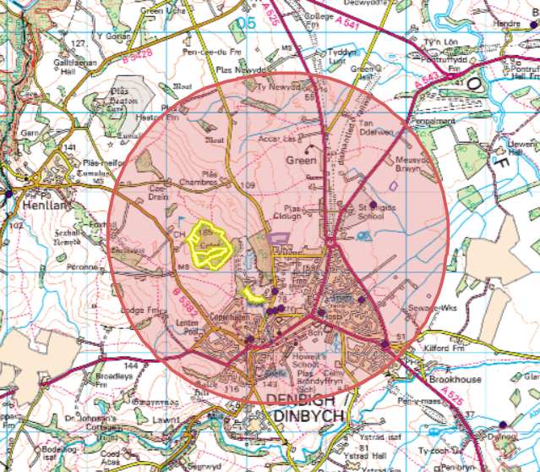

Crest Mawr Wood SSSI approx. 490 meters to the west of the site:
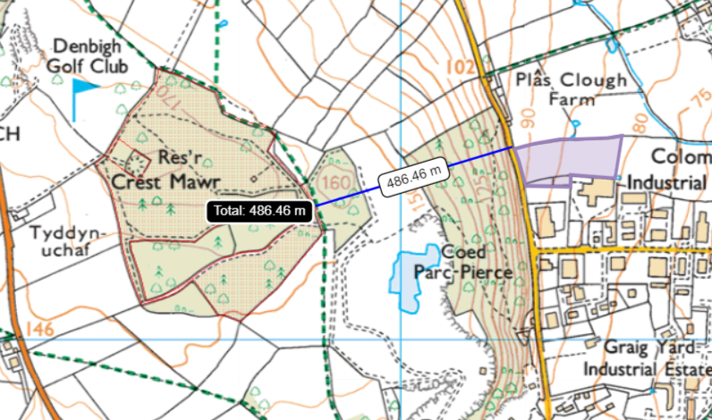

Graig Quarry SSSI Approx 660 meters south west from the site:


