Permit
The Environmental Permitting (England & Wales) Regulations 2016

Mr Daniel Aneurin Rhodri James, Mrs Carys Ellen James, Mr Gareth Rhodri James, and Mrs Sian James

Ffynnoncyff Lagoon
Ffynnoncyf Farm
Ferwig
Ceredigion
SA43 1QD

Permit number

EPR/DB3090CE

Permit
The Environmental Permitting (England and Wales) Regulations 2016
Permit number

EPR/DB3090CE

The Natural Resources Body for Wales (“Natural Resources Wales”) authorises, under regulation 13 of the Environmental Permitting (England and Wales) Regulations 2016

Mr Daniel Aneurin Rhodri James, Mrs Carys Ellen James, Mr Gareth Rhodri James, and Mrs Sian James (“the operator”),

whose principal office is

Stepside

Gwbert Road

Cardigan

SA43 1PH

to operate waste operations at

Ffynnoncyff Lagoon

Ffynnoncyf Farm

Ferwig

Ceredigion

SA43 1QD

to the extent authorised by and subject to the conditions of this permit.

Under regulation 27(2) of the Regulations, standard rules SR2010 No17 are conditions of this permit.

Name | Date
Huw Davies | 19/09/2023

Authorised on behalf of Natural Resources Wales

Schedule 1 - Site plan
This is the plan referred to in the standard rules SR2010 No17

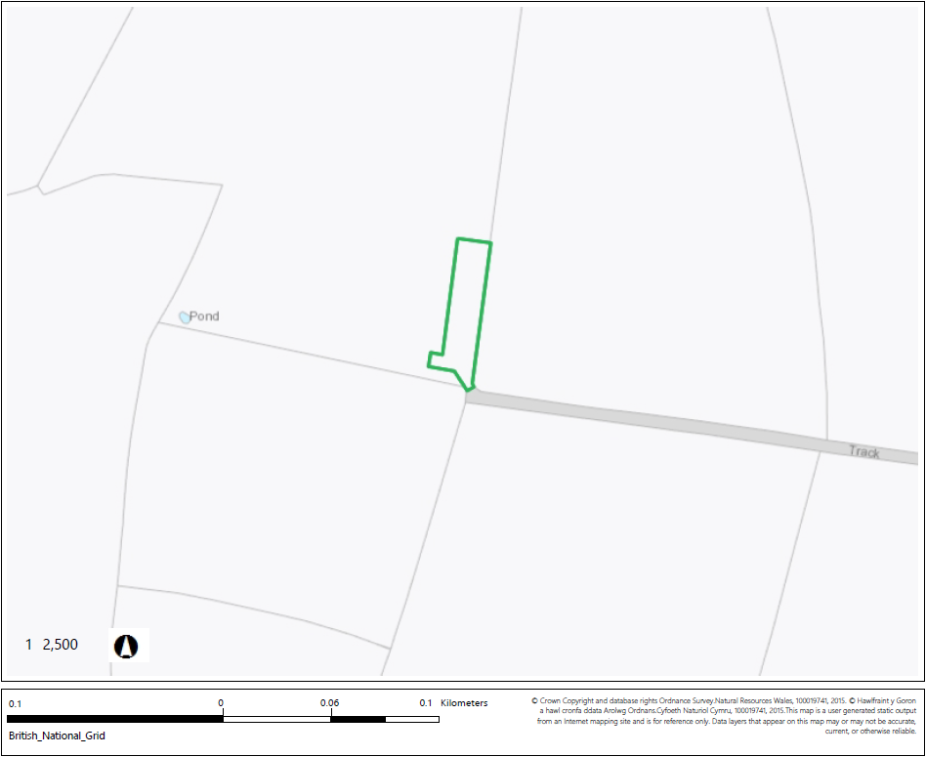

END OF PERMIT

