CRoW Appendix 4 (140_10_SD02)  CRoW Act 2000: Natural Resources Wales application for permission - Formal Notice |  | 
Natural Resources Wales Formal Notice.
Requirements of Section 28I of the Wildlife & Countryside Act 1981 as amended by the Countryside and Rights of Way Act (CRoW) 2000.
Duty in relation to granting any consent, licence or permit for activities likely to damage Sites of Special Scientific Interest (SSSI).
Guide to filling in this form for Natural Resources Wales staff:
To be completed by Permitting Officers for any applications for a permission which the Natural Resources Wales has considered under S28G duties to protect and enhance SSSIs. This applies to all proposed permissions within a SSSI, and to operations outside the SSSI boundary which are likely to damage its special features.
Refer to OI 140_10 ‘Applying the Countryside and Rights of Way (CRoW) Act 2000 to applications for permits with potential for impact on Sites of Special Scientific Interest (SSSI)’, including the flowchart in Appendix 2.
Pink italic text – drafting notes, to be deleted before completion/consultation.
Blue text – examples, to be replaced with permission-specific information.
Ensure you have completed all sections.
- Natural Resources Wales area/region/NPS hub: | Northeast Wales
- Name of SSSI: | Afon Dyfrdwy & Nant-y-Belan and Prynela Woods SSSI
- Type of permission: | Environmental Permit
- Date for Natural Resources Wales permit determination: | 06/12/2023
- Predicted 28-day date for response from NRW conservation/ecology (under S28 I(4)): | n/a
- Natural Resources Wales reference no: | PAN-021721
- National grid reference: | SJ 28383 42274
- Description of proposal: | A Tier 2 bespoke permit variation based on the standard rule set SR2010 No12 Treatment of waste to produce soil, soil substitutes and aggregate. This permit allows the operator to store waste at a specified location and treat it to produce soil, soil substitutes and aggregate. Permitted wastes do not include hazardous wastes.  The total quantity of waste that can be stored and subsequently treated at the site under this permit shall be no more than 75,000 tonnes per year. This permit does not allow the burning of any wastes, either in the open, inside buildings or in any form of incinerator.  The variation consists of solely increasing the permit boundary of the waste facility. See the proposed permit boundary increase below from the updated site plan. The proposed site boundary increase is a northerly direction where the SSSI sites are located in a southerly and south easterly relation to the waste facility. Therefore, this normal variation to increase the permitted area does not reduce the distance the waste facility is from the SSSI sites.  Current permit boundary  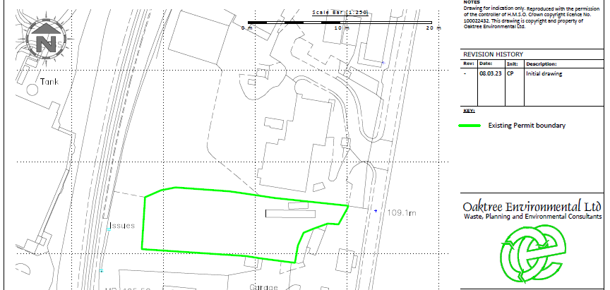  Proposed permit boundary increase relevant to this normal variation.  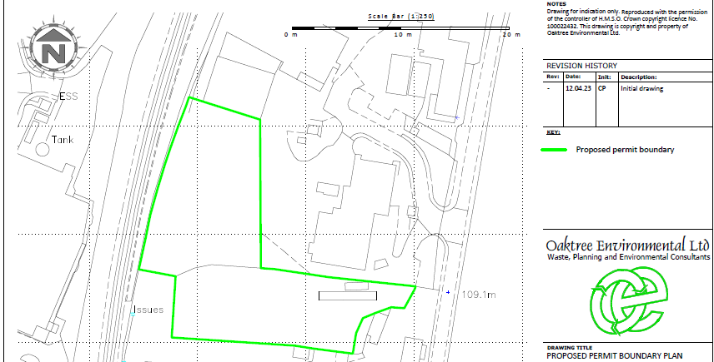
- Is the proposed activity within (wholly or partially) the SSSI boundary? | NO  The map below shows the nearby SSSIs from the waste site (within 2km).  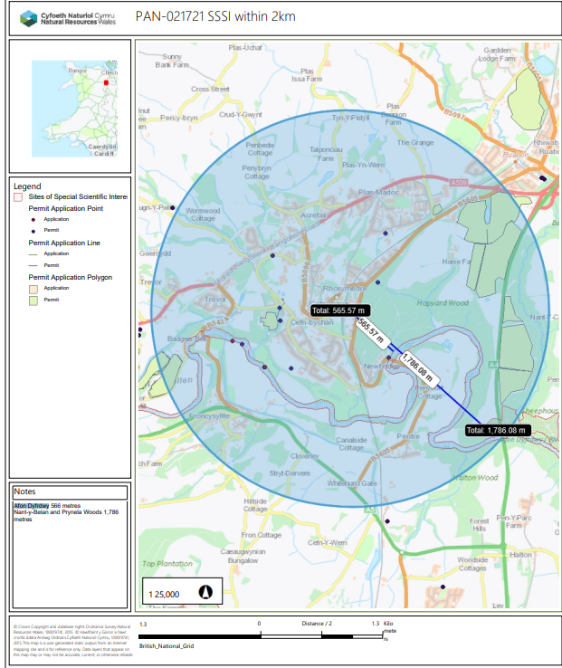  .  The waste site is located 566 metres from the Afon Dyfrdwy SSSI and 1,786 metres from the Nant-y-Belan and Prynela Woods SSSI.
- Has there been any pre-application discussion or correspondence with NRW conservation/ecology | NO
- What aspect(s) of the proposed permission may damage the features which are of special interest for the SSSI?
The following ‘Operations Requiring Consent’ (or other activities associated with the permission) that may cause damage) are relevant to the proposed permission.

Afon Dyfrdwy SSSI

7. Dumping, spreading, or discharging of any materials.

21. Destruction, construction, removal, rerouting, or regrading of roads, tracks,
walls, wells, fences, hardstands, banks, ditches or other earthworks, including
soil and rock exposures.

22. Storage of materials.

26. Use of vehicles, vessels or craft.

Nant-y-Belan and Prynela Woods SSSI

7. Dumping, spreading, or discharging of any waste materials.

21. Destruction, construction, removal, of roads, tracks, walls, fences, hardstands, banks, ditches, or other earthworks.

The following SSSI features, and mechanisms of impact have been considered to assess the likelihood of damage:

Afon Dyfrdwy SSSI

Fish

- Salmon
- Bullhead
- Brook lamprey
- River lamprey
- Sea lamprey

Mammels

- Otter

Aquatic and shingle dwelling invertebrates

- Club-tailed dragonfly
- The stonefly
- Isogenus nubecula
- The weevil Baris lepidii

Plants

- Slender hare’s-ear
- Sea barley
- Hard-grass
- Floating water plantain

Habitats

- Four river habitat types
- Saltmarsh transition habitats

Geological features

Natural exposures of Upper Carboniferous rocks at Dee Bridge.

Fluvial landforms and processes related to the development of the River Dee near Rhewl, and between Holt and Worthenbury.

Nant-y-Belan and Prynela Woods SSSI

- Semi-natural broadleaved woodland

No potential impact pathways were identified during this appendix 4 assessment. This is due to the fact the waste facility is located 566 metres from the Afon Dyfrdwy SSSI and 1,786 metres from the Nant-y-Belan and Prynela Woods SSSI. This tier 2 bespoke permit is based on the stand rules permit SR2010 No12 Treatment of waste to produce soil, soil substitutes and aggregate. This means the most likely mechanisms of impacts to the SSSI sites is through dust emissions via crushing and sorting of wastes. The operator has provided a risk assessment which mitigates the risk of dust emissions leaving the site boundary. The waste activities under this tier 2 bespoke permit are unlikely to cause detriment to the special features of these SSSIs due to the distance the waste facility is from the SSSI sites (no pathway).

- Decision
i) The proposed permission is not likely to damage any of the flora, fauna or geological or physiological features which are of special interest.

There are no potential impact pathways from this waste facility to cause detriment to the above SSSI features. This is due to the fact the waste facility is located 566 metres from the Afon Dyfrdwy SSSI and 1,786 metres from the Nant-y-Belan and Prynela Woods SSSI. This tier 2 bespoke permit is based on the stand rules permit SR2010 No12 Treatment of waste to produce soil, soil substitutes and aggregate. This means the most likely mechanisms of impacts to the SSSI sites is through dust emissions via crushing and sorting of wastes. The operator has provided a risk assessment which mitigates the risk of dust emissions leaving the site boundary. The waste activities under this tier 2 bespoke permit are unlikely to cause detriment to the special features of these SSSIs due to the distance the waste facility is from the SSSI sites (no pathway).

Natural Resources Wales is minded to: Issue the permission

- Name and job title of Natural Resources Wales officer: | Owen Clee  Permitting Officer
- Date form sent to NRW conservation/ecology | n/a
For Natural Resources Wales use only, once NRW conservation/ecology response received
- NRW conservation/ecology comment on assessment: | Please delete as appropriate:  i) NRW conservation/ecology advise the operation can go ahead  ii) NRW conservation/ecology advise the operation can go ahead with conditions  iii) NRW conservation/ecology advise against permitting the operation  Please ensure that the NRW conservation/ecology response is attached to this Formal Notice.
- Name and job title of NRW conservation/ecology officer:
- Date of receipt of NRW conservation/ecology response:

