PAN-022857 My Map Report:
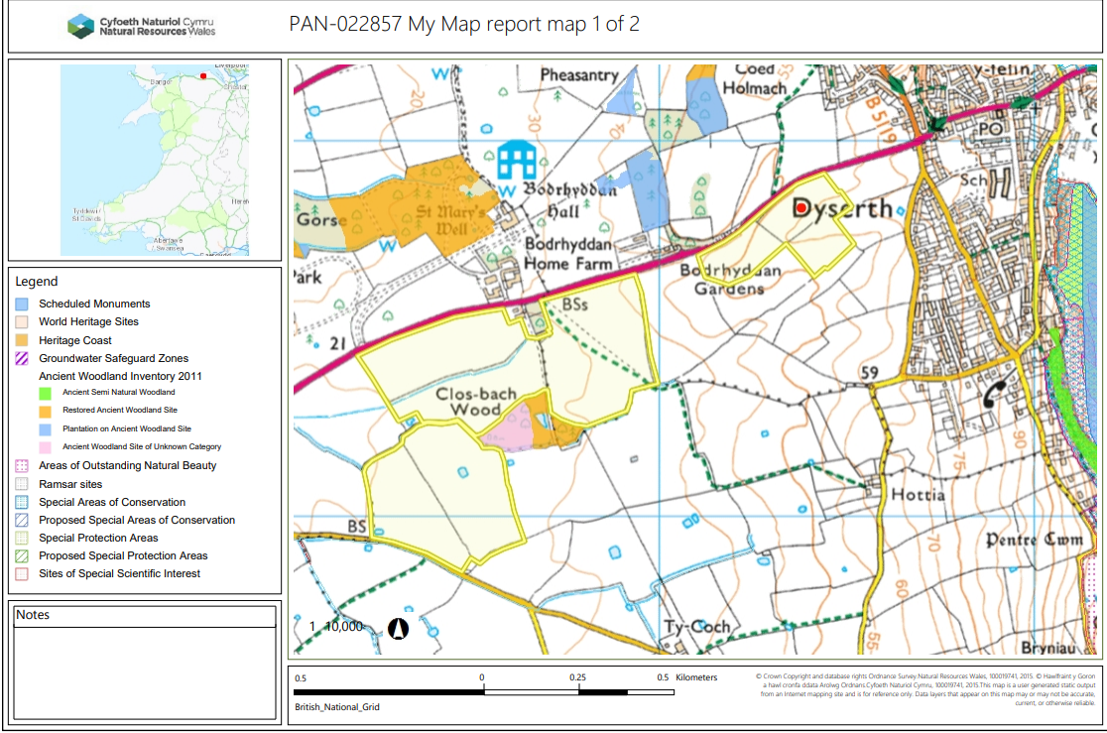

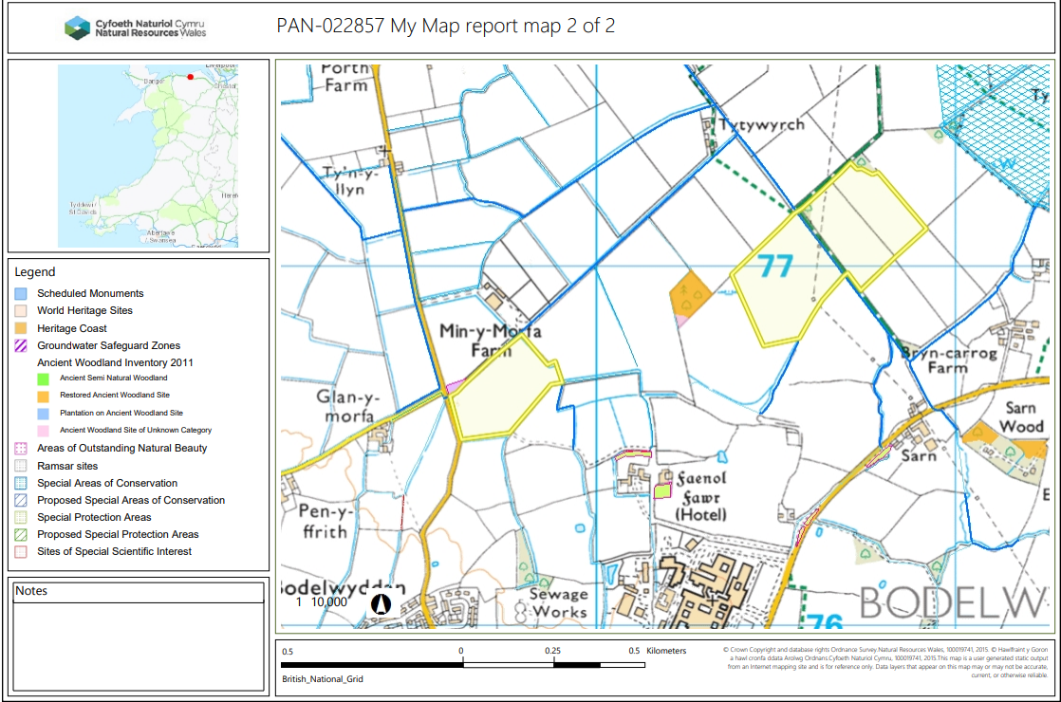
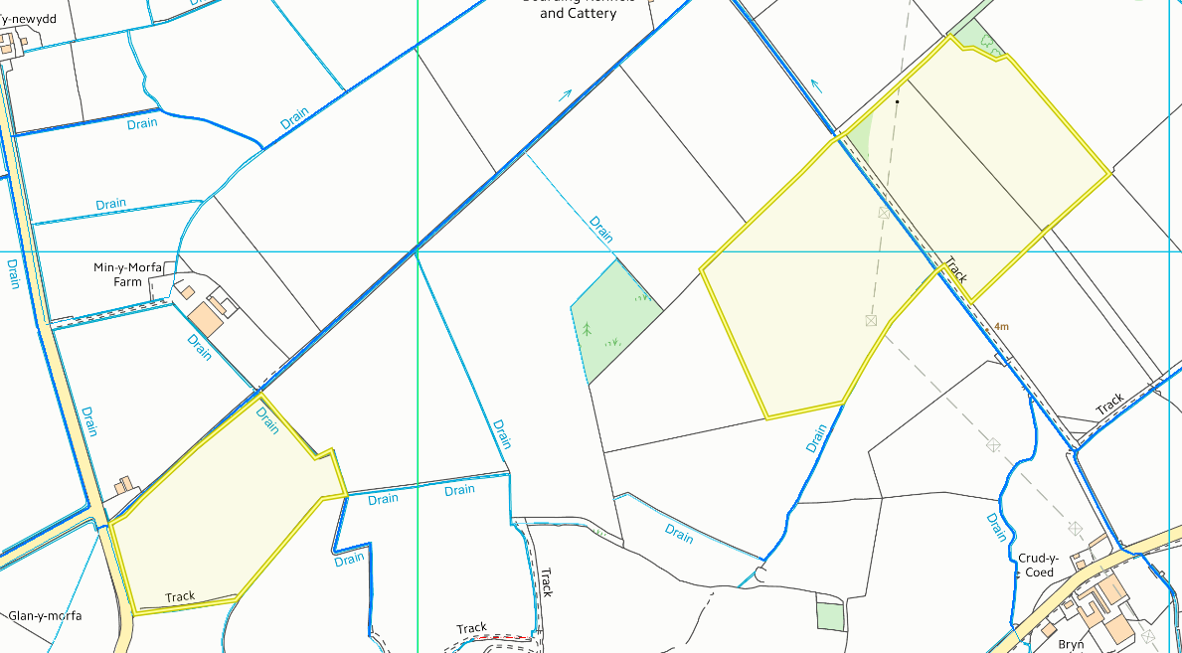
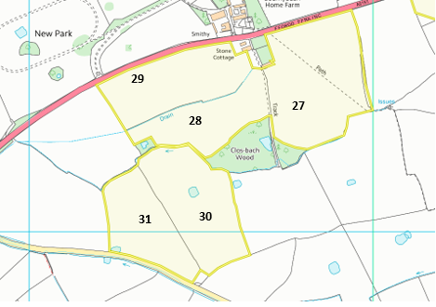
Detailed river network:
6909

5392

9973

Fields 30 & 31 contain surface waters i.e., ponds. These areas have implemented 10 metre no spread buffer zones to mitigate the risk of runoff from entering the water courses. This is in compliance with SR2010no4.
Fields 27, 28, 29, 30, 31 perimeters border land drains. These areas have implemented 10 metre no spread buffer zones to mitigate the risk of runoff from entering the water courses. This is in compliance with SR2010no4.

30
31

30
Fields 9973, 5392 & 6909 perimeters border land drains. These areas have implemented 10 metre no spread buffer zones to mitigate the risk of runoff from entering the water courses. This is in compliance with SR2010no4.

Groundwater protection zones (source)
None in range.

Wells, springs, or boreholes used for the supply of water for human consumption including from a private water supply or supplies
None in range.

any springs wells or boreholes not used to supply water for domestic or food production purposes within 50m

None in range.

European designated sites- Natura 2000 (SPA, pSPA, SAC or cSAC) or Ramsar- or SSSI within 500m

None in range.

Other protected sites:
- Scheduled Ancient Monument- None in range.

- Local Nature Reserve- None in range.

- National Nature Reserve- None in range.

- Ancient Woodlands-
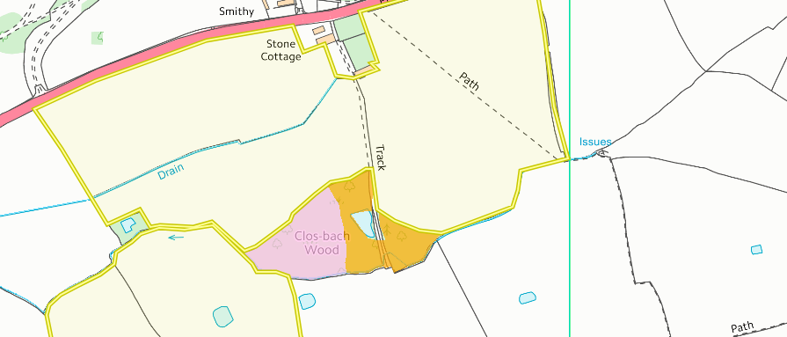
27

28

Fields 27 & 28 is located next to an ancient woodland site named: . This has been shown in the updated site plan from the request for information 1 response. There is a 10 metres no spread buffer zone in placer to mitigate the risk of nutrients and or PTE form the waste from causing detriment to the site.

- Local Wildlife Sites (SINC)- None in range.

- National Park- None in range.

- Groundwater Safeguard Zone- None in range.

- ANOBs- None in range.

- Heritage coast- None in range.

- World Heritage Sites - None in range.

- Hedges- Nothing of concern.

- Ditches- See Slope map below.

- Section 7 species – None in range.

Slope Map
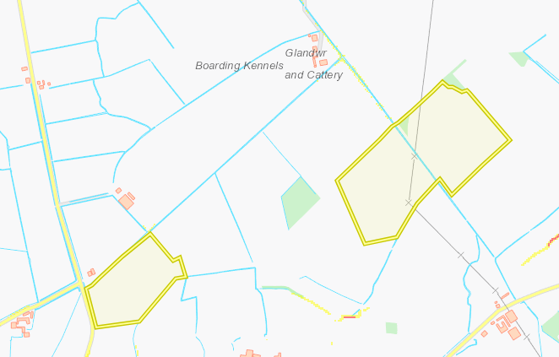
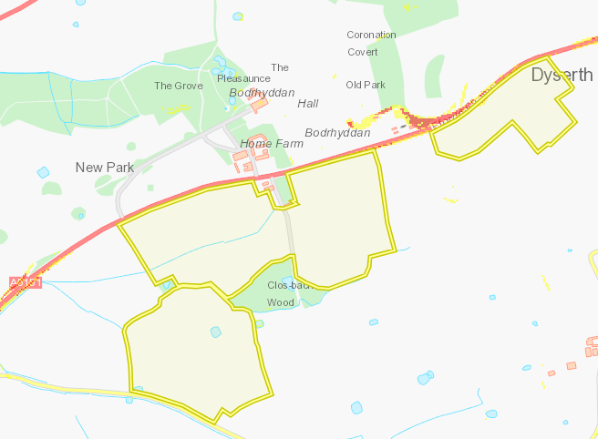
All the fields in this deployment are located on flat to gently sloping land (0-7º). Therefore, the runoff risk for this deployment has been determined as low.

