Methods statement
Project Background:
This project is part of the Nature Networks programme, a new Welsh Government multi-year funded programme focusing on improving the condition of protected sites across Wales. It provides an important opportunity to help tackle the nature and climate emergencies, scaling up investment in nature recovery through the design and delivery of a multi-year programme. The programme aims to deliver increased resilience of protected sites and the terrestrial, freshwater and marine networks in which they sit. The integrated nature of the programme ensures that the land and water in Wales is managed sustainability and in an integrated way.
Maerl forms part of the Pembrokeshire Marine SAC ‘Large Shallow Inlets & Bays’ and ‘Estuaries’ features which are currently in unfavourable condition (Pembrokeshire Marine SAC Indicative site level feature condition assessment 2018). In addition to this, the Milford Haven Maerl bed is the only known live Maerl bed in Welsh waters. There is evidence to show that it has been present within the Haven for thousands of years but monitoring over the last 15-20 years has indicated a significant decline in abundance and extent of live Maerl. The cause of the decline is unknown, but it is known that Maerl is highly sensitive to smothering through sediment deposition (Wilson et al 2004). The work proposed seeks to gain an understanding of the extent and structure of the bed as well as gain insight into past sediment regimes that allowed a healthy maerl bed to form. The conservation objectives for the Pembrokeshire Marine SAC (Reg. 37) state that 'the Milford Haven waterway complex would benefit from restorative action…’ and the data gained from this survey would be used to inform the feasibility of any restoration initiatives.
Benefits of the proposed work:
- Understand depth and extent of bed in the past
- Understand past conditions (in terms of sediment regime) that supported a thriving maerl bed.
- Understand role of physical disturbance on decline of maerl bed.
- Store material for potential further analyses – for example contaminant analysis, ancient DNA (aDNA).
This work would be an important step in examining the cause of decline and enable us to look for management measures or guidance that could improve the resilience of the maerl bed and promote recovery and help us understand baseline conditions that would be needed for successful restoration.
The survey would consist of a total of 6 sites (Figure 1.), with 3 x 2m cores to be taken per site. Sites have been chosen areas that will give us an idea of historic maerl bed depth and extent and how conditions in deeper and shallower areas have changed over time. In addition, sites have been chosen based on having little (less than 1%, live maerl) to minimise impact to the reef.

Core locations:
Sampling to take place from a vessel (a Lochin 33 survey vessel, the ‘Sea Leopard’), using a gravity corer with mechanical hammer (Figures 2,3). The corer will be cleaned before deployment to ensure spread of INNS is avoided. The diameter of the corer is 7cm and the coring method ensures that the area of impact is limited to the diameter of the corer only, the surrounding seabed will remain unimpacted A Bruce anchor (40cm in length Figure 3) would be needed to hold the vessel in position. Sampling will take place during calm weather to minimise the need for a second anchor, although on occasion a second anchor may be needed to maintain a fixed position. As for the coring, anchoring would only take place in areas will <1% live maerl to minimise damage to the bed.
Sampling will take place at slack water to enable any suspended sediment from the process to settle quickly and to minimise any movement of the anchor on the seabed. Due to the small diameter of the core it is expected that the holes will infill quickly, without intervention and is not expected that the holes would increase in diameter due to scour.
The footprint of these removals in comparison to the size of the bed is very small, each core would impact 38.5cm² area and the survey as a whole (18 cores) would therefore impact 693cm² (0.0693m²). This equates to 0.000000231% of the area of the maerl bed which contained live maerl in 2016 (Moore et al., 2017).
The survey is expected to take no more than 3 days and time on site will be minimised. Although no survey sites lie within the South Hook LNG jetty exclusion zone, we will contact South Hook LNG each day prior to surveying. MHPA will also be contacted to issue a notice to mariners. Navigational rules will be followed throughout, including display of appropriate navigational lights if operating in low light conditions.

Proposed analyses of sediment cores:
• Scanning of cores using a Geotek XCT (X-ray tomography) system or equivalent to identify depths of maerl layers.
• Measurement of maerl nodule size for each portion of the core.
• Radionucleotide dates per core (e.g. Pb‑210).
• Carbon dates from calcified organisms within the deeper portion of core.
• PSA analysis of core sections to identify changes in sedimentation regime.

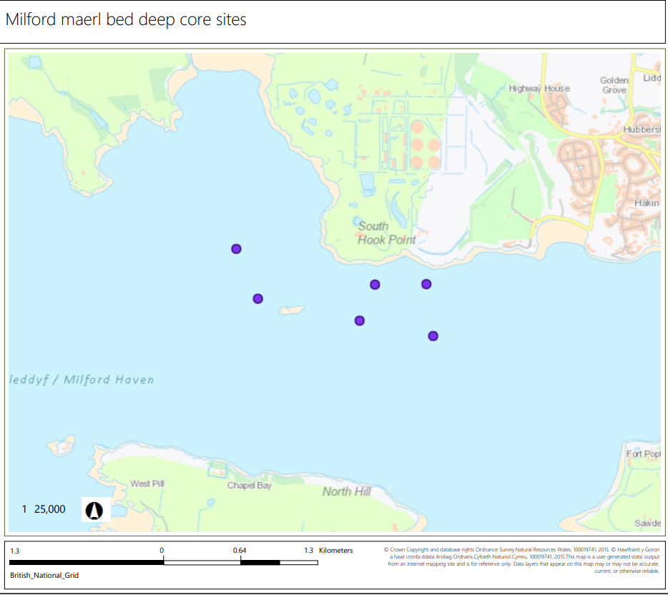
Figure 1. Location of 6 proposed survey sites.

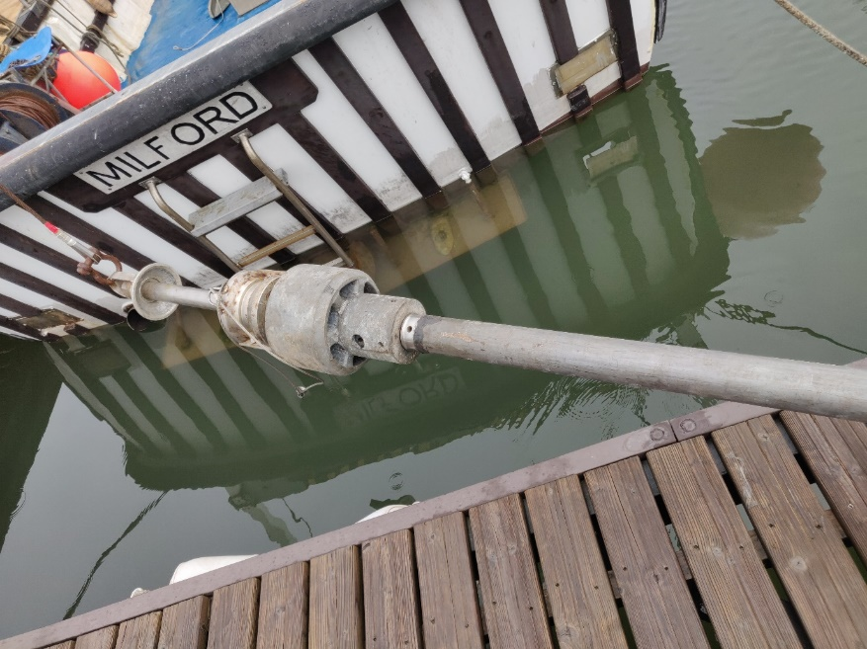
Figure 2. Gravity corer with addition of extra messenger weight to assist with seabed penetration.
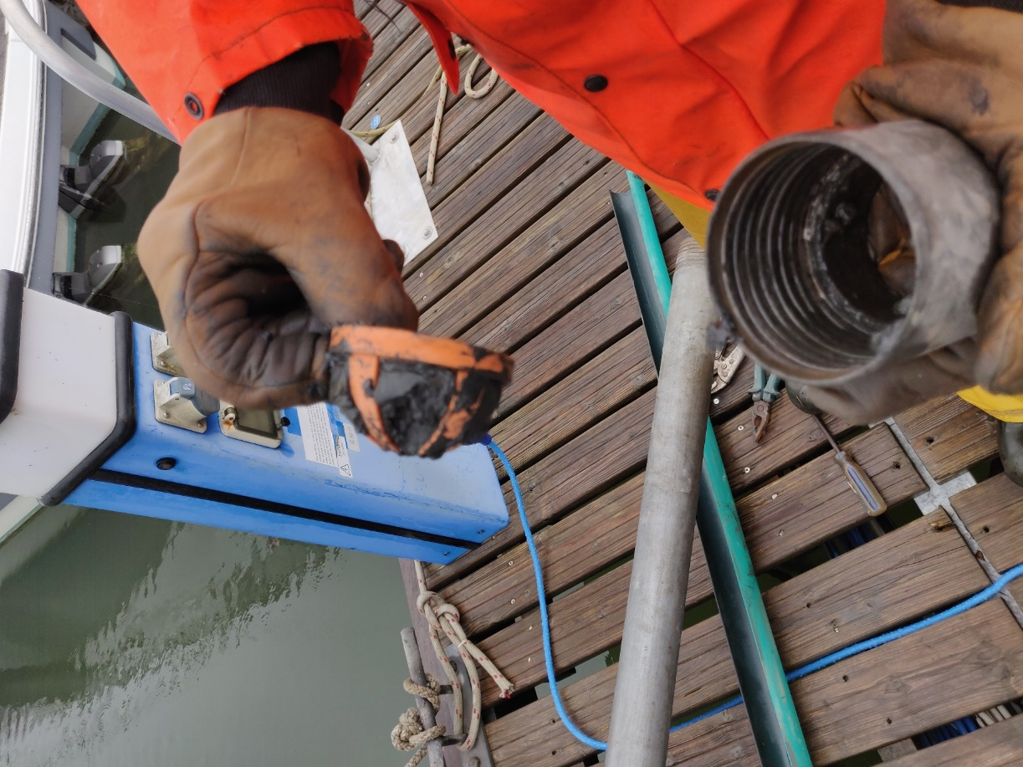
Figure 3. Base of gravity corer and core catcher.

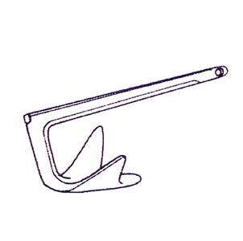
Figure 4. 40cm Bruce anchor used to hold vessel position when coring.

