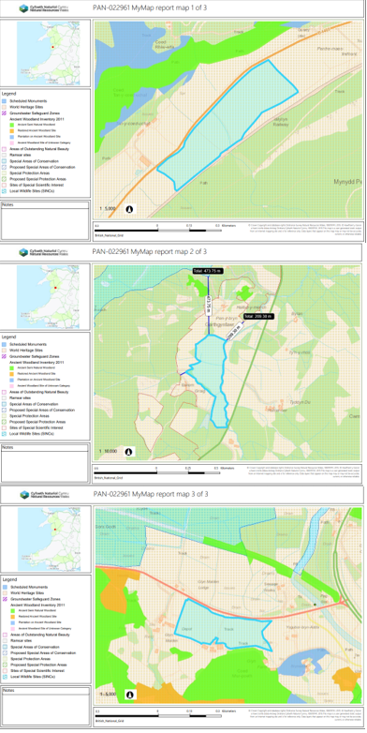
PAN-022961 My Map Report

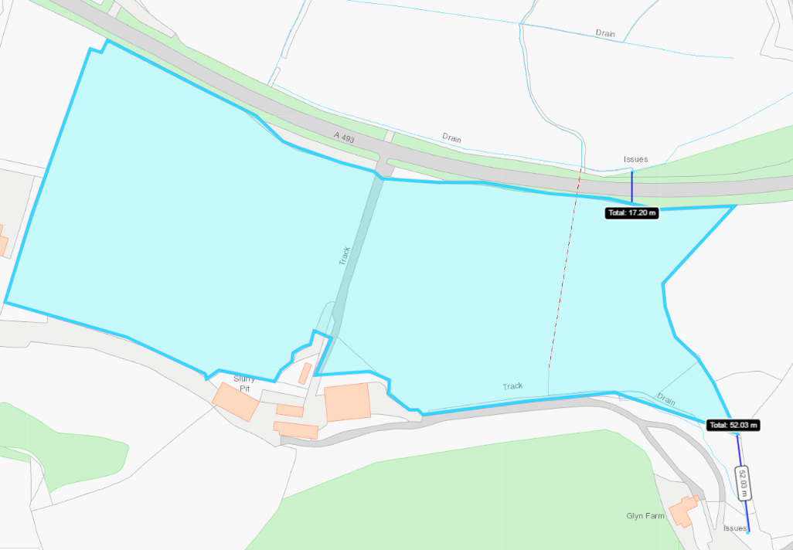
Detailed river network:

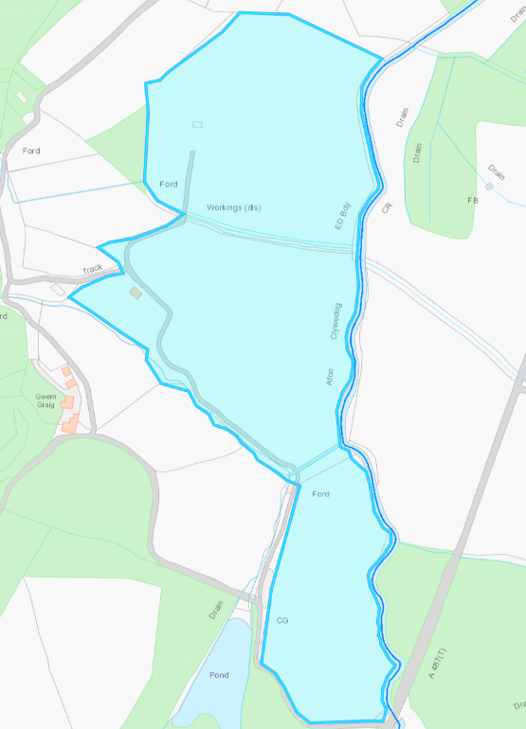
Field 1113 contains a underground pipeline, no action needed.
Field 0865
Field 9846
Field 1416
Fields 1416, 9846 & 0865 border the Afon Clywedog. There is a 20 meter no spread buffer zone in place to mitigate the risk of surface runoff and/or leachate from entering the water course.
Field 1113
Field 9216
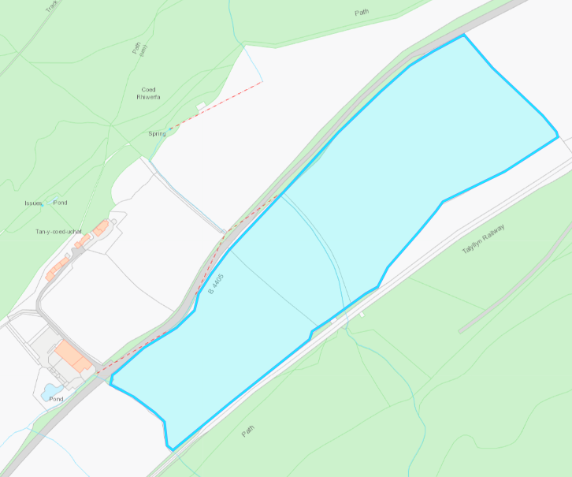
Field 2585 contains a water issue running through the centre of the field. There is a 10 metre no spread buffer zone in place to mitigate the risk of surface runoff and/or leachate from entering the water course.
Field 2585
Field 0264
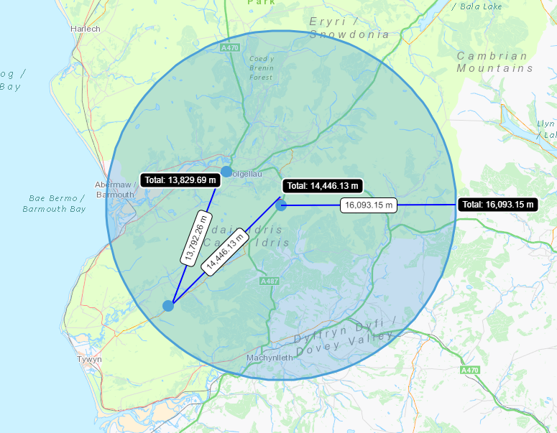
Field and farms are within a 10-mile radius (16.093 m) from farm addresses

Groundwater protection zones (source)
None in range.
Wells, springs, or boreholes used for the supply of water for human consumption including from a private water supply or supplies no storage or spreading within 50 meters)
None in range.
any Springs wells or boreholes not used to supply water for domestic or food production purposes within 50m
None in range.
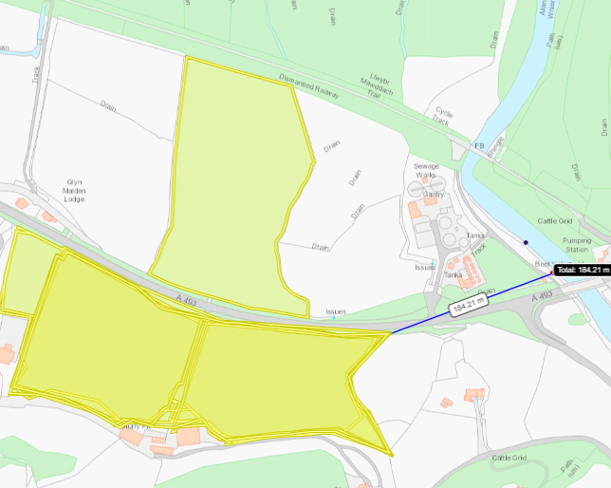
Any spring (or issue), well or borehole used to supply water for domestic or food production purposes within 250m (shown on map)
Field 1113 is located 184 metres from an licensed abstracted, but the licence had expired 31/03/2018. No action needed.
Field 1113

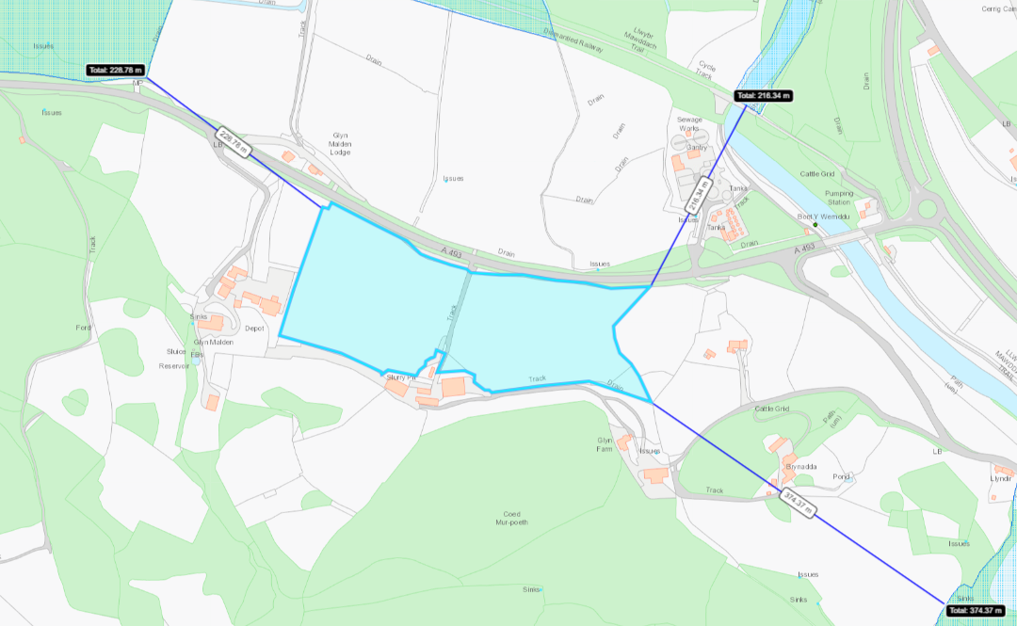
European designated sites- Natura 2000 (SPA, pSPA, SAC or cSAC) or Ramsar- or SSSI within 500m
Meirionnydd Oakwoods and Bat Sites SAC & Bryn y Gwin Isaf SSSI.

Mawddach Estuary SSSI & Peninsula and the Sarnau SAC & the Mawddach Estuary SSSI.
Field 1113
Field 9216
Field 9216 is located 229 metres from the leyn Peninsula and the Sarnau SAC & the Mawddach Estuary SSSI.
Field 1113 is located 216 metres from the leyn Peninsula and the Sarnau SAC & the Mawddach Estuary SSSI.
Field 1113 is located 374 metres Meirionnydd Oakwoods and Bat Sites SAC & Bryn y Gwin Isaf SSSI.
Field 9216 is located 361 metres from the Llwyn-iarth SSSI.
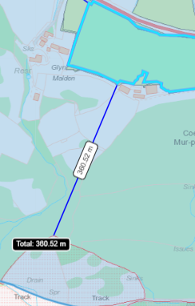
Field 9216
Llwyn-iarth SSSI

Fields 9846 is the closest field located next to the Cadair Idris SSSI (49 metres)
Field 0865 is located 209 metres away from the Cadair Idris SSSI.
Field 0865 is located 473 metres from the Cadair Idris SAC.
No impact pathways were identified from the reaching the SSSI and SAC sites due to the distance the sites are from the fields.

Cadair Idris SAC
Cadair Idris SSSI
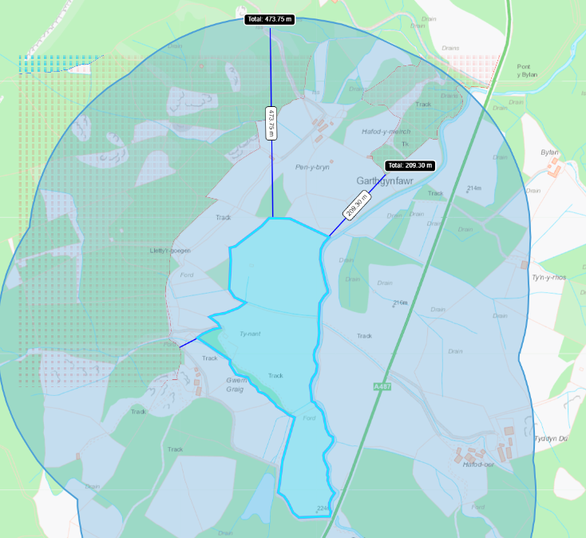
Field 0865
Field 1416
Field 9846

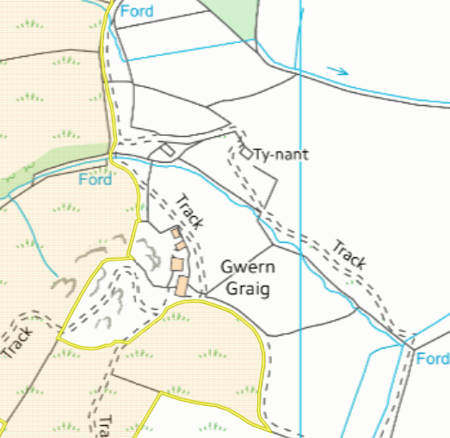
A water issue runs along the border of field 9846 that is hydrologically connected to the Cadair Idris SSSI. There is a 10 meter no spread buffer zone in place to prevent nutrients from entering the water course.
Field 9846 is located downstream of the Cadair Idris SSSI (see elevation profile below) therefore the water course is not an impact pathway for the wastes to reach the SSSI.
Cadair Idris SSSI
Field 9846
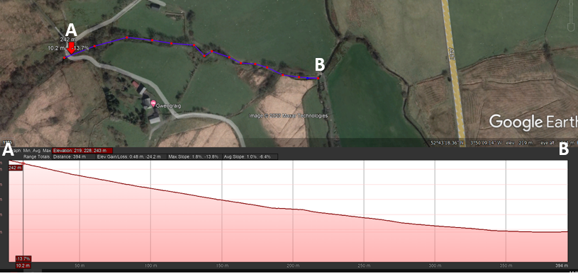
Cadair Idris SSSI
Field 9846

Other protected sites:
- Protected Species- None in range.

- Protected Habitats- None in range.

- Scheduled Ancient Monument- None in range.

- Local Nature Reserve- None in range.

- National Nature Reserve- None In range.

- Ancient Woodlands-
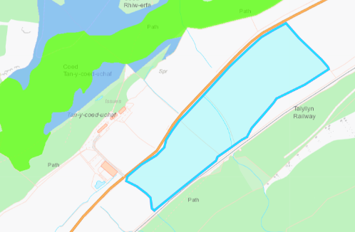
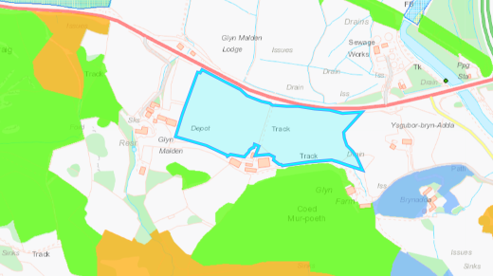
Field 2585
Field 0264
Field 1113
Field 9216
Field 1113 is located 8 metres from an Ancient Semi Natural Woodland. There Is an 10 metre no spread buffer zone in place to prevent nutrients from entering the woodland.
Field 9216 is located 136 metres from an Ancient Semi Natural Woodland. There Is an 10 metre no spread buffer zone in place to prevent nutrients from entering the woodland.
Field 2585 is located 60 metres from an Ancient Semi Natural Woodland. There Is a 10 metre no spread buffer zone in place to prevent nutrients from entering the woodland.

- Local Wildlife Sites (SINC)- None in range.

- National Park -All the fields lie within the Snowdonia national park.

- Groundwater Safeguard Zone- None in range.

- World Heritage Sites – None in range.

- Hedges- Nothing of concern.

- Ditches- see slope assessment below.

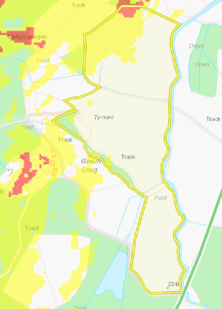
Slope Map
Field 0865 contains highly sloping land that has that has been buffered in the request for information 1.
Field 9846 contains moderately sloping land that has been partially buffered by a no spread buffer.
Field 1416 is located on flat to gently sloping land and do not pose a surface runoff risk.
The surface runoff risk for fields 0865 & 9846 has been determined as low. This is because highly sloping land (12º +) in field 0865 has been buffered by a no spread zone(north of field). The wastes being spread are non-stackable liquids where there a 10 metre no spread buffer zone along the boundaries of these fields to reduce the risk of wastes leaving the field boundary. In addition to a no spread buffer zone west of the field.
The moderately sloping land (7-12º) in field 9849 is minimal where this a 10 metre no spread buffer zone along the west boundary of the field to reduce the risk of surface runoff.
Field 1416 contains flat to gently sloping land (0-7º) and does not require migration to reduce the risk of surface runoff.

Field 1416
Field 9846
Field 0865
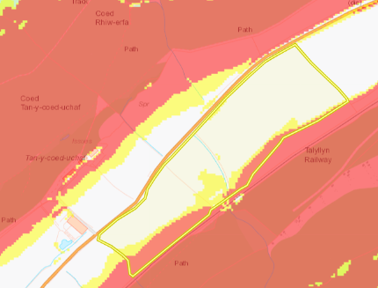
Fields 9216 & 1113 contains highly sloping land and has been buffered by a no spread buffer zone.
The moderately sloping land in field 9216 is contained to the field due to the pathway running through the centre of fields 9216 & 1113 where landspreading is not taking place. Therefore, there is little risk of runoff leaving the field boundary.
The moderately sloping land in field 1113 is also contained to the field.

Field 0264 contains highly sloping land that has been buffered in the request for information 1.
Field 2585 contains highly sloping land and has been buffered by a no spread buffer zone.
This risk of runoff is minimal.

Field 2585
Field 0264
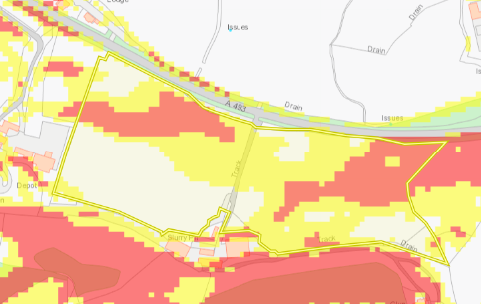
Field 9216
Field 1113

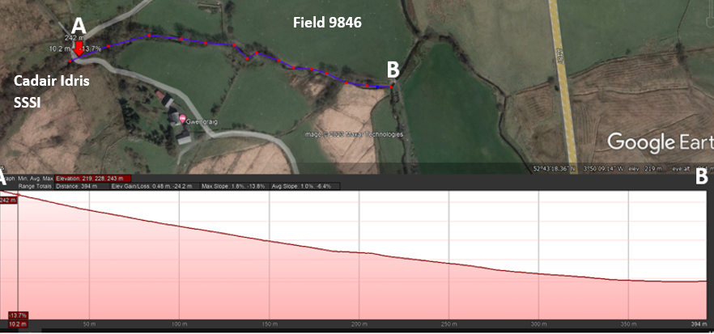
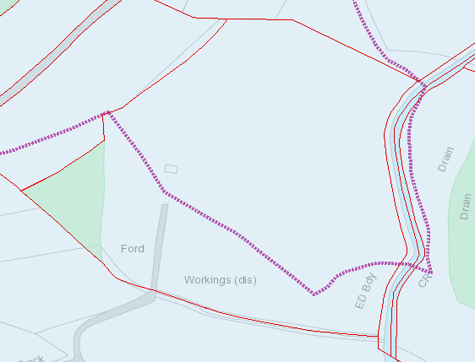

A possible impact pathway was identified in field 9846 where a water issue borders the field. The water issue is hydrologically connected to the Cadair Idris SSSI. But the field is located downstream of the Cadair Idris SSSI (see elevation profile below) therefore the water course is not an impact pathway for the wastes to reach the SSSI. There is also a 10 metre no spread buffer zone in place to prevent prevents entering the water course.
Fields 0865 contains a public right of way that has been displayed in the request for information 1.

Field 0865

