CRoW Appendix 4 (140_10_SD02)  CRoW Act 2000: Natural Resources Wales application for permission - Formal Notice |  | 
Natural Resources Wales Formal Notice.
Requirements of Section 28I of the Wildlife & Countryside Act 1981 as amended by the Countryside and Rights of Way Act (CRoW) 2000.
Duty in relation to granting any consent, licence or permit for activities likely to damage Sites of Special Scientific Interest (SSSI).
Guide to filling in this form for Natural Resources Wales staff:
To be completed by Permitting Officers for any applications for a permission which the Natural Resources Wales has considered under S28G duties to protect and enhance SSSIs. This applies to all proposed permissions within a SSSI, and to operations outside the SSSI boundary which are likely to damage its special features.
Refer to OI 140_10 ‘Applying the Countryside and Rights of Way (CRoW) Act 2000 to applications for permits with potential for impact on Sites of Special Scientific Interest (SSSI)’, including the flowchart in Appendix 2.
Pink italic text – drafting notes, to be deleted before completion/consultation.
Blue text – examples, to be replaced with permission-specific information.
Ensure you have completed all sections.
- Natural Resources Wales area/region/NPS hub: | Northwest Wales
- Name of SSSI: | Mawddach Estuary SSSI, Bryn y Gwin Isaf SSSI, Llwyn-iarth SSSI, Cadair Idris SSSI.
- Type of permission: | Landspreading deployment under standard rules permit SR2010 No4
- Date for Natural Resources Wales permit determination: | 18/09/2023
- Predicted 28 day date for response from NRW conservation/ecology (under S28 I(4)): | n/a
- Natural Resources Wales reference no: | PAN-022961
- National grid reference: | Fields X Y coordinates  1 1416 276142 , 315165  2 9846 275980 , 315469  3 0865 276081 , 315650  4 1113 271111 , 318130  5 9216 270925 , 318168  6 2585 266258 , 305856  7 0264 266027 , 305641  Storage:  1A: 276227, 314918  2 B: 270968, 318069
- Description of proposal: | A land spreading application to spread a total of 10 non stackable waste streams coded EWC 19 09 02 at 3 farm addresses Cefn Naw Clawdd, Dolgellau, Glyn Farm, Dolgellau, Tan Y Coed Uchaf, Bryncrug. The fields are within a 10-mile radius of the farm addresses. The wastes will be spread on grass fields. The application rate ranges from 150-250 tonnes per ha, with a total tonnage to spread 5,325 tonnes.  The waste will be spread over 21.3 ha hectares of land within the listed fields at Cefn Naw Clawdd, Glyn Farm and Tan Y Coed Uchaf farm. The wastes may be stored in a lagoon, above ground store or spread on delivery. The wastes will be spread via dribble bar which is an appropriate application method for the waste type.  Targeted periods of spreading on grass fields include early spring 2024 (late February – May), after cutting of silage, and prior to grazing through summer and autumn 2023 (August- September).  The wastes may be applied separately or in combination. If the wastes are applied in combination the total combined amount applied will not exceed 250t/ha, the total nitrogen loading will be less than 250kg/ha, and the amount of available nitrogen and total or available phosphate and potash (whichever is appropriate) will not exceed the fertiliser recommendation or the amount removed in crop offtake, whichever is the greater.  All fields are pH 8 and above so can receive alum-based sludge.  The landspreading activity will comply with CoGAP.
- Is the proposed activity within (wholly or partially) the SSSI boundary? | NO  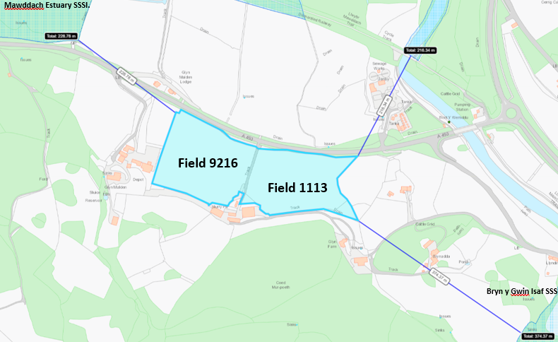  Field 1113 is the closest field located from the Mawddach Estuary SSSI (216 metres).  Field 1113 is the closest field located from the Bryn y Gwin Isaf SSSI (374 metres).  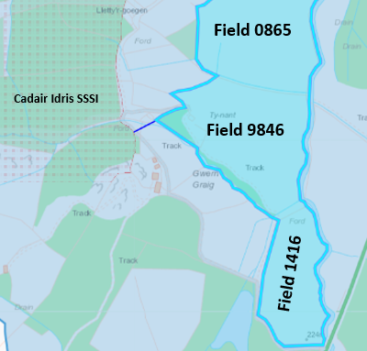  Field 9846 is the closest field located to the Cadair Idris SSSI (49 metres).  Field 9216 is located 361 metres from the Llwyn-iarth SSSI.  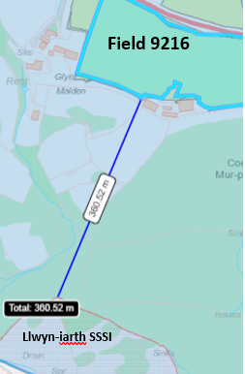
- Has there been any pre-application discussion or correspondence with NRW conservation/ecology | NO
- What aspect(s) of the proposed permission may damage the features which are of special interest for the SSSI?

The following ‘Operations Requiring Consent’ (or other activities associated with the permission) that may cause damage) are relevant to the proposed permission.

Mawddach Estuary SSSI,

5. Application of manure, slurry, silage liquor, fertilisers, and lime.

7 Dumping, spreading, or discharging of any materials.

22. Storage of materials.

26. Use of vehicles or craft.

Bryn y Gwin Isaf SSSI

26. Use of vehicles, machinery, or other devices likely to produce noise, fumes and heat.

Llwyn-iarth SSSI

5. Application of manure, slurry, silage liquor, fertilisers, and lime.

7. Dumping, spreading, or discharging of any materials.

22. Storage of materials.

26. Use of vehicles.

Cadair Idris SSSI

5. Application of manure, slurry, silage liquor, fertilisers, and lime.

7. Dumping, spreading, or discharging of any materials.

22. Storage of materials.

The following SSSI features, and mechanisms of impact have been considered to assess the likelihood of damage:

Mawddach Estuary SSSI,

Habitats

- Estuary
- Intertidal muddy gullies
- Bog
- Salt marsh
- Coastal fen
- Swamp
- Wet woodland

Rare plants

- Rare dwarf spike-rush,
- Lax-flowered sea lavender
- Perennial glasswort
- sharp rush,
- marshwort
- lesser bulrush
- brown beak-sedge
- bog rosemary,
- great sundew
- Wavy St John’s-wort,
- moor-grass tussocks.
- greater spearwort
- rare cyperus sedge
- scarce narrow-leaved helleborine
- small adder’s tongue
- smooth cat’s-ear

Birds

- Skylark
- Barn owl
- Song thrush
- Redshank
- Snipe

Mammals

- Otter
Fish

- Sea lamprey and non-spawning
- Allis shad
- Twaite shad.
- Mullet.

River shingle invertebrates

- Four rove beetles
- Two ground beetles
- Money spider
- Wolf spider
- Scavenger water
- Grimmia arenaria
- Pallavicinia lyellii

Fish

- Atlantic Salmon

Other special features

- Neutral and marshy grassland & bracken
- Woodland, and linear features such as hedgerows and lines of trees along the riverbanks
- Lempholemma polyanthus (Lichen)
- Fairbourne spit
- Reed bunting
- Grasshopper warbler
- Reed warbler
- Kingfisher
- Water rail goosander
- Chough
- Wintering wildfowl and Waders include wigeon, teal, oystercatcher, curlew and shelduck.

Bryn y Gwin Isaf SSSI

- Lesser horseshoe bats (approx. 700)

Llwyn-iarth SSSI

- Lowland neutral grassland
- Flushes
- Fen
- Population of wood bitter-vetch
- A mosaic of habitats including marshy grassland, wet dwarf shrub heath, acid grassland, scrub
- and woodland

Cadair Idris SSSI

Geological

- Ordovician igneous and sedimentary succession exposed in natural rock outcrops. 2.2 Pleistocene/Quaternary landform assemblage comprising cirques, protalus ramparts, moraines, landslides,
alluvial fans, stratified screes, blockstreams, and associated deposits.

Habitat

- Blanket bog
- Wet and dry heaths
- Lichen/bryophyte heath
- Marshy grassland
- Tall herb and fern ledges
- Vegetated natural rock exposures
- Lakes (nutrient-poor lakes)
- Broadleaved woodland
- Flush and spring
- Calcareous and species-rich acid grassland

Plants

- Hairy greenweed
- Welsh eyebright. Nationally scarce mosses,
- liverworts and lichens including the liverwort Radula voluta,
- Slender green feather moss and an edge of range lichen.
- Nationally rare and scarce invertebrates
- Population of lesser horseshoe bats

- Decision
i) The proposed permission is not likely to damage any of the flora, fauna or geological or physiological features which are of special interest.

- There are no impact pathway for features to be affected due to the distance the fields are from the SSSI sites. This is due to the distances the fields are from the SSSI sites as shown in section 9 of the appendix 4.

- A possible impact pathway was identified in field 9846 where a water issue borders the field. The water issue is hydrologically connected to the Cadair Idris SSSI. But the field is located downstream of the Cadair Idris SSSI (see elevation profile below) therefore the water course is not an impact pathway for the wastes to reach the SSSI. There is also a 10 metre no spread buffer zone in place to prevent prevents entering the water course.

- Field 1416, 9846 & 0865 border the Afon Clwdog river. There is a 20 metre no spread buffer zone in place to prevent nutrients and/or PTEs from entering the water course. All other water issues are buffered by 10 metres and comply with SR2010no4.

- Fields that are highly sloping have been buffered by no spread buffer zones to mitigate the risk of surface runoff leaving the field boundaries.

- Wastes will be spread via dribble bar. This application method is appropriate for the waste types and apply the wastes directly to the ground to reduce the risk of surface runoff.

- The water treatment sludges are being spread on fields well above a soil p.H of 6. Where the fields are between a soil p.H of 8-8.2. Therefore, the risk of Al becoming mobile is very unlikely.

- The operator will avoid the land spreading activity at sensitive times i.e., the breeding season.

- Spreading will only be undertaken when weather conditions are suitable within restrictions outlined in CoGAP.

- Machinery operations will take account of soil conditions, slopes etc.

- Liquid spreading machinery will be turned off and lifted away from soil prior to turning at the end of each run.

- Machinery will be checked daily when in use, regularly serviced and spreading equipment calibrated. Umbilical hoses will be regularly checked for damage to prevent leaks.

- Machinery turns will not be executed in the buffer strips.

- Waste deliveries to field/stores will be supervised.

- All spillages will be reported immediately to the NRW.

Natural Resources Wales is minded to: Issue the permission

- Name and job title of Natural Resources Wales officer: | Owen Clee  Permitting Officer
- Date form sent to NRW conservation/ecology | n/a
For Natural Resources Wales use only, once NRW conservation/ecology response received
- NRW conservation/ecology comment on assessment: | Please delete as appropriate:  i) NRW conservation/ecology advise the operation can go ahead  ii) NRW conservation/ecology advise the operation can go ahead with conditions  iii) NRW conservation/ecology advise against permitting the operation  Please ensure that the NRW conservation/ecology response is attached to this Formal Notice.
- Name and job title of NRW conservation/ecology officer:
- Date of receipt of NRW conservation/ecology response:



