River Dee Tidal Section: Beeches Drain Outfall
Address: Nr B5129 Saltney Ferry, Flintshire. CH4 0BT Grid Ref: SJ 3532 6670
Proposal: Replacement of Tidal Door
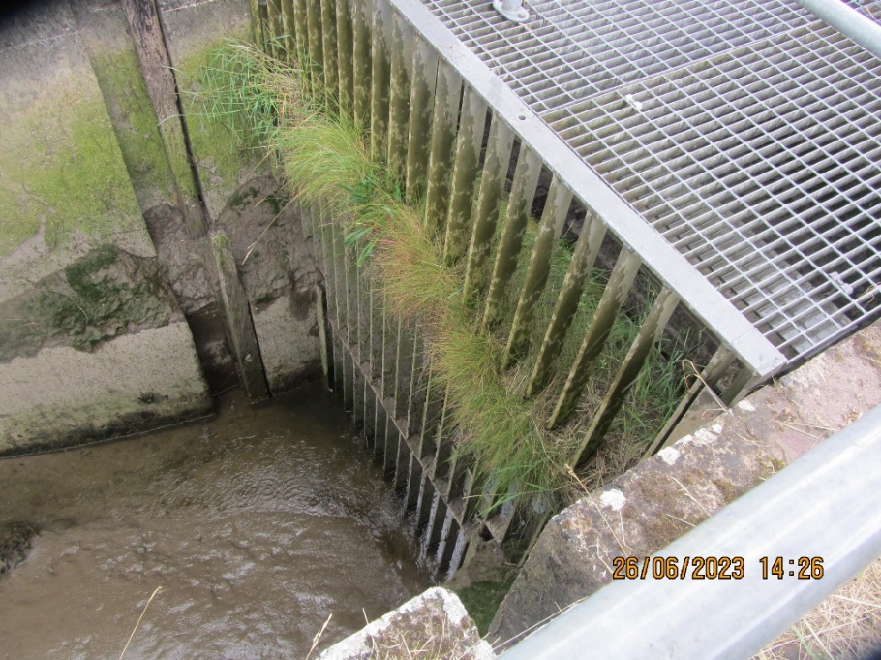
Outlet to Beeches sluice structure containing existing tidal door.
Historical background
Beeches Drain outfall forms part of the raised tidal defence (known as Hawarden Embankment) on the canalised section of the River Dee downstream of Chester. The structure was built in 1939 and formed part of the tidal defence securing the large land reclamation scheme to re-align the Dee in the 18th Century. The areas of Saltney Ferry, Sandycroft & Queensferry are found behind this defence. A flood risk model recently showed that there were significant numbers of property at risk of flooding if this structure was to fail.
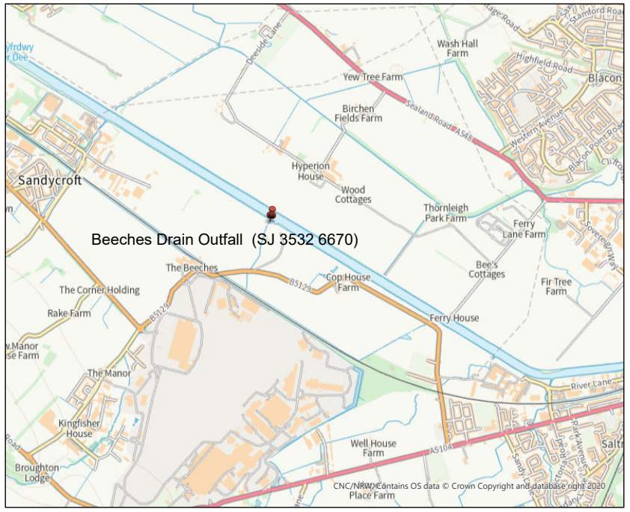
Whilst the tidal channel and embankments are man-made, they do fall into the River Dee SSSI & SAC status. The outfall structure is within these protected sites and therefore assent will be required to carry out the proposed tidal door replacement.
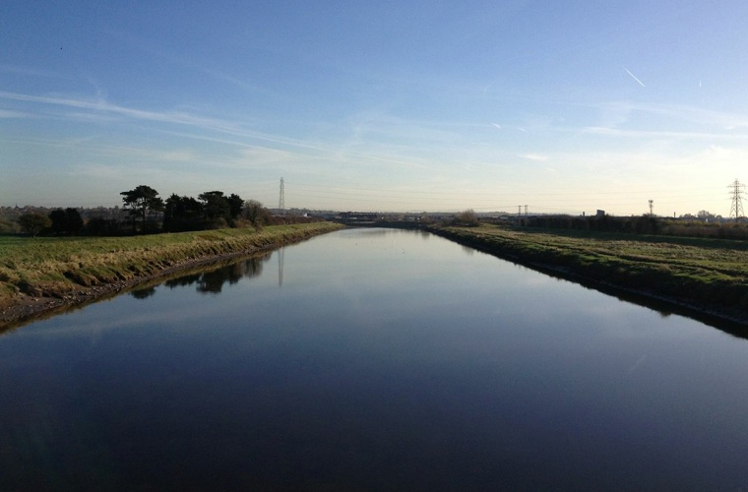
Canalised Tidal Dee: Tidal defences on either side with various outfalls including Beeches Drain
Background
A structural inspection carried out by Integral in December 2020 highlighted the poor condition of both the outer flap valve (tidal door) and inner or secondary flap valve. The secondary (inner) valve had failed as a defence having seized in an open position and having a 300mm hole in the door. As a result this was replaced by a new penstock on the outside wall of the inlet chamber which was completed in 2022.
The Integral report identified considerable corrosion of the tidal door fixings and retaining brackets and mentions that it would be impossible to replace these individual components given the age of the door. It therefore recommended that replacement of the door should be carried out in the near future.
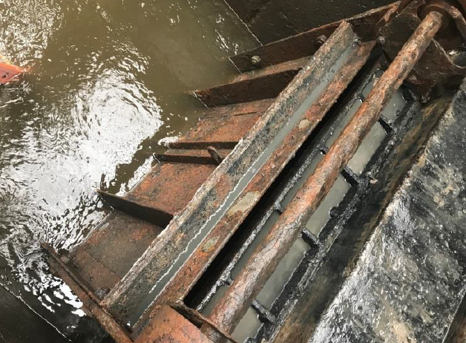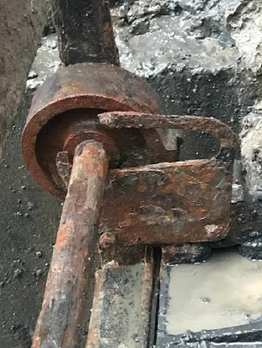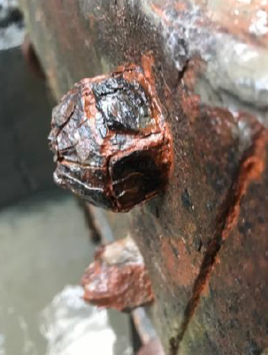
Photographs from Integral Inspection Report (Dec 2020)
Proposal
With the current condition of this tidal door and the potential risk of failure, increasing tidal flood risk to many properties and businesses, a new tidal door acting as the primary line of defence is needed. Given the findings of the Integral report the current FRM asset inspection (T98) has this asset at condition grade 4 (poor) when it’s target condition is 3 (fair), thus identifying this as a high consequence asset ‘below required condition’ in the FRM Corporate Dashboard.
Whilst gravity fed top hung non-return valves are very common as a means of defence, they also lower the potential hydrological connectivity with inter-tidal areas. There are many Water Framework Directive advantages in considering an alternative to traditional top-hung doors, allowing greater connectivity when tides are low but still providing a secondary line of defence when flood risk increases with high tides. A large spring tide on this canalised section of the Dee can generate a difference in height between the defended landward side and the level of the tide on the embankments of between 3-4m.
NRW have already approached three different suppliers for potential door replacement options but only one of these suppliers have come back with the preferred option of using side hung doors. We have recently used a similar product to replace the tidal door at Sealand Main Drain Outfall (also on the Tidal Dee Section) and found it to be more efficient, allows better fish passage and easy to install.
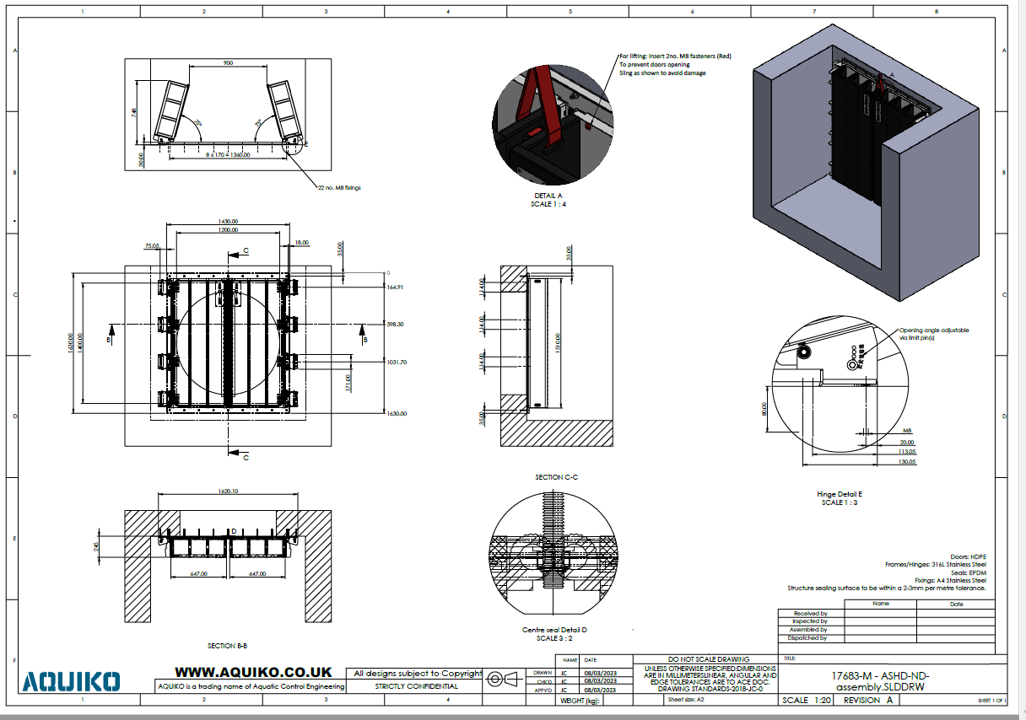
Details of Preferred Side Hung Door Option
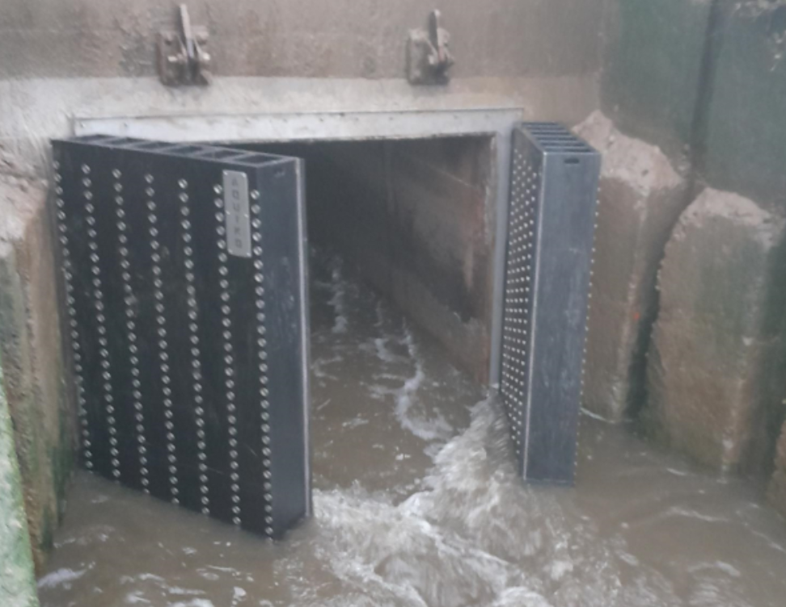
New Side Hung Doors at Sealand Main Drain Outfall similar to those proposed for Beeches Drain.
Methodology
Transportation of the required materials will be across agricultural fields up to the embankment access point by tractor & trailer (landowner to be consulted). From here a tracked excavator will be used to transport the short distance to the outfall structure. This excavator will remove the existing open mesh flooring & old gate and then lift the new tidal doors into position, securing to the headwall of the structure with a series of nuts & bolts. Confined spaces procedures will apply for access to the existing tidal gate with appropriate methodology & control measures in place.
It is also proposed to remove the existing trash screen immediately downstream of the door as this is not effective and hinders access for ongoing maintenance & inspection as well as being detrimental to fish passage. The excavator will also pull back some material that has slumped into the channel immediately downstream of the trash screen (see photos below) in order to improve flow conveyance and fish passage.
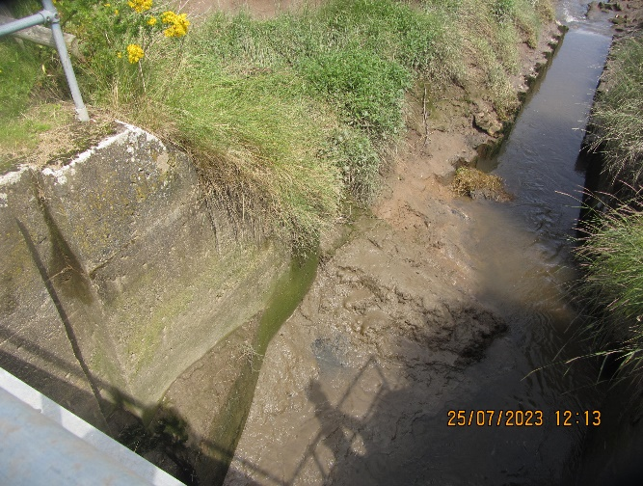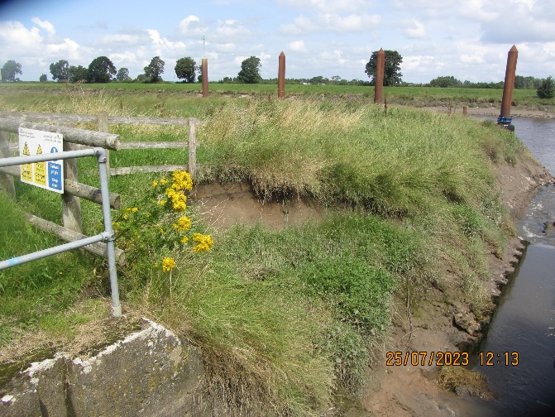
It is proposed for the excavator to work from the berm/foreshore area so assent will be required as well as a Marine Licence (Band 1 – Low Risk Activity). No work will be required from the water and there are no envisaged impacts on navigation. The Harbour Master (Dee Conservancy) and Trinity House will be contacted as part of the Marine Licence application.
Upon completion of fitting the new doors the open mesh flooring will be lowered back into position and secured with all the working areas then reinstated.
Pollution Prevention Measures
- The work is planned to take place in November 2023 to coincide with some low tides but may be pushed back to early 2024 if ground conditions and fluvial flows are not favourable. Duration is only expected to be 2-3 working days. We plan to carry out the work when the agricultural land will be dry, thus reducing any risk of diffuse pollution entering the watercourse.
- All machinery used on site will have biodegradable hydraulic oil to reduce the environmental impact if a burst hydraulic pipe occurs.
- All relevant Pollution Prevention guidance will be referred to and implemented, i.e. GPP5: Works & Maintenance in or near water.
- Before any civils works starts on site, a method of temporary dewatering/over-pumping needs to be in place should there be any excessive fluvial flows in Beeches Drain. The recently installed penstock at the upstream end will be ideal for isolating flows through the structure and this will therefore be closed for the short duration of the work.
- A small porta-dam consisting of visqueen & dumpy bags can then be installed in the channel downstream of the existing door & trash screen to prevent levels in the River Dee entering the working area. As previously mentioned the timing of the works will be around low tides and for a short duration.
- Upstream of the penstock a large diameter perforated plastic pipe will be placed in a vertical position. This will assist in reducing sediment entering the pump inlet. Within the large plastic pipe a 6” inlet suction hose will be housed running to a super silent, fully bunded pump. This pump will be located on the bank away from the watercourse. This pump will be able to contain any fuel or oil leakage as it will be retained within the unit itself, helping to reduce the risk of any potential contamination.

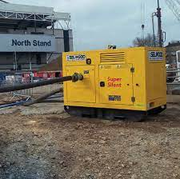
Example of a 6” super silent, double bunded pump.

- The lay-flat outlet pipe from the 6” pump will be positioned slightly further inland where it can discharge onto scrub land. This grassed area will have coir floc mats laid and pinned onto the full length (over 5m) of the discharge section of land. These mats are 100% natural fibre and are biodegradable; they have been designed for water quality management purposes for pumped river restoration projects. Having these mats placed along the full length of the front face provides further opportunity to capture any sediment being discharged. The mats help bind silt within the deep natural fibres as the pumped water travels over and through it, allowing sedimentation to form within them. The mats will also help dissipate the energy of the discharged water, reducing the risk of any erosion.

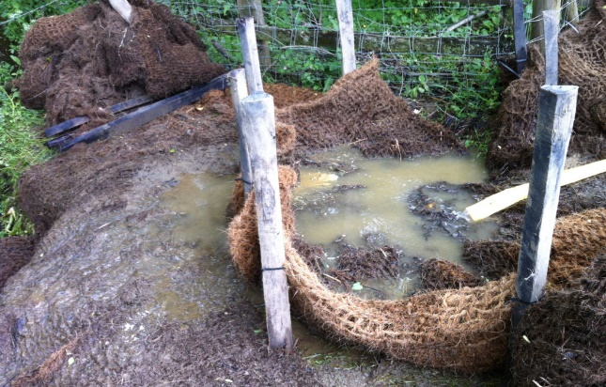
Examples of coir floc mats being used in removing any fine sediment
h. Daily checks of the floc mats will be carried out by the site supervisor, and these will be replenished as and when required. This will be part of the site’s daily checks in preventing pollution incidents. Following completion of the work, the floc mats will be collected and disposed of correctly.
- All operatives on site will be inducted with particular attention paid in their Toolbox Talk to the risk of environmental pollution. This will include highlighting what the risks are from the operation and planning an emergency response should an incident occur. Pollution prevention grab bags will be available on site at all times.
- The Dee Integrated Workforce Team will be the Principal Contractor for these works utilising their own fleet of vehicles & plant including the excavator.
- The Lead Site Supervisor will be made responsible for the control measures put in place to reduce the risk of pollution, as well as carry out daily checks to make sure these measures are still relevant and in place. Their findings will be documented on a daily record.
- The site compound will be made secure from the general public by 2m tall safety fencing. All materials will be stored within this compound and access will be restricted to only NRW staff. Signage will be erected warning of site hazards.
- Although there have been no INNS observed at the site, general biosecurity measures will be carried out to include steam cleaning of excavator before bringing onto site to prevent spread of invasive non-native plants and on removal from site. The operatives shall be aware of and work in accordance with standard good practice, for example, cleaning boots and equipment regularly.

