CRoW Appendix 4 (140_10_SD02)  CRoW Act 2000: Natural Resources Wales application for permission - Formal Notice |  | 
Natural Resources Wales Formal Notice.
Requirements of Section 28I of the Wildlife & Countryside Act 1981 as amended by the Countryside and Rights of Way Act (CRoW) 2000.
Duty in relation to granting any consent, licence or permit for activities likely to damage Sites of Special Scientific Interest (SSSI).
- Natural Resources Wales area/region/NPS hub: | Mid
- Name of SSSI: | Coed y Cefn SSSI  Cwm Gwynllyn SSSI  River Wye (Upper Wye) / Afon Gwy (Gwy Uchaf) SSSI  New House Meadow SSSI  Rhagnentydd Gwy Uchaf / Upper Wye Tributaries SSSI  Carn Gafallt SSSI
- Type of permission: | Landspreading deployment under SR2010 No4
- Date for Natural Resources Wales permit determination: | 03/10/2023
- Predicted 28 day date for response from NRW conservation/ecology (under S28 I(4)): | n/a saved for information only
- NRW reference no: | PAN-023088 under EPR-HB3503LF
- National grid reference: | Fields:  Dderw  01 TM DF SN9598968431  02 TM DF SN9643268587  03 TM DF SN9655468500  04 TM DF SN9646068421  05 TM DF SN9659668364  06 TM DF SN9645268242  08 TM DF SN9635968353  Noyadd Farm  30E SN9558366668  6481 + 6895 SN9566665879  7788 SN9577165885  8978 SN9589565804  9291 SN9592465926  Glan-Elan  04 TM NGE SN9652866883  05 TM NGE SN9656666979  06 TM NGE SN9660467089  10 TM NGE SN9650267186  11 TM NGE SN9652766781  12 TM NGE SN9634166867  Storage:  SN9638668486- field 08 TM DF (Dderw)  SN9645968338- field 08 TM DF (Dderw)  SN9553366620- field 30E (Noyadd Farm)  SN9597765911- field 9291 (Noyadd Farm)  SN9662767157- field 06 TM NGE (Glan-Elan)
- Description of proposal: | An application to spread a total of 1053 tonnes of sludge from water clarification (waste code 19 09 02) across fields totalling 38.3 hectares in Rhayader, Powys.  Wastes will be spread using a rear discharge muck spreader in accordance with the Code of Good Agricultural Practise and the Environmental Permitting Regulations.  Waste is solid in nature and has low run-off risk given that spreading to be only undertaken when conditions are suitable and that no spreading will occur in periods where heavy rain is forecast or if land is waterlogged.  application rates in agricultural benefit statement not to be exceeded, and are low (21 and 28 t/ha).  Wind speed and direction to be assessed before stockpiling and spreading and proximity to surrounding receptors. Spread when conditions are suitable. No spread areas enforced in fields close to SSSIs. Material has low potential for dust.  Maximum stockpile size is 378 tonnes, all stockpiles are within fields included in this deployment and Appendix 4 assessment. Site stockpile locations in suitable locations and not near watercourses and not where there is a field gradient directly towards nearby watercourses.  Proximity to SSSIs  - Coed y Cefn SSSI- 412m from field 01 TM DF at the nearest point and over 500m from other fields. It is at a higher elevation than the field(s).  - Cwm Gwynllyn SSSI- 370m from field 01 TM DF at the nearest point. It is at a higher elevation than the field(s).  - New House Meadow SSSI–214m from 10 TM NGE & 240m from 06 TM NGE at the nearest points, separated by fields and high hedgerows, there is no visible slope between SSSI and fields.  - Carn Gafallt SSSI- field 8978 is 395m, field 7788 is 460m & field 6481 + 6895 is 410m at the nearest points. It is at a higher elevation than the field(s).  - Rhagnentydd Gwy Uchaf / Upper Wye Tributaries SSSI- Field 9291 is 43m away from the SSSI is buffered by a road and hedgerows. Field 30E is surrounded by the SSSI to the north and east sides, however there is a field between 30E and the SSSI which is separated from 30E by fencing, and an additional buffer zone of 20 meters along this fencing.  - River Wye (Upper Wye) / Afon Gwy (Gwy Uchaf) SSSI:  - 11 TM NGE is approx. 440 meters to the east of the SSSI at the nearest point. They are separated by fields, high hedgerows, two roads and bank of woodland.  - 10 TM NGE/06 TM NGE are approx. 470 meters to the south east of the SSSI at the nearest point. They are separated by fields and high hedgerows, there is no visible slope between SSSI and fields.  - No spread areas in fields 02 TM DF 2, 05 TM DF & 03 TM DF where fields slope in the direction of the SSSI, there is also a wooded area between the fields and SSSI. The nearest point is approx. 70 meters.
- Is the proposed activity within (wholly or partially) the SSSI boundary? | No
- Has there been any pre-application discussion or correspondence with NRW conservation/ecology | No
- What aspect(s) of the proposed permission may damage the features which are of special interest for the SSSI?
 | The following ‘Operations Requiring Consent’ (or other activities associated with the permission) that may cause damage) are relevant to the proposed permission. | The following SSSI features and mechanisms of impact have been considered to assess the likelihood of damage:
Coed y Cefn SSSI | 7. Dumping, spreading or discharge of any waste materials | A population of the hairy wood ant, invertebrates associated with wood ant nests, oak woodland, acid  grassland and bracken affected by poor woodland management, chemical use and grazing.
Cwm Gwynllyn SSSI | 7. Dumping, spreading or discharge of any waste materials | Broadleaved semi-natural woodland, Oligotrophic standing water, breeding birds affected by poor woodland management, change in water levels/drainage, Nutrient Enrichment/Pollution, Scrub encroachment, Invasive plants and animals, Engineering works and Development and grazing.
River Wye (Upper Wye) / Afon Gwy (Gwy Uchaf) SSSI | 7. Dumping, spreading or discharging of any materials | River and riverside plants, riverside mosses and liverworts, otters, wintering area for goosander, spawning and juvenile Atlantic salmon, twaite shad, sea lamprey, river lamprey, populations of brook lamprey and bullhead, aquatic invertebrates. Also broadleaved woodland, scrub, acid and marshy grassland, tall weeds, acid bog, swamp and marginal vegetation, ponds in old river channels and river gravel and species of breeding birds, bats and terrestrial plants and invertebrates. See SMS for full list.  These can be affected by river quality, water quantity, Obstructions to migration, Management of riverbanks, Engineering works/gravel extraction, Fishery management, Invasive alien species, Disturbance, Recreation, Alder disease, Catchment management
New House Meadow SSSI | 7. Dumping, spreading or discharging of any materials | Unimproved neutral grassland affected by Soil Chemistry, Scrub and Bracken Encroachment and grazing.
Rhagnentydd Gwy Uchaf / Upper Wye Tributaries SSSI | 7. Dumping, spreading, discharging or storage of any material | Otter, Atlantic Salmon, Bullhead, also broadleaved woodland, acid, semi-improved and marshy grassland, bracken, tall ruderals, swamp, ponds and shingle banks affected by Water quality, Water quantity, Agricultural land / bankside habitat management, Fishery management, Engineering works, recreation (otters only), Mink hunting (otters only), Invasive alien species, Alder disease, Road Casualties (otters only), Obstructions to migration
Carn Gafallt SSSI | 7. Dumping, spreading or discharging of any materials | Upland dry heath, Broadleaved woodland, Mosses and liverworts, Lichens, Breeding birds, Insects and molluscs affected by Burning and Cutting, Stock Feeding and Fertilisers, Woodland Management, changes in drainage, Bracken and Scrub Encroachment, Non-native Trees and Shrubs, Air Pollution, Grazing
- Decision
i) The proposed permission is not likely to damage any of the flora, fauna or geological or physiological features which are of special interest.

- Coed y Cefn SSSI- no conceivable impact pathway for harm given distance and elevation, and waste form (solid).
- Cwm Gwynllyn SSSI- no conceivable impact pathway for harm given distance and elevation, and waste form (solid).
- New House Meadow SSSI– no conceivable impact pathway for harm given distance, slope, and waste form (solid).
- Carn Gafallt SSSI- no conceivable impact pathway for harm given distance and elevation, and waste form (solid).
- Rhagnentydd Gwy Uchaf / Upper Wye Tributaries SSSI- no conceivable impact pathway for harm given distance, waste form (solid) and additional buffers.
- River Wye (Upper Wye) / Afon Gwy (Gwy Uchaf) SSSI-
- no conceivable impact pathway for harm given distance (Glan Elan fields), waste form (solid) and additional buffers (Dderw fields).

Natural Resources Wales is minded to issue the permission

- Name and job title of Natural Resources Wales officer: | Louise Bailey  Permitting Officer
- Date form sent to NRW conservation/ecology | n/a saved for information only

Application maps
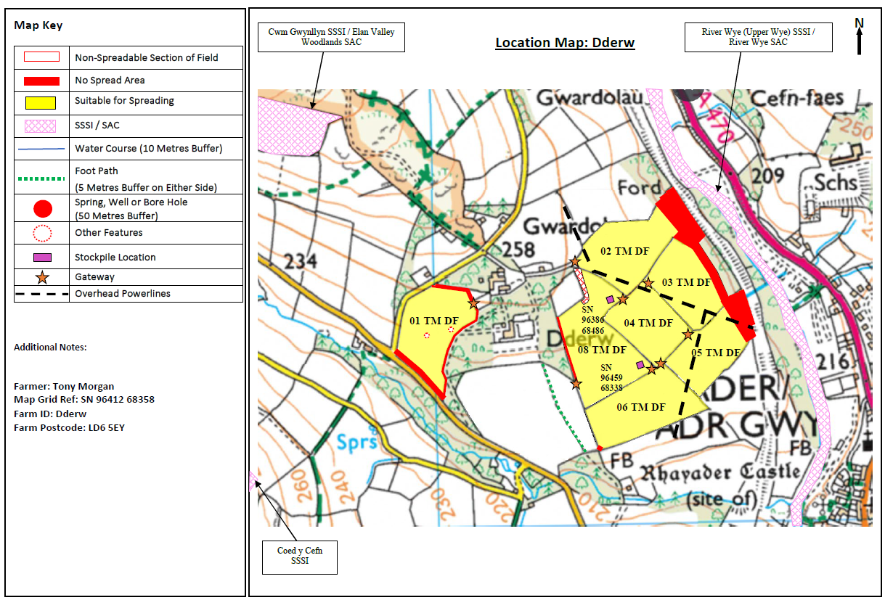
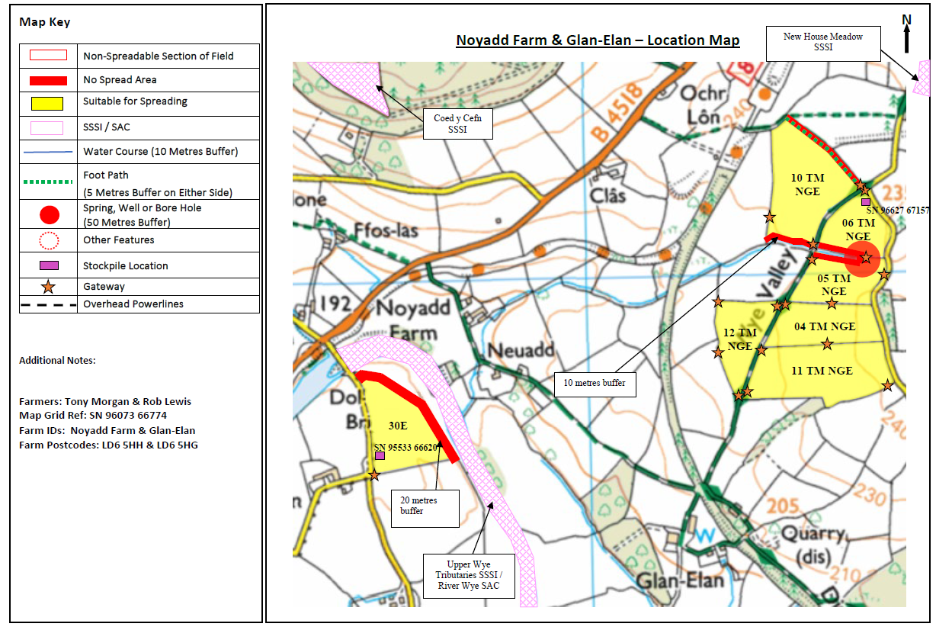
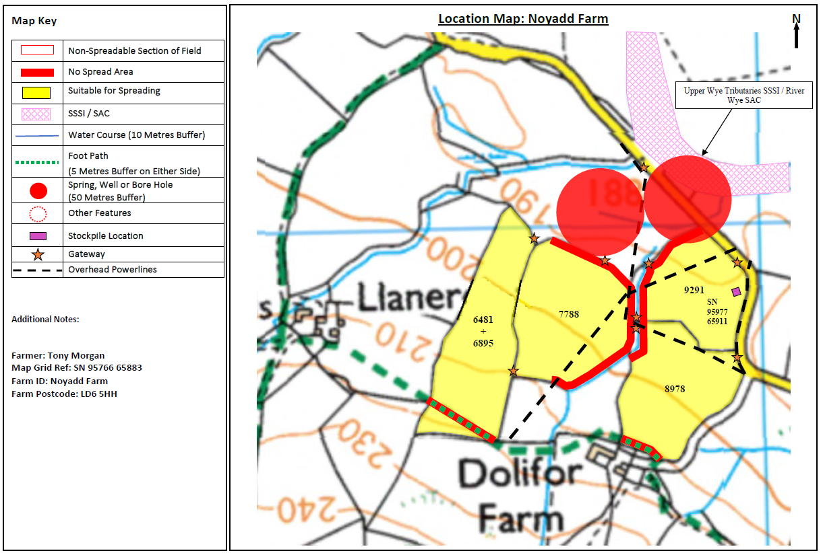

Coed y Cefn SSSI
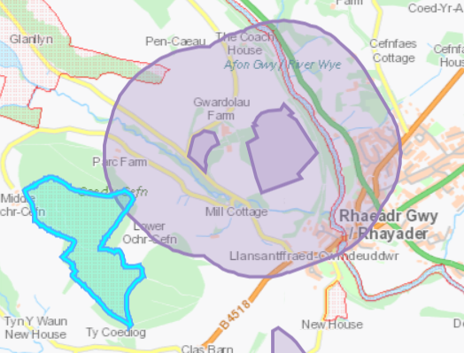

Cwm Gwynllyn SSSI
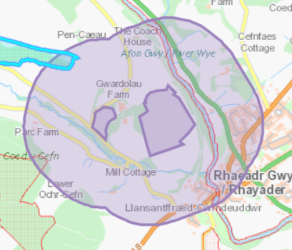

River Wye (Upper Wye) / Afon Gwy (Gwy Uchaf) SSSI
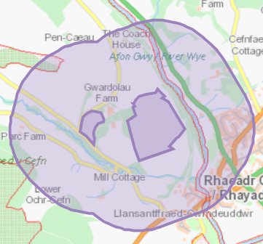

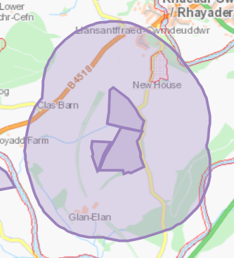

New House Meadow SSSI
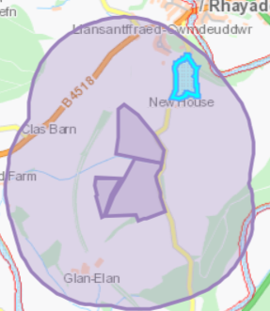

Rhagnentydd Gwy Uchaf / Upper Wye Tributaries SSSI
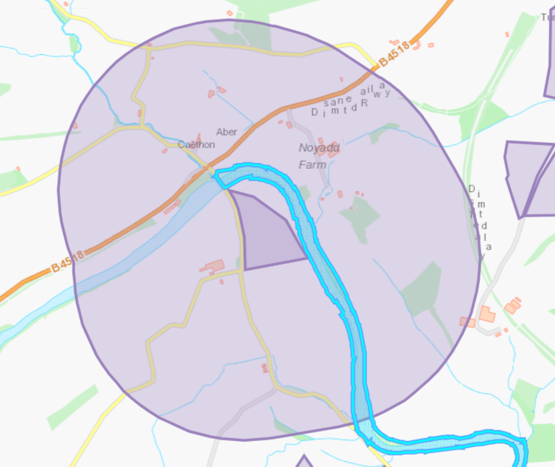
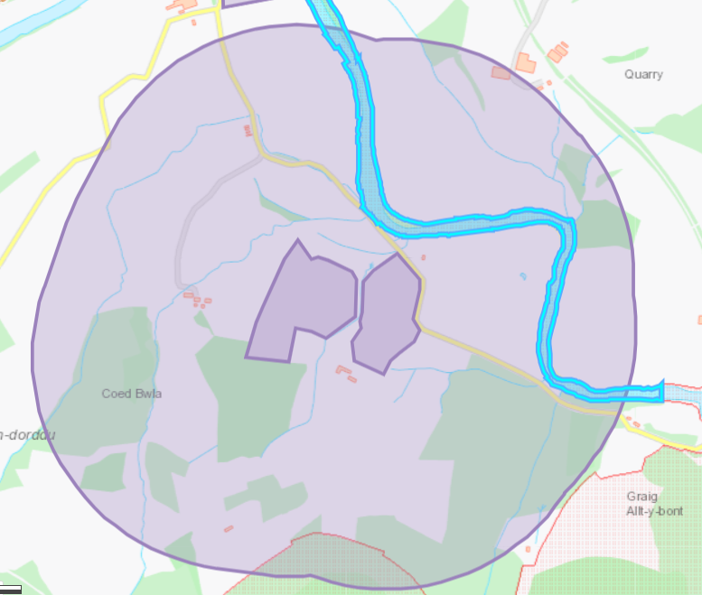

Carn Gafallt SSSI


