Notice of variation and consolidation with introductory note
The Environmental Permitting (England & Wales) Regulations 2016

Merthyr (South Wales) Limited

Cwmbargoed Disposal Point C
Fochriw Road
Merthyr Tydfil
CF48 4AE

Variation application number
PAN-018819/PAN-018820

Consolidated permit number

AE2013403

Cwmbargoed Disposal Point C

Consolidated permit number AE2013403

Introductory note

This introductory note does not form a part of the notice.

The following notice gives notice of the variation of environmental permits AE2013403 and AE2013404 referred to in the status logs below and the replacement of those permits with a consolidated environmental permit.

This variation is the inclusion of anionic flocculant and caustic soda to treat the final effluent and storm discharge. The discharges are comprised of settled opencast site drainage

Following a site audit, the final effluent suspended solids limits will be reduced over a three-year period to fall in line with the site’s other discharges. The reduction will be as;

Year 1 Dec 2023 - 100mg/l Suspended Solids

Year 2 Dec 2024 - 80mg/l Suspended Solids

Year 3 Dec 2025 - 50mg/l Suspended Solids.

Iron limits have also been included to be monitored by Natural Resources Wales and the Operator in line with the Operating Techniques document referenced in Table S1.2.

The schedules specify the changes made to the permit.

The status log of a permit sets out the permitting history, including any changes to the permit reference number. It is not backdated before 6 April 2010.

Status Log of permit A: AE2013403
Description | Date | Comments
Application  AE2013403/V002 (Variation) | Duly made  23/08/2018 | Application to change the registered holders name from Miller Argent to Merthyr (South Wales) Limited
Variation issued  AE2013403/V002 | 21/09/2018 | Varied permit issued to Merthyr (South Wales) Limited
Application  PAN-018819  (Variation and consolidation)  AE2013403/V003 | Duly made  29/07/2022 | Application to vary and update the permit to modern conditions. Variation to include the use of flocculent to treat the surface water discharge and improvement plan to reduce the suspended solids limits over a three-year period
Variation issued AE2013403 | 21/09/2023 | Varied and consolidated permit issued in modern condition format.

Status Log of permit B: AE2013404
Description | Date | Comments
Application Administrative variation AE2013404/V002 | Duly Made  23/08/2018 | Application to change the registered holders name from Miller Argent to Merthyr (South Wales) Limited
Variation issued AE2013404/V002 | 21/09/2018 | Varied permit issued to Merthyr (South Wales) Limited
Application PAN-018820  (Variation and consolidation)  AE2013404/V003 | Duly made  29/07/2022 | Application to vary and update the permit to modern conditions. Variation to include the use of flocculent to treat the surface water discharge.
Variation issued AE2013403 | 21/09/2023 | Varied and consolidated permit issued in modern condition format.

End of introductory note

Notice of variation and consolidation
The Environmental Permitting (England and Wales) Regulations 2016

The Natural Resources Body for Wales (“Natural Resources Wales”) in exercise of its powers under regulations 18 and 20 of the Environmental Permitting (England and Wales) Regulations 2016 varies and consolidates environmental permits

permit numbers

AE2013403

AE2013404

issued to:

Merthyr (South Wales) Limited (“the operator”)

whose registered office is

Lanyon House

Mission Court

Newport

Wales

NP20 2DW

company registration number 04261274

to operate a regulated facility at

Cwmbargoed Disposal Point C

Fochriw Road

Merthyr Tydfil

CF48 4AE

to the extent set out in the schedules.

The notice shall take effect from 21/09/2023

The number of the consolidated permit is AE2013403

Name | Date
Emma Jones | 21/09/2023

Authorised on behalf of Natural Resources Wales

Schedule 1 – changes in the permit
All conditions have been varied by the consolidated permit as a result of the application made by the operator.

Schedule 2 – consolidated permit

Consolidated permit issued as a separate document.

Permit
The Environmental Permitting (England and Wales) Regulations 2016

Permit number

AE2013403

This is the consolidated permit referred to in the variation and consolidation notice for application PAN-018819 and PAN-018820 authorising,

Merthyr (South Wales) Limited (“the operator”),

whose registered office is

Lanyon House

Mission Court

Newport

Wales

NP20 2DW

company registration number 04261274

to operate a water discharge activity

Cwmbargoed Disposal Point C

Fochriw Road

Merthyr Tydfil

CF48 4AE

to the extent authorised by and subject to the conditions of this permit.

Name | Date
Emma Jones | 21/09/2023

Authorised on behalf of Natural Resources Wales

Conditions

Management

General management

The operator shall manage and operate the activities:

in accordance with a written management system that identifies and minimises risks of pollution, including those arising from operations, maintenance, accidents, incidents, non-conformances and those drawn to the attention of the operator as a result of complaints; and

using sufficient competent persons and resources.

Records demonstrating compliance with condition 1.1.1 shall be maintained.

Any person having duties that are or may be affected by the matters set out in this permit shall have convenient access to a copy of it kept at or near the place where those duties are carried out.

2 Operations
2.1 Permitted activities

2.1.1 The operator is only authorised to carry out the activities specified in schedule 1 table S1.1 (the “activities”).

2.2 The site

2.2.1 The activities shall not extend beyond the site, being the land shown edged in green and the discharges shall be made at the points marked on the site plan at schedule 7 to this permit and as listed in table S3.2 (discharge points).

2.3 Operating techniques
2.3.1 (a) The activities shall, subject to the conditions of this permit, be operated using the techniques and in the manner described in the documentation specified in schedule 1, table S1.2, unless otherwise agreed in writing by Natural Resources Wales.
(b) If notified by Natural Resources Wales that the activities are giving rise to pollution, the operator shall submit to Natural Resources Wales for approval within the period specified, a revision of any plan or other documentation (“plan”) specified in schedule 1, table S1.2 or otherwise required under this permit which identifies and minimises the risks of pollution relevant to that plan, and shall implement the approved revised plan in place of the original from the date of approval, unless otherwise agreed in writing by Natural Resources Wales.
2.3.2 For the discharge under storm condition specified in Schedule 3, table S3.1:
- The discharge shall only occur when and only for as long as the passed forward is equal to or greater than the overflow setting indicated and shall only consist of flows in excess of that figure.
- The capacity of the water storage facility must be fully utilised before a discharge occurs.

3 Emissions and monitoring

3.1 Emissions to water

3.1.1 There shall be no point source emissions to water except from the sources and emission points listed in schedule 3.

3.1.2 The limits given in schedule 3 shall not be exceeded.

Emissions of substances not controlled by emission limits

Emissions of substances not controlled by emission limits (excluding odour) shall not cause pollution. The operator shall not be taken to have breached this condition if appropriate measures, including, but not limited to, those specified in any approved emissions management plan, have been taken to prevent or where that is not practicable, to minimise, those emissions.

3.2.2 The operator shall:

(a) if notified by Natural Resources Wales that the activities are giving rise to pollution, submit to Natural Resources Wales for approval within the period specified, an emissions management plan which identifies and minimises the risks of pollution from emissions of substances not controlled by emission limits;

(b) implement the approved emissions management plan, from the date of approval, unless otherwise agreed in writing by Natural Resources Wales.

3.2.3 All liquids in containers, whose emission to water or land could cause pollution, shall be provided with secondary containment, unless the operator has used other appropriate measures to prevent or where that is not practicable, to minimise, leakage and spillage from the primary container.

3.3 Monitoring

3.3.1 The operator shall, unless otherwise agreed in writing by Natural Resources Wales, undertake the monitoring specified in the following tables in schedule 3 to this permit:

(a) point source emissions specified in tables S3.1 and S3.3.

3.3.2 The operator shall maintain records of all monitoring required by this permit including records of the taking and analysis of samples, instrument measurements (periodic and continual), calibrations, examinations, tests and surveys and any assessment or evaluation made on the basis of such data.

3.3.3 Permanent means of access shall be provided to enable sampling/monitoring to be carried out in relation to the emission points specified in schedule 3 tables S3.1, S3.2 and S3.3 unless otherwise agreed in writing by Natural Resources Wales.

4 Information

4.1 Records

All records required to be made by this permit shall:

be legible;

be made as soon as reasonably practicable;

if amended, be amended in such a way that the original and any subsequent amendments remain legible, or are capable of retrieval; and

be retained, unless otherwise agreed in writing by Natural Resources Wales, for at least 6 years from the date when the records were made.
4.1.2 The operator shall keep on site all records, plans and the management system required to be maintained by this permit, unless otherwise agreed in writing by Natural Resources Wales.

4.2 Reporting

4.2.1 The operator shall send all reports and notifications required by the permit to Natural Resources Wales using the contact details supplied in writing by Natural Resources Wales.

4.2.2 Within 28 days of the end of the reporting period the operator shall, unless otherwise agreed in writing by Natural Resources Wales, submit reports of the monitoring and assessment carried out in accordance with the conditions of this permit, as follows:

in respect of the parameters and emission points specified in schedule 4 table S4.1;

for the reporting periods specified in schedule 4 table S4.1 and using the forms specified in schedule 4 table S4.2; and

giving the information from such results and assessments as may be required by the forms specified in those tables.

4.3 Notifications

Natural Resources Wales shall be notified without delay following the detection of:

any malfunction, breakdown or failure of equipment or techniques, accident, or emission of a substance not controlled by an emission limit which has caused, is causing or may cause significant pollution;

the breach of a limit specified in the permit; or

any significant adverse environmental effects.

4.3.2 Any information provided under condition 4.3.1 shall be confirmed by sending the information listed in schedule 5 to this permit within the time period specified in that schedule.

4.3.3 Where Natural Resources Wales has requested in writing that it shall be notified when the operator is to undertake monitoring and/or spot sampling, the operator shall inform Natural Resources Wales when the relevant monitoring and/or spot sampling is to take place. The operator shall provide this information to Natural Resources Wales at least 14 days before the date the monitoring is to be undertaken.

4.3.4 Natural Resources Wales shall be notified within 14 days of the occurrence of the following matters, except where such disclosure is prohibited by Stock Exchange rules:

Where the operator is a registered company:

any change in the operator’s trading name, registered name or registered office address; and

(b) any steps taken with a view to the operator going into administration, entering into a company voluntary arrangement or being wound up.

Where the operator is a corporate body other than a registered company:

any change in the operator’s name or address; and

any steps taken with a view to the dissolution of the operator.

4.3.5 Where the operator proposes to make a change in the nature or functioning, or an extension of the activities, which may have consequences for the environment and the change is not otherwise the subject of an application for approval under the Regulations or this permit:

(a) Natural Resources Wales shall be notified at least 14 days before making the change; and

(b) the notification shall contain a description of the proposed change in operation.

4.4 Interpretation

4.4.1 In this permit the expressions listed in schedule 6 shall have the meaning given in that schedule.

4.4.2 In this permit references to reports and notifications mean written reports and notifications, except where reference is made to notification being made “without delay”, in which case it may be provided by telephone.

Schedule 1 - Operations

Table S1.1 Activities
Activity reference | Description of activity | Limits of specified activity
A1 | Discharge of trade effluent comprising of settled opencast drainage via C | - The discharge shall be made via a reinforced concrete channel.  - Anionic polyelectrolyte flocculant can be added to treat Suspended Solids  - Caustic Soda can be added for pH balancing.  - The chemical dosing material shall at all times conform to the appropriate British Standards specification(s)
A2 | Drainage of trade effluent comprising of settled opencast drainage discharged under storm conditions via C1 | The discharge shall be made via a 500mm diameter concrete pipe.

Table S1.2 Operating techniques
Activity reference | Description of documentation | Parts | Date Received
A1, A2 | Environmental Planning and Management Ref: CP61  Issue: 73  Date: March 2022 | All | 29/07/2022

Schedule 2 - Waste types, raw materials and fuels

Wastes are not accepted as part of the permitted activities and there are no restrictions on raw materials or fuels under this schedule.

Schedule 3 – Emissions and monitoring

Table S3.1a Point Source emissions to water (other than sewer) – emission limits and monitoring requirements – Effective up to and including 31st December 2023
Discharge source and discharge point ref. & location | Parameter | Limit (including unit) | Reference Period | Limit of effective range | Monitoring frequency | Compliance Statistic
A1  Trade effluent consisting of settled opencast site drainage via C | Maximum rate of discharge | 1037 m³ | Total daily volume | N/A | N/A | Maximum
 | Suspended solids (measured after drying at 105º C) | 200 mg/l | Instantaneous (spot sample) | N/A | Continuous | Maximum
 | pH | 5 to 9 | Instantaneous (spot sample) | N/A | See Table S1.2 | Minimum and maximum
 | Iron | 3,000 µg/l | Instantaneous (spot sample) | N/A | See Table S1.2 | Maximum
 | Visible oil or grease | No significant trace present | Instantaneous (spot sample) | N/A | N/A | No significant trace
A2  Storm Overflow via C1 | Overflow Setting | 2125 l/s | Instantaneous (spot sample) | Condition 2.3.2 applies | N/A | Minimum
A2  Storm Overflow via C1 | Suspended Solids (measured after drying at 105° | 500 mg/l | Instantaneous (spot sample) | N/A | Continuous | Maximum
A2  Storm Overflow via C1 | pH | 5 to 9 | Instantaneous (spot sample) | N/A | See Table S1.2 | Minimum and Maximum
A2  Storm Overflow via C1 | Visible oil or grease | No significant trace present | Instantaneous (spot sample) | N/A | N/A | No significant trace
A2  Storm Overflow via C1 | Discharges start and end times | No limit set | N/A | N/A | Whenever a discharge occurs | N/A

Table S3.1b Point Source emissions to water (other than sewer) – emission limits and monitoring requirements – Effective from 1st January 2024 until 31st December 2024
Discharge source and discharge point ref. & location | Parameter | Limit (including unit) | Reference Period | Limit of effective range | Monitoring frequency | Compliance Statistic
A1  Trade effluent consisting of settled opencast site drainage via C | Maximum rate of discharge | 1037 m³ | Total daily volume | N/A | N/A | Maximum
 | Suspended solids (measured after drying at 105º C) | 100 mg/l | Instantaneous (spot sample) | N/A | Continuous | Maximum
 | pH | 5 to 9 | Instantaneous (spot sample) | N/A | See Table S1.2 | Minimum and maximum
 | Iron | 3000 µg/l | Instantaneous (spot sample) | N/A | See Table S1.2 | Maximum
 | Visible oil or grease | No significant trace present | Instantaneous (spot sample) | N/A | N/A | No significant trace
A2  Storm Overflow via C1 | Overflow Setting | 2125 l/s | Instantaneous (spot sample) | Condition 2.3.2 applies | N/A | Minimum
A2  Storm Overflow via C1 | Suspended Solids (measured after drying at 105° | 500 mg/l | Instantaneous (spot sample) | N/A | Continuous | Maximum
A2  Storm Overflow via C1 | pH | 5 to 9 | Instantaneous (spot sample) | N/A | See Table S1.2 | Minimum and Maximum
A2  Storm Overflow via C1 | Visible oil or grease | No significant trace present | Instantaneous (spot sample) | N/A | N/A | No significant trace
A2  Storm Overflow via C1 | Discharges start and end times | No limit set | N/A | N/A | Whenever a discharge occurs | N/A

Table S3.1b Point Source emissions to water (other than sewer) – emission limits and monitoring requirements – Effective from 1st January 2025 until 31st December 2025
Discharge source and discharge point ref. & location | Parameter | Limit (including unit) | Reference Period | Limit of effective range | Monitoring frequency | Compliance Statistic
A1  Trade effluent consisting of settled opencast site drainage via C | Maximum rate of discharge | 1037 m³ | Total daily volume | N/A | N/A | Maximum
 | Suspended solids (measured after drying at 105º C) | 80 mg/l | Instantaneous (spot sample) | N/A | Continuous | Maximum
 | pH | 5 to 9 | Instantaneous (spot sample) | N/A | See Table S1.2 | Minimum and maximum
 | Iron | 3000 µg/l | Instantaneous (spot sample) | N/A | See Table S1.2 | Maximum
 | Visible oil or grease | No significant trace present | Instantaneous (spot sample) | N/A | N/A | No significant trace
A2  Storm Overflow via C1 | Overflow Setting | 2125 l/s | Instantaneous (spot sample) | Condition 2.3.2 applies | N/A | Minimum
A2  Storm Overflow via C1 | Suspended Solids (measured after drying at 105° | 500 mg/l | Instantaneous (spot sample) | N/A | Continuous | Maximum
A2  Storm Overflow via C1 | pH | 5 to 9 | Instantaneous (spot sample) | N/A | See Table S1.2 | Minimum and Maximum
A2  Storm Overflow via C1 | Visible oil or grease | No significant trace present | Instantaneous (spot sample) | N/A | N/A | No significant trace
A2  Storm Overflow via C1 | Discharges start and end times | No limit set | N/A | N/A | Whenever a discharge occurs | N/A

Table S3.1b Point Source emissions to water (other than sewer) – emission limits and monitoring requirements – Effective from 1st January 2026
Discharge source and discharge point ref. & location | Parameter | Limit (including unit) | Reference Period | Limit of effective range | Monitoring frequency | Compliance Statistic
A1  Trade effluent consisting of settled opencast site drainage via C | Maximum rate of discharge | 1037 m³ | Total daily volume | N/A | N/A | Maximum
 | Suspended solids (measured after drying at 105º C) | 50 mg/l | Instantaneous (spot sample) | N/A | Continuous | Maximum
 | pH | 5 to 9 | Instantaneous (spot sample) | N/A | See Table S1.2 | Minimum and maximum
 | Iron | 3000 µg/l | Instantaneous (spot sample) | N/A | See Table S1.2 | Maximum
 | Visible oil or grease | No significant trace present | Instantaneous (spot sample) | N/A | N/A | No significant trace
A2  Storm Overflow via C1 | Overflow Setting | 2125 l/s | Instantaneous (spot sample) | Condition 2.3.2 applies | N/A | Minimum
A2  Storm Overflow via C1 | Suspended Solids (measured after drying at 105° | 500 mg/l | Instantaneous (spot sample) | N/A | Continuous | Maximum
A2  Storm Overflow via C1 | pH | 5 to 9 | Instantaneous (spot sample) | N/A | See Table S1.2 | Minimum and Maximum
A2  Storm Overflow via C1 | Visible oil or grease | No significant trace present | Instantaneous (spot sample) | N/A | N/A | No significant trace
A2  Storm Overflow via C1 | Discharges start and end times | No limit set | N/A | N/A | Whenever a discharge occurs | N/A

Table S3.2 Discharge points
Effluent Name | Discharge Point | Discharge point NGR | Receiving water/Environment
A1 Trade effluent | C | SO 09200 05660 | Nant Gyrawd
A2 Storm effluent | C1 | SO 09210 05660 | Nant Gyrawd

Table S3.3 Monitoring points
Effluent(s) and discharge point(s) | Monitoring type | Monitoring point NGR | Monitoring point reference
A1 Trade effluent | Flow Monitoring | SO 09220 05730 | Flow Monitoring Point
A1 Trade effluent | Effluent Monitoring | SO 09200 05660 | C
A2 Storm effluent | Storm Overflow Monitoring | SO 09210 05660 | C1

Schedule 4 – Reporting

Determinant’s, for which reports shall be made, in accordance w2ith conditions of this permit, are listed below

Table S4.1 Reporting of monitoring data
Determinant | Monitoring point reference | Reporting period | Period begins
Suspended Solids | C, C1 | Monthly | 1st of the month
Discharge start and end times | C1 | Half yearly | 1st of the month
pH | C, C1 | Monthly | 1st of the month
Iron | C, C1 | See Table 1.2 | See Table 1.2
Flow Monitoring | Flow Monitoring Point | Monthly | 1st of the month

Table S4.2 Reporting forms
Determinant | Reporting format
Suspended Solids | Electronic format specified by Natural Resources Wales
Discharge start and end times | Electronic format specified by Natural Resources Wales
pH | Electronic format specified by Natural Resources Wales
Iron | Electronic format specified by Natural Resources Wales
Flow Monitoring | Electronic format specified by Natural Resources Wales

Schedule 5 - Notification

These pages outline the information that the operator must provide.

Units of measurement used in information supplied under Part A and B requirements shall be appropriate to the circumstances of the emission. Where appropriate, a comparison should be made of actual emissions and authorised emission limits.

If any information is considered commercially confidential, it should be separated from non-confidential information, supplied on a separate sheet and accompanied by an application for commercial confidentiality under the provisions of the EP Regulations.

Part A
Permit Number | AE2013403

Name of operator
Location of Facility | Cwmbargoed Disposal Point C, Fochriw Road, Merthyr Tydfil, CF48 4AE

Time and date of the detection

(a) Notification requirements for any malfunction, breakdown or failure of equipment or techniques, accident, or emission of a substance not controlled by an emission limit which has caused, is causing or may cause significant pollution

To be notified within 24 hours of detection

Date and time of the event

Reference or description of the location of the event

Description of where any release into the environment took place

Substances(s) potentially released

Best estimate of the quantity or rate of release of substances

Measures taken, or intended to be taken, to stop any emission

Description of the failure or accident.

(b) Notification requirements for the breach of a limit

To be notified within 24 hours of detection unless otherwise specified below

Emission point reference/ source

Parameter(s)

Limit

Measured value and uncertainty

Date and time of monitoring

Measures taken, or intended to be taken, to stop the emission

Time periods for notification following detection of a breach of a limit
Parameter | Notification period

(c) Notification requirements for the detection of any significant adverse environmental effect

To be notified within 24 hours of detection

Description of where the effect on the environment was detected

Substances(s) detected

Concentrations of substances detected

Date of monitoring/sampling

Part B - to be submitted as soon as practicable

Any more accurate information on the matters for notification under Part A.

Measures taken, or intended to be taken, to prevent a recurrence of the incident

Measures taken, or intended to be taken, to rectify, limit or prevent any pollution of the environment which has been or may be caused by the emission

The dates of any unauthorised emissions from the facility in the preceding 24 months.

Name*

Post

Signature

Date

* authorised to sign on behalf of the operator

Schedule 6 - Interpretation
“accident” means an accident that may result in pollution.
“annually” means once every year.
“application” means the application for this permit, together with any additional information supplied by the operator as part of the application and any response to a notice served under Schedule 5 to the EP Regulations.

“emissions of substances not controlled by emission limits” means emissions of substances to air, water or land from the activities, which are not controlled by an emission or background concentration limit.
“EP Regulations” means The Environmental Permitting (England and Wales) Regulations SI 2016 No.1154 and words and expressions used in this permit which are also used in the Regulations have the same meanings as in those Regulations.
“groundwater” means all water, which is below the surface of the ground in the saturation zone and in direct contact with the ground or subsoil.
“Natural Resources Wales” means the Natural Resources Body for Wales established by article 3 of the Natural Resources Body for Wales (Establishment) Order 2012. The Natural Resources Body for Wales (Functions) Order 2013 transferred the relevant functions of the Countryside Council for Wales, and functions of the Environment Agency and the Forestry Commission in Wales to the Natural Resources Body for Wales.
“quarter” means a calendar year quarter commencing on 1 January, 1 April, 1 July or 1 October.

“year” means calendar year ending 31 December.

Schedule 7 - Site plan
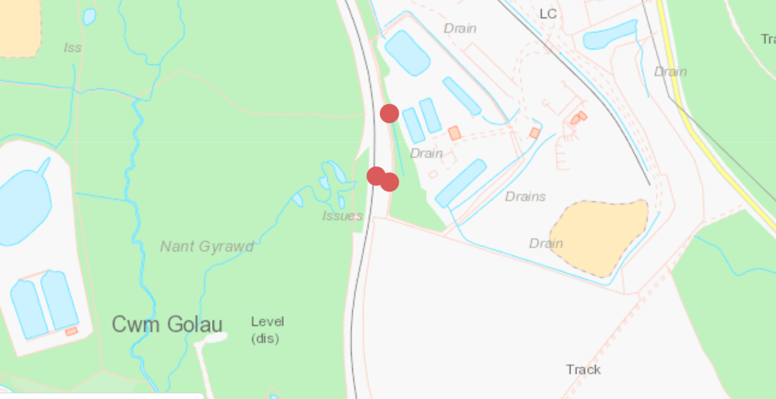
C1
C
Flow Monitoring Point

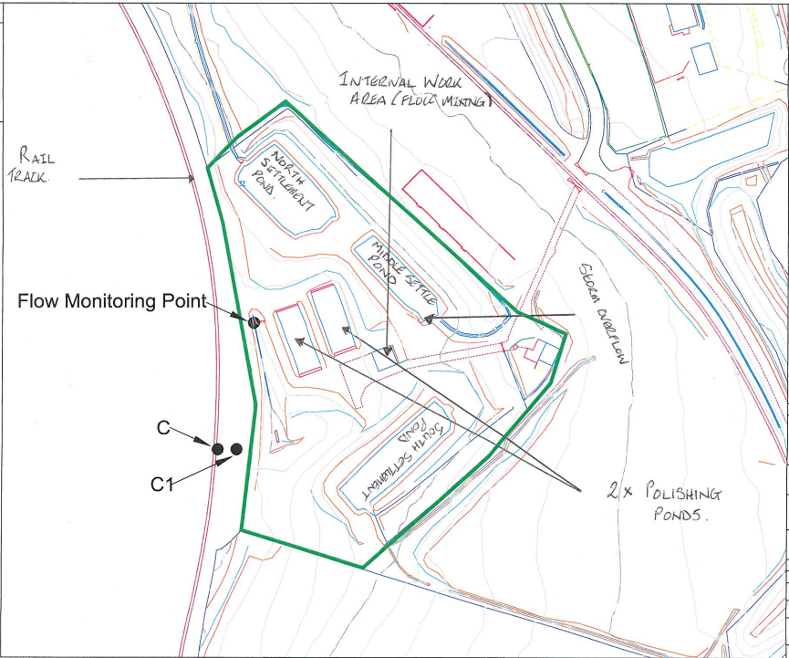

© Crown Copyright and database right 2023. Ordnance Survey licence number 100019741.

END OF PERMIT

