Site location
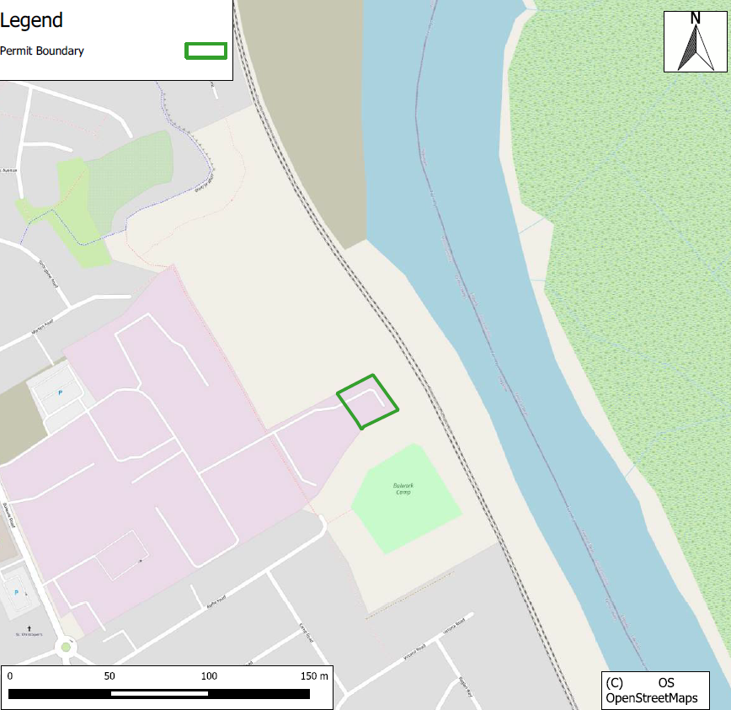

Proximity to human occupation
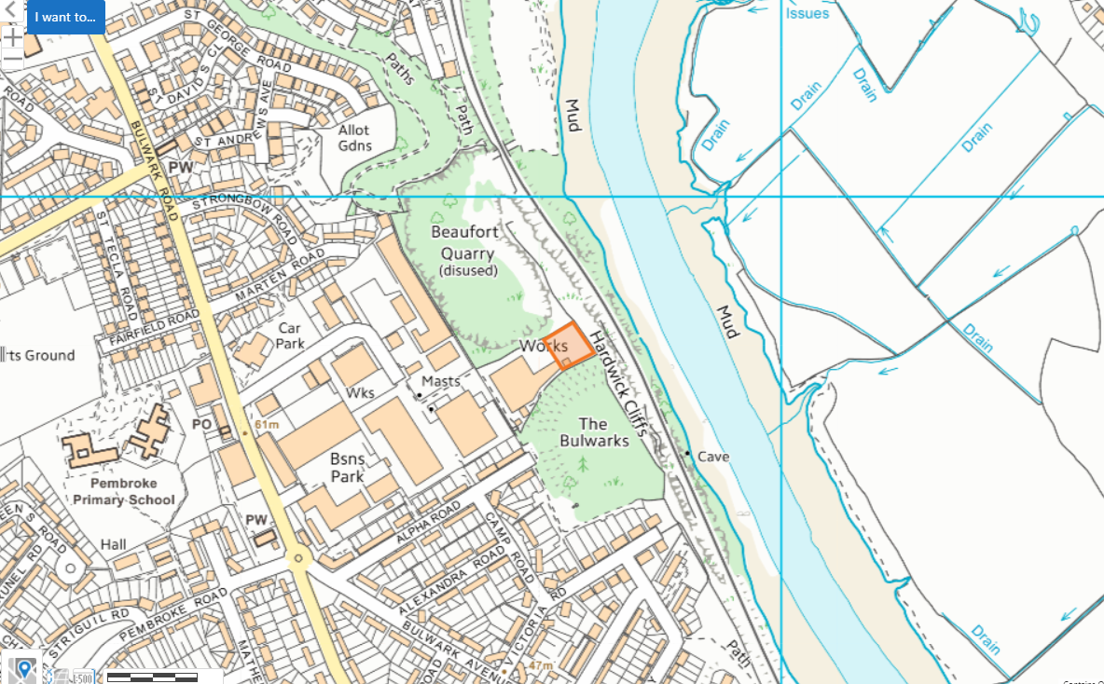

SSSI- 2km search radius
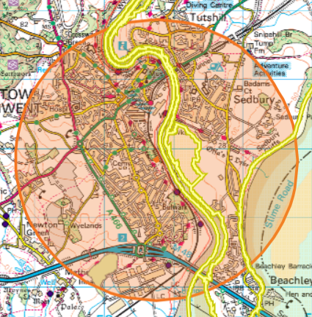
- Pierce, Alcove And Piercefield Woods (Wales)
- River Wye (Lower Wye) / Afon Gwy (Gwy Isaf) (Wales)
- Severn Estuary (Wales)
- Pennsylvania Fields, Sedbury (England)
- River Wye (England)
- Lower Wye Gorge (England)
- Severn Estuary (England)

River Wye (Lower Wye) / Afon Gwy (Gwy Isaf) (Wales) approx. 48 meters away
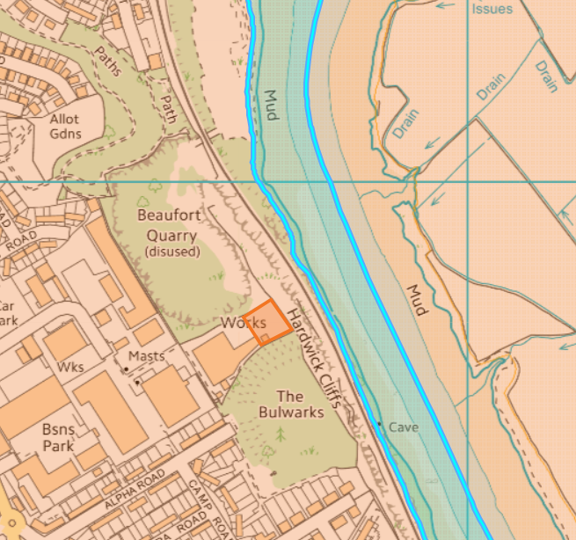
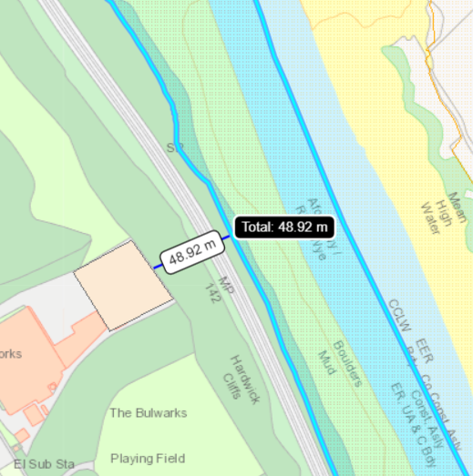
Pennsylvania Fields, Sedbury (England) approx. 186 meters away
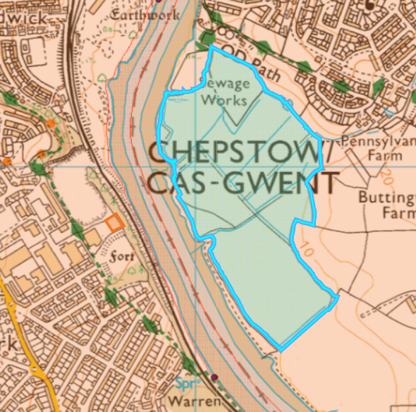
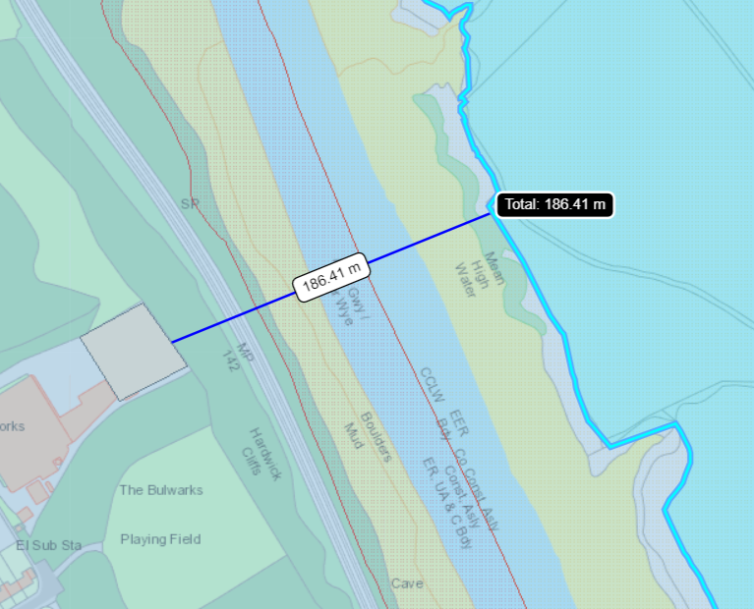

River Wye (England) approx. 110 meters away
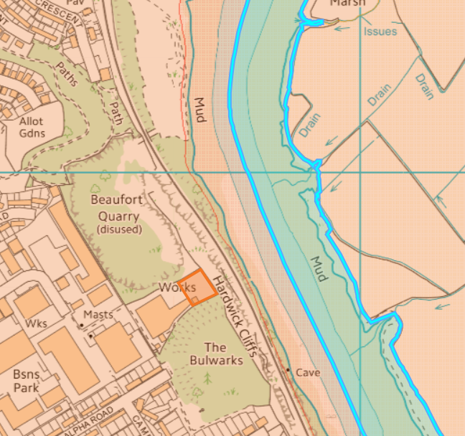
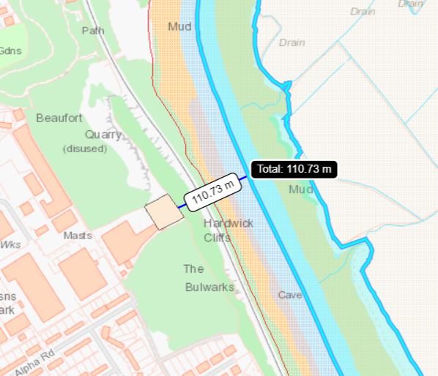

Pierce, Alcove And Piercefield Woods SSSI (Wales) approx. 1.3 km
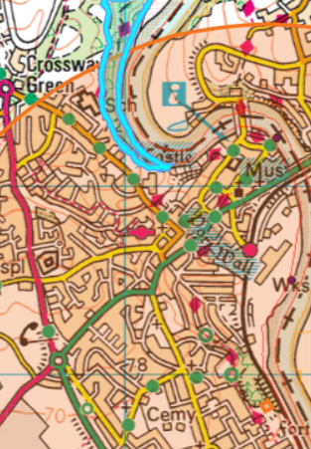
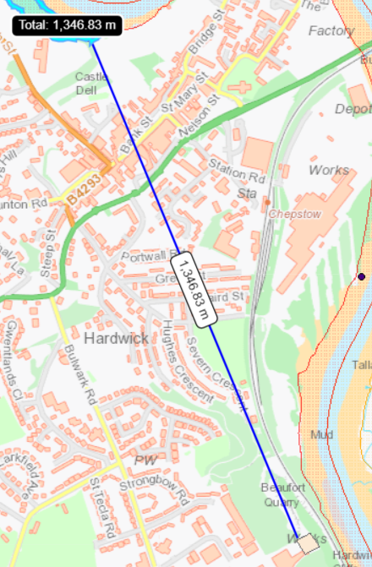
Severn Estuary SSSI (England) approx. 1.2 km to the east, 1.7 km to the south
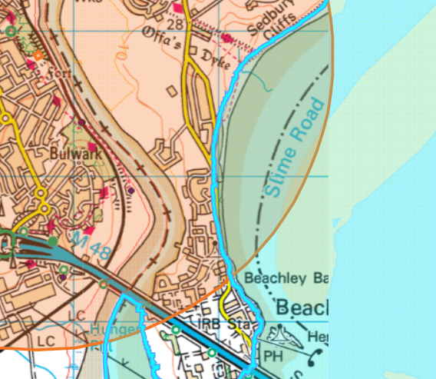
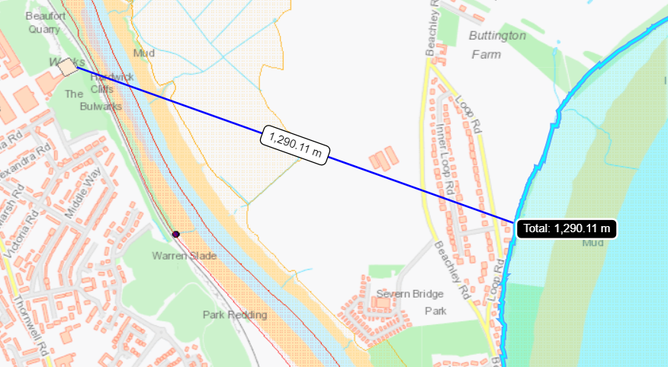
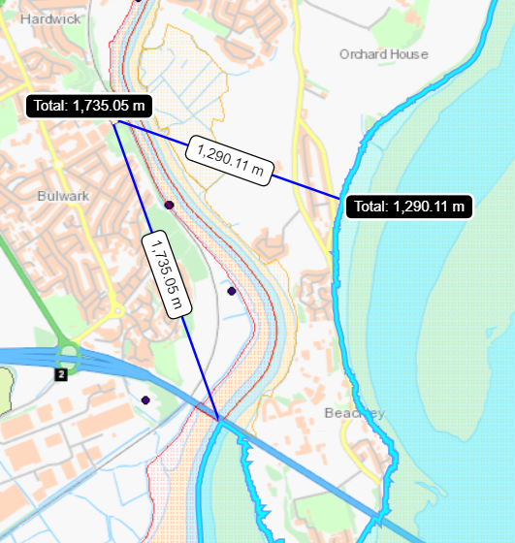

Severn Estuary SSSI (Wales) approx. 1.6km
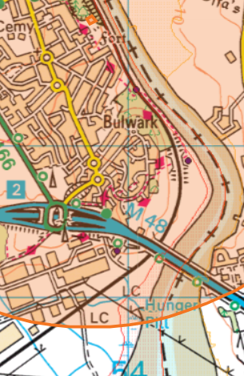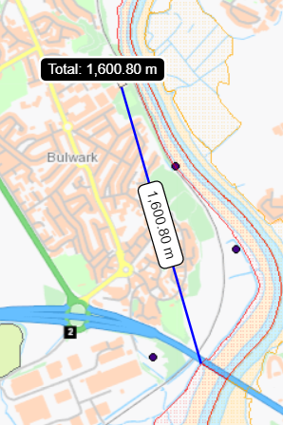
Lower Wye Gorge SSSI (England) approx. 1.9 km
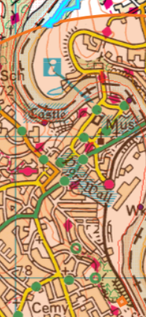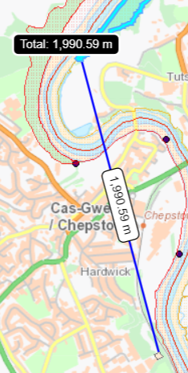

SAC – 1km
SAC: River Wye / Afon Gwy (England) approx. 110 meters
SAC: River Wye / Afon Gwy (Wales) approx. 48 meters away
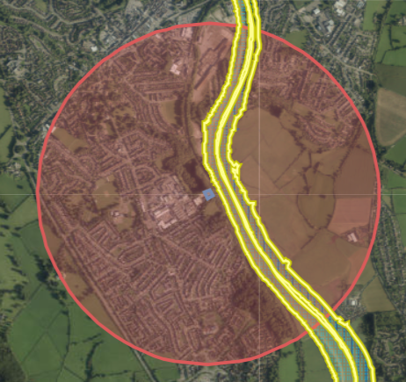
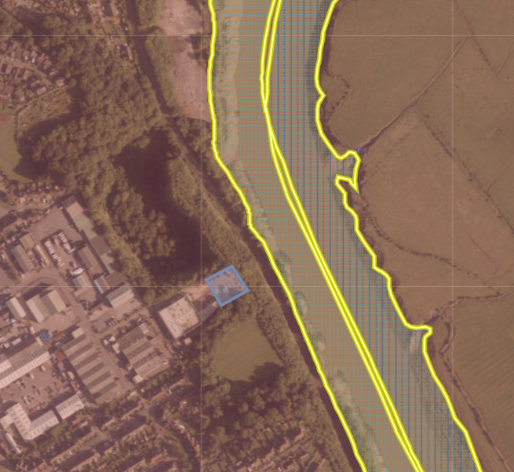

Aquifer Designation (Superficial)
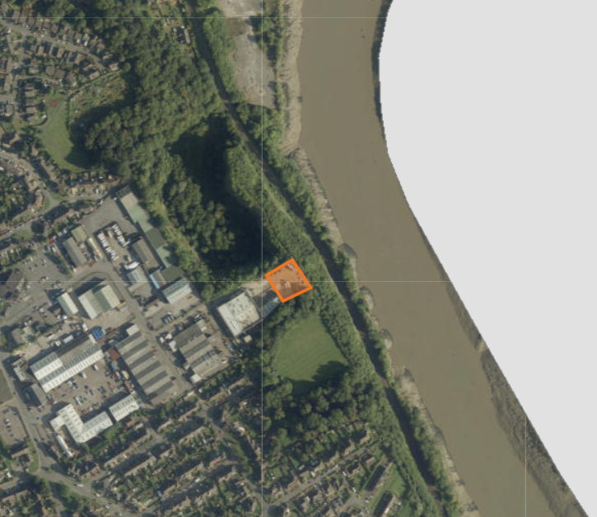
No SPZ within 2km of the site
Aquifer Designation (Bedrock)
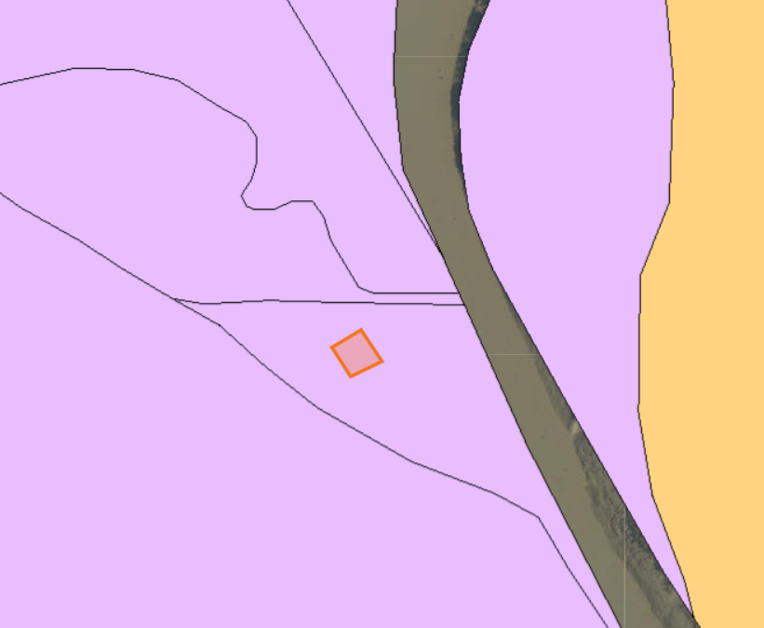 No SPZ within 2km of the site
AQMA- 2km

Monmouthshire Council- Chepstow AQMA- An area encompassing properties either side of the A48, between the roundabout with the A466 to the west and extending east just beyond the junction with the B4293 at Hardwick Terrace.
- Pollutants- NO2
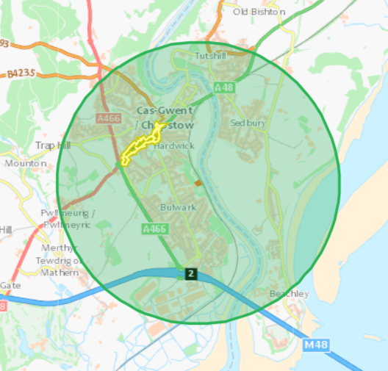

Flood plain
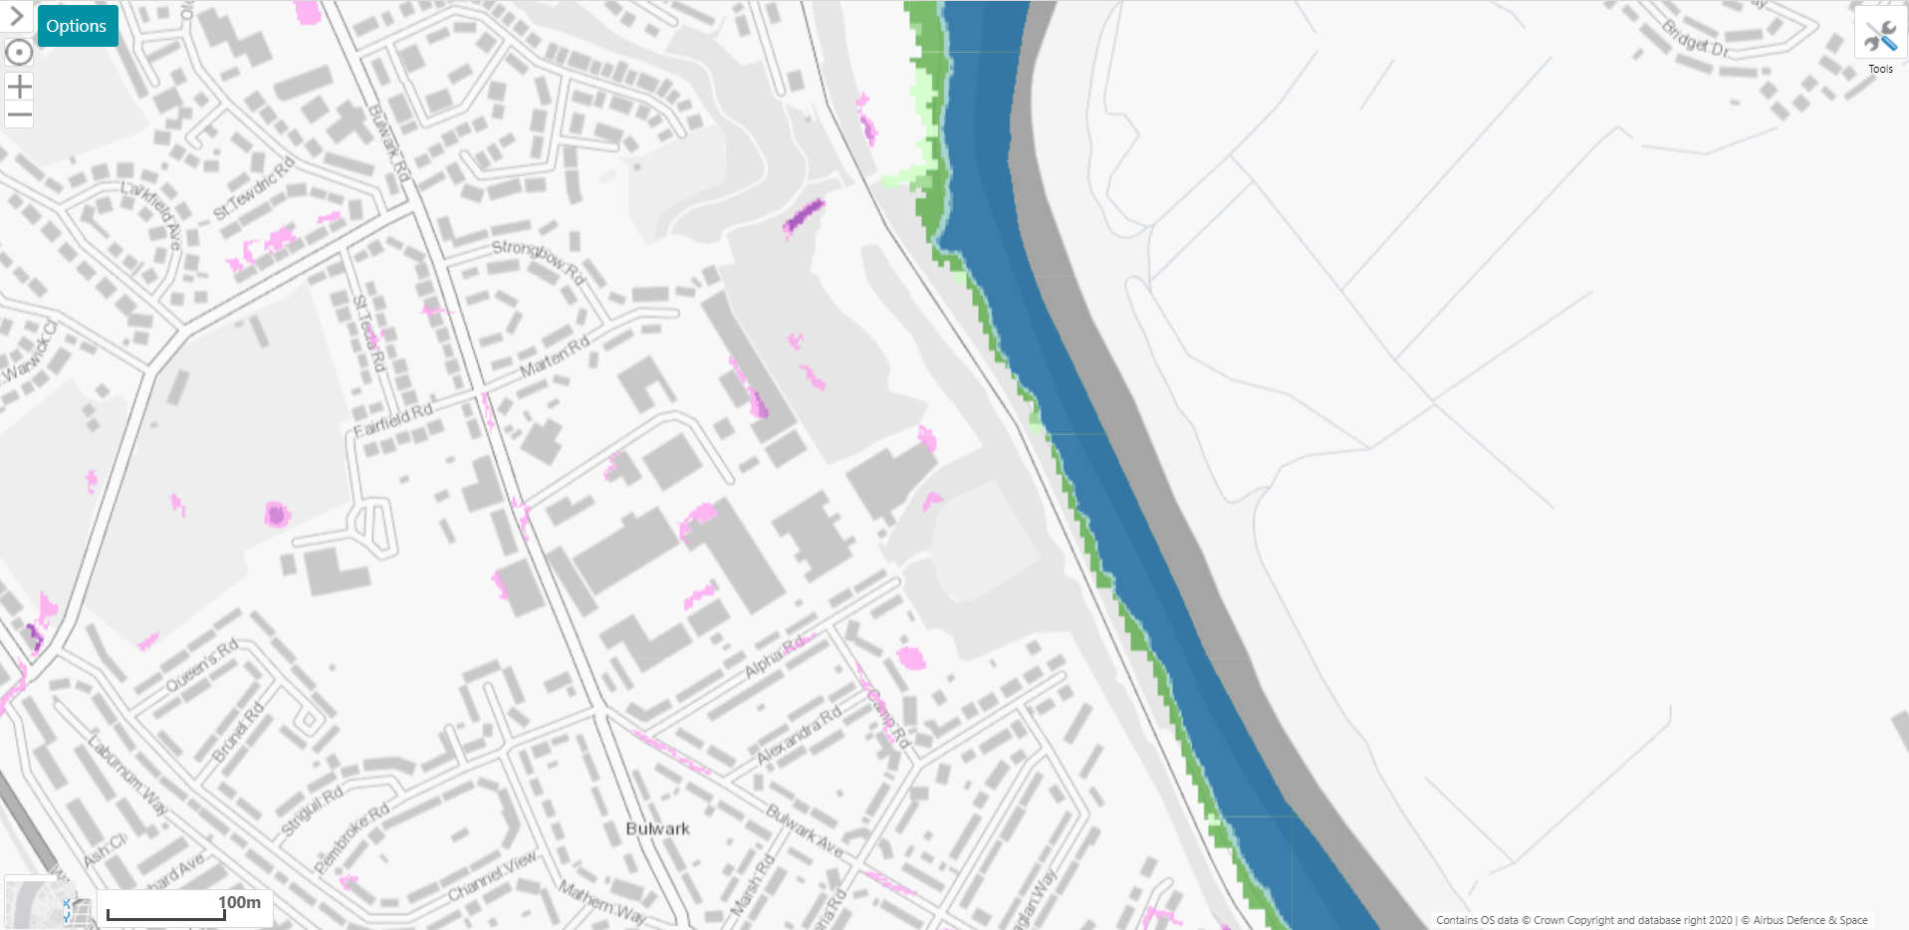

Surface water courses
River Wye approx.40 meters from the site
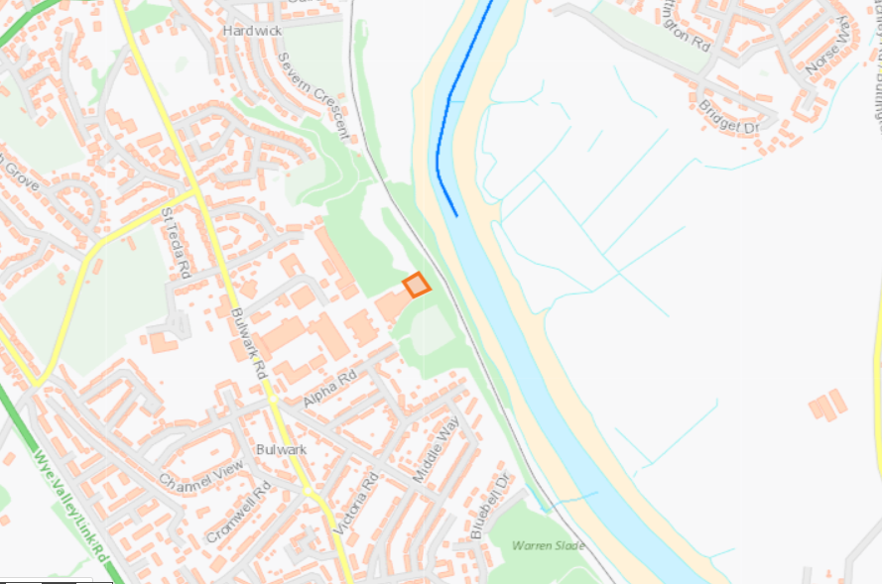

Protected species and habitats and LRC PPS Section 7 species within 500 meters
Habitats: Intertidal mudflats, Mudflats, Coastal and floodplain grazing marsh
Species: migratory routes for River Lamprey, Atlantic Salmon, Twaite Shad, Unidentified Shad, European Eel, Sea Lamprey
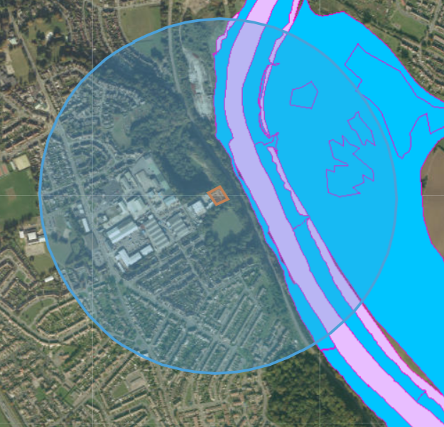
LRC PPS Section 7 species
- Variety of Butterflies/moths recorded at Chepstow (Hughes Crescent)
- Mammals- West European Hedgehog (Bulwark Avenue and St Andrews Avenue, Hazel Dormouse (Lancaut Nature Reserve), Lesser Horseshoe Bat (St Peter's Cave and Yankee Cave: Bulwark)
- Birds- Starling (Chepstow Bulwark Gwent) , Black-headed Gull/Curlew/European Herring Gull (Lower River Wye)
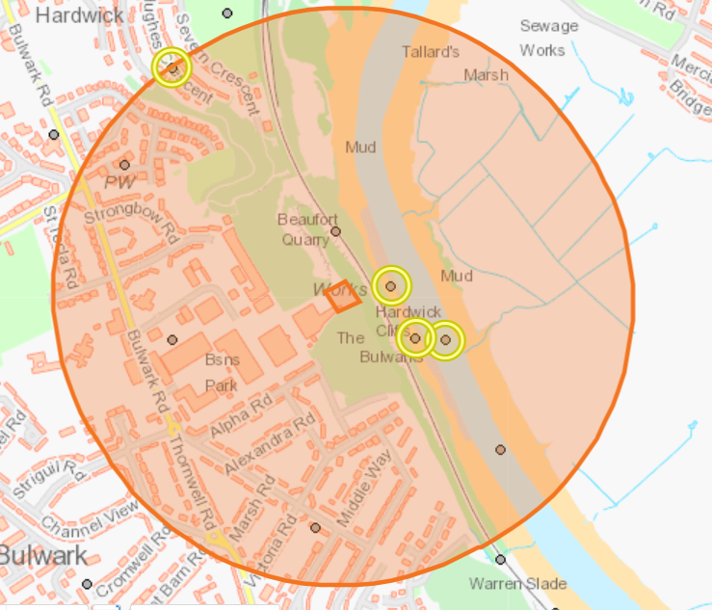
Listed Buildings, Historic Monuments, Scheduled Monuments, World Heritage Sites, Heritage Coast within 500 meters
Historic Monuments: ST CHRISTOPHER, BULWARK (church), MODERN HOUSING ESTATE, CHEPSTOW, 2x DEMOLISHED CHAPEL, CHEPSTOW: THE BULWARKS (HILLFORT), ST PETER'S CAVE (cave)
Scheduled Monuments: Bulwarks Camp and St Peter's Cave
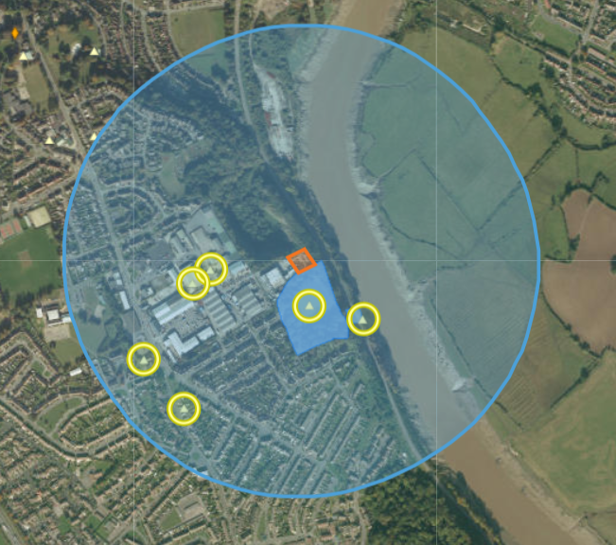
Ancient Woodland within 500 m
- Restored ancient woodland site and ancient semi natural woodland
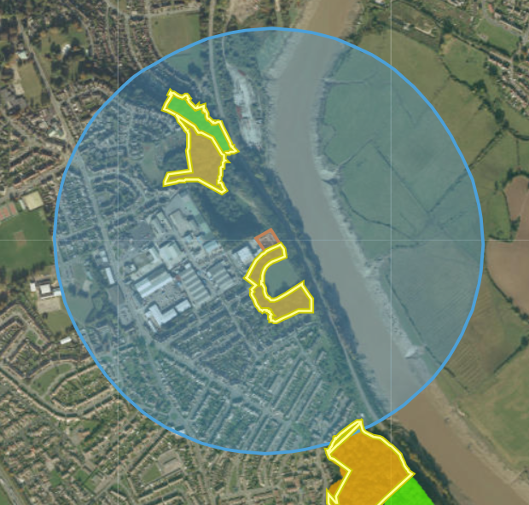

Local Wildlife Sites (SINCs) within 500 m
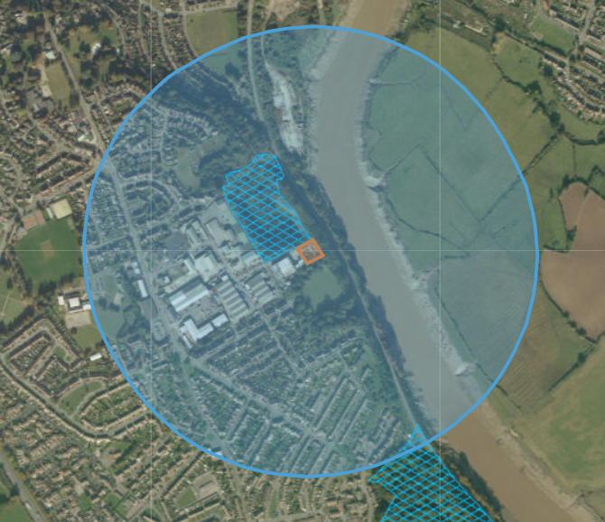
- Beaufort Quarry
- Warren Slade & Park Warren (Ancient and Semi Natural Woodland)

