CRoW Appendix 4 (140_10_SD02)  CRoW Act 2000: Natural Resources Wales application for permission - Formal Notice |  | 
Natural Resources Wales Formal Notice.
Requirements of Section 28I of the Wildlife & Countryside Act 1981 as amended by the Countryside and Rights of Way Act (CRoW) 2000.
Duty in relation to granting any consent, licence or permit for activities likely to damage Sites of Special Scientific Interest (SSSI).
Guide to filling in this form for Natural Resources Wales staff:
To be completed by Permitting Officers for any applications for a permission which the Natural Resources Wales has considered under S28G duties to protect and enhance SSSIs. This applies to all proposed permissions within a SSSI, and to operations outside the SSSI boundary which are likely to damage its special features.
Refer to OI 140_10 ‘Applying the Countryside and Rights of Way (CRoW) Act 2000 to applications for permits with potential for impact on Sites of Special Scientific Interest (SSSI)’, including the flowchart in Appendix 2.
Pink italic text – drafting notes, to be deleted before completion/consultation.
Blue text – examples, to be replaced with permission-specific information.
Ensure you have completed all sections.
- Natural Resources Wales area/region/NPS hub: | South Central
- Name of SSSI: | - Penycastell, Cefn Cribwr  - Storm Down  - Waun Cimla
- Type of permission: | Bespoke waste permit
- Date for Natural Resources Wales permit determination: | 16/12/2023
- Predicted 28 day date for response from NRW conservation/ecology (under S28 I(4)): | N/A
- Natural Resources Wales reference no: | PAN-021479
- National grid reference: | SS 83427 81951
- Description of proposal: | The proposed site will be a household waste amenity site taking both hazardous and non-hazardous wastes, as well as accepting some municipal waste. The site will have a total annual throughput of 20,017 tonnes per year. There will be no treatment activities taking place on site.
- Is the proposed activity within (wholly or partially) the SSSI boundary? | NO  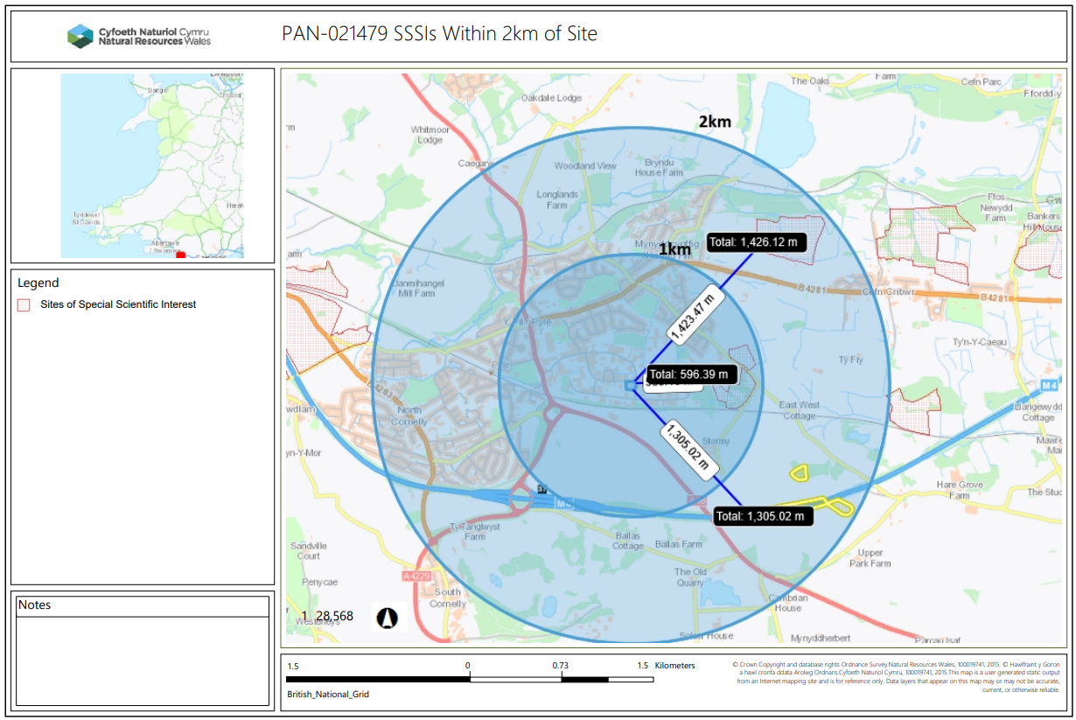  - Penycastell, Cefn Cribwr. 596m.  - Stormy Down. 1305m.  - Waun Cimla. 1426m.
- Has there been any pre-application discussion or correspondence with NRW conservation/ecology | NO
- What aspect(s) of the proposed permission may damage the features which are of special interest for the SSSI?
Penycastell, Cefn Cribwr
The following ‘Operations Requiring Consent’ (or other activities associated with the permission) that may cause damage) are relevant to the proposed permission.
21. Destruction, construction, removal, rerouting, or regrading of roads, tracks, walls, fences, hardstands, banks, ditches or other earthworks, including soil and rock exposures.
22. Storage of materials
23. Erection of permanent or temporary structures or the undertaking of engineering works, including drilling or the laying, maintenance or removal of pipelines and cables, above or below ground.
24. Modification of natural or man-made features.
26. Use of vehicles.

The following SSSI features and mechanisms of impact have been considered to assess the likelihood of damage:
- Marshy grasslands

Storm Down
The following ‘Operations Requiring Consent’ (or other activities associated with the permission) that may cause damage) are relevant to the proposed permission.
21. Construction, removal or destruction of roads, tracks, walls, fences, hardstands, banks, ditches or other earthworks or the laying, maintenance or removal of pipelines and cables, above or below ground.
23. Erection of permanent or temporary structures or the undertaking of engineering works, including drilling.

The following SSSI features and mechanisms of impact have been considered to assess the likelihood of damage:
- Rhaetian Quarella Sandstone

Waun Cimla

The following ‘Operations Requiring Consent’ (or other activities associated with the permission) that may cause damage) are relevant to the proposed permission.
11. Destruction, removal or pruning of any plant or plant remains, including tree, herb, hedge, moss or turf (N.b., only relevant during site construction)
21. Construction, removal or destruction of roads, tracks, walls, fences, hardstands, banks, ditches or other earthworks.
23. Erection of permanent or temporary structures or the undertaking of engineering works, including the laying, maintenance or removal of pipelines and cables.
26. Use of vehicles likely to damage the special interest.

The following SSSI features and mechanisms of impact have been considered to assess the likelihood of damage:
- Marshy Grassland

- Decision
i) The proposed permission is not likely to damage any of the flora, fauna or geological or physiological features which are of special interest.
- Penycastell, Cefn Cribwr. The proposed activities will be, at minimum, 596m from the operations on site. There is no conceivable pathway from the waste site to the SSSI as there are no connecting waterways and there is no significant dust risk from the activities.
- Storm Down. The site is solely designated for its sandstone qualities, which will not be affected by any of the operations on site.
- Waun Cimla. The proposed activities will be, at minimum, 1426m from the operations on site. There is no conceivable pathway from the waste site to the SSSI as there are no connecting waterways and there is no significant dust risk from the activities.

Natural Resources Wales is minded to:
Issue the permission

- Name and job title of Natural Resources Wales officer: | Rhiannon Smith  Permitting Officer
- Date form sent to NRW conservation/ecology | N/A
For Natural Resources Wales use only, once NRW conservation/ecology response received
- NRW conservation/ecology comment on assessment: | Please delete as appropriate:  i) NRW conservation/ecology advise the operation can go ahead  ii) NRW conservation/ecology advise the operation can go ahead with conditions  iii) NRW conservation/ecology advise against permitting the operation  Please ensure that the NRW conservation/ecology response is attached to this Formal Notice.
- Name and job title of NRW conservation/ecology officer:
- Date of receipt of NRW conservation/ecology response:

