CRoW Appendix 4 (140_10_SD02)  CRoW Act 2000: Natural Resources Wales application for permission - Formal Notice |  | 
Natural Resources Wales Formal Notice.
Requirements of Section 28I of the Wildlife & Countryside Act 1981 as amended by the Countryside and Rights of Way Act (CRoW) 2000.
Duty in relation to granting any consent, licence or permit for activities likely to damage Sites of Special Scientific Interest (SSSI).
- Natural Resources Wales area/region/NPS hub: | South East
- Name of SSSI: | Pierce, Alcove And Piercefield Woods (Wales)  River Wye (Lower Wye) / Afon Gwy (Gwy Isaf) (Wales)  Severn Estuary (Wales)  Pennsylvania Fields, Sedbury (England)  River Wye (England)  Lower Wye Gorge (England)  Severn Estuary (England)
- Type of permission: | Bespoke Environmental Permit for a Clinical Waste Transfer Station
- Date for Natural Resources Wales permit determination: | 17/02/2023
- Predicted 28 day date for response from NRW conservation/ecology (under S28 I(4)): | n/a saved for information only
- Natural Resources Wales reference no: | PAN-021000
- National grid reference: | ST 53761 92830
- Description of proposal: | Application is for the secure storage and transfer of select non-hazardous, washroom and medicine waste, predominantly from commercial and industrial sectors.  The proposed waste types are non-hazardous and nonbiodegradable.  All waste will be collected separately and stored appropriately at the Site before being transferred to a suitably licenced facility.  The waste will comprise of non-infectious sharps (18 01 01, 18 02 01 and 20 01 99), feminine hygiene products, nappies, and bandages (18 01 04), non-hazardous medicines (18 01 09, 18 02 08 and 20 01 32) and other separately collected non-hazardous waste, e.g., non-infectious sharps, dead animals, or vomit (20 01 99).  There will be no treatment or sorting of waste carried out on Site.  Waste throughputs are expected to be less than 1,000 tonnes per year. The Operator will store a maximum quantity of 50 tonnes of waste, at any one time. Waste will be stored for a maximum of 1 month.  Waste will be stored securely, in appropriate containers on impermeable surfacing with sealed drainage.  Waste storage areas comprise impermeable surfacing, with kerbing to contain any run-off. There is no discharge from the waste storage areas. Any controlled water will be contained and removed from Site to a suitably licenced facility.  - Sanitary waste will be collected in bags from multiple washrooms and placed into a larger bag for transit. Upon arrival at the Site, the double-bagged waste will be placed into an enclosed, lockable metal bin (triple containment). Sanitary waste will be stored for no longer than 7 days. The triple containment of the waste will have the effect of providing mitigation against both odour, leakage, and interaction with other waste.  - Medicine waste will be collected in ‘blue-stream” pharmaceutical waste bins. It is considered that the medicine waste will consist of blister packs and non-hazardous domestic ‘over the counter’ medicines which are expired, unused, damaged, or no longer needed. The bins in which the medicine waste is collected remain sealed so no contamination or mixing of waste can occur. Upon arrival at the Site the smaller sealed bins are collectively stored in secure larger storage containers.  - Sharps waste will be collected in sealed sharps bins. The bins in which the sharps are collected remain sealed so no contamination or mixing of waste can occur. Upon arrival to the Site, these smaller secure bins will be collectively stored in secure metal cages or bins.  Sharps accepted onto Site are collected from commercial properties and are non-infectious, including but not limited to Stanley knives, Sewing needles, Scalpels and blades and Broken glass.  - Ancillary bathroom waste will be stored in a separate sealed bin.  Dusty wastes will not be accepted to site and will be rejected in accordance with the waste rejection procedure
- Is the proposed activity within (wholly or partially) the SSSI boundary? | No  River Wye (Lower Wye) / Afon Gwy (Gwy Isaf) (Wales) approx. 48 meters away  Pennsylvania Fields, Sedbury (England) approx. 186 meters away  River Wye (England) approx. 110 meters away  Pierce, Alcove And Piercefield Woods SSSI (Wales) approx. 1.3 km  Severn Estuary SSSI (England) approx. 1.2 km to the east, 1.7 km to the south  Severn Estuary SSSI (Wales) approx. 1.6km  Lower Wye Gorge SSSI (England) approx. 1.9 km
- Has there been any pre-application discussion or correspondence with NRW conservation/ecology | No
- What aspect(s) of the proposed permission may damage the features which are of special interest for the SSSI?
SSSI | ‘Operations Requiring Consent’ (or other activities associated with the permission) that may cause damage) are relevant to the proposed permission | SSSI features have been considered to assess the likelihood of damage | Mechanisms of impact have been considered to assess the likelihood of damage
River Wye (Lower Wye) / Afon Gwy (Gwy Isaf) (Wales) (England) | None | - Running water supporting Ranunculion vegetation  - Otter  - Fish Species-  - Atlantic salmon, Twaite shad, Sea lamprey, river lamprey, Bullhead  - Flowering rush  - Rare and scarce mosses and liverworts  - Goosander  - White-clawed or Atlantic stream crayfish  - Aquatic invertebrates  - These include broadleaved woodland, scrub, flood plain grassland, tall weeds, swamp and marginal vegetation, intertidal mud, saltmarsh and river gravel and sandbanks. This diversity of habitats similarly supports a wide range of species, including breeding birds, bats and terrestrial plants and invertebrates. | - Water quality  - Water quantity  - Bankside habitat management  - Fishery management  - Invasive alien species  - Development works  - Navigation & Recreation
Pennsylvania Fields, Sedbury (England) | 22 Storage of materials | - Marshy grassland with intermittent inundation by estuarine waters | - Undergrazing  - Prevention of flooding
Pierce, Alcove And Piercefield Woods SSSI (Wales) | None | - Semi-natural broadleaved woodland | - Past management  - Livestock grazing  - Invasive and exotic species
Severn Estuary SSSI (Wales) (England) | n/a not assessed due to small scale of the activity and distance between SSSI and site (approx. 1.2km)
Lower Wye Gorge SSSI (England) | n/a not assessed due to small scale of the activity and distance between SSSI and site (approx. 1.9 km)
- Decision
i) The proposed permission is not likely to damage any of the flora, fauna or geological or physiological features which are of special interest.
This is because there no pathway for features to be affected. This permit is for a small amount of waste that will be triple contained (double bagged and stored within metal bin) on an impermeable surface with no water discharges from the permitted area.

Natural Resources Wales is minded to issue the permission
- Name and job title of Natural Resources Wales officer: | Louise Bailey  Permitting Officer
- Date form sent to NRW conservation/ecology | n/a saved for information only 24/10/2023

Site location
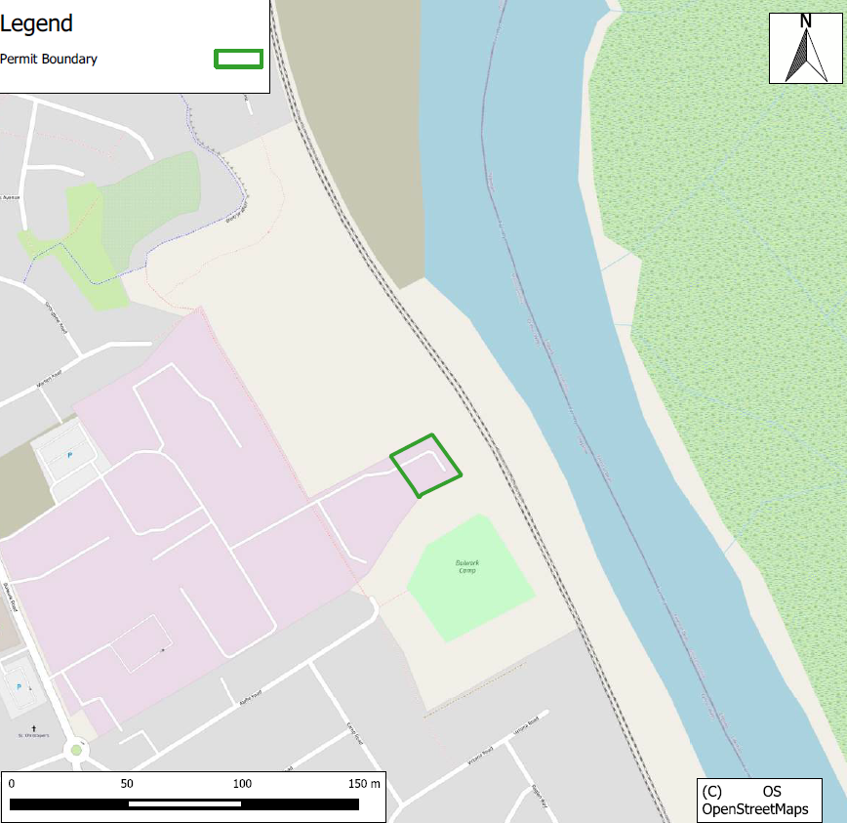

SSSI- 2km search radius
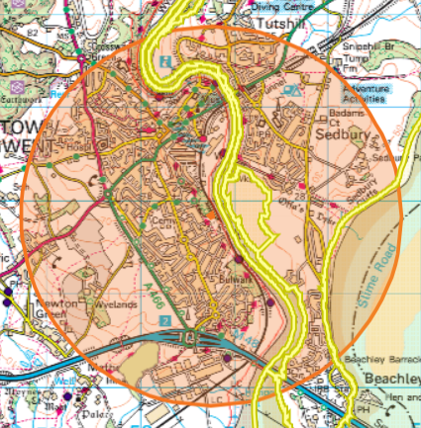
- Pierce, Alcove And Piercefield Woods (Wales)
- River Wye (Lower Wye) / Afon Gwy (Gwy Isaf) (Wales)
- Severn Estuary (Wales)
- Pennsylvania Fields, Sedbury (England)
- River Wye (England)
- Lower Wye Gorge (England)
- Severn Estuary (England)

River Wye (Lower Wye) / Afon Gwy (Gwy Isaf) (Wales) approx. 48 meters away
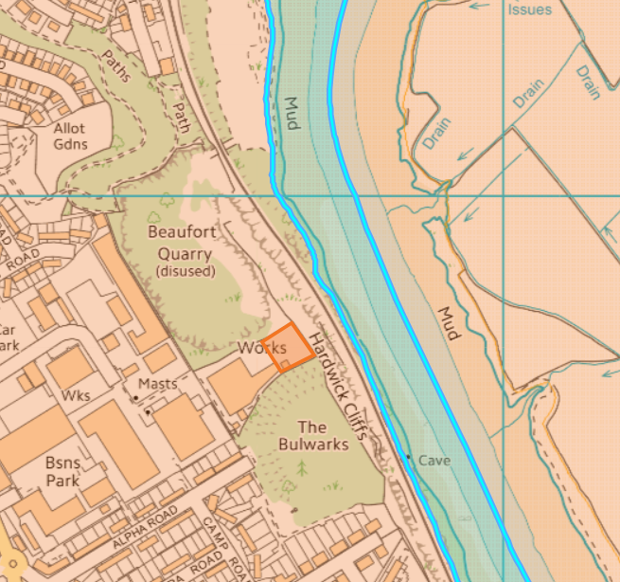
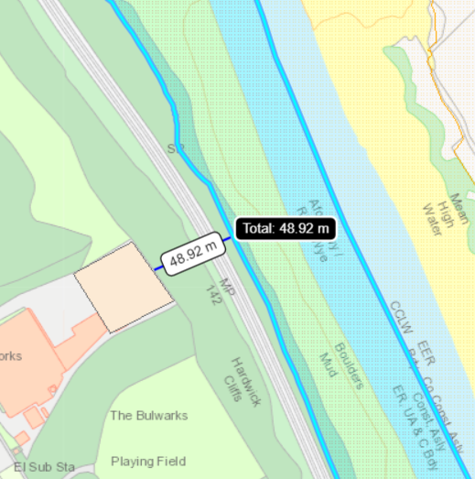
Pennsylvania Fields, Sedbury (England) approx. 186 meters away
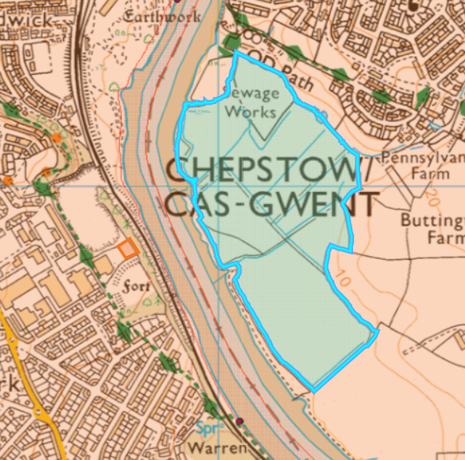
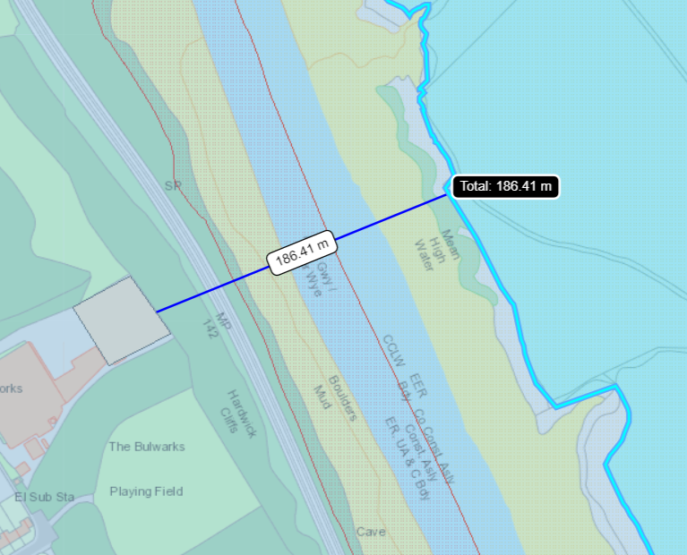

River Wye (England) approx. 110 meters away
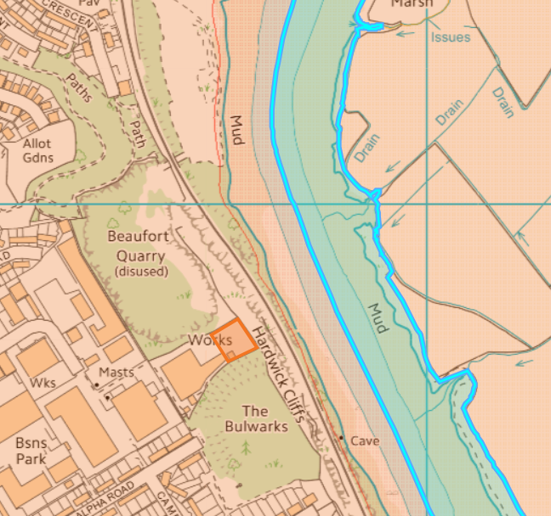
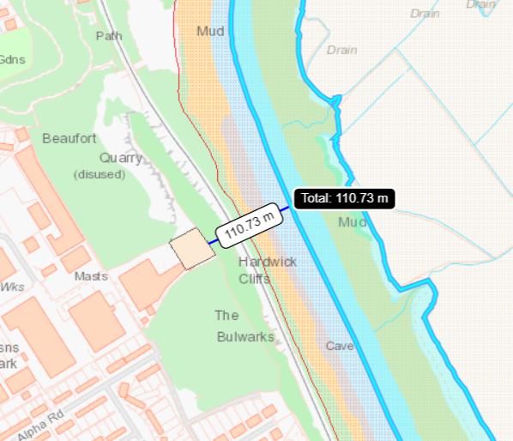

Pierce, Alcove And Piercefield Woods SSSI (Wales) approx. 1.3 km
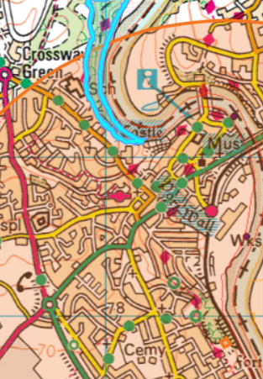
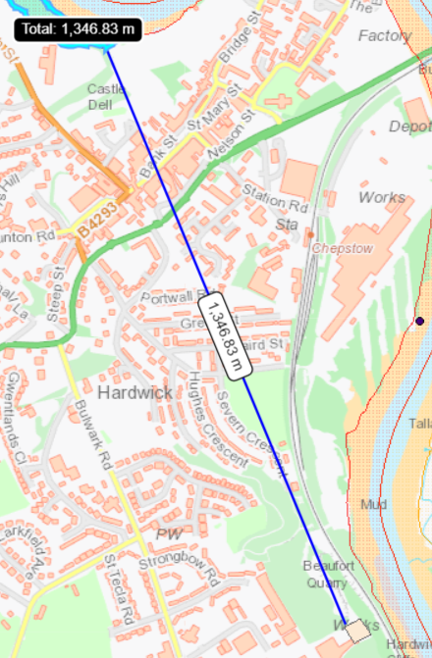
Severn Estuary SSSI (England) approx. 1.2 km to the east, 1.7 km to the south
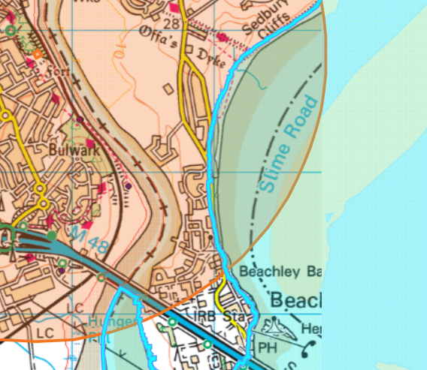
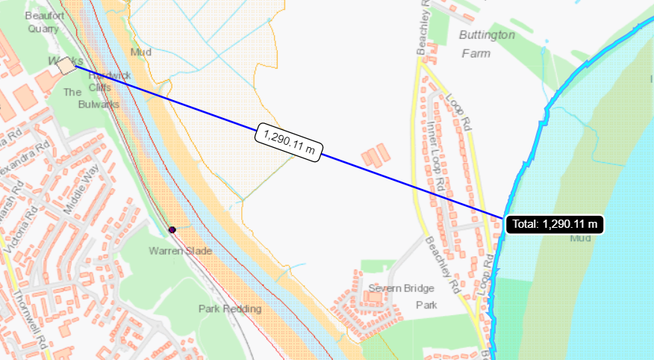
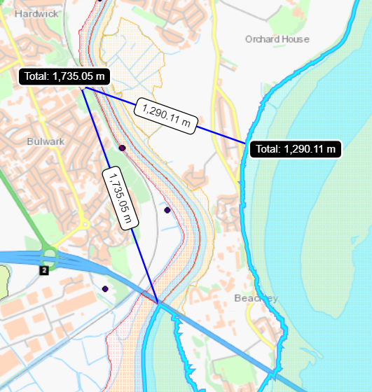

Severn Estuary SSSI (Wales) approx. 1.6km
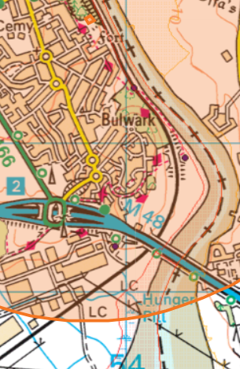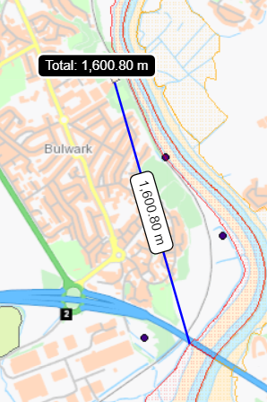
Lower Wye Gorge SSSI (England) approx. 1.9 km


