Cwrtgwenddwr Woods Recycling Centre Compliance Visit Photographs

Taken by Malcolm Dines

12th October 2023

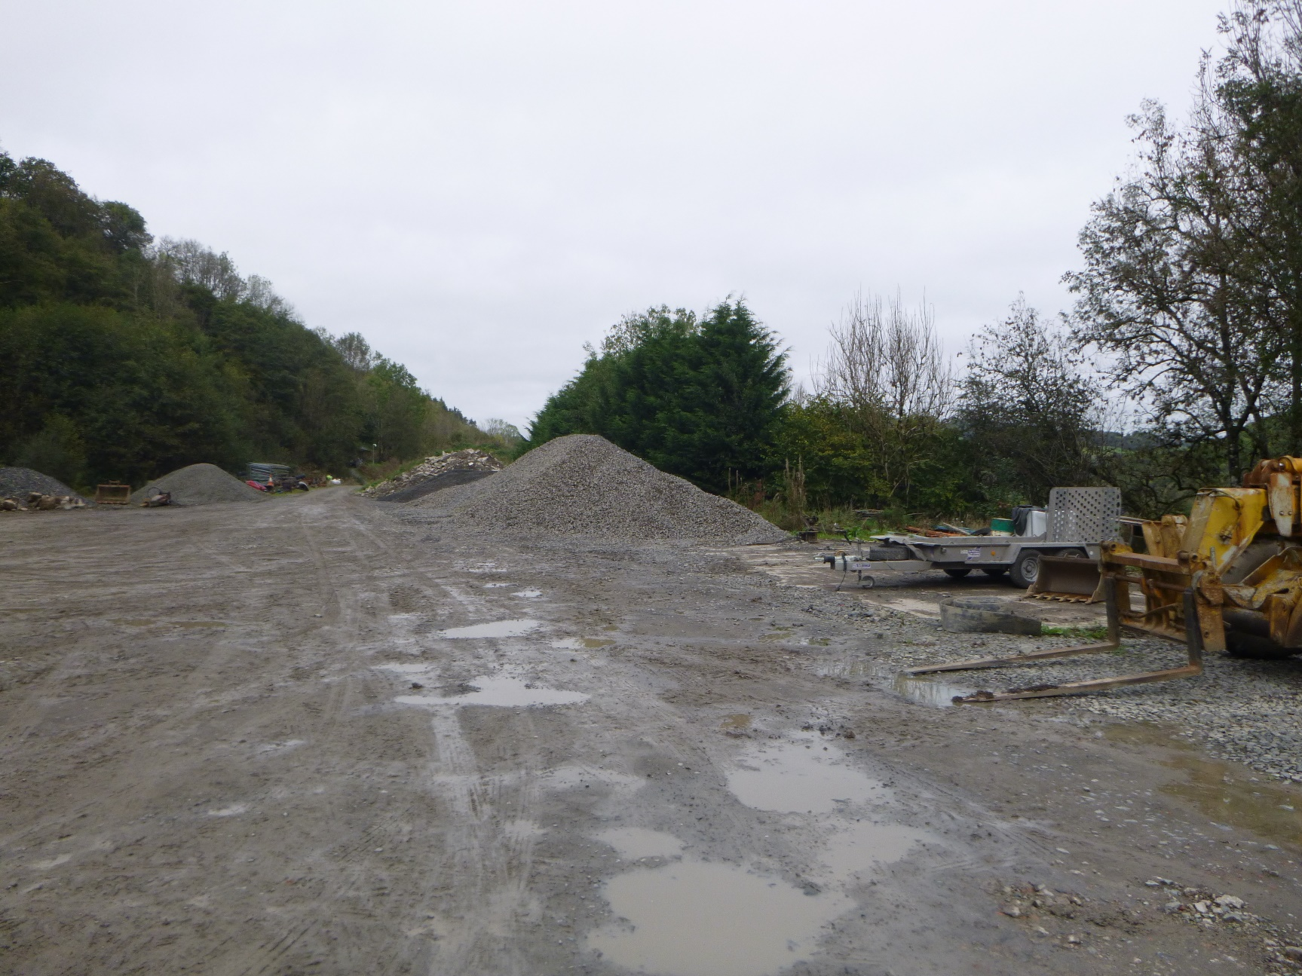
Machinery parked on ara of site marked as “Wash Bay” on site pan in EMS
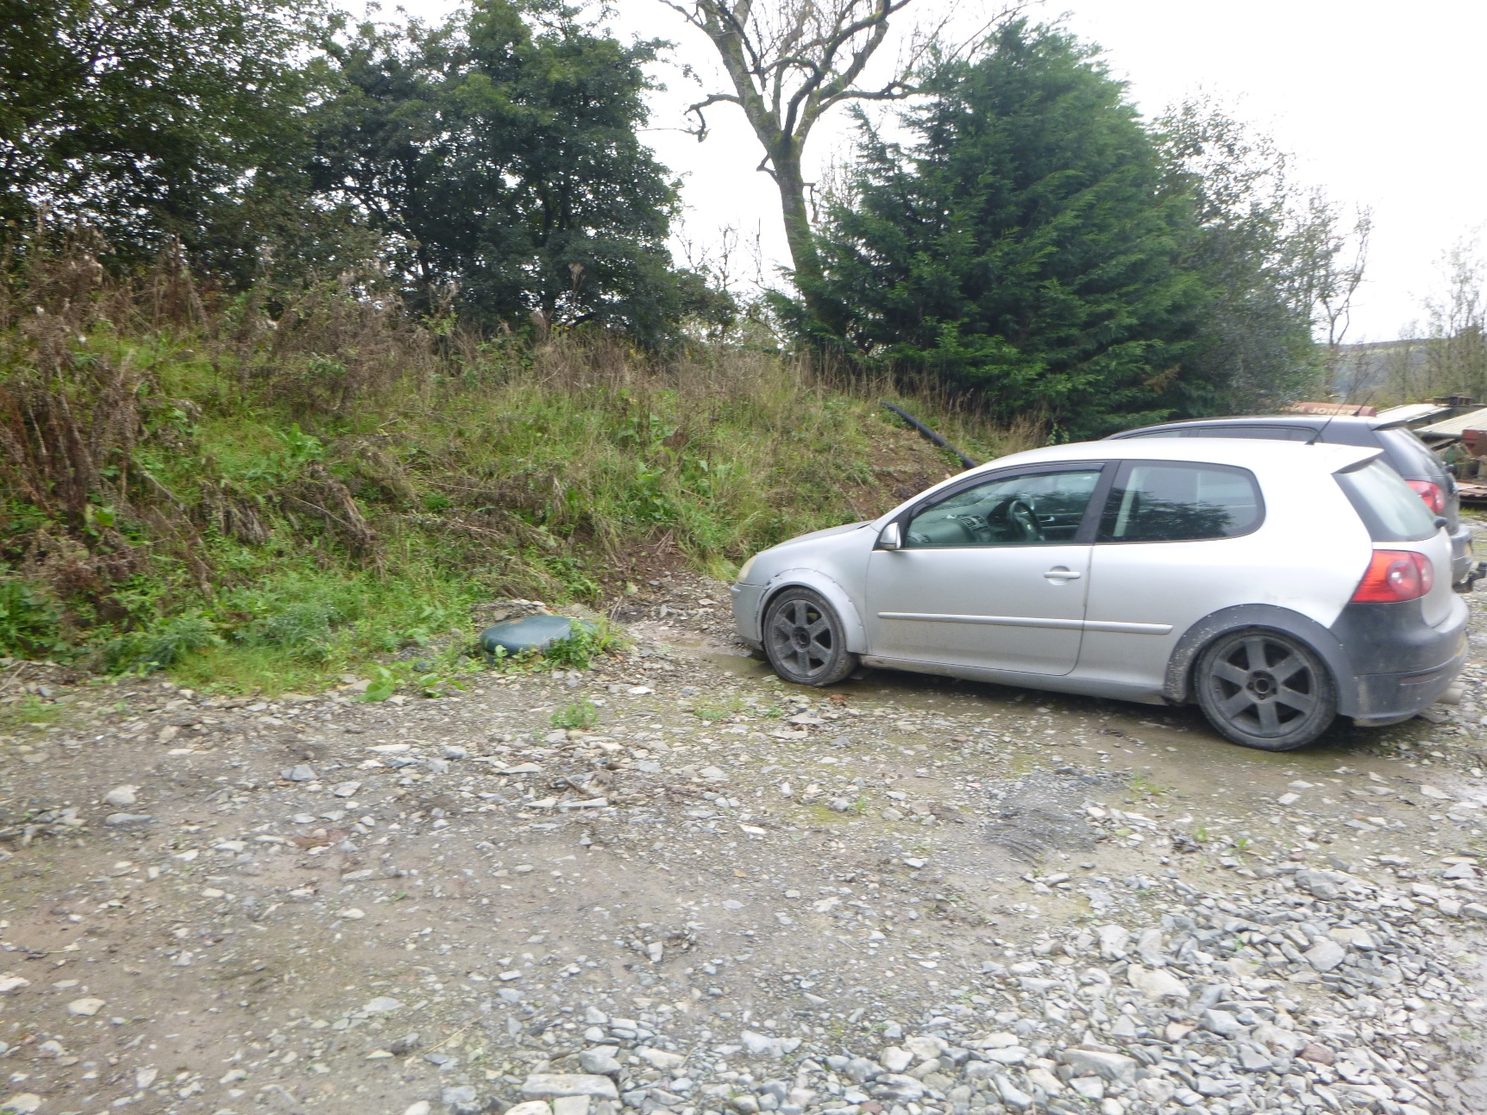
Location of surface water storage tank
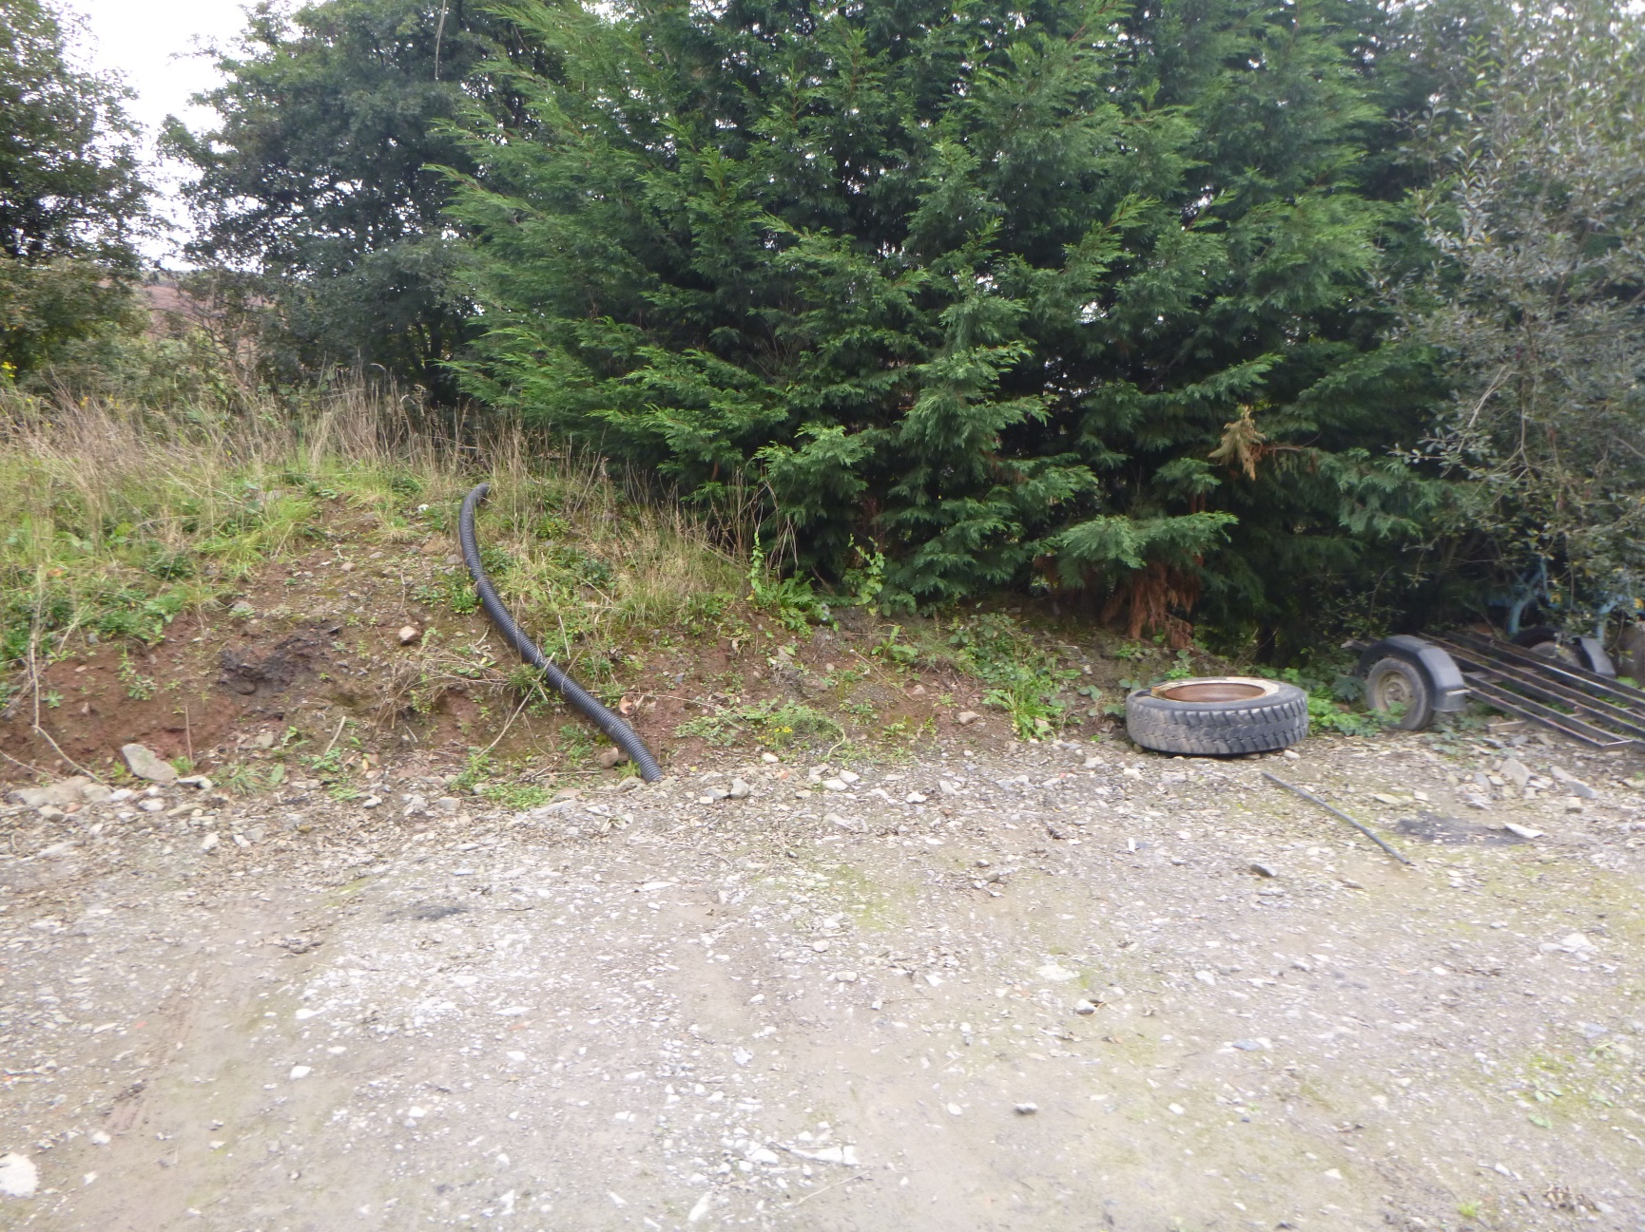
Drainage pipe from area of surface water drainage tank
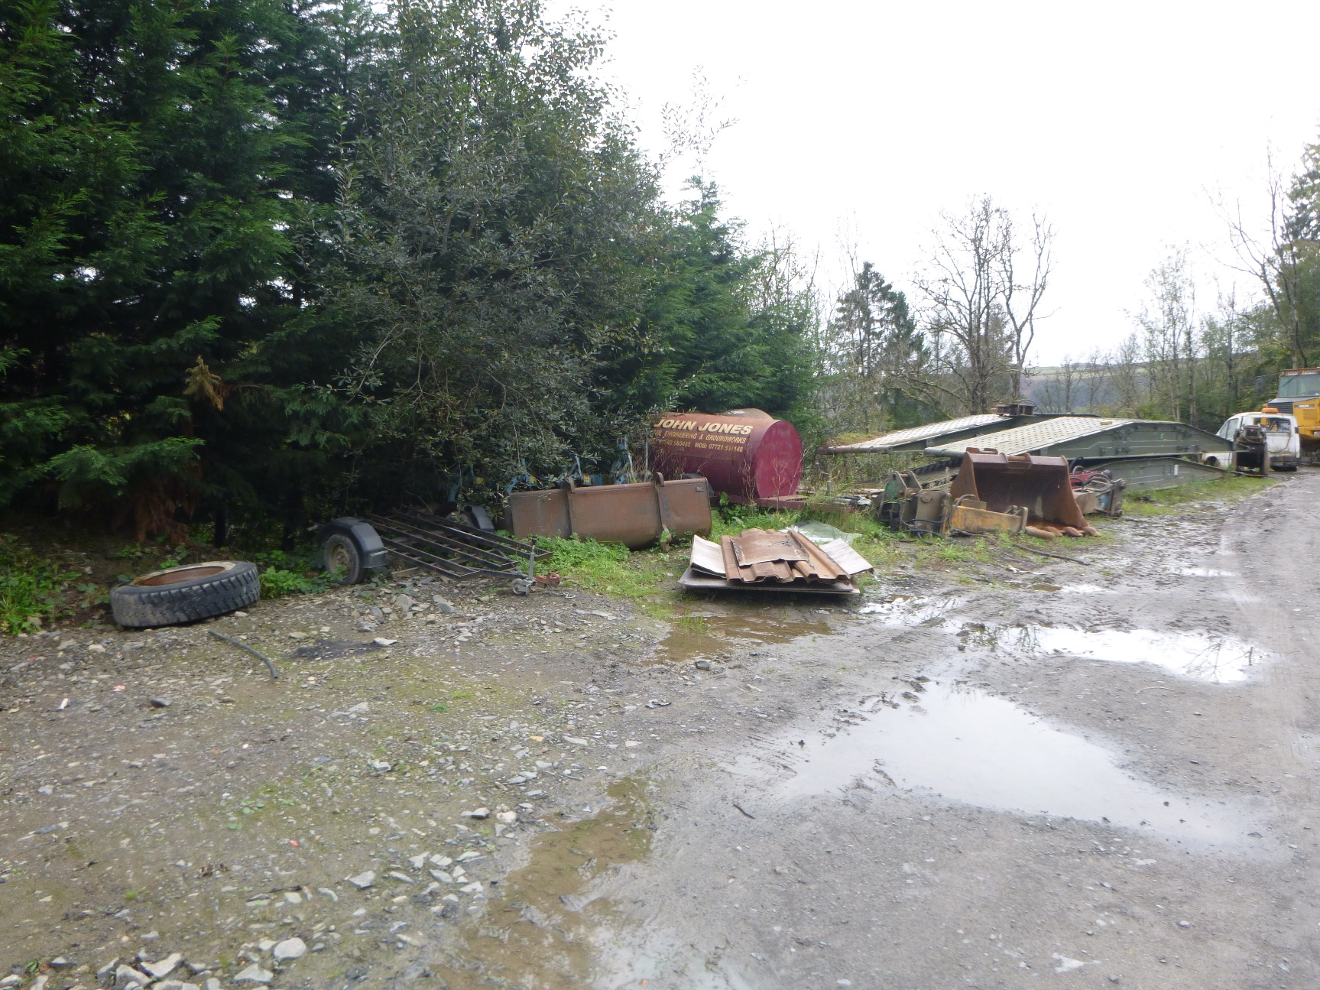
Location of three-stage interceptor. Manholes not visible during inspection.
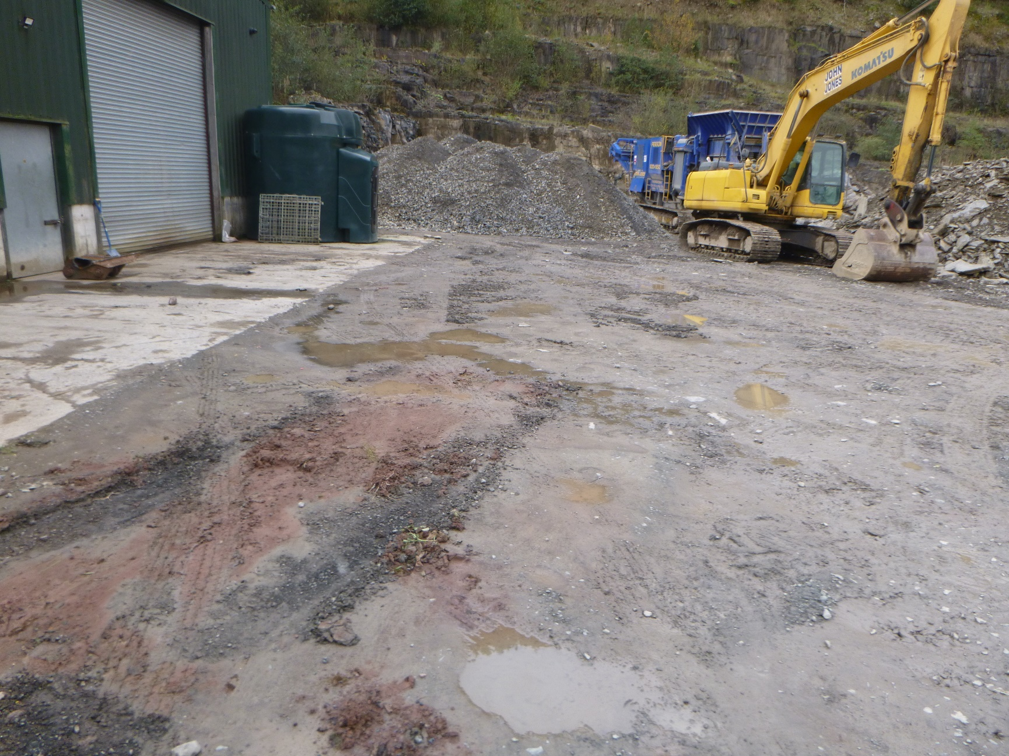
Bunded fuel store stored on concrete surface
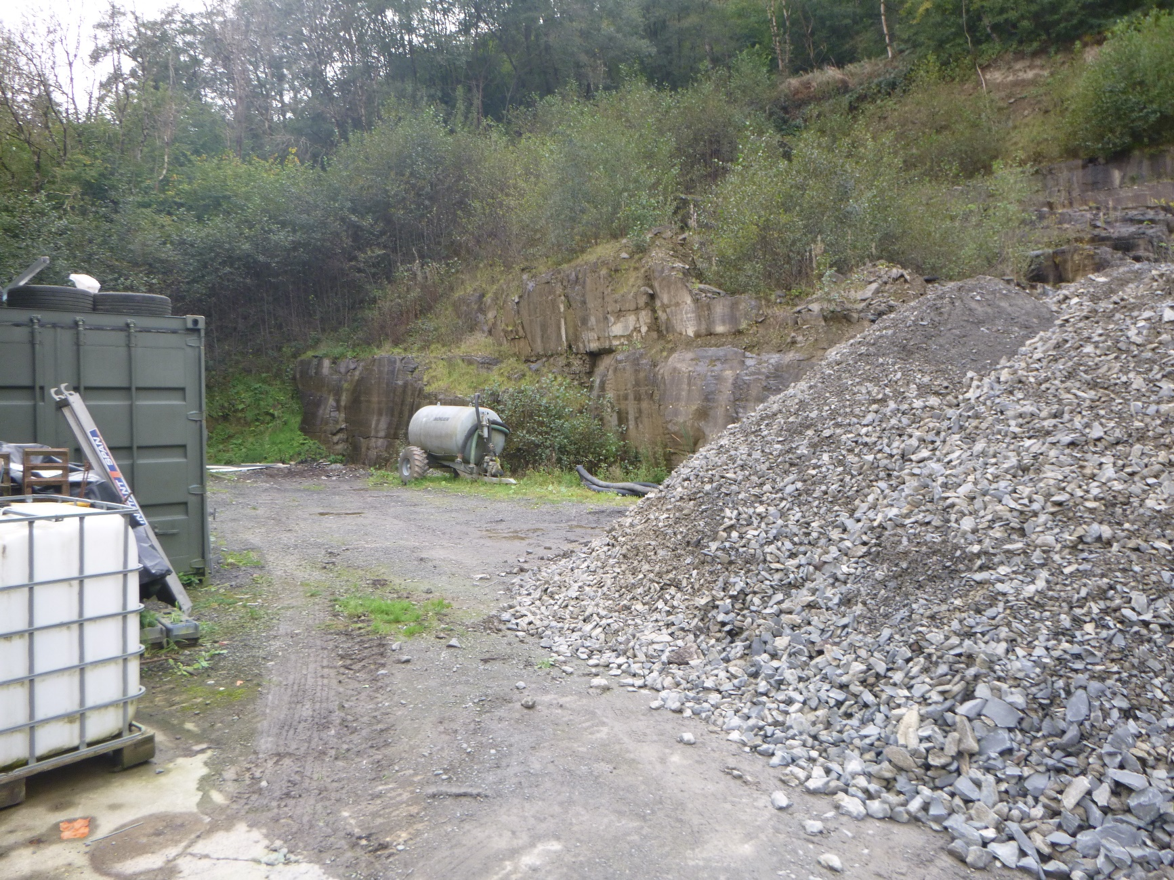
Rear of the site with water bowser and area of burning.
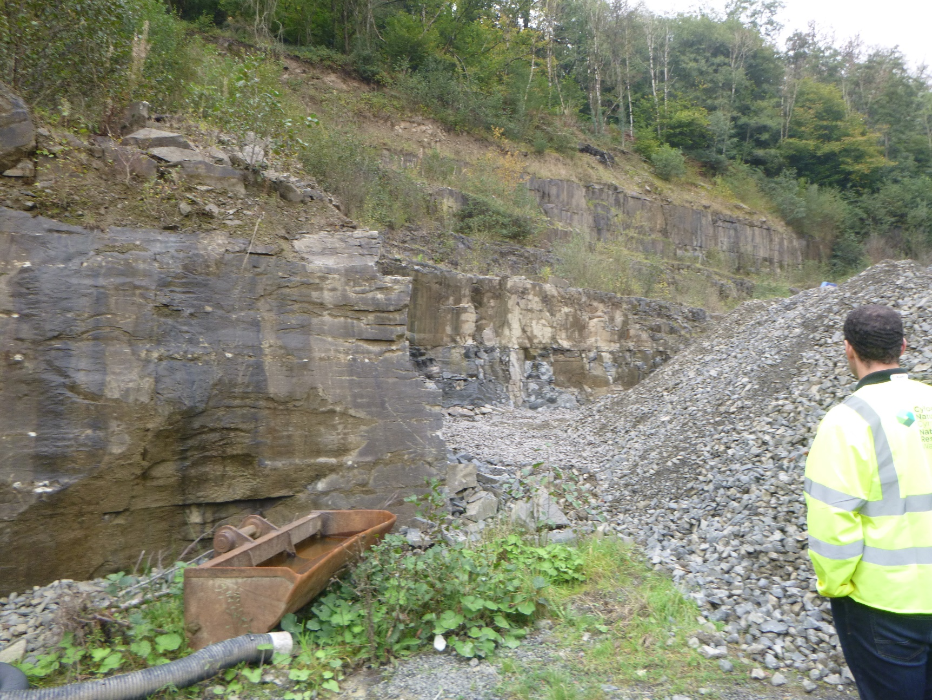
Drainage channel at base of quarry now piped and backfilled
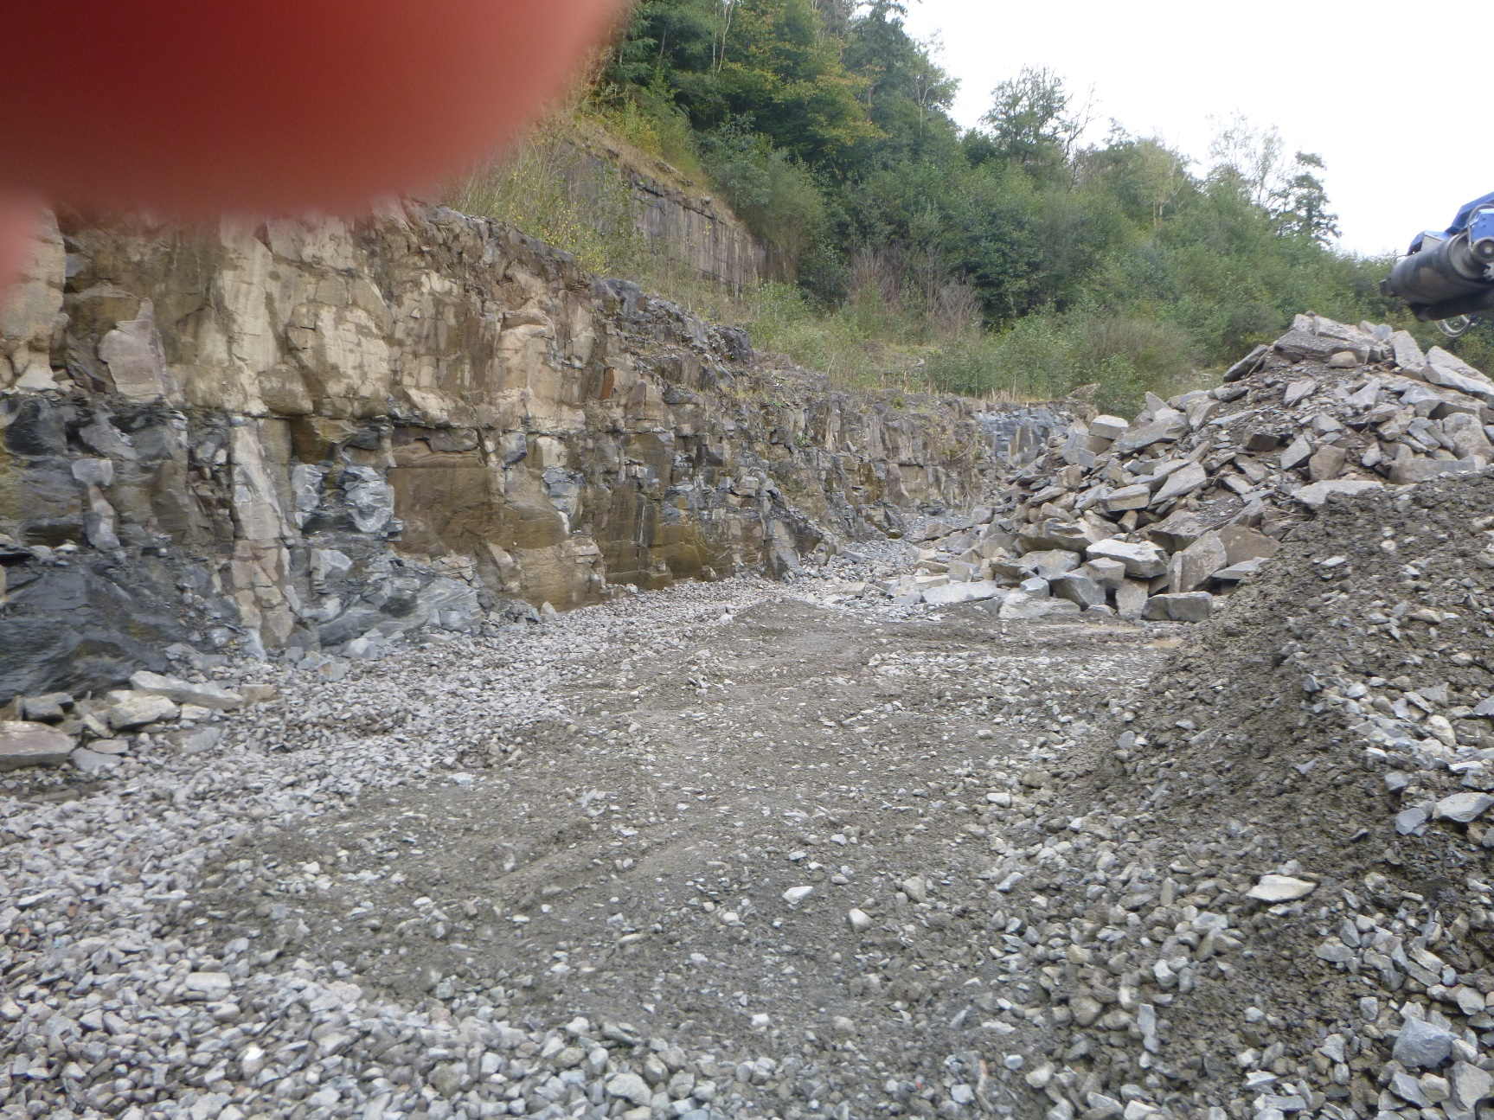
Rear of site showing quarry wall and backfilled drainage channel
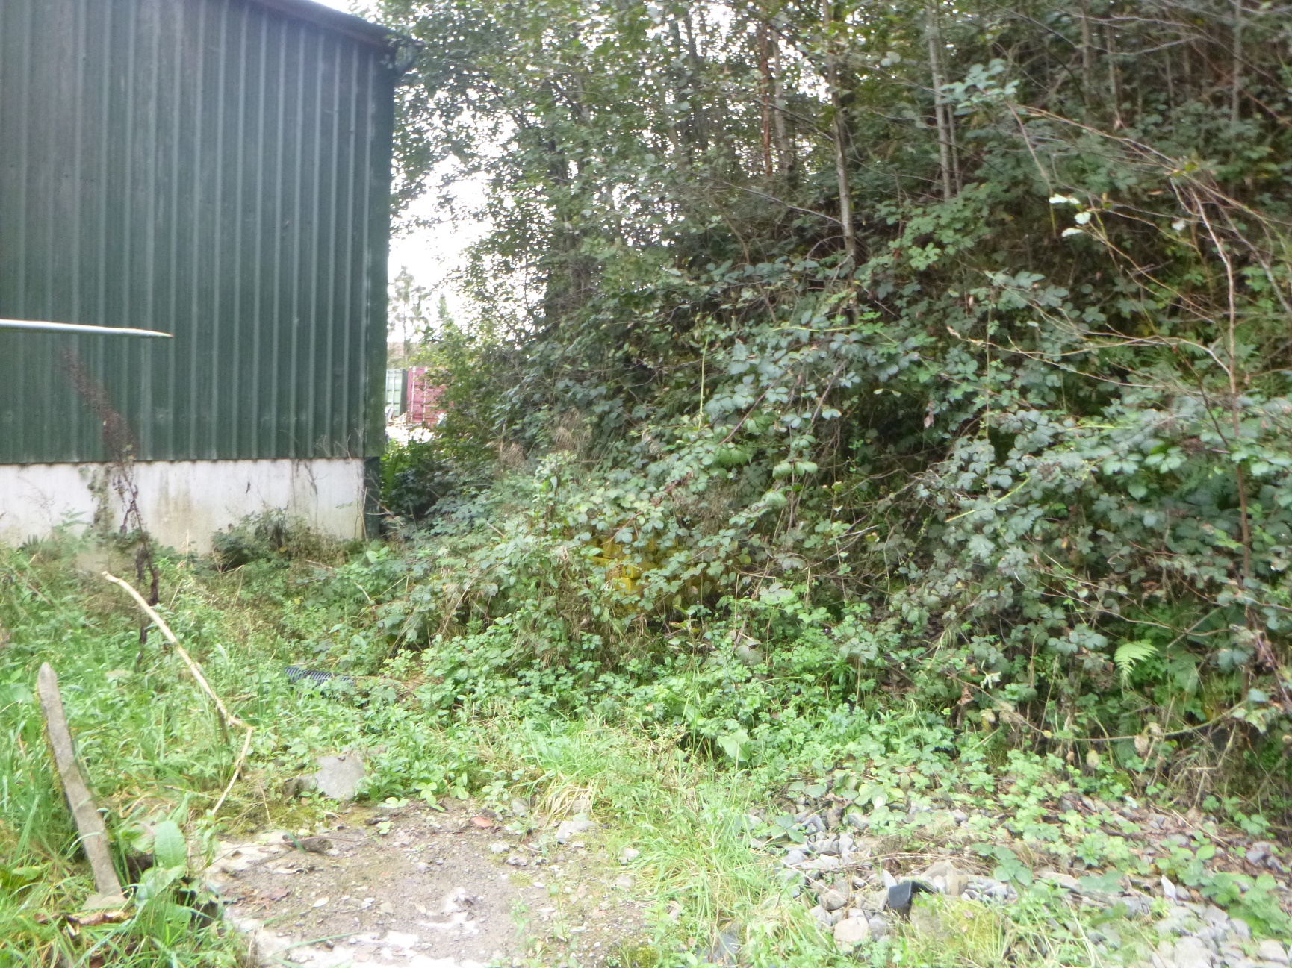
Location at south end of site where surface water drain from quarry wall discharges and flows to watercourse
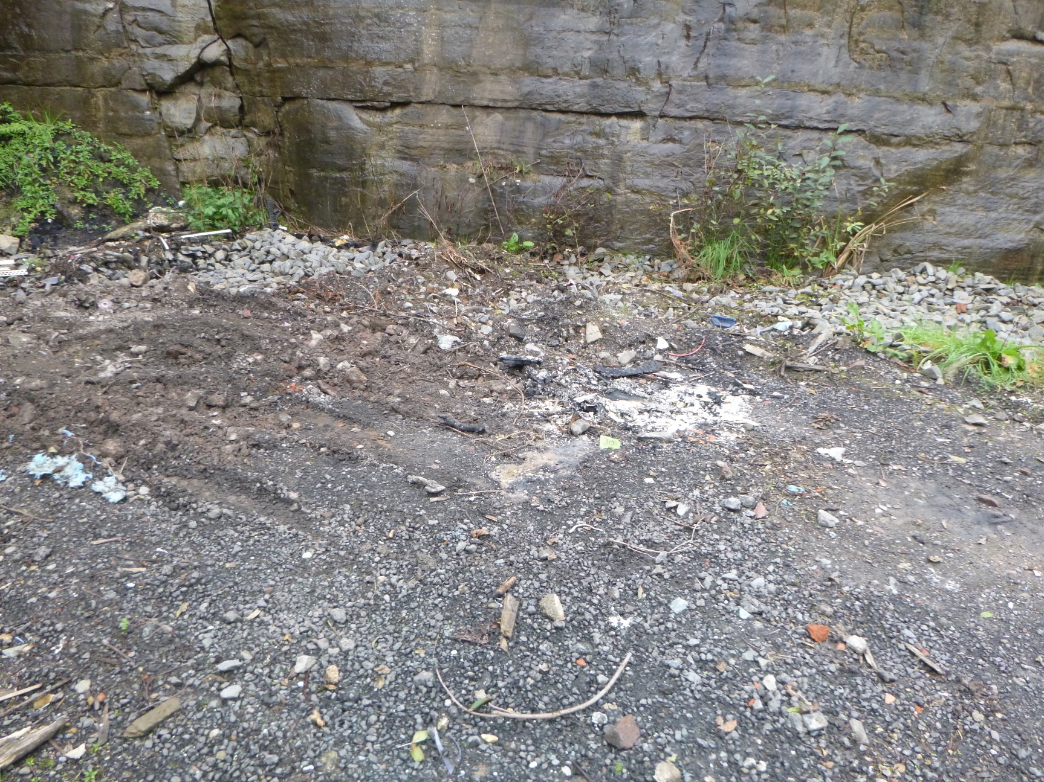
Area of site where waste has been burned
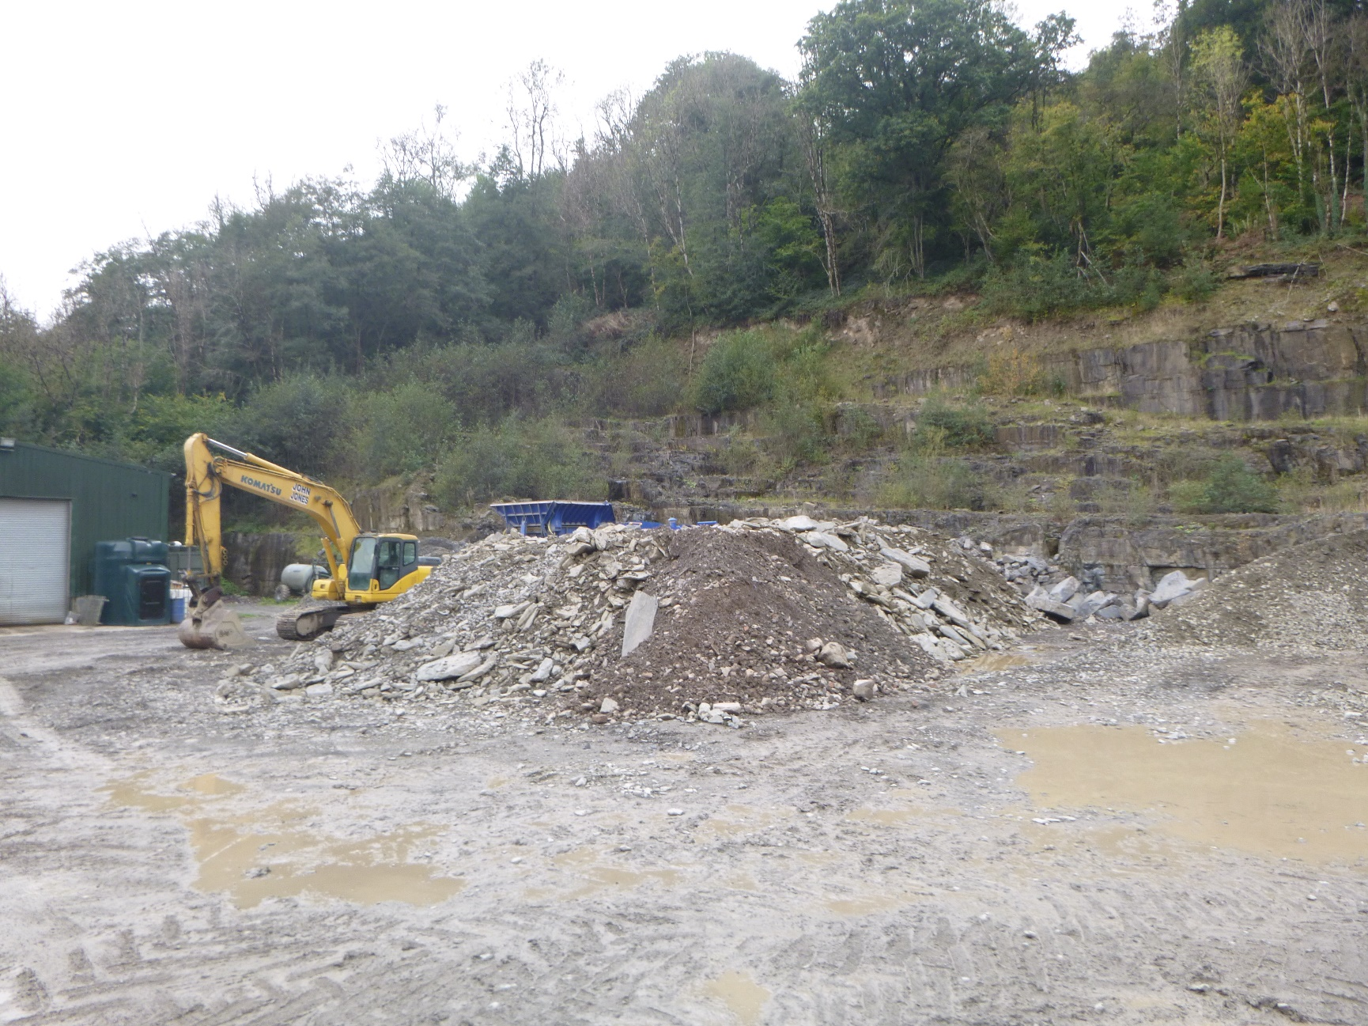
Unprocessed waste stockpile
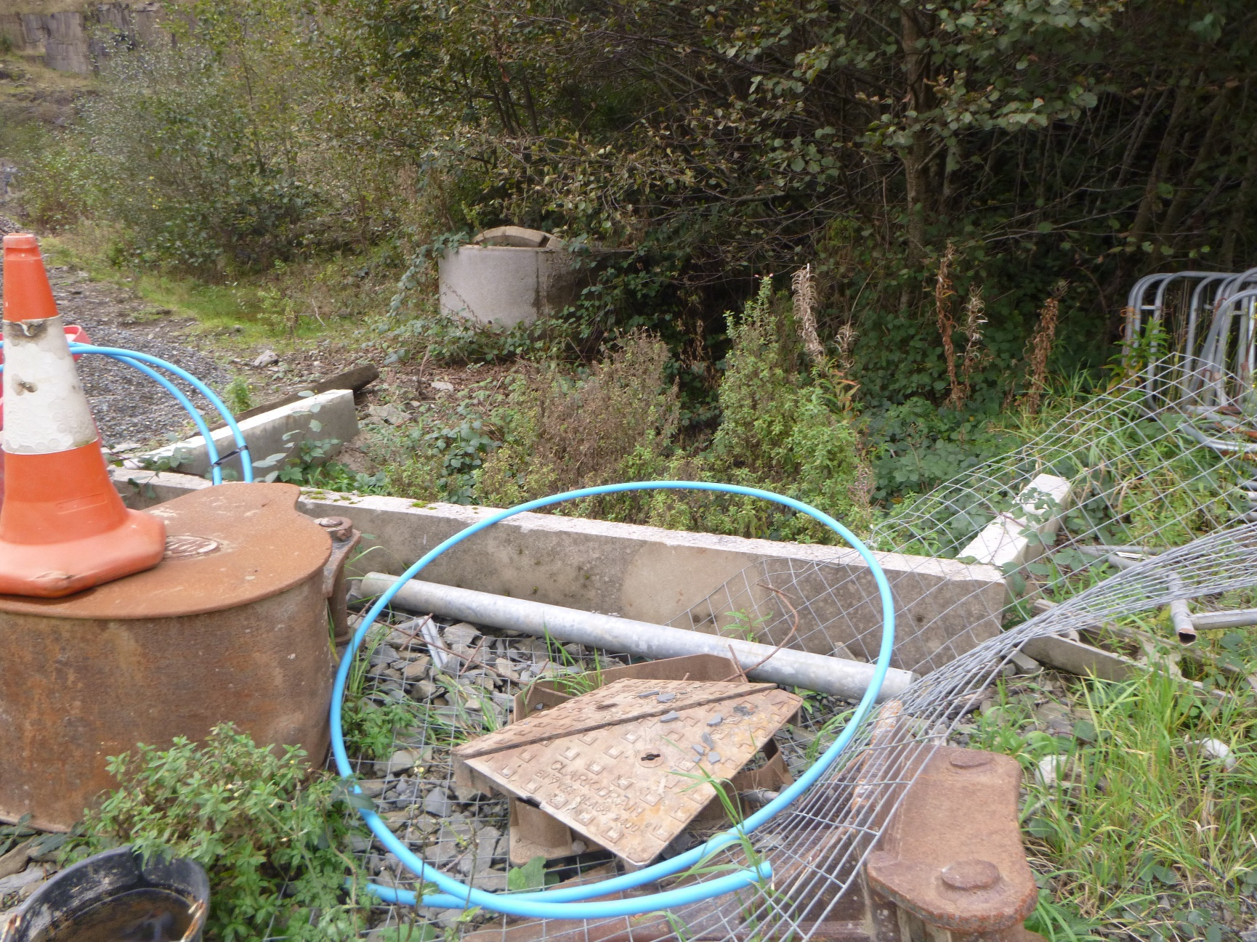
Upstream side of culvert for stream passing under the site. Kerbs have been added since first visit to site
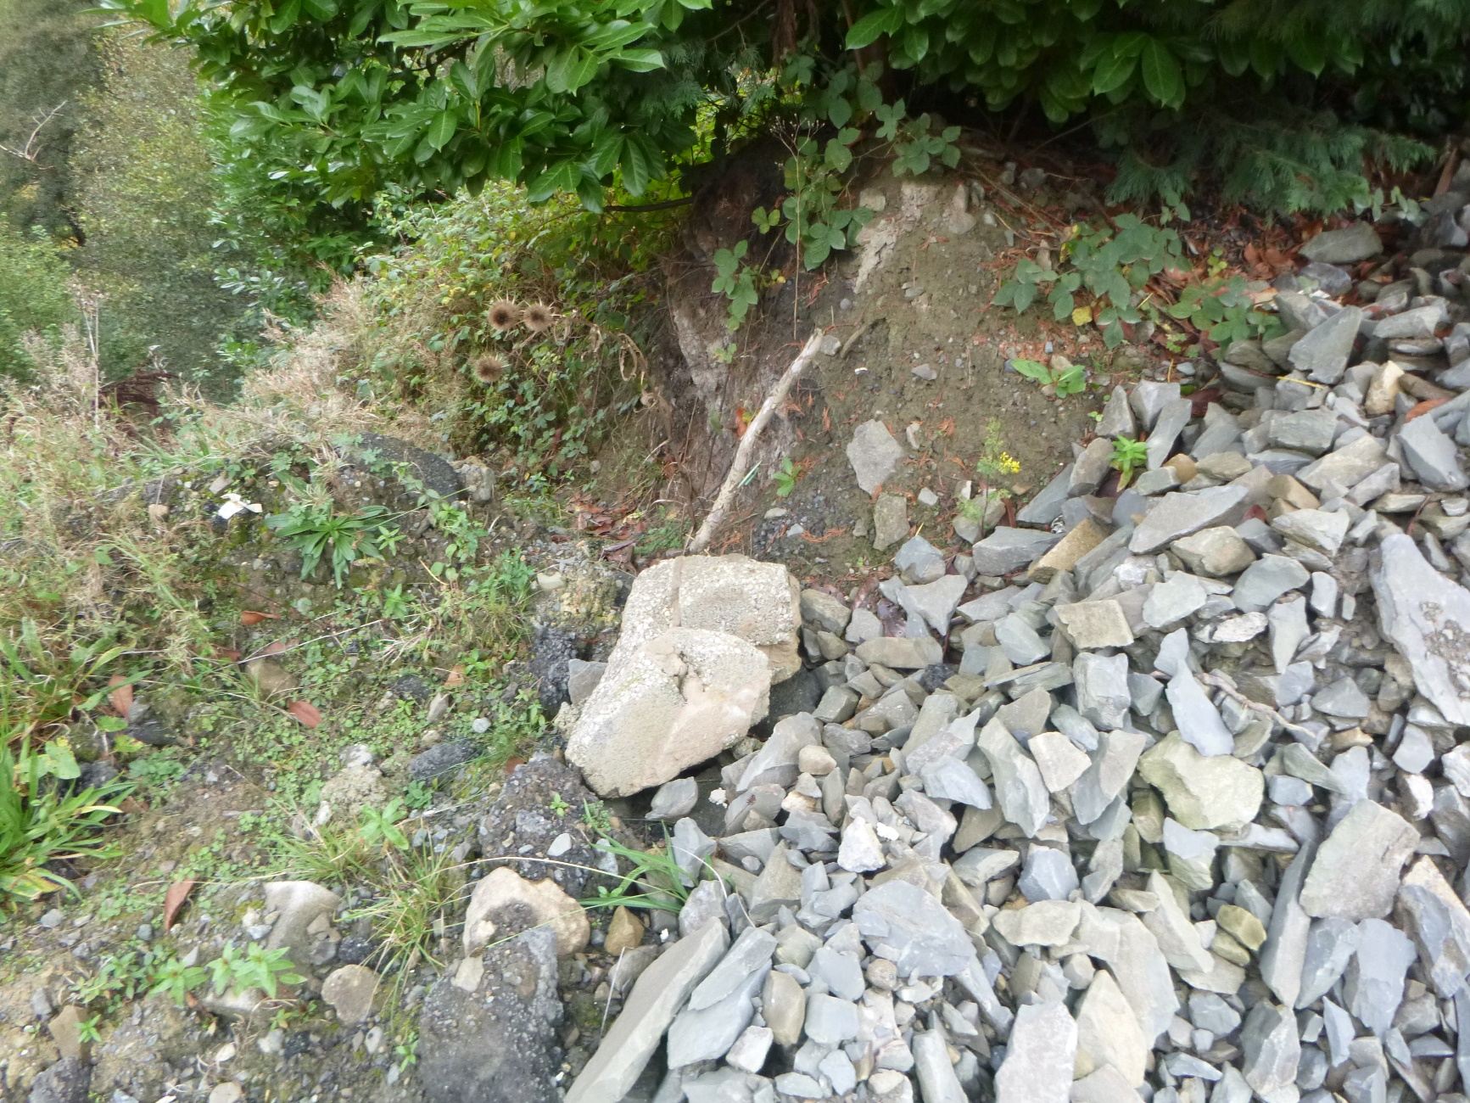
Eastern edge of the site above culverted stream showing stone bund to prevent run-off
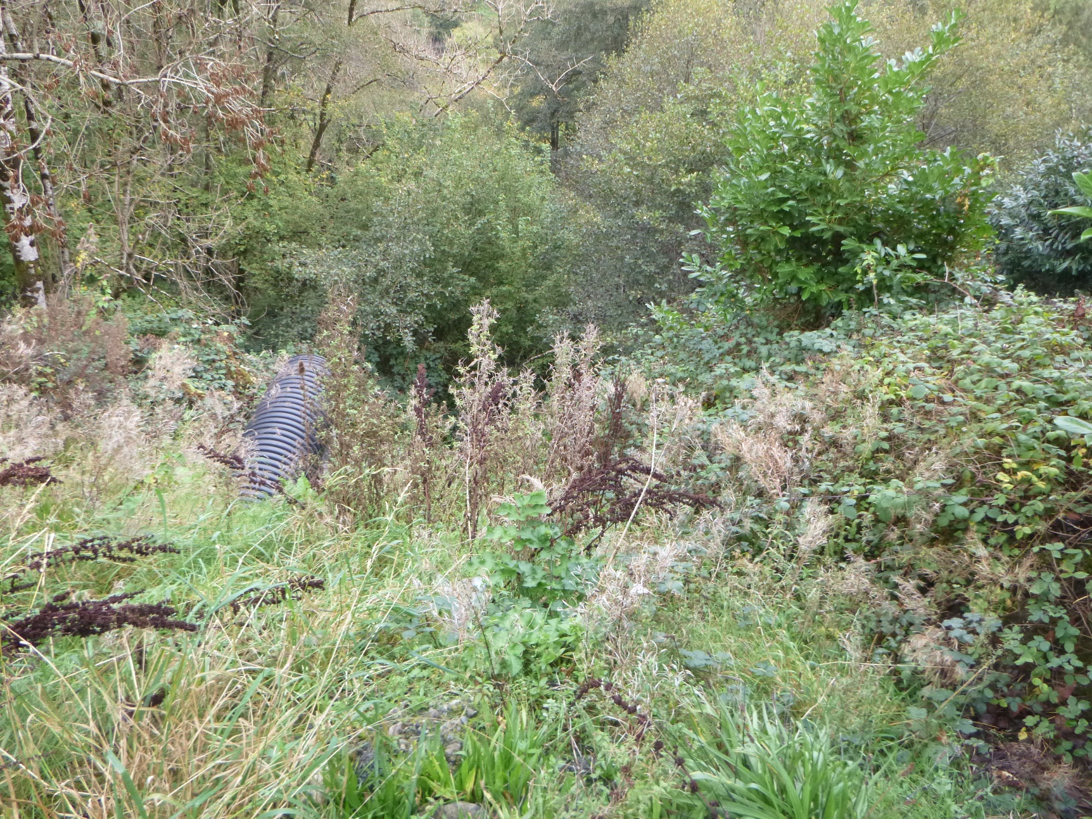
View of stream discharging from culvert below the eastern edge of the site
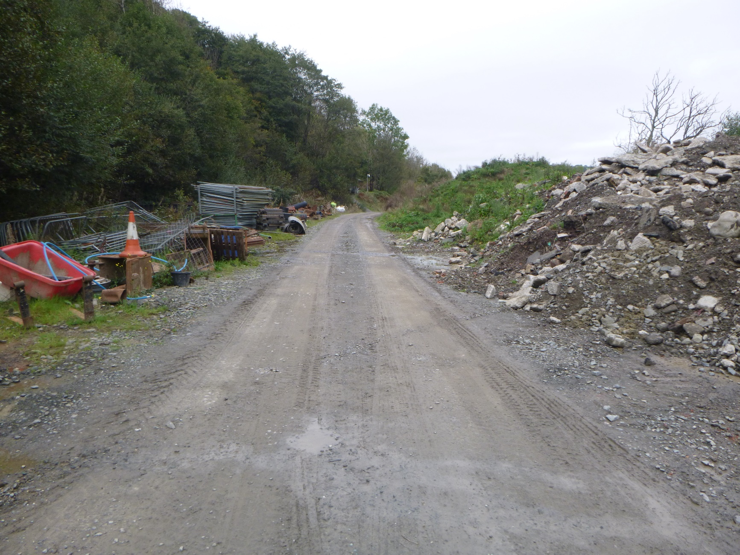
View from the culverted stream looking to the north end of the site
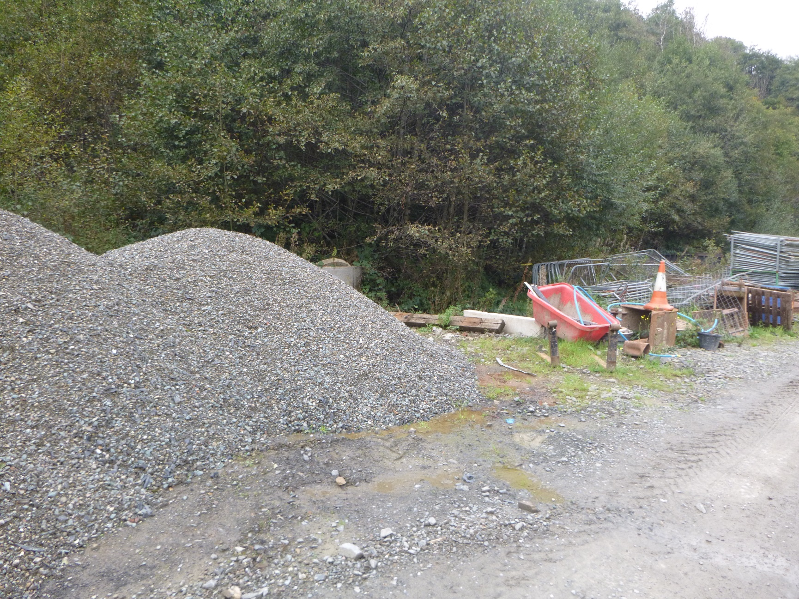
View of the entrance to the stream culvert (behind kerbs) and aggregate stockpile
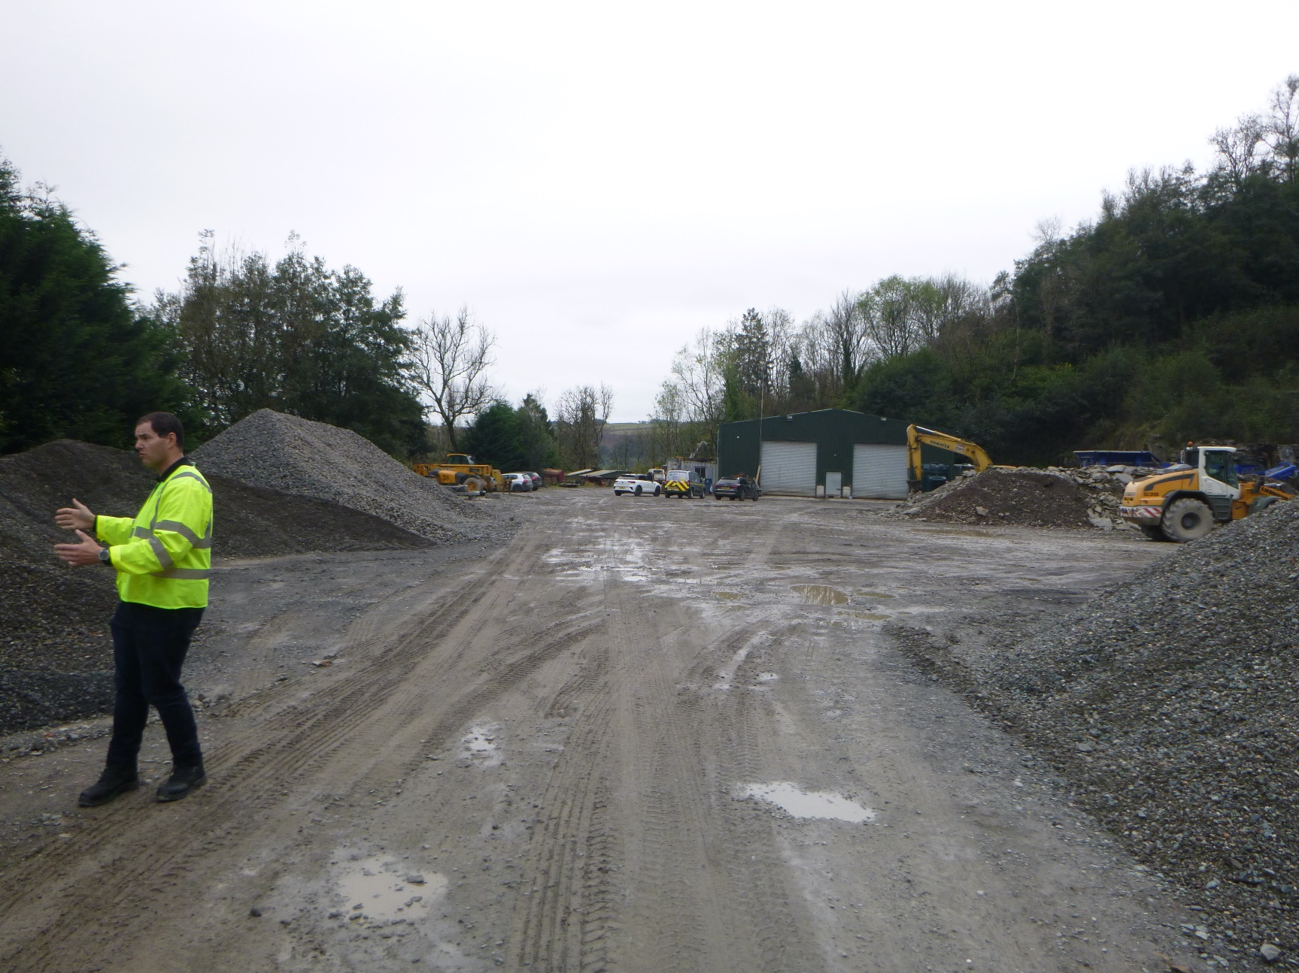
View from culverted stream looking south into the site.

