PAN-023140 My Map Report:
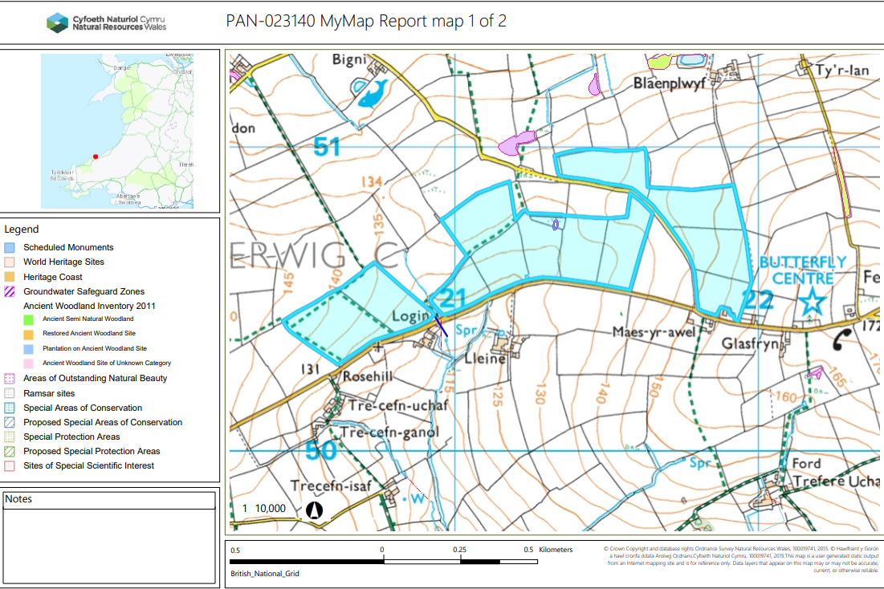
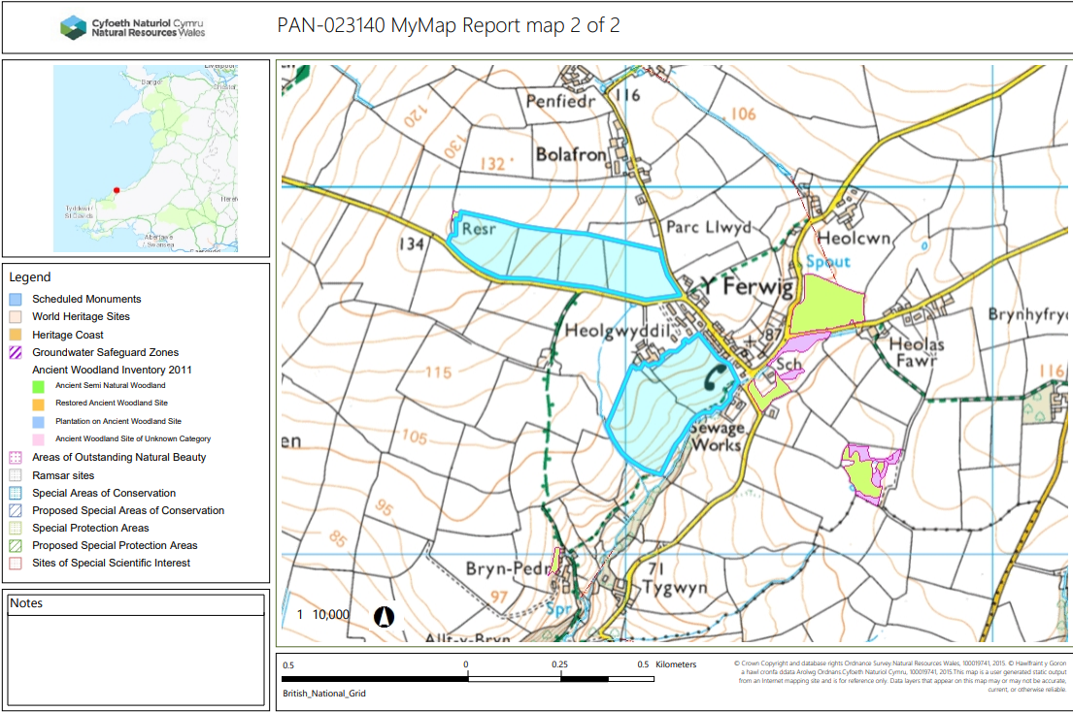

Detailed river network:
Heolgwyddil 3
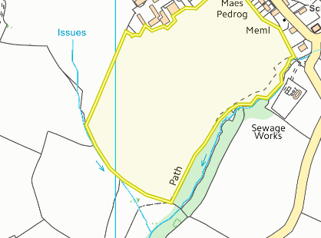
Field Heolgwyddil 3 borders a water issue. There is an no spread buffer zone in place to prevent nutrients from entering the water course.
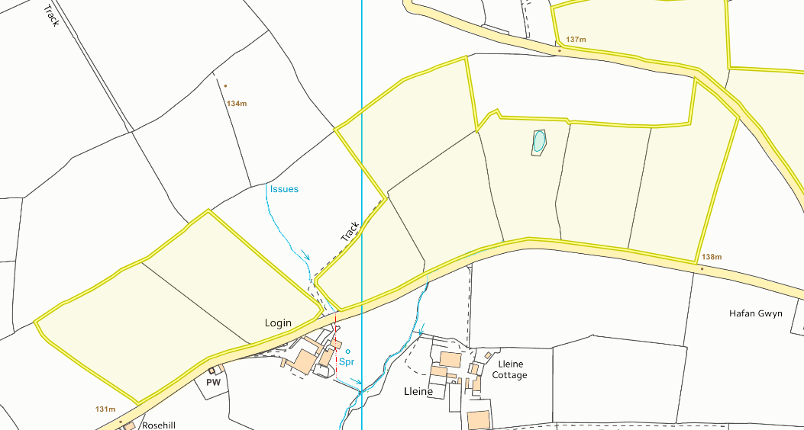
Field 1
Field 0252 & 7949 borders a water issue. There is a 10 metre no spread buffer zone in place to prevent nutrients from entering the water course and complies with SR2010No4.
Field 1 contains a pond which has been buffered by 10 metres to prevent nutrients from entering the water course and complies with SR2010No4.
A spring is located 84 meters from field 7849 (closest field). As the spring is located over 50 metres away no action is needed.

Source protection zones
None in range.
Wells, springs or boreholes used for the supply of water for human consumption including from a private water supply or supplies
None in range.
any springs wells or boreholes not used to supply water for domestic or food production purposes within 50m

None in range.

European designated sites- Natura 2000 (SPA, pSPA, SAC or cSAC) or Ramsar- or SSSI within 500m

None in range.

Other protected sites:
- Protected Species- None on range.
- Protected Habitats-
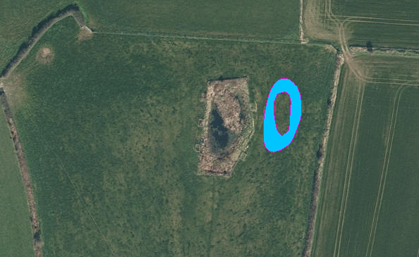
Field 1
Field 1 contains a protected habitat: reed beds. Aerial imagery suggests this feature is located in the pond and not in spreading area of field 1. There is a no spread buffer zone in place where the pond and reeds are located in field 1. No action needed .

- Scheduled Ancient Monument- None in range.

- Local Nature Reserve- None in range.

- National Nature Reserve- None in range.

- Ancient Woodlands- None in range.

- Local Wildlife Sites (SINC)- None in range.

- National Park- None in range.

- Groundwater Safeguard Zone- None in range

- Heritage coast- None in range

- World Heritage Sites - None in range

- Hedges- Nothing of concern

- Ditches- see slope assessment below

- Local residents

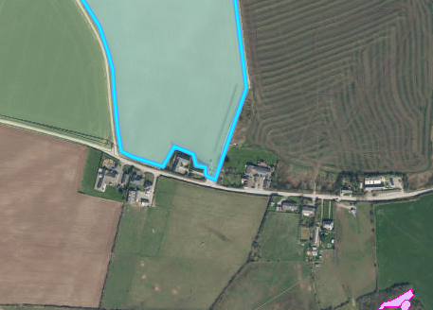
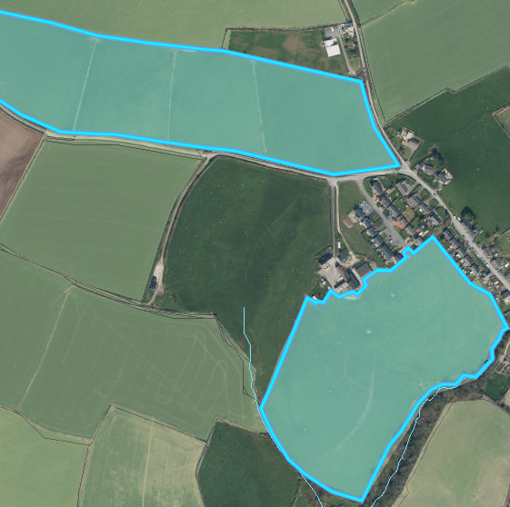
Fields Heolgwyddil 3, Heolgwyddil 5, 6 , 7, 8065 are located nearby residential properties and the Felinwynt rainforest centre. The wastes that are proposed to be spread on the fields are dairy wastes (EWC 02 05 01) where odour can be an issue. The applicant has provided an odour management plan as part of the submitted application and has reduced the risk of significant odour proliferation by submitting an odour management plan that complies with the H4 guidance.

8065
H7
H6
H5
Heolgwyddil 3

Slope Map
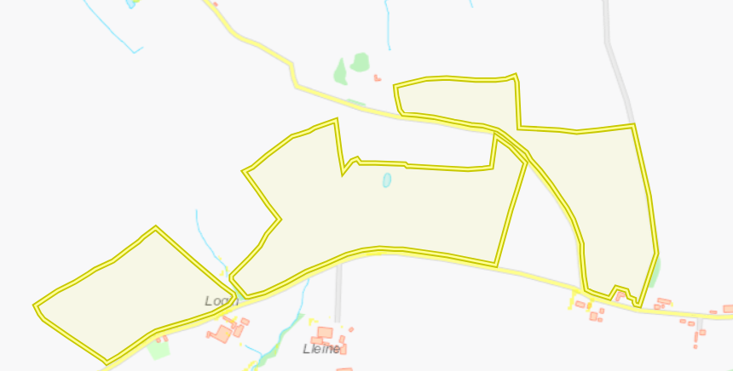
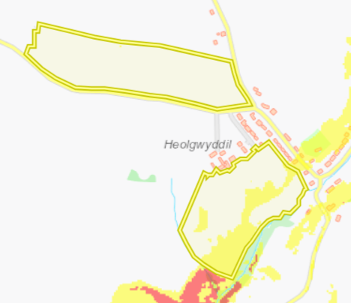
Field Heolgwyddil 3 is located on partially moderately sloping land (0-7º). There is an no spread buffer zone in place along the boundary of the field that borders the water issue to prevent nutrients and/or PTEs from entering the water. The waste is also being applied with an appropriate application method (dribble bar) that applied the waste directly to the soil. One application of waste will not exceed 50 tonnes per hectare to minimize surface runoff.
4993
8065
5565
4165
1
0876
1561
0252
7849
6240
H5
H6

H7
H8
H9
Heolgwyddil 3
Fields 1 to 8065 are located on flat to gently sloping land, and do not pose a surface runoff risk.

