Tata Steel UK
Port Talbot Steelworks

Quarterly On-site Ambient PM₁₀ Monitoring Report for Quarter 3 2023

 |  |  | Signed | Dated
Written | Neil Haines | Principal Consultant | 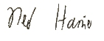 | 24/10/2023

Initial Circulation
General Circulation
Tata Steel UK
Peter Quinn
Nathan Ace
Neil Haines
Nicola Parnell
Rhiannon Bennett
Mark Clayton
Freya Ashton
Harshika Patel

Natural Resources Wales
Rhodri Morgan
Doug Cowie
Neil Herbert
Paul Gibson

The contents of this report are the exclusive property of Tata Steel and are confidential. The contents must not be disclosed to any other party without Tata Steel’s previous consent which (if given) is in any event conditional upon that party indemnifying Tata Steel against all costs, expenses and damages claims which might arise pursuant to such disclosure.
Table of Contents

1 Introduction 4
2 Monitor/Sensor Deployment and Data Capture 5
3 Monitored Data Trends 6
4 Monitored Data Rose Diagrams 7
5 Deposition Sensor Trends 8
6 Conclusions 11
Appendix A 12

Introduction

This report describes and assesses the data produced from Tata Steel’s on-site ambient air quality monitoring network and covers the period 1st July to 30th September 2023 (Q3 2023). The report will:
- outline monitor and sensor deployment and data capture over the course of the monitoring period;
- describe the trends in monitored data with reference to any changes that occurred over the course of the monitoring period; and
- present and interpret rose diagrams for data recorded over the course of the monitoring period.

Conclusions relating to the above points are presented in Section 6.

Over the course of this quarter there were ten breaches of the daily mean PM₁₀ air quality objective at the Automatic Urban Rural Network (AURN) site in Port Talbot, summarised in Table 1 below.

Table 1 – Summary of breach days from 1st July to 30th September 2023

No. | Date | Daily Mean PM₁₀ at the AURN (µg/m³) | Estimated trans- boundary influence^{*1} (µg/m³) | AURN PM₁₀ with trans-boundary influence removed (µg/m³) | Local influence above norm^{*2} (µg/m³) | PM_{2.5} Fraction (%) | Trans-boundary event? | Wind direction predominantly towards town from site?*³
1 | 02/07/23 | 55.3 | 3.8 | 51.5 | 29.0 | 18 | NO | YES
2 | 03/07/23 | 52.7 | 0 | 52.7 | 30.2 | 18 | NO | YES
3 | 23/07/23 | 51.5 | 0 | 51.5 | 29.0 | 24 | NO | YES
4 | 12/08/23 | 53.0 | 0 | 53.0 | 30.5 | 16 | NO | YES
5 | 19/08/23 | 68.6 | 3.8 | 64.9 | 42.4 | 17 | NO | YES
6 | 21/08/23 | 54.8 | 0 | 54.8 | 32.3 | 15 | NO | YES
7 | 06/09/23 | 53.2 | 15.9 | 37.4 | 14.9 | 33 | YES
8 | 07/09/23 | 54.9 | 27.6 | 27.3 | 4.8 | 31 | YES
9 | 08/09/23 | 57.5 | 27.5 | 30.0 | 7.5 | 28 | YES
10 | 09/09/23 | 59.5 | 4.6 | 54.9 | 32.4 | 42 | NO | YES

*¹ Transboundary influence estimated by subtracting the daily mean PM₁₀ concentration at Narberth from the long-term average PM₁₀ concentration at Narberth (10.9 µg/m³ - average over the period 2017 to 2021)
*² Local influence above norm estimated by subtracting the long-term average PM₁₀ concentration at the AURN (22.5 µg/m³ - average over the period 2017 to 2021) from the daily mean PM₁₀ concentration at the AURN after removing any transboundary influence
*³ Only for localised events, based on the wind direction recorded at the on-site meteorological stations

These breaches have been investigated by Tata Steel and the reports already submitted to NRW under separate cover. Three of the breaches, which occurred on the 6th, 7th and 8th of September, at a time when Saharan dust was affecting large parts of the UK, were attributed to the influence of transboundary pollution (i.e. not attributed to localised events). The information in Table 1 will be considered when undertaking the analysis in the following sections of the report.

PM₁₀ Monitor/Sensor Deployment and Data Capture Rates
The locations of the monitors and sensors included in the network during Q3 2023 are illustrated in Figure 1, Appendix A. There are currently no plans to change the existing network.

Table 2 gives the data capture rates for each of the PM₁₀ monitors and sensors in the network. The TOPAS monitors require calibration every two years, for which they must be returned to the manufacturer, and the calibration status of each of the monitors is also shown below. The Vortex sensors can generally be updated remotely and in case of a more serious failure they will be replaced, so they do not have the same off-site calibration requirement as the TOPAS monitors.

Table 2 – Data capture rates for monitors and sensors deployed between 1st July and 30th September 2023

Monitor / Sensor | % PM₁₀ data capture over entire monitoring period | Calibration due | Start date of operation
GCI / Centre TOPAS Monitor | 57% | 30/12/2023 | 07/08/2023
Harbour TOPAS Monitor | 100% | 25/07/2025 | 17/11/2022
Penrhyn TOPAS Monitor | 5% | 11/09/2025 | 26/09/2023
BOS Lagoon (AQM20) | 95% | No calibration period specified by the providers | 14/04/2021
Canteen (AQM16) | 94% | No calibration period specified by the providers | 01/04/2021
CAPL (AQM17) | 85% | No calibration period specified by the providers | 27/04/2021
Contractor Compound (AQM13) | 62% | No calibration period specified by the providers | 07/05/2021
Tarmac Offices (AQM14) | 65% | No calibration period specified by the providers | 12/10/2021
Average | 70%

The average data capture rate for the on-site network during Q3 2023 was 70%, with only the Harbour TOPAS monitor, the BOS Lagoon Vortex sensor and the Canteen Vortex sensor achieving more than 90%. The reasons for data capture of below 90% at the other monitors and sensors during the quarter are outlined below.

GCI/Centre and Penrhyn TOPAS Monitors

Both of these monitors suffered from air flow errors during Q1 and were returned to the manufacturer for repair. The repairs took longer than expected and monitoring was not reinstated until 7th August (GCI/Centre) and 26th September (Penrhyn).

Contractor Compound, Tarmac Offices and CAPL Sensor Data Capture

Communications issues between the sensors and the network caused significant data loss from these monitors during the previous quarter and these issues continued into Q3. Although the sensors have a small amount (7 days’ worth) of on-board data storage, they are designed for constant communication with the network and so if any outage lasts longer than 7 days, the earlier data cannot be retrieved. The providers came onto site in early August to update the firmware for the sensors and switch to a different communications channel with less noise, and data capture since that time has improved. The Tarmac Offices Vortex sensor has achieved 100% data capture since 2nd August, the CAPL sensor 100% since 9th August and the Contractor Compound sensor 100% since 23rd August.

It should be noted that data capture has risen significantly since the previous quarter (70% overall compared to 40%), reflecting the efforts made to improve the reliability of the monitoring network. Tata Steel will continue to update NRW on the current status of the On-site Monitor Network via the Quarterly On-site Monitoring Report for Q4 2023.

Monitored Data Trends
CUSUM plots are used to illustrate the trends in PM₁₀ concentrations recorded at the Margam Fire Station monitor (AURN) and on-site monitors and sensors over the course of the monitoring period. The monitored PM₁₀ trends for the AURN monitor and on-site monitors and sensors are presented as daily CUSUM plots in Figure 1. In this plot, the CUSUM data have been normalised to allow easier comparison of the trends. The principal interest is to identify which, if any, of the on-site monitors and sensors show similar trends to the AURN monitor, as this may indicate that they are affected by similar sources. It is also relevant to examine the trends of the on-site monitors and sensors around breach days at the AURN.

Figure 1 – Daily CUSUM trends for the monitors and sensors between 1st July and 30th September 2023 plotted against PM₁₀ breach days occurring at the AURN Monitor during Q3 (red bars)

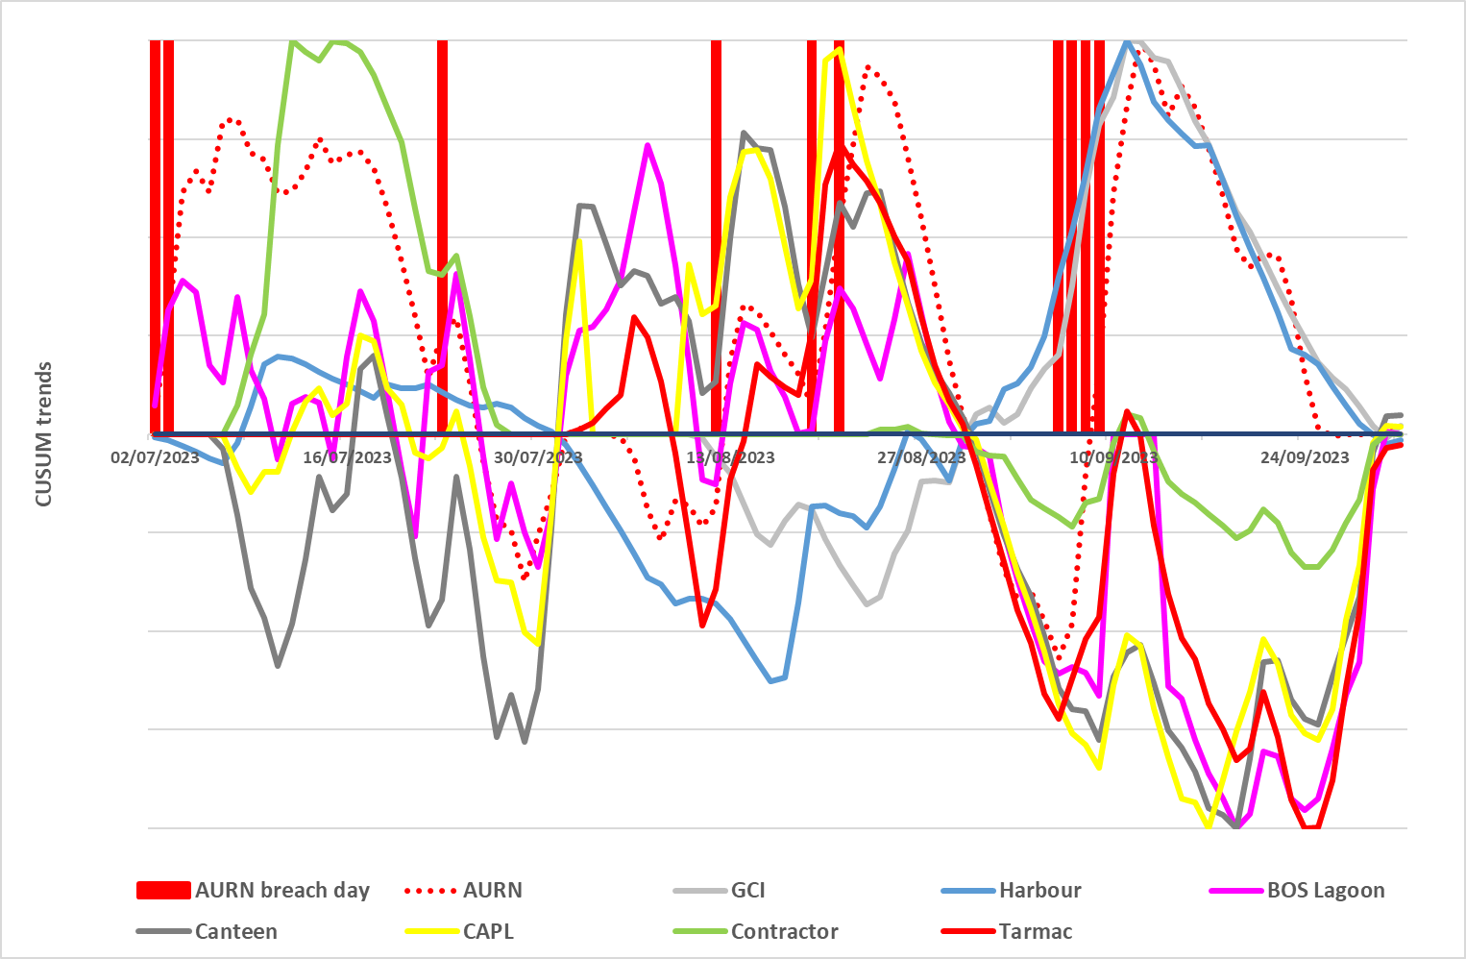

The most obvious feature shown in Figure 1 is that the CUSUM trends for all the monitors and sensors show a sharp rise (i.e. PM₁₀ concentrations were well above the quarterly average) at the time of the Saharan dust episode in early September. This demonstrates that this natural event had a significant impact across the whole Tata Steel site, as would be expected. It should be noted that when comparing the trend for the AURN monitor with trends for the on-site monitors and sensors, it is the slope of the lines over a given period that is important rather than the absolute values.

Comparing the trends over the rest of the period, the two sensors that seem to correlate best with the AURN monitor, at least until the middle of September, are those at the Contractors’ Compound and the Tarmac Offices, though both of these had significant data gaps over the period. For greater clarity, Figure 2 shows the trends for just these two sensors and the AURN. There is less correlation for the other on-site monitors and sensors.

The breach day reports previously submitted to NRW have outlined any unusual on-site activities or Environmental Incident reports that coincided with periods of elevated localised PM₁₀ concentration at the AURN, but no strong links were demonstrated that could unequivocally identify a cause or causes.

Figure 2 – Daily CUSUM trends for selected sensors between 1st July and 30th September 2023

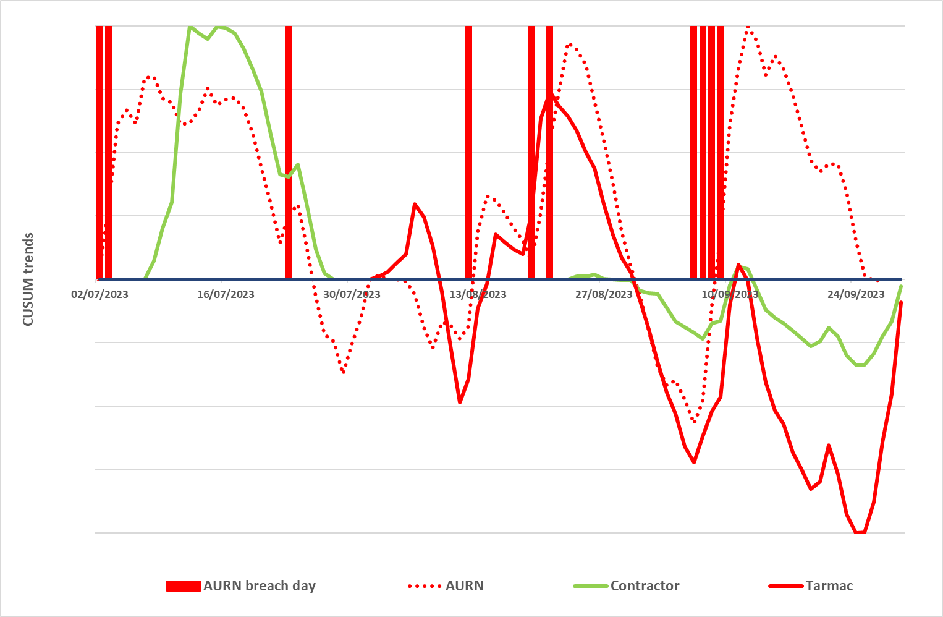

.

Monitored Data Rose Diagrams
Rose diagrams for data from the Tata Steel-owned monitors and sensors are presented in Figures 2 and 3 in Appendix A. Data was collected at the Penrhyn TOPAS monitor for only a few days at the end of the quarter, so no rose has been produced for this location. The rose diagrams illustrate the PM₁₀ concentrations measured at each location when the wind blew from different directions – the concentrations are shown as percentiles of concentration, with the outermost band showing the 95th percentile.

Potential sources of PM₁₀ that may impact the site monitors and sensors are discussed in Table 3 – the most critical wind directions are based on the 90th percentile concentrations so as not to over-weight occasional high levels that may be attributable to transient sources such as vehicle movements. The potential sources discussed in Table 3 are not necessarily the same as those that impact the monitors located in the town. The analysis presented in Figures 2 and 3 in Appendix A and Table 3 below has been completed using wind data collected from Little Warren.

Table 3 - Summary of potential sources impacting the on-site monitors and sensors between 1st July and 30th September 2023

Monitor/ Sensor | Critical wind directions impacting the monitor/sensor | Potential sources in close proximity to the monitor/sensor | Potential sources further away from the monitor/sensor
GCI / Centre | NNE (20°) | Blast Furnaces  BF Stockhouses | Off-site sources
GCI / Centre | NE to E (40° to 90°) | Blast Furnaces | Off-site sources
GCI / Centre | W (260° to 280°) | Tarmac slag handling  Burdening stockyards | Coast
GCI / Centre | NW to N (330° to 360°) | BF Stockhouses | Off-site sources
Harbour | N to E (10° to 90°) | Burdening Stockyards | Hanson Cement  Blast Furnaces  Slag Granulation Plant  Off-site sources
Harbour | ESE (110° to 130°) | Tarmac Slag Handling | Sinter Plant  Steel & Slab  Harsco MR Plant
Harbour | SSE (150° to 160°) | Tarmac Slag Handling | Beach
BOS Lagoon | NE (30° to 60°) | Steel & Slab | Off-site sources
BOS Lagoon | E (80° to 100°) | Slab Yards | Rolling Mills  Off-site sources
BOS Lagoon | SE (130° to 140°) |  | Off-site sources
BOS Lagoon | S to N (170° to 10°) | Morfa coke ovens  Beach  Harsco MR Plant | Coast  Tarmac slag handling  Burdening stockyards
Canteen | E (90° to 100°) |  | Off-site sources
Canteen | SE (140° to 150°) | Cold Mill | Off-site sources
Canteen | S to NW (180° to 340°) | Rolling Mills  Slab Yards | Steel & Slab  Harsco MR Plant  Morfa Coke Ovens  Coast
CAPL | E (90° to 120°) |  | Off-site sources
CAPL | SE (140° to 150°) |  | Off-site sources
CAPL | NW (290° to 300°) | Slab yards | Steel & Slab
Contractor Compound | SE to S (120° to 180°) | Sinter Plant | Slag Granulation Plant
Contractor Compound | SW to W (200° to 260°) | Burdening stockyards | Coast
Tarmac Offices | E (70° to 90°) | Plating Pits | Rolling Mills  Off-site sources
Tarmac Offices | SW to W (130° to 250°) | Tarmac Slag Handling | Coast

In summary, the site monitors/sensors were impacted by PM₁₀ from a wide range of wind directions which include both on-site and off-site sources. Tata Steel will use the information presented above to further the understanding of potential sources that may have an impact on off-site receptors and to develop targeted improvement programmes.

Deposition Sensor Trends

In early 2019, Tata Steel commenced a rental agreement with Aloatec Innovative Solutions for two automatic dust deposition sensors. A third sensor, at the Lock Gates location, joined the network towards the end of June 2021.

Data capture from these sensors over the quarter exceeded 90%; deposition data are missing for the following dates:
- Lock Gates – 1st to 3rd July, 9th to 13th July, 7th September
- Penrhyn – 1st to 3rd July, 8th to 10th July, 8th to 11th September
- Canteen – 21st to 24th September

Wind data from the Tata Steel on-site monitor network (CES Roof weather station) is used by Aloatec for further analysis of the deposition data, but during Q3 the transfer of this data was hindered by changes to the firewall which meant that wind direction data was only available within the Aloatec system from 21st September. For this reason, the rose diagrams and other directional analysis that are usually produced have not been included in this report as they would have covered only the last few days of the period. So long as there are no further issues with the data transfer, this analysis will recommence in the next quarter.

Figures 3, 4 and 5 illustrate the variation of deposition rates for each of the three sensors over the quarter. The black lines are the daily mean deposition rate, the red lines are monthly average deposition rates and the blue bars indicate rainfall.

Figure 2 – Dust deposition data trend for the Lock Gates Aloatec ADA Sensor for the period 1st July and 30th September 2023

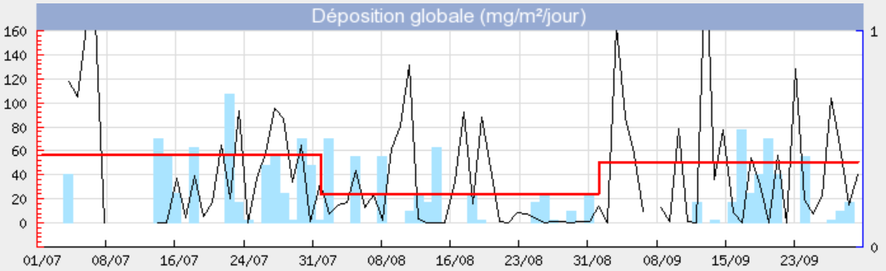

Figure 3 – Dust deposition data trend for the Penrhyn Aloatec ADA Sensor for the period 1st July and 30th September 2023.

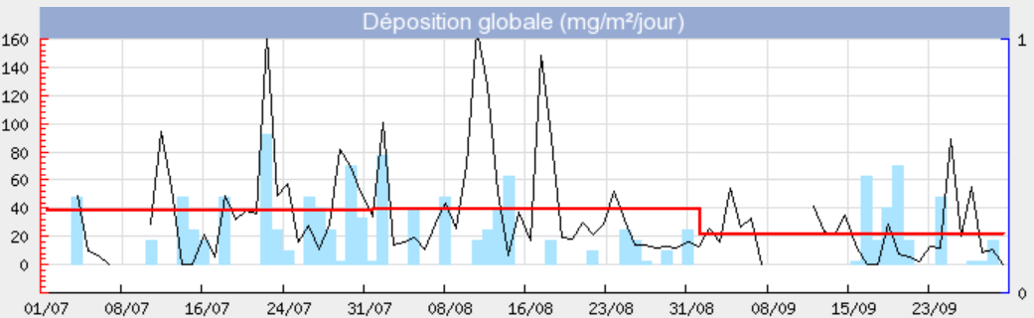

Figure 4 – Dust deposition data trend for the Canteen Aloatec ADA Sensor for the period 1st July and 30th September 2023.

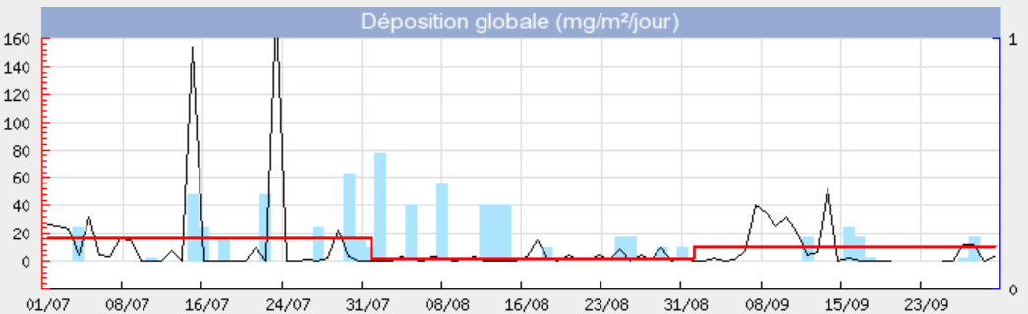

Conclusions

- During Q3 2023, there were ten breaches of the daily mean PM₁₀ air quality objective in Port Talbot. These breaches have been investigated and the reports submitted to NRW under a separate cover. Three of the breaches were attributed to the influence of trans-boundary pollution (i.e. not attributed to localised events).
- The average data capture during the quarter was 70% across all the on-site PM₁₀ monitors and sensors. This is a significant increase since the previous quarter (70% overall compared to 40%), reflecting the efforts made to improve the reliability of the monitoring network.
- The CUSUM trends for all the PM₁₀ monitors and sensors show a sharp rise at the time of a regional-scale Saharan dust episode in early September, demonstrating that this natural event had a significant impact across the whole Tata Steel site.
- Dust rose diagrams show that the on-site monitors and sensors were impacted by PM₁₀ from a wide range of wind directions which include both on-site and off-site sources.
- Tata Steel will continue to review the effectiveness of the on-site network and further develop methods to assess the results to improve understanding of dust sources across the site.

Appendix A

Figure 1 – Locations of Tata Steel monitors/sensors


