Fields overview
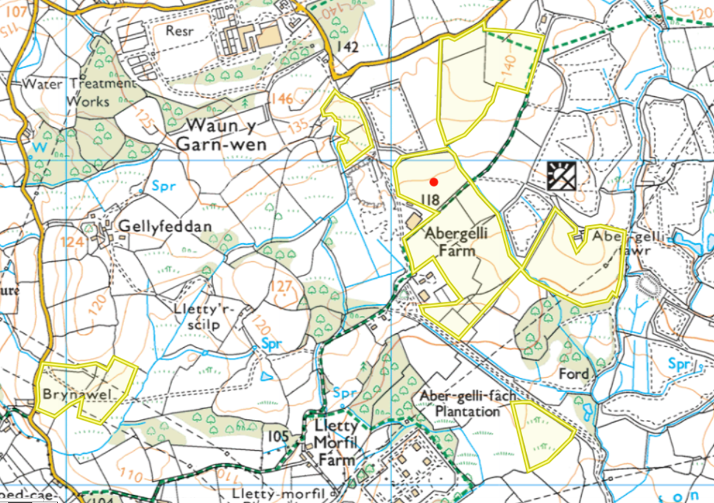

Surface water courses (issues in blue)
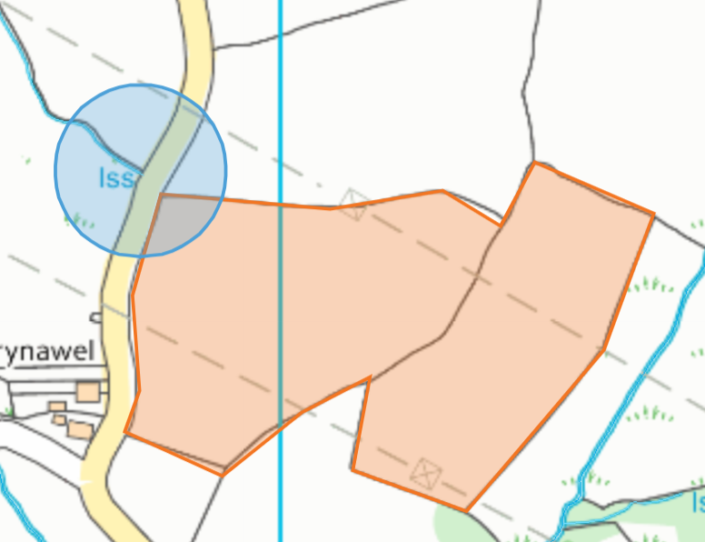
- Issue not buffered- RFI
- No watercourses requiring buffers

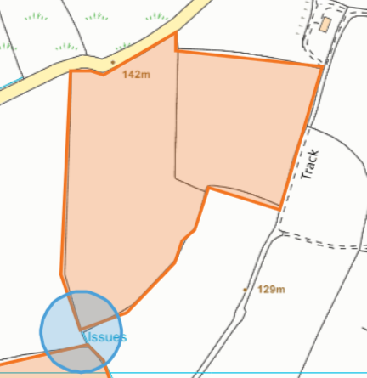
- Issue buffered
- No watercourses requiring buffers

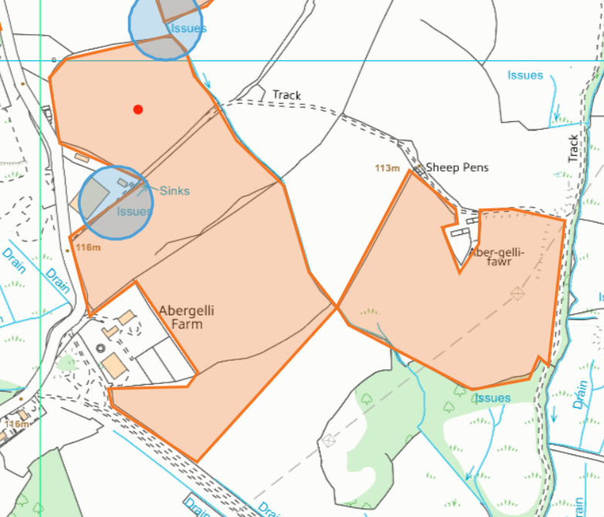
- Issue not buffered- RFI
- Watercourses buffered
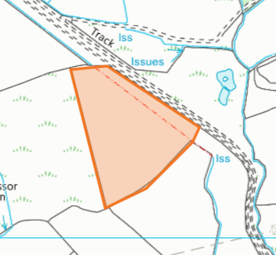
- Watercourses buffered
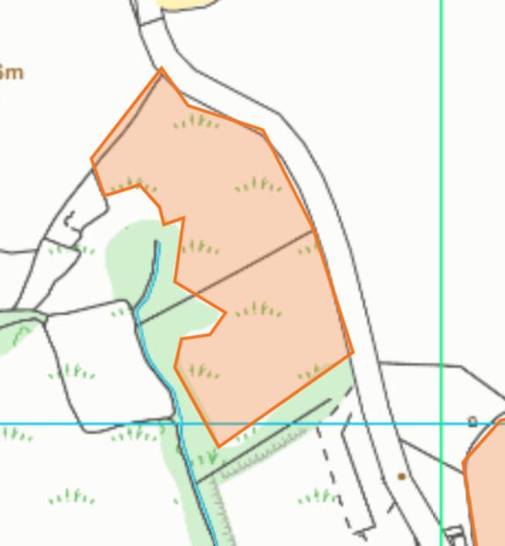
- No watercourses within 10 meters, no buffers required
Abstraction
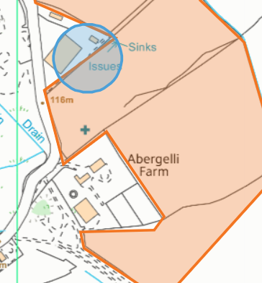
- Buffer in place

Public Rights of Way
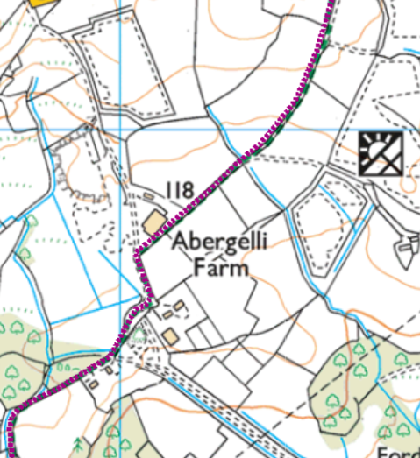
- Not shown on site plan- RFI

Slope
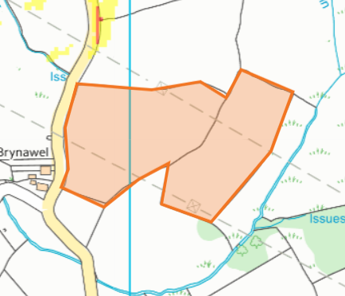
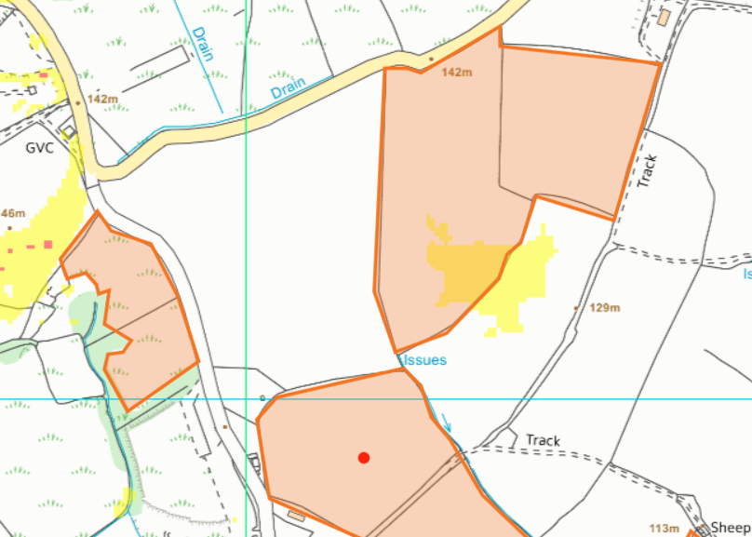
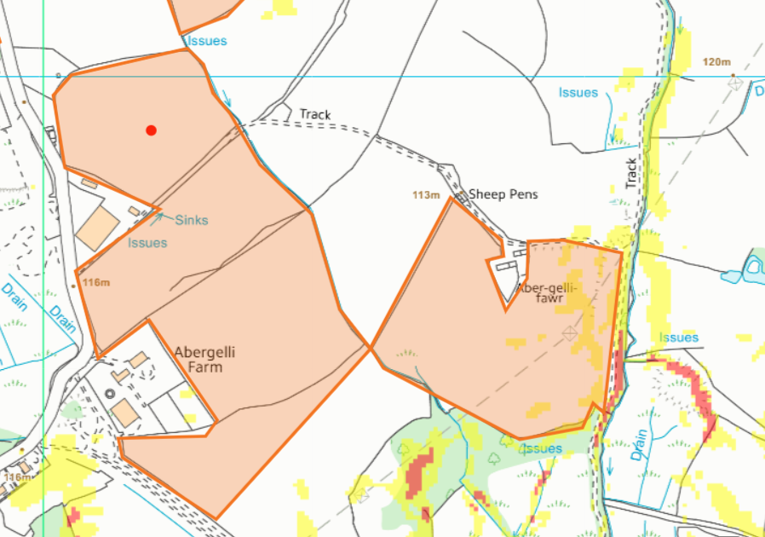
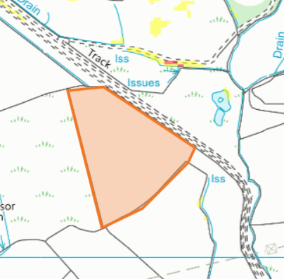

Protected species/habitats
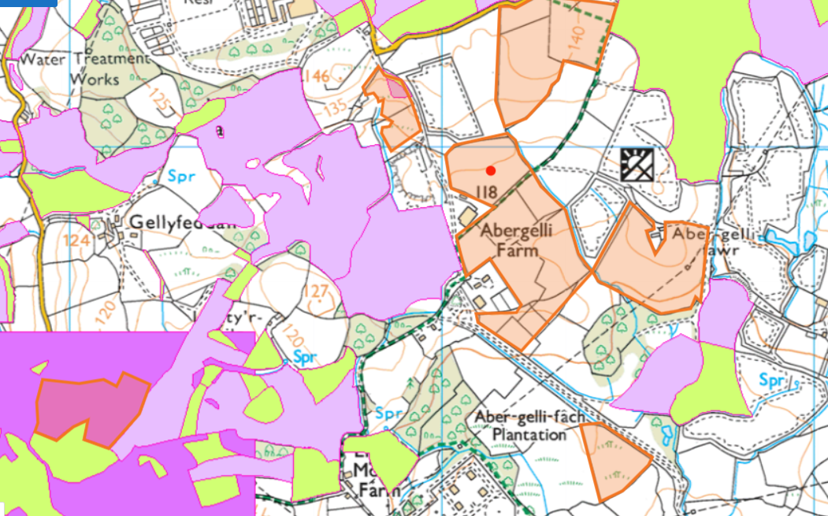
- Field 26/27- Marsh Fritillary butterfly (over whole square due to incomplete grid ref)
- Field 25- Purple moor grass and rush pastures and Lowland dry acid grassland and Lowland calcareous grassland

Ancient Woodlands
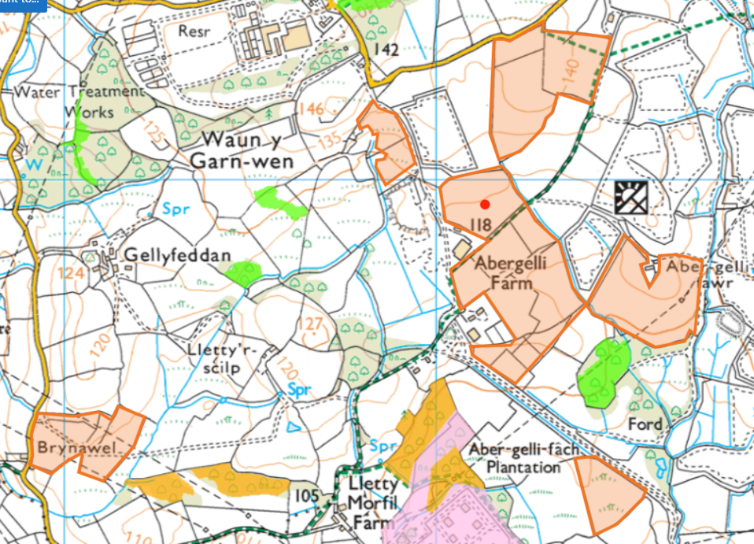
- None within of near field boundaries

Local Wildlife Sites (SINC)
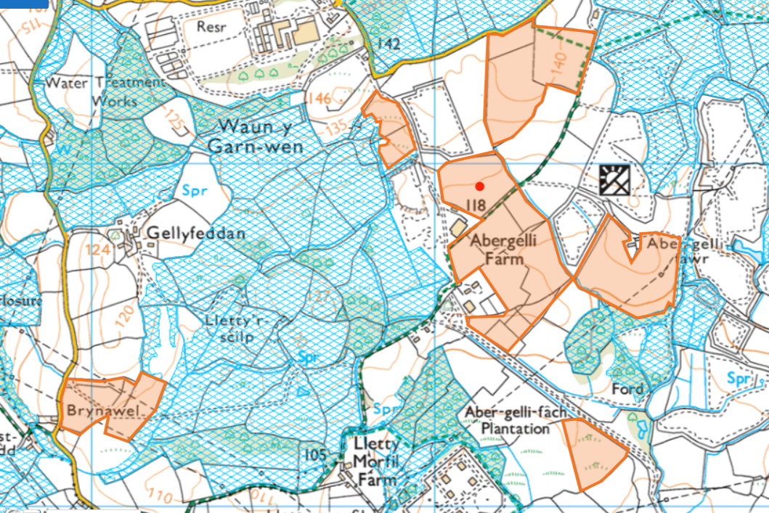
- Application map (2. Location Plan_Abergelli Farm 1 (2023)) only shows SINC Waun Garn Wen over a small area due to miscommunication on previous deployment
- See next pages for field specific information

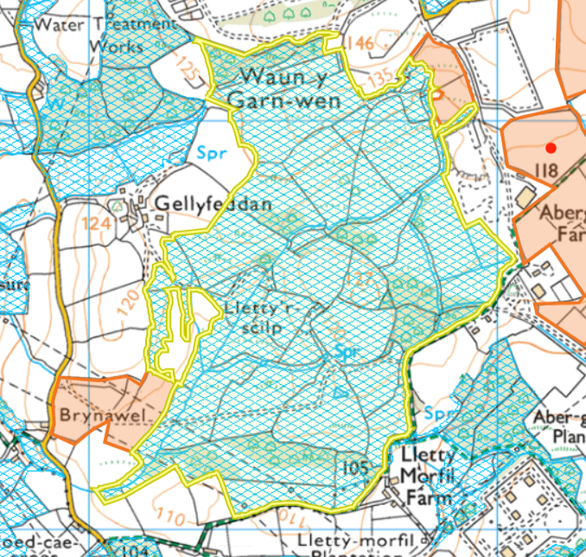
- Waun Garn Wen- borders fields 25 and 27
- For further information on please contact Swansea Council - Deborah.Hill@swansea.gov.uk
- No spread area and 10 meter buffer on boundary with field 25
- 10 meter buffer on boundary with field 27

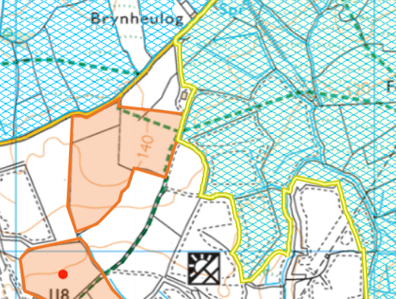
- Rhyd-Y-Pandy Valley and Grasslands borders field 3732
- For further information on please contact Swansea Council - Deborah.Hill@swansea.gov.uk
- 10 meter no spread area is required

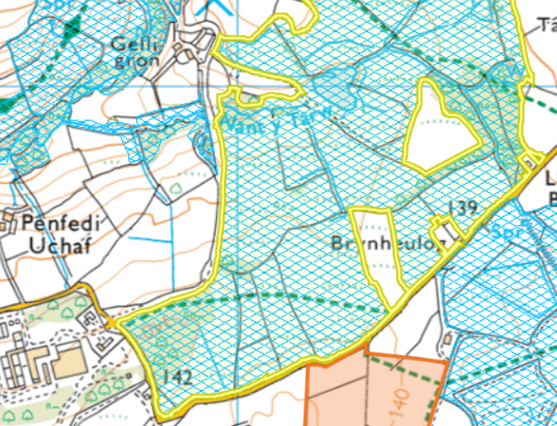
- Rhos Fawr north of field 2225, but this is separated by a road so no buffer is required.
- For further information on please contact Swansea Council - Deborah.Hill@swansea.gov.uk
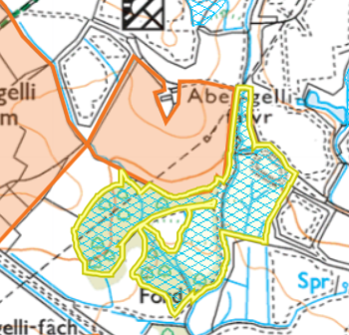
- Llety-Morfil borders field 5867
- For further information on please contact Swansea Council - Deborah.Hill@swansea.gov.uk
- 10 meter buffer is in place

Other
National Park- None
Scheduled Monument- none
Local Nature Reserve- None
National Nature Reserve- None

