MyMap report
Application site plan- activity area in yellow. Not know if this is to be the permit boundary, or if this is one of the many other boundary lines.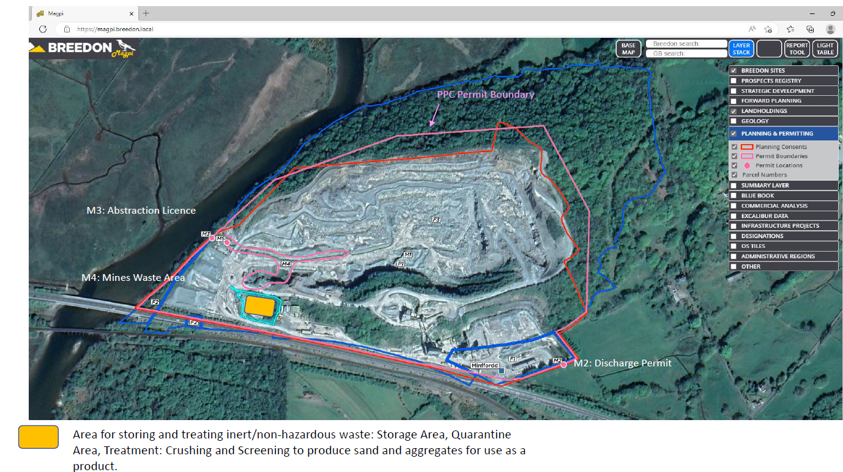

Addresses within 500 meters
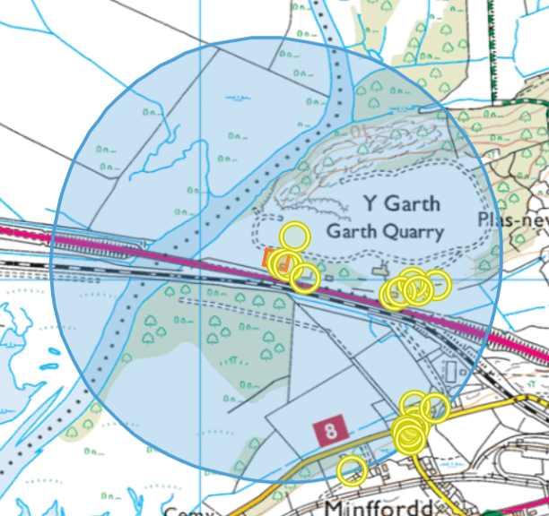
Circles to the south of the map are all residential:
- GLANDON,MINFFORDD,PENRHYNDEUDRAETH,LL48 6HP
- Y GRAIG,MINFFORDD,PENRHYNDEUDRAETH,LL48 6HP

- 3,OSMOND TERRACE,MINFFORDD,PENRHYNDEUDRAETH,LL48 6HW
- RHOS,MINFFORDD,PENRHYNDEUDRAETH,LL48 6HP
- 4,OSMOND TERRACE,MINFFORDD,PENRHYNDEUDRAETH,LL48 6HW
- 1,OSMOND TERRACE,MINFFORDD,PENRHYNDEUDRAETH,LL48 6HW
- 6,OSMOND TERRACE,MINFFORDD,PENRHYNDEUDRAETH,LL48 6HW
- 5,OSMOND TERRACE,MINFFORDD,PENRHYNDEUDRAETH,LL48 6HW

Proximity to Human Occupation
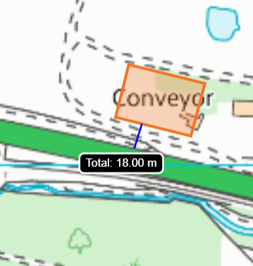

Assessment under wildlife, countryside or habitats legislation
SSSI within 2km
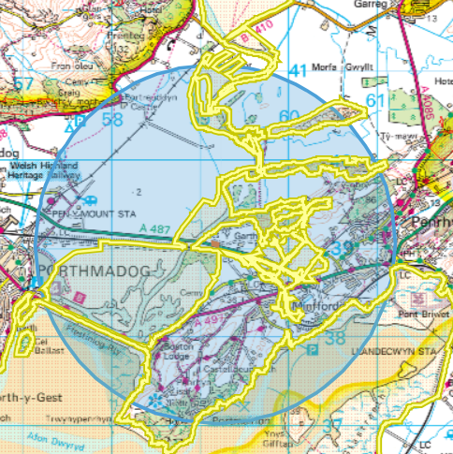
- Glaslyn
- Morfa Harlech
- Ysbyty Bron y Garth

Glaslyn SSSI 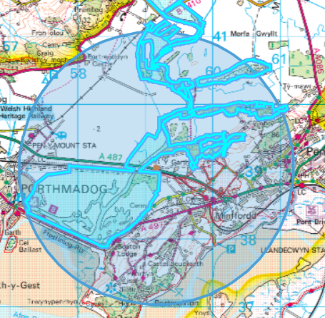

Glaslyn SSSI 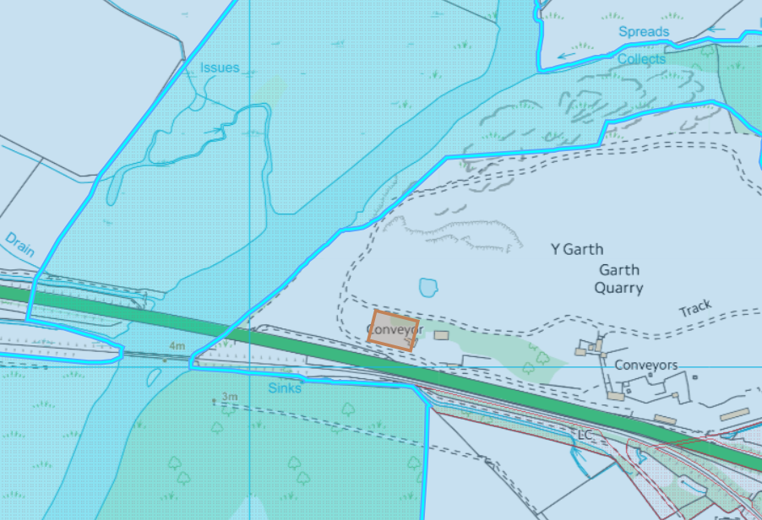

Morfa Harlech SSSI 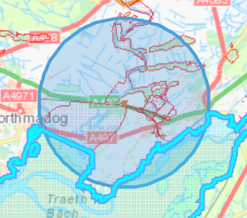

Morfa Harlech SSSI 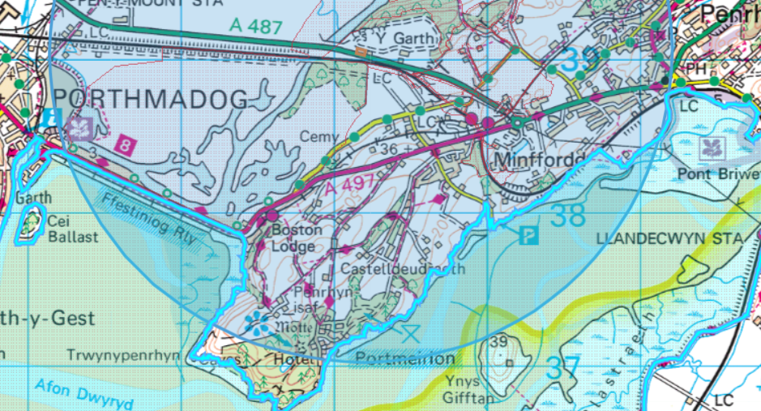

Ysbyty Bron y Garth SSSI 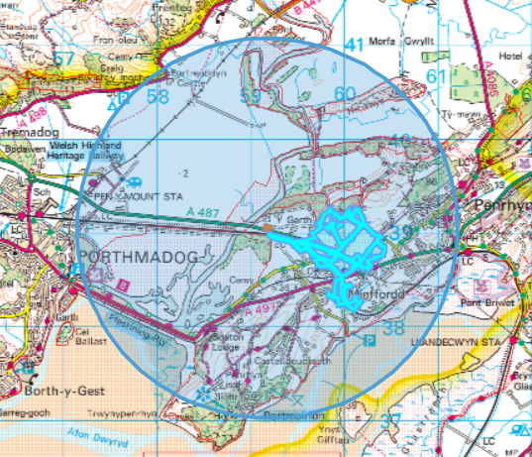

Ysbyty Bron y Garth SSSI 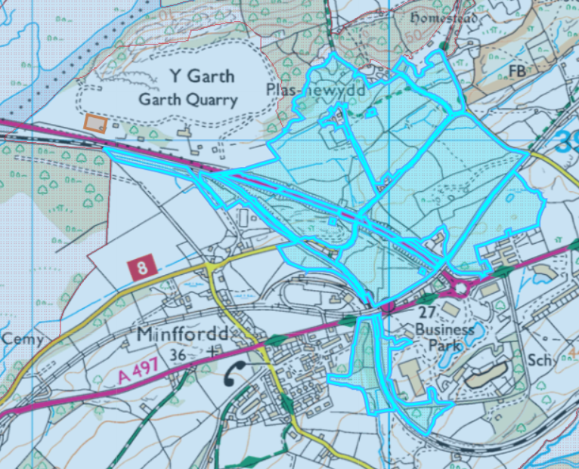

SAC, pSAC, SPA, pSPA, Ramsar within 1km
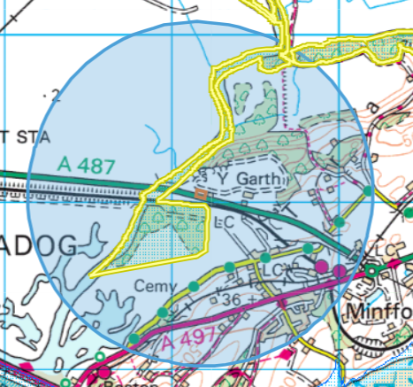
Coedydd Derw a Safleoedd Ystlumod Meirion / Meirionnydd Oakwoods and Bat Sites SAC x 2

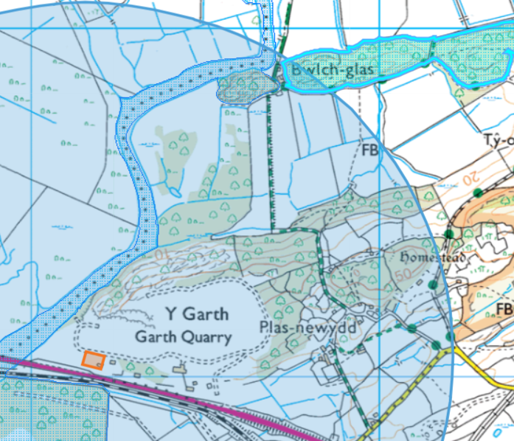

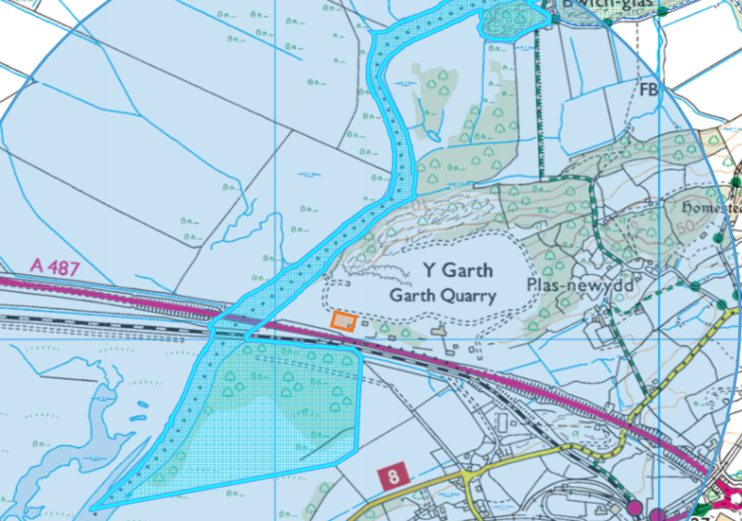

Groundwater/Aquifers
- Aquifer Designation (Superficial)
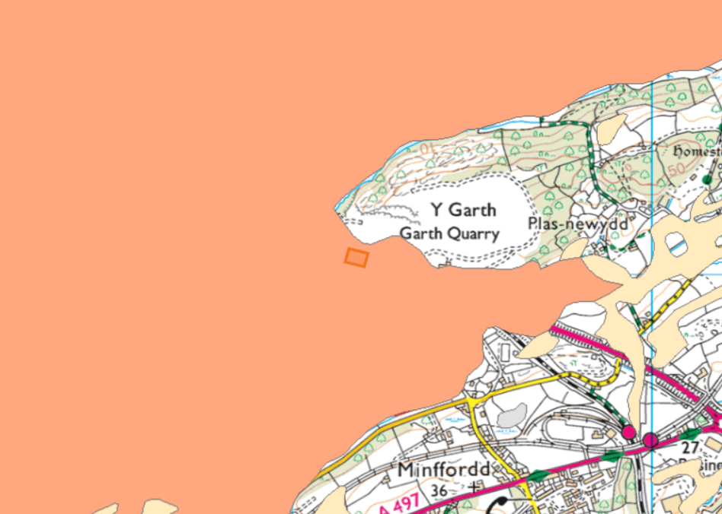
*Not on a groundwater source protection zone

- Aquifer Designation (Bedrock)
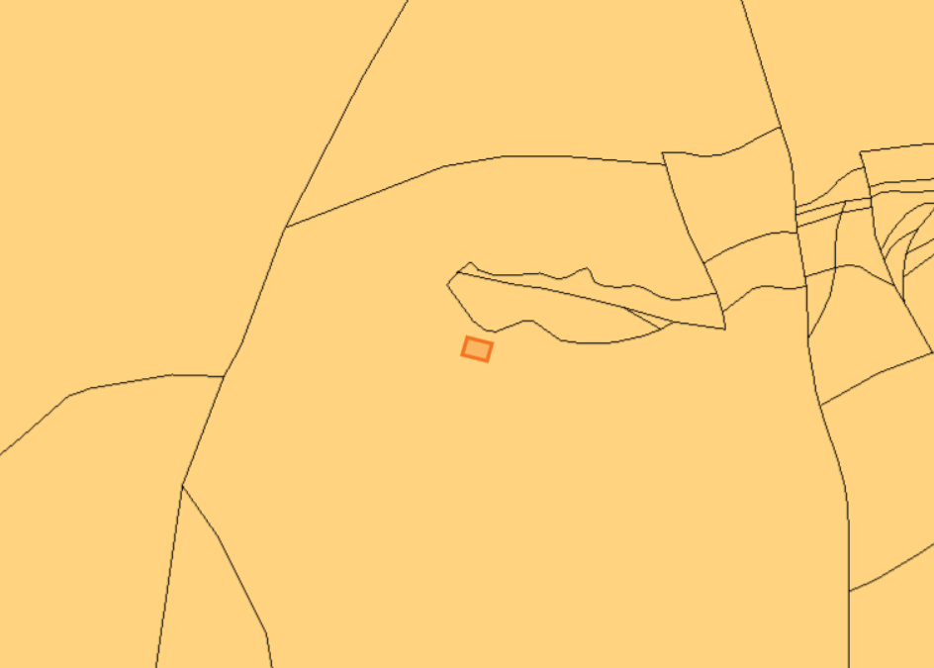
*Not on a groundwater source protection zone

Surface water courses (sinks/issues/springs/wells etc.)
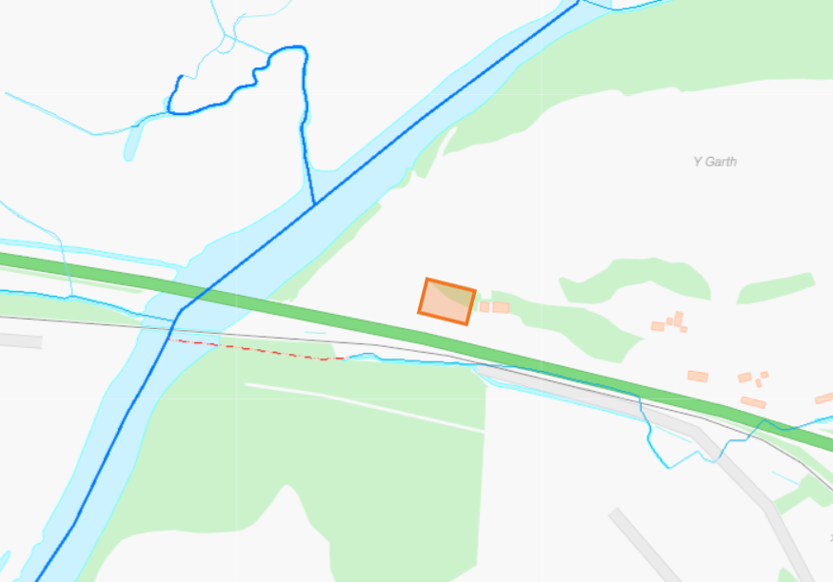
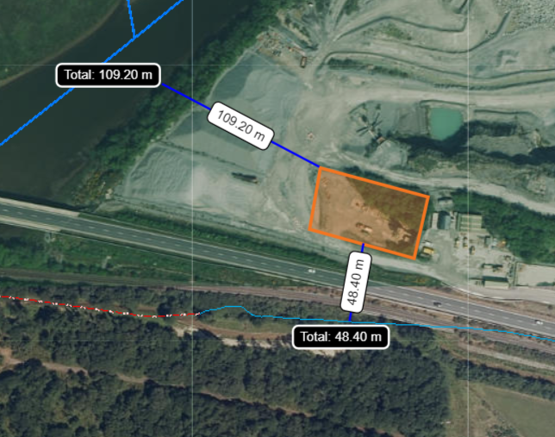
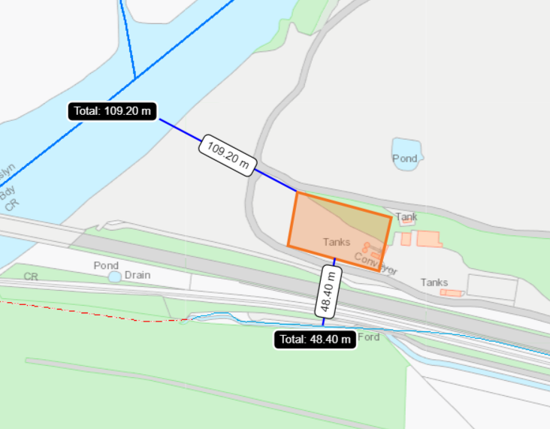
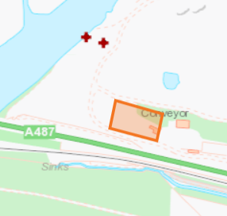
Abstractions: WA/065/0006/006

Flood Plain
- Flood risk from the sea
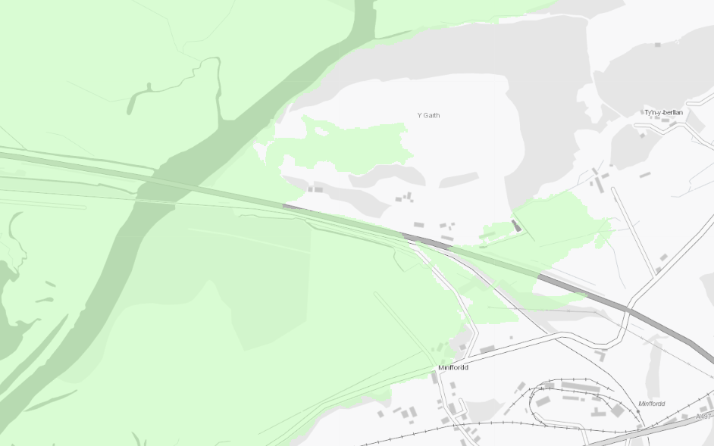

- Flood risk from rivers
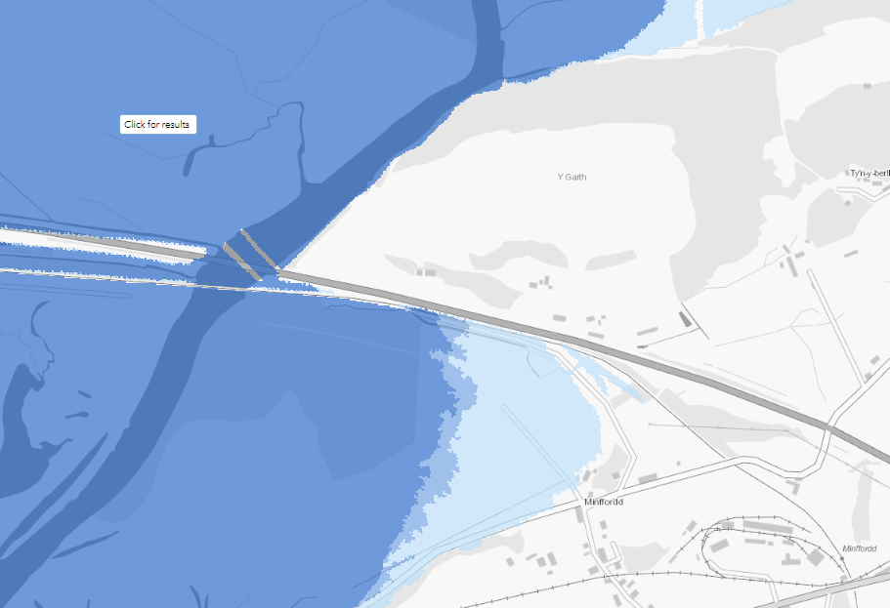

- Flood risk from Surface Water and Small Watercourses
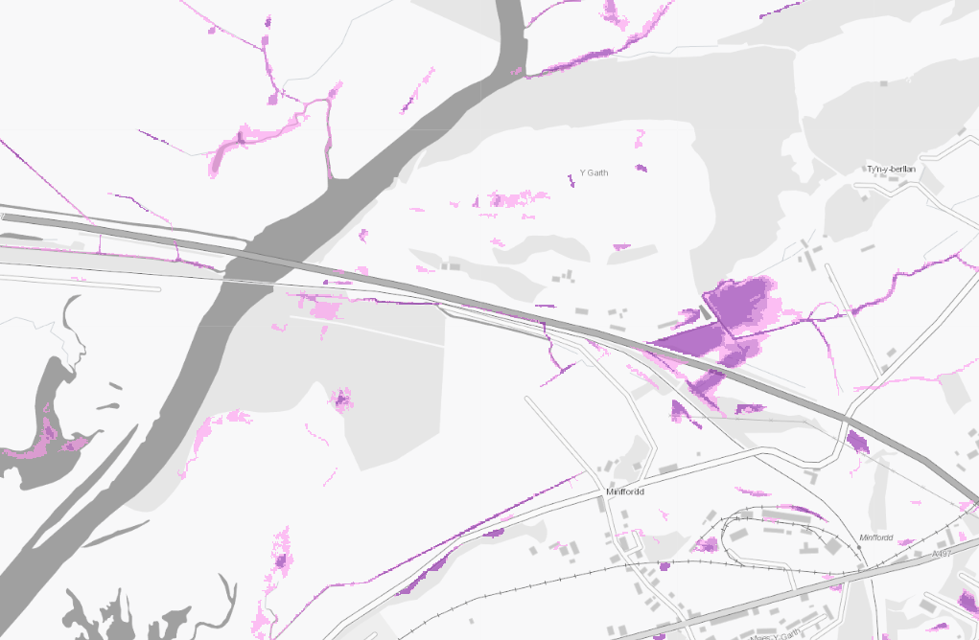

Historic items (ancient monuments, historic sites etc.)
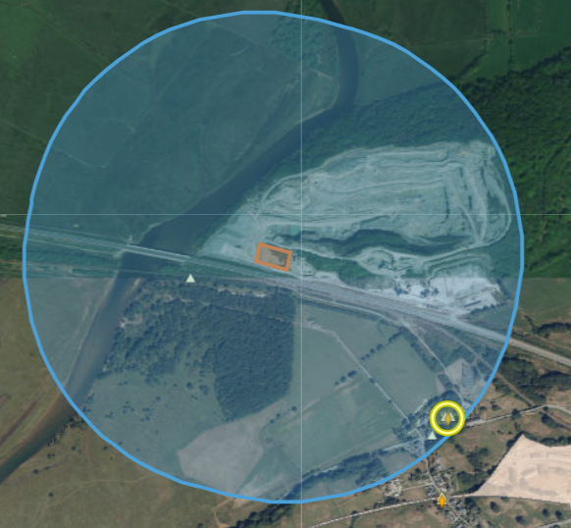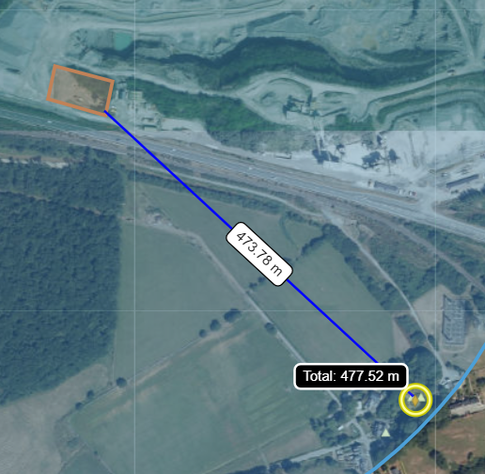
Listed building- Rhos House application 477 meters away

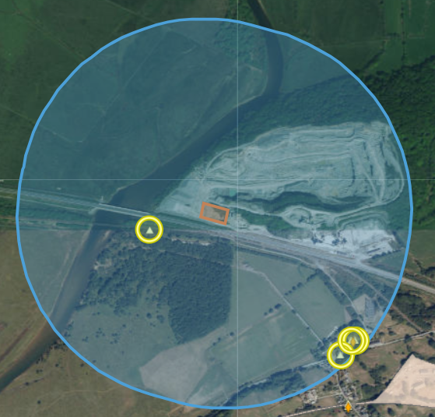
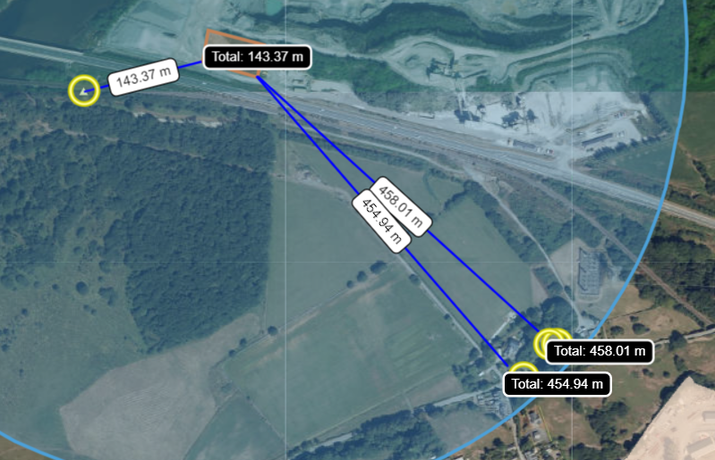
Historic monuments
GRAIG RHOS (458 meters to the SE)
GLAN-Y-DON (454 meters to the SE)
GWAITH DAFYDD-Y-MINER (143 meters to the SW)
GWINDY-Y-RHOS; RHOS (458 meters to the SE)
Ancient woodlands
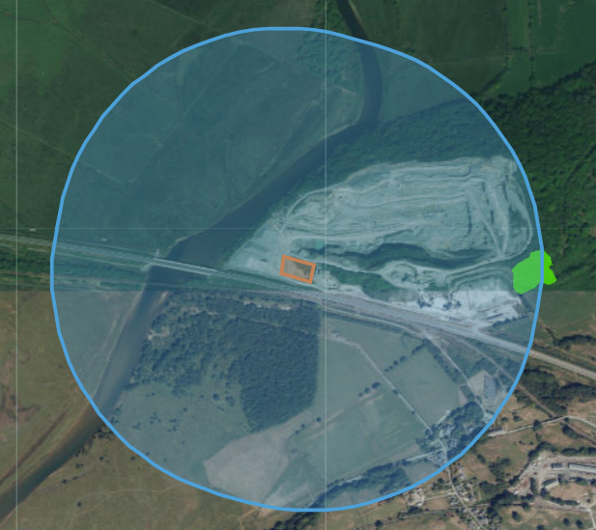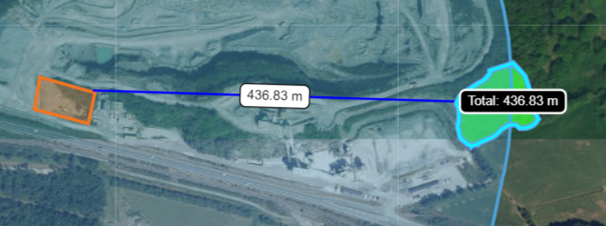
- Ancient Semi Natural Woodland (437m to the east)

Protected habitats/species and section 6/7 species

Habitats
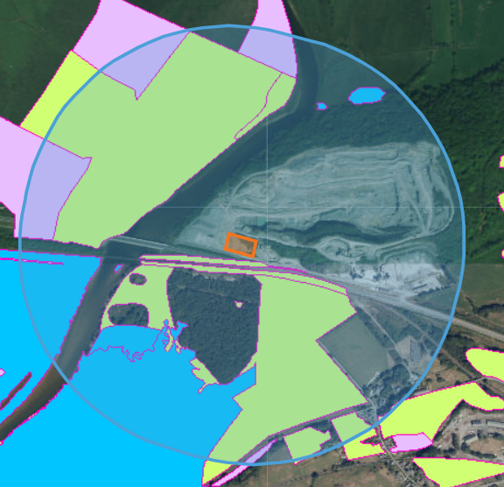
To the south of the main road and on the western bank of the river
- Reedbeds
- Lowland dry acid grassland and Lowland calcareous grassland
- Purple moor grass and rush pastures
- Lowland dry acid grassland
- Coastal saltmarsh

Species
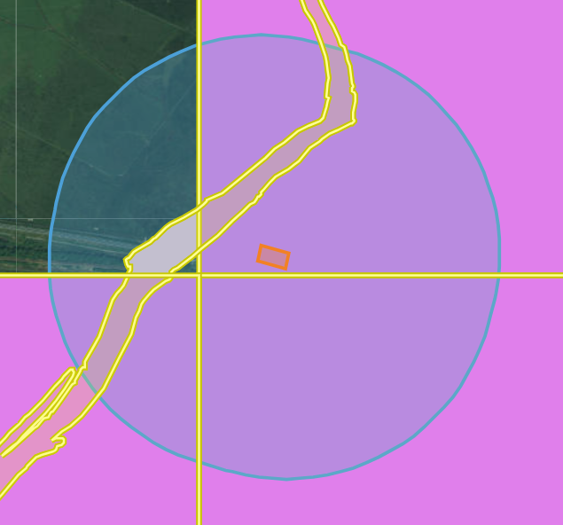
In river:
- European Eel migratory route
- Atlantic Salmon migratory route

Grid squares:
- Threatened Lichen
- Threatened Bryophyte

Section 7 species
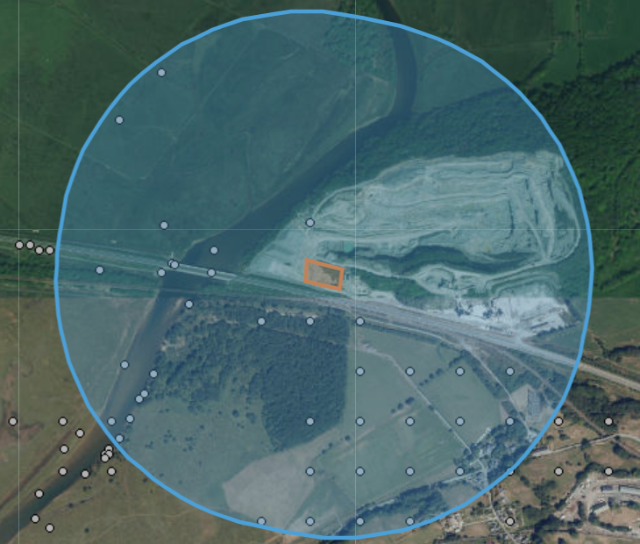

To the south of the main road, within the river, and on the banks of the river:
Birds: Black-headed Gull, Common Reed Bunting, Cuckoo, Curlew, Curlew, Dunnock, Eurasian Skylark, European Herring Gull, Lapwing, Song Thrush, Starling
Butterflies and Moths: Broom Moth, Buff Ermine, Cinnabar, Dusky Brocade, Garden Tiger, Grass Rivulet, Grey Dagger, Large Nutmeg, Mullein Wave, Oblique Carpet, Powdered Quaker, Shaded Broad-bar, Shoulder-striped Wainscot, Small Square-spot, White Ermine,
Mammals: Brown Hare, Brown Long-eared Bat, Common Pipistrelle, European Otter, European Water Vole, Lesser Horseshoe Bat, Noctule Bat, Soprano Pipistrelle
Plants: Lesser Butterfly-orchid

Within the quarry: European Otter; although the grid reference is not very accurate (SH591391) so otter location might not be in the quarry.

