Notice of variation and consolidation with introductory note
The Environmental Permitting (England & Wales) Regulations 2016

Dwr Cymru Cyfyngedig

Llangennech Wastewater Treatment Works
Heol Y Parc
Llangennech
Llanelli
SA14 8UY

Variation application number
PAN-004425

Permit number

BC0006501

Llangennech Wastewater Treatment Works

Permit number BC0006501

Introductory note

This introductory note does not form a part of the notice.

The following notice gives notice of the variation and consolidation of an environmental permit.

The permit has been varied to amend the final effluent sampling point location. The final effluent sampling point National Grid Reference has been added to table S3.4.

The schedules specify the changes made to the permit.

The status log of a permit sets out the permitting history, including any changes to the permit reference number. It is not backdated before 6 April 2010.

Status log of the permit
Description | Date | Comments
Application received PAN-004425  (variation and consolidation) | Duly made  16/01/2019 | Application to vary the final effluent sampling point location.
Variation determined BC0006501/V002 | 04/03/2019 | Permit issued to Dwr Cymru Cyfyngedig.

End of introductory note

Notice of variation and consolidation
The Environmental Permitting (England and Wales) Regulations 2016

The Natural Resources Body for Wales (“Natural Resources Wales”) in exercise of its powers under regulation 20 of the Environmental Permitting (England and Wales) Regulations 2016 varies and consolidates

permit number

BC0006501

issued to:

Dwr Cymru Cyfyngedig (“the operator”)

whose registered office is

Pentwyn Road

Nelson

Treharris

Mid Glamorgan

CF46 6LY

company registration number 02366777

to operate a regulated facility at

Llangennech Wastewater Treatment Works

Heol Y Parc

Llangennech

Llanelli

SA14 8UY

to the extent set out in the schedules.

The notice shall take effect from 04/03/2019

Name | Date
Emily Roe 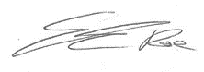 | 04/03/2019

Authorised on behalf of Natural Resources Wales

Schedule 1
Only Table S3.4 and Schedule 7 – Site plan have been varied by the consolidated permit BC0006501 as a result of the application made by the operator.

Schedule 2 – consolidated permit

Consolidated permit issued as a separate document

Permit
The Environmental Permitting (England and Wales) Regulations 2016

Permit number

BC0006501

This is the consolidated permit referred to in the variation and consolidation notice for application PAN-004425 authorising,

Dwr Cymru Cyfyngedig (“the operator”),

whose registered office is

Pentwyn Road

Nelson

Treharris

Mid Glamorgan

CF46 6LY

company registration number 02366777

to operate a water discharge activity at

Llangennech Wastewater Treatment Works

Heol Y Parc

Llangennech

Llanelli

SA14 8UY

to the extent authorised by and subject to the conditions of this permit.

Name | Date

Authorised on behalf of Natural Resources Wales

Conditions
- Management
  - General management
    - The operator shall manage and operate the activity:
      - in accordance with a written management system that identifies and minimises risks of pollution so far as is reasonably practicable, including those risks arising from operations, maintenance, accidents, incidents, non-conformances and those drawn to the attention of the operator as a result of complaints; and
      - using sufficient competent persons and resources.
    - Records demonstrating compliance with condition 1.1.1 shall be maintained.
    - Any person having duties that are or may be affected by the matters set out in this permit shall have convenient access to a copy of the permit.
- Operations
  - Permitted activities
    - The only activity authorised by the permit is the activity specified in schedule 1 table S1.1.
  - The site
    - The discharge activity shall take place at the discharge point marked on the site plan at schedule 7 to this permit, and as listed in table S3.2.
  - Operating techniques
    - For the activity referenced in schedule 1, table S1.1 The operator shall comply with the relevant requirements of the Urban Waste Water Treatment (England and Wales) Regulations 1994.

- Emissions and monitoring
  - Emissions to water
    - The limits given in schedule 3 table S3.1 shall not be exceeded.
    - The limits in schedule 3 table S3.1 to which this condition applies may be exceeded where: in any series of samples of the discharge taken at regular but randomised intervals in any period of twelve consecutive months as listed in column 1 of schedule 3A, no more than the relevant number of samples, as listed in column 2 of schedule 3A, exceed the applicable limit for that relevant parameter. For relevant parameters subject to schedule 3C the assessment is based on a fixed calendar year from 1 January to 31 December inclusive.

      - For the emission limits in schedule 3 table S3.1 to which this condition applies, no sample of the discharge taken at a time when unusual weather conditions are adversely affecting the operation of the waste water treatment works, shall be taken into account in deciding whether or not the emission limit has been complied with.
      - On any occasion where unusual weather conditions adversely affect the operation of the waste water treatment works, the operator shall use its best endeavours to mitigate that adverse effect.
      - For any sample of the discharge taken to be considered for the purposes of (a) above, the operator shall notify Natural Resources Wales in writing within 14 days of becoming aware that an emission limit has been exceeded. That notification shall include a full description of the unusual weather conditions and their impact on the operation of the works.

      - For the emission limits in schedule 3 table S3.1 to which this condition applies, no sample of the discharge taken at a time when abnormal operating conditions are adversely affecting the operation of the waste water treatment works, shall be taken into account in deciding whether or not the emission limit has been complied with.
      - On any occasion where abnormal operating conditions adversely affect the operation of the waste water treatment works, the operator shall use its best endeavours to mitigate that adverse effect.
      - For any sample of the discharge taken to be considered for the purposes of (a) above, the operator shall notify Natural Resources Wales in writing within 14 days of becoming aware that an emission limit has been exceeded. That notification shall include a full description of the abnormal operating conditions and their impact on the operation of the works.

      - If the measured Dry Weather Flow exceeds the permitted Dry Weather Flow limit then the operator shall, as soon as is practicable, investigate the reasons for the exceedance. The operator shall report the reasons for the exceedance to Natural Resources Wales and the steps that it proposes to take to restore compliance. An exceedance of the Dry Weather Flow limit shall not be recorded as a failure if the operator takes appropriate steps to restore compliance;
      - If the measured Dry Weather Flow exceeds the permitted Dry Weather Flow limit because of unusual rainfall during the 12-month period, then it will not be recorded as a failure of the Dry Weather Flow limit. For the purposes of this condition, unusual rainfall shall mean rainfall that causes significantly higher sewage flows during the three-month period that normally records the lowest flows;
      - The permitted Dry Weather Flow limit is set at the operator’s planned annual 80% exceeded flow;
      - For compliance with this permit, the measured Dry Weather Flow is that total daily volume that is exceeded by 90% of the recorded measured total daily volume values in any period of 12 months; and
      - For unusual rainfall to be considered, the operator shall notify Natural Resources Wales and provide supporting evidence as part of the normal specified data returns.

  - Emissions of substances not controlled by emission limits
    - The operator shall take appropriate measures to minimise so far as reasonably practicable the polluting effects of the emissions of substances in the discharge not controlled by emission limits (excluding odour).
  - Monitoring
    - The operator shall, unless otherwise agreed in writing by Natural Resources Wales, undertake the monitoring specified in the following tables in schedule 3 to this permit:
      - point source emissions specified in tables S3.1 and S3.4;
      - inlet quality specified in tables S3.1 and S3.4.
    - The operator shall maintain records of all monitoring required by this permit.
    - Monitoring equipment, techniques, personnel and organisations employed for the emissions monitoring programme specified in condition 3.3.1 shall have either MCERTS certification or MCERTS accreditation (as appropriate), where available, unless otherwise agreed in writing by Natural Resources Wales.
    - Accessible monitoring points shall be provided and maintained to enable the emissions monitoring programme to be carried out at the monitoring points specified in table S3.4 of schedule 3 and shown marked on the site plan in schedule 7.
    - The monitoring programme for the parameters subject to schedule 3B shall be:
      - pre-scheduled to cover a calendar year and the programme recorded before the start of a calendar year sample period; and
      - spot samples collected at approximately equal intervals during the year, including samples from different days of the week and different times. Approximately 10% of samples should be outside the normal sampling window which is 9am-3pm, Monday to Friday.
    - After becoming aware, or following a notification that a sample has not been taken on the schedule 3B Monitoring Programme pre-scheduled date, or is lost, or a result for that sample cannot be reported, the operator shall record the details and reschedule the sample.
    - The monitoring programme for the parameters subject to schedule 3C shall be:
(a) pre-scheduled before each calendar year;
(b) Unless otherwise agreed in writing by Natural Resources Wales, the operator shall submit the monitoring programme for the following calendar year to Natural Resources Wales before the 1st of December; and
(c) samples must be collected at approximately equal intervals during the year from different days of the week and approximately 10% of samples should be taken at weekends.
3.3.8 Unless otherwise agreed in writing by Natural Resources Wales, after becoming aware, or following notification that a sample has not been taken on the schedule 3C Monitoring Programme pre-scheduled date, or is lost, or a result for that sample cannot be reported, the operator shall notify Natural Resources Wales of the missed even and the reschedule date as soon as reasonably practicable.

- Information
  - Records
    - All records required to be made by schedule 3, 4 and 5 to this permit shall:
      - be legible;
      - be made as soon as reasonably practicable;
      - if amended, be amended in such a way that the original and any subsequent amendments remain legible, or are capable of retrieval; and
      - be retained, unless otherwise agreed in writing by Natural Resources Wales, for at least 6 years from the date when the records were made.
    - The operator shall maintain convenient access, in either electronic or hard copy, to the records, plan and management system required to be maintained by this permit.

  - Reporting
    - The operator shall send all reports and notifications required by the permit to Natural Resources Wales using the contact details supplied in writing by Natural Resources Wales.
    - Within the time period after the end of the reporting period specified in schedule 4 table S4.1 the operator shall, unless otherwise agreed in writing by Natural Resources Wales, submit reports of the monitoring and assessment carried out in accordance with the conditions of this permit, as follows:
      - in respect of the parameters and monitoring points specified in schedule 4 table S4.1;
      - for the reporting periods specified in schedule 4 table S4.1 and using the forms specified in schedule 4 table S4.2; and
      - giving the information from such results and assessments as may be required by the forms specified in those tables.
  - Notifications
    - Natural Resources Wales shall be notified as soon as reasonably practicable following detection, within the site of the regulated facility of:
    - any malfunction, breakdown or failure of equipment or techniques, accident, or emission of a substance not controlled by an emission limit which has caused, is causing or may cause significant pollution; and
    - any breach of a limit specified in schedule 3 table S3.1 including individual exceedances of limits which are covered by condition 3.1.2.
Any other significant adverse environmental effects, which may have been caused by the activity, shall also be notified to Natural Resources Wales as soon as reasonably practicable following detection.
    - The information provided under condition 4.3.1 shall be supported by sending the information listed in schedule 5 to this permit within the time period specified in that schedule.
    - Where Natural Resources Wales has requested in writing that it shall be notified when the operator is to undertake monitoring and/or spot sampling specified in schedule 3B/3C, the operator shall inform Natural Resources Wales when the relevant monitoring and/or spot sampling is to take place. The operator shall provide this information to Natural Resources Wales at least 14 days before the date the monitoring is to be undertaken.
    - Natural Resources Wales shall be notified within 14 days of the occurrence of the following matters, except where such disclosure is prohibited by Stock Exchange rules:
Where the operator is a registered company:
      - any change in the operator’s trading name, registered name or registered office address; and
      - any steps taken with a view to the operator going into administration, entering into a company voluntary arrangement or being wound up.
Where the operator is a corporate body other than a registered company:
      - any change in the operator’s name or address; and
      - any steps taken with a view to the dissolution of the operator.
    - Where the operator proposes to make a change in the nature of the activity by increasing the concentration of, or the addition of, or allowing the introduction of, a substance to the activity to an extent that the operator considers could have a significant adverse environmental effect on the receiving waters, and the change is not permitted by emission limits specified within schedule 3 table S3.1 or the subject of an application for approval under the EP Regulations or under the terms of this permit:
      - Natural Resources Wales shall be notified in writing at least 14 days before the increase or addition or allowing the introduction; and
      - the notification shall contain a description of the proposed change.
    - The operator shall inform Natural Resources Wales in writing of any change, or proposed change, to the population equivalent such as would make a material change to the application of the Regulations and shall, on request, inform the Natural Resources Wales in writing of the actual population equivalent.

  - Interpretation
    - In this permit the expressions listed in schedule 6 shall have the meaning given in that schedule.
    - In this permit references to reports and notifications mean written reports and notifications, except where reference is made to notification being made “as soon as reasonably practicable”, in which case it may be provided by telephone.

Schedule 1 – Operations
Table S1.1 Activities
Description of activity | Limits of specified activity
Discharge of secondary treated sewage effluent via Outlet 1 | N/A

Schedule 2 – Waste types, raw materials and fuels
Schedule 2 not in use.

Schedule 3 – Emissions and monitoring
Table S3.1 Point Source emissions to water (other than sewer) – emission limits and monitoring requirements
Effluent and discharge point | Parameter | Limit (including unit) | Reference Period | Limit of effective range | Monitoring frequency | Compliance Statistic
Secondary treated sewage effluent via Outlet 1 | Dry weather flow | 1678 m³/day | Total daily volume | N/A | Continuous | Condition 3.1.5 applies
Secondary treated sewage effluent via Outlet 1 | 15-minute instantaneous or averaged flow | No limit set. Record as l/s | 15 minute | N/A | Continuous | N/A
Secondary treated sewage effluent via Outlet 1 | ATU-BOD as O₂ | 40 mg/l | Instantaneous (spot sample) | N/A | As specified in schedule 3B | Look up table  (Conditions 3.1.2 and 3.1.3 apply)
Secondary treated sewage effluent via Outlet 1 | ATU-BOD as O₂ | 80 mg/l | Instantaneous (spot sample) | N/A | As specified in schedule 3B | Maximum  (Condition 3.1.3 applies)
Secondary treated sewage effluent via Outlet 1 | Suspended solids (measured after drying at 105ºC) | 44 mg/l | Instantaneous (spot sample) | N/A | As specified in schedule 3B | Look up table  (Conditions 3.1.2 and 3.1.3 apply)
Secondary treated sewage effluent via Outlet 1 | Suspended solids (measured after drying at 105ºC) | 120 mg/l | Instantaneous (spot sample) | N/A | As specified in schedule 3B | Maximum  (Condition 3.1.3 applies)
Secondary treated sewage effluent via Outlet 1 | Visible oil or grease | No significant trace present so far as is reasonably practicable | Instantaneous (visual examination) | N/A | N/A | No significant trace  (Condition 3.1.3 applies)
Secondary treated sewage effluent via Outlet 1 | ATU-BOD as O₂ (UWWTR) | Minimum of 70 % removal compared to influent | 24 hour composite | To be compliant a sample has to meet the 70% removal standard or the 25 mg/l limit not both | As specified in schedule 3C | Look up table  (Conditions 3.1.2 and 3.1.4 apply)
Secondary treated sewage effluent via Outlet 1 | ATU-BOD as O₂ (UWWTR) | 25 mg/l
Secondary treated sewage effluent via Outlet 1 | ATU-BOD as O₂ (UWWTR) | 50 mg/l | 24 hour composite | This limit does not apply if a sample has met the 70% removal standard | As specified in schedule 3C | Maximum  (Condition 3.1.4 applies)
Secondary treated sewage effluent via Outlet 1 | COD as O₂ (UWWTR) | Minimum of 75 % removal compared to influent | 24 hour composite | To be compliant a sample has to meet the 75% removal standard or the 125 mg/l limit not both | As specified in schedule 3C | Look up table  (Conditions 3.1.2 and 3.1.4 apply)
Secondary treated sewage effluent via Outlet 1 | COD as O₂ (UWWTR) | 125 mg/l
Secondary treated sewage effluent via Outlet 1 | COD as O₂ (UWWTR) | 250 mg/l | 24 hour composite | This limit does not apply if a sample has met the 75% removal standard | As specified in schedule 3C | Maximum  (Condition 3.1.4 applies)

Table S3.2 Discharge point
Effluent Name | Discharge Point | Discharge point NGR | Receiving water/Environment
Secondary treated sewage effluent | Outlet 1 | SN 56721 00904 | Loughor Estuary

Table S3.3
Table S3.3 not in use

Table S3.4 Monitoring points
Effluent and discharge point | Monitoring type | Monitoring point NGR | Monitoring point reference
Secondary treated sewage effluent via Outlet 1 | Influent sampling | SN 56728 01037 | Influent sample point
Secondary treated sewage effluent via Outlet 1 | Final effluent sampling | SN 56795 00956 | Final effluent sample point
Secondary treated sewage effluent via Outlet 1 | UWWTR effluent sampling | SN 56795 00956 | Final effluent sample point
Secondary treated sewage effluent via Outlet 1 | MCERTS flow monitoring point | SN 56341 01379 | Flow monitoring point

Schedule 3A - Look up table
Look up table
Number of samples taken in any period of 12 months | Maximum number of samples permitted to exceed limit for given parameter
4–7 | 1
8–16 | 2
17–28 | 3
29–40 | 4
41–53 | 5
54–67 | 6
68–81 | 7
82–95 | 8
96–110 | 9
111–125 | 10
126–140 | 11
141–155 | 12
156–171 | 13
172–187 | 14
188–203 | 15
204–219 | 16
220–235 | 17
236–251 | 18
252–268 | 19
269–284 | 20
285–300 | 21
301–317 | 22
318–334 | 23
335–350 | 24
351–365 | 25

Schedule 3B - OSM tier 2 sampling frequency
Tier 2 Category | Parameter | `Normal frequency` of samples per year | Reduced Sampling frequency after 12 consecutive months of numeric permit compliance, samples per year or pro rata over the remainder of a year | On numeric limit failure return to normal frequency as soon as reasonably practicable, samples per 12 months | Out of hours samples
> 5m3/d (but not in tier 3) with numeric limits for ammoniacal nitrogen (expressed as N), nutrients, hazardous pollutants, UWWTR self monitoring | Sanitary  Non sanitary | 12  6 | 6  6 | 12  6 | For 12 samples 1 out of hours sample per annum, for 6, 1 every 2 years on average
>20 m3/d (but not in tier3) with numeric limits for one or more of biochemical oxygen demand or suspended solids or pH or temperature only. | Sanitary | 12 | 4 | 12 | For 12 samples 1 out of hours sample per annum, for 4, 1 every 3 years on average

Schedule 3C – Urban Waste Water Treatment Regulations sampling frequency
Population equivalent | Samples per year | Reduced sampling frequency after a year without an UWWTR exceedance or failure, samples per year | Following an UWWTR exceedance or failure return to the higher frequency in the year that follows, samples per year
2,000 to 9,999 | 12 | 4 | 12
10,000 to 49,999 | 12 | N/A | N/A
50,000 or over | 24 | N/A | N/A

Schedule 4 – Reporting
Parameters, for which reports shall be made, in accordance with conditions of this permit, are listed below.
Table S4.1 Reporting of monitoring data
Parameter | Monitoring point reference | Reporting period | Period begins
Dry Weather Flow (daily flows total) | Final effluent sample point | Annually  Report to be submitted within 2 months of the end of the calendar year | 1 January
15-minute flow | Final effluent sample point | Reports to be provided to Natural Resources Wales upon request  Report to be submitted within 28 days unless otherwise specified in writing by Natural Resources Wales | Upon request by Natural Resources Wales
UWWTR - ATU-BOD as O₂, COD as O₂ | Influent sample point and Final effluent sample point | Monthly  Report to be submitted within 28 days | 1st of month
Operator Self Monitoring - ATU-BOD as O₂, suspended solids (measured after drying at 105ºC) | Final effluent sample point | Quarterly  Report to be submitted within 28 days | 1st of month
Operator Self Monitoring | Final effluent sample point | Annually  Report to be submitted within 2 months of the end of the calendar year | 1 January

Table S4.2 Reporting forms
Parameter | Reporting format
Dry Weather Flow (daily flows total) | WISKI electronic format specified by Natural Resources Wales
15-minute flow | WISKI electronic format specified by Natural Resources Wales
Flow to storm tank (Flow 4) Monitoring | WISKI electronic format specified by Natural Resources Wales,  on request, form as agreed in writing by Natural Resources Wales
UWWTR – ATU-BOD as O₂, COD as O₂ | Electronic format specified by Natural Resources Wales
OSM - ATU-BOD as O₂, suspended solids (measured after drying at 105ºC) | Quarterly - Electronic format specified by Natural Resources Wales
Operator Self Monitoring summary report | Annually - Summary report of compliance with the monitoring programme specified in Table 3.1 and schedule 3B in a format specified by Natural Resources Wales

Schedule 5 – Notification
These pages outline the information that the operator must provide.
Units of measurement used in information supplied under Part A and B requirements shall be appropriate to the circumstances of the emission. Where appropriate, a comparison should be made of actual emissions and authorised emission limits.
If any information is considered commercially confidential, it should be separated from non-confidential information, supplied on a separate sheet and accompanied by an application for commercial confidentiality under the provisions of the EP Regulations.

Part A
Permit Number | BC0006501
Name of operator
Location of Facility | Llangennech Wastewater Treatment Works
Time and date of the detection

(a) Notification requirements for any malfunction, breakdown or failure of equipment or techniques, accident, or emission of a substance not controlled by an emission limit which has caused, is causing or may cause significant pollution
To be notified within 7 days of detection unless otherwise agreed in writing by the Natural Resources Wales.
Date and time of the event
Reference or description of the location of the event
Description of where any release into the environment took place
Substances(s) potentially released/type or nature of sewage released
Best estimate of the quantity or rate of release of substances and/or duration of discharge
Best estimate of the environmental impact of the discharge
Measures taken, or intended to be taken, to stop any emission
Description of the failure or accident.

(b) Notification requirements for the breach of a limit specified in schedule 3 table S3.1 (including individual exceedances of limits which are covered by condition 3.1.2)
The information specified below is to be notified to Natural Resources Wales as soon as reasonably practicable following detection.
Monitoring point reference/ source
Self monitoring regime (where relevant) | OSM/UWWTR
Type of failure | e.g. LUT failure/LUT exceedance/upper tier/other
Date of sample/event
Parameter
Result and units
Limit and units

Part B – to be submitted as soon as reasonably practicable unless otherwise agreed in writing by Natural Resources Wales
Any more accurate information on the matters for notification under Part A.
Measures taken, or intended to be taken, to prevent a recurrence of the incident/breach/exceedance
Measures taken, or intended to be taken, to rectify, limit or prevent any pollution of the environment which has been or may be caused by the emission

Name*
Post
Signature
Date
* authorised to sign on behalf of the operator

Schedule 6 – Interpretation
“abnormal operating conditions” include but are not limited to, the circumstances described in Regulation 40(1) of, or paragraph 6(5) of Schedule 21 to, the Environmental Permitting Regulations 2016 (illegal discharge to sewer), unusual weather, or during a defined period where the permit authorising the permitted activity has been varied for reasons such as capital works construction.
“accident” means an accident that may result in pollution.
"annually" means once every year.
“application” means the application for this permit, together with any additional information supplied by the operator as part of the application and any response to a notice served under Schedule 5 to the EP Regulations.
“appropriate measures” for the purposes of the emission of substances not controlled by emission limits condition (condition 3.2.1) do not require the operator to undertake treatment to a level beyond that specified in schedule 1 table S1.1, or to carry out routine monitoring for substances not controlled by emission limits.
“ATU-BOD as O₂” means the biochemical oxygen demand (measured after 5 days at 20ºC with nitrification suppressed by the addition of allylthiourea).
“COD as O₂” means the chemical oxygen demand (measured using the standard dichromate procedure).
“emissions of substances not controlled by emission limits” means emissions of substances to air, water or land from the permitted activities, which are not controlled by an emission limit.
“EP Regulations” means The Environmental Permitting (England and Wales) Regulations SI 2016 No.1154 and words and expressions used in this permit which are also used in the Regulations have the same meanings as in those Regulations.
“MCERTS” means the Natural Resources Wales’ Monitoring Certification Scheme.
“monitoring frequency” as used in Table S3.1 in the context of event duration monitoring is the temporal interval at which a change in state between no discharge and discharge is to be detected.
“Natural Resources Wales” means the Natural Resources Body for Wales established by article 3 of the Natural Resources Body for Wales (Establishment) Order 2012. The Natural Resources Body for Wales (Functions) Order 2013 transferred the relevant functions of the Countryside Council for Wales, and functions of the Environment Agency and the Forestry Commission in Wales to the Natural Resources Body for Wales.
"quarter" means a calendar year quarter commencing on 1 January, 1 April, 1 July or 1 October.
“significant pollution” means a high level impact incident as indicated by NRW incident classification system.
“unusual weather conditions” includes, but is not limited to:
    - low ambient temperatures, or the freezing of mechanical equipment in the works;
    - significant snow deposits;
    - tidal or fluvial flooding;
    - weather conditions causing unforeseen loss of power supply to the sewage treatment that could not be ameliorated by the reasonable provision and operation of standby generation facilities.
“Urban Waste Water Treatment (England and Wales) Regulations 1994 (UWWTR)” means Urban Waste Water Treatment (England and Wales) Regulations 1994 SI 2841and the words and expressions used in this permit which are also used in the Regulations have the same meanings as in those Regulations.
“year” means calendar year ending 31 December.

Schedule 7 – Site plan
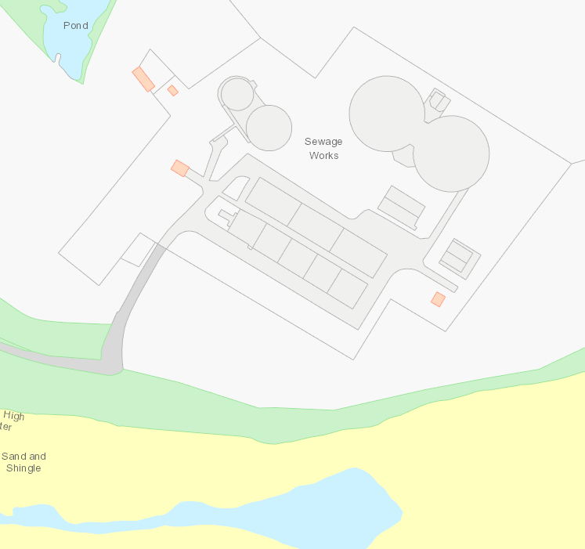
Final effluent sample point
Influent sample point
Outlet 1
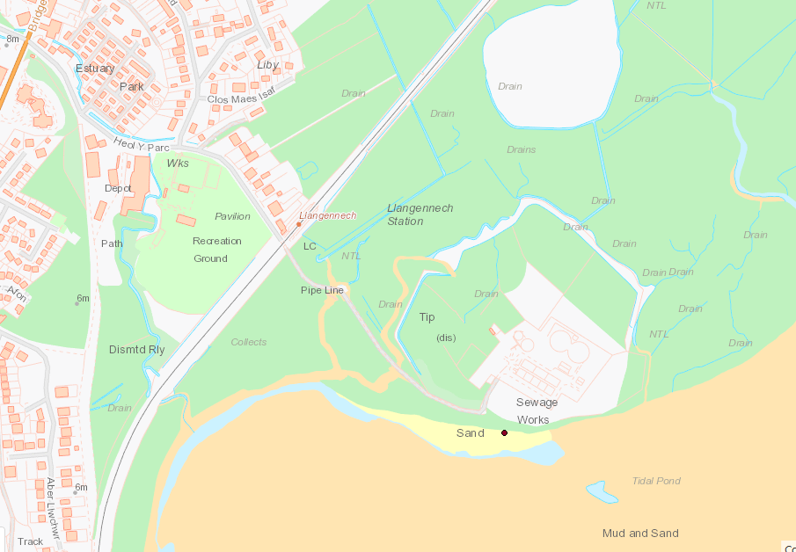
Flow monitoring point
© Crown Copyright and database right 2019. Ordnance Survey licence number 100019741.

END OF PERMIT

