PAN-020836 MyMap report
Application site plan
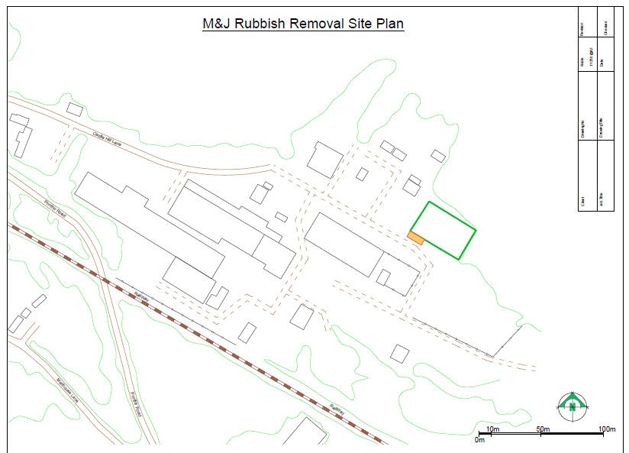

Proximity to Human Occupation
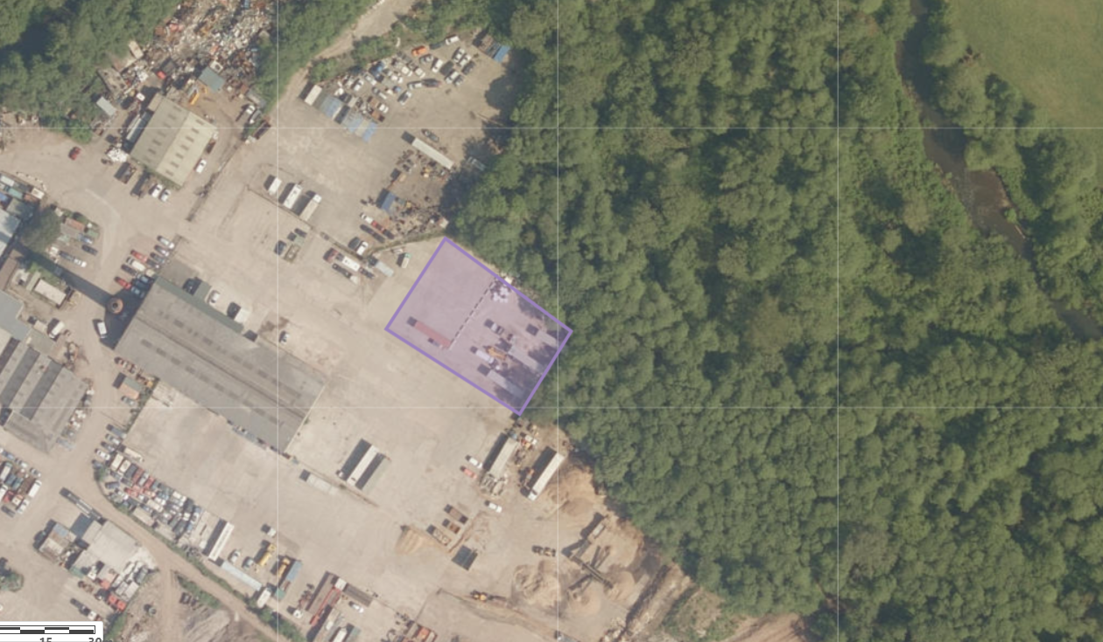

Assessment under wildlife, countryside or habitats legislation
River Usk (Lower Usk) / Afon Wysg (Wysg Isaf) SSSI- 1.5 km away (screening distance is 2km)
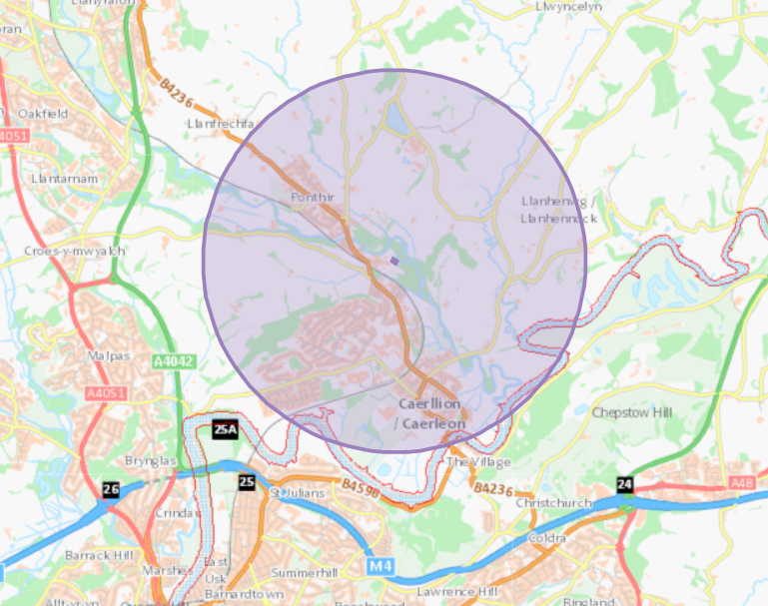
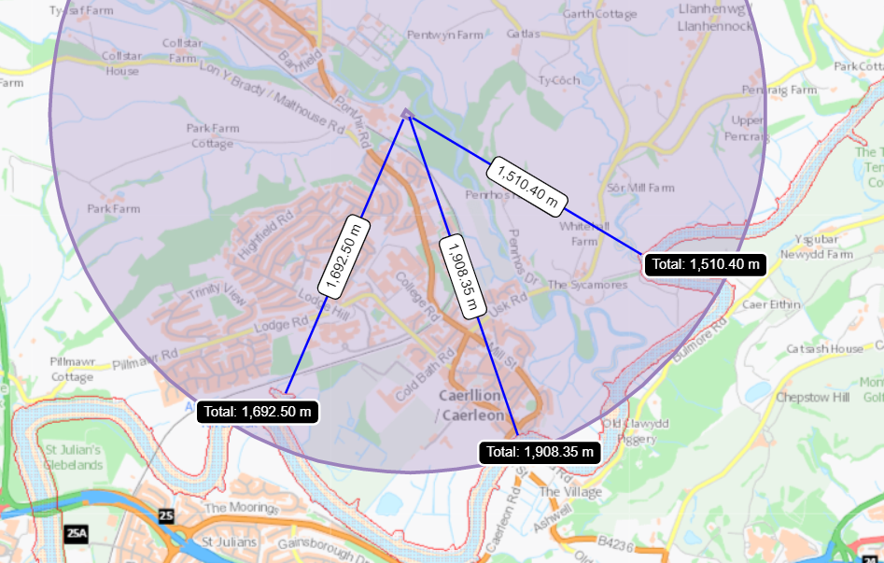

- no SAC, pSAC, SPA, pSPA, or Ramsar were found within 1km of the site

Groundwater/Aquifers
Aquifer Designation (Superficial)
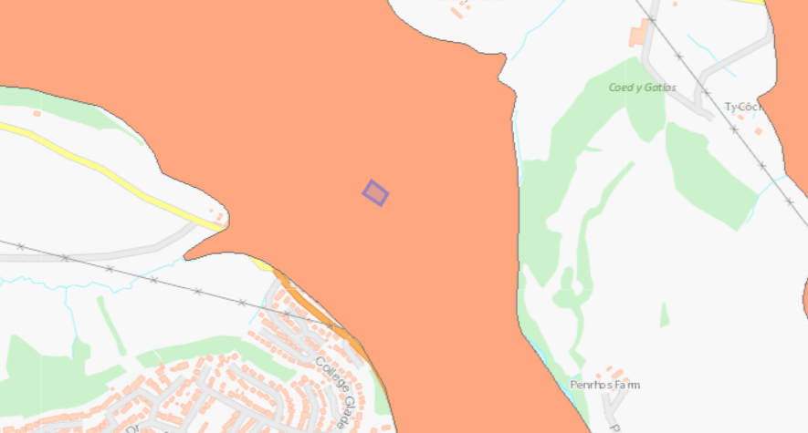

Aquifer Designation (Bedrock)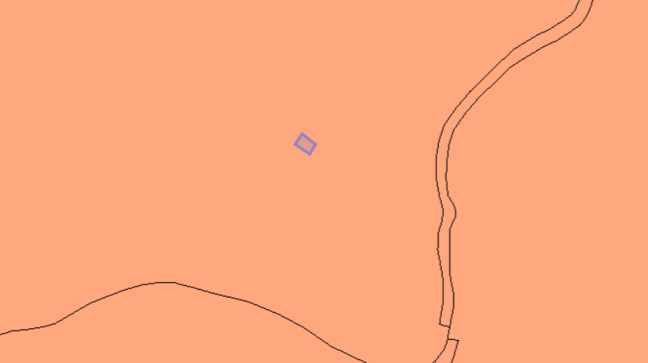
- site is not on a groundwater Source Protection Zones

Sensitivity of surface water
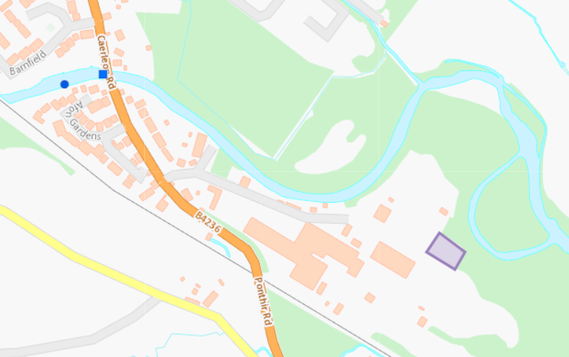
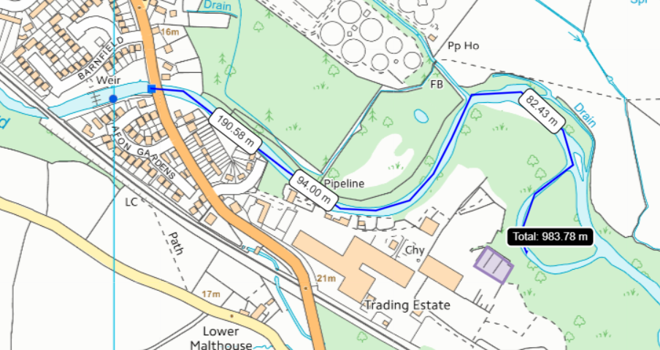
Grade B less than 1km upstream of the presumed discharge point (no drainage map has been provided)

Air Quality Management Zone
Newport City Council- Caerleon High Street AQMA- A number of properties along either side of the High Street in Caerleon.
Pollutants- NO2
Approx 1.7 km away from the site
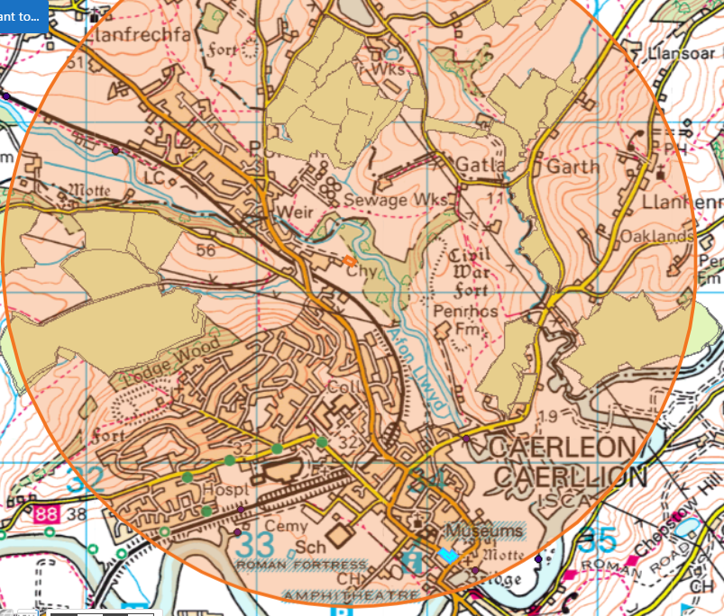
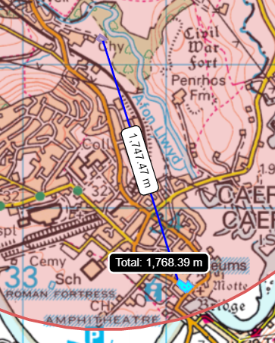

Flood Plain
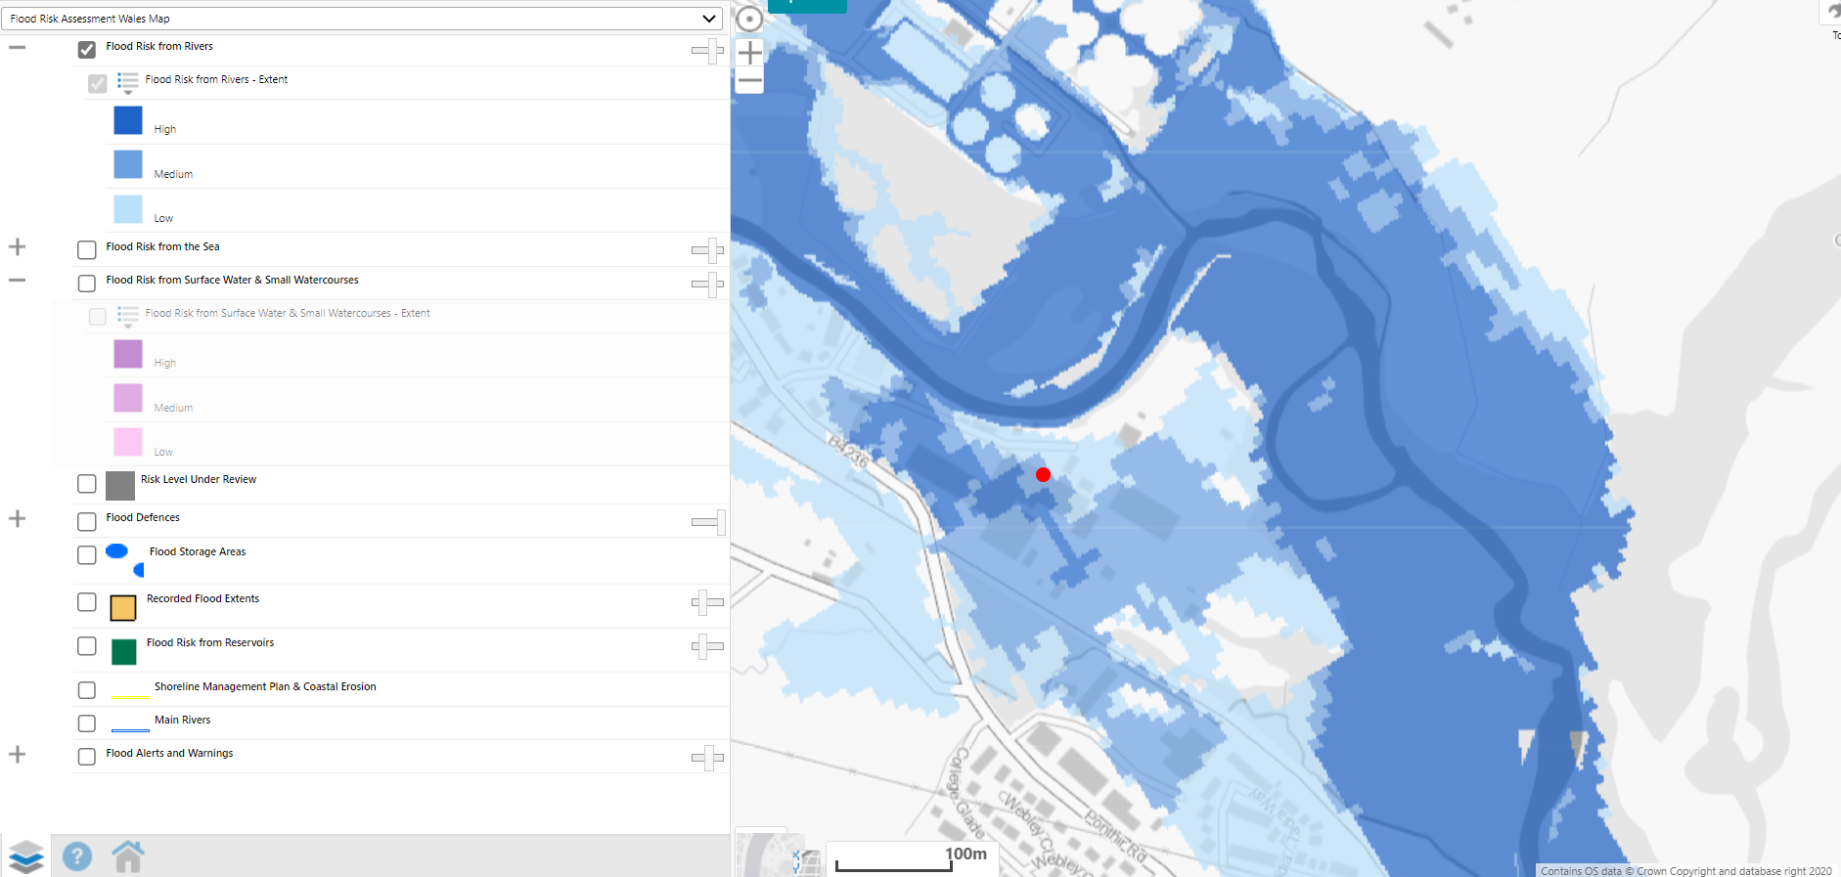
Site is at Medium/Low risk of flooding from Rivers
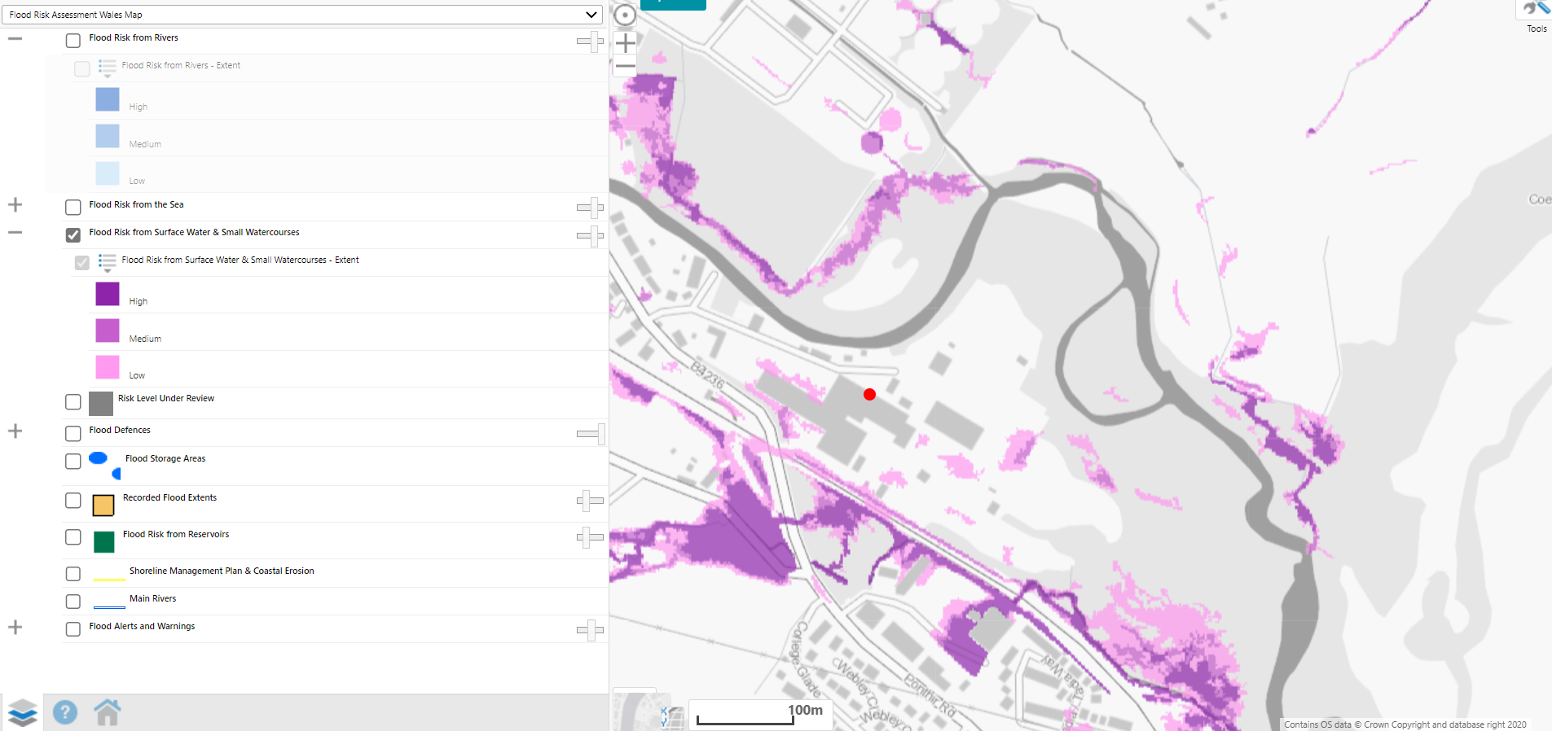

Protected Habitats for Permitting Screening
Purple moor grass and rush pastures
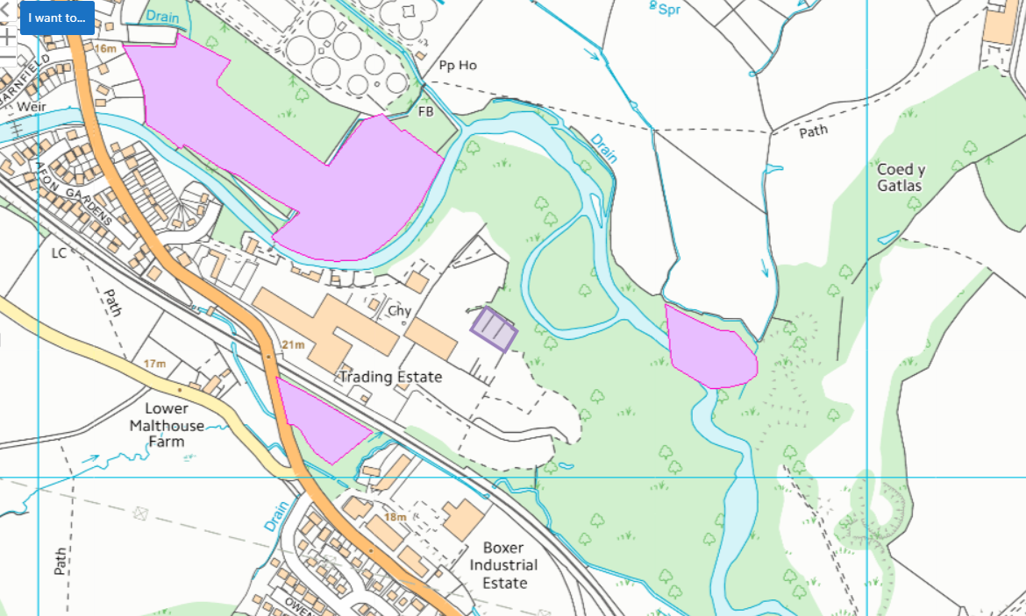
Protected Species for Permitting Screening
Migratory route (European Eel migratory route, Atlantic Salmon migratory route and Bullhead)
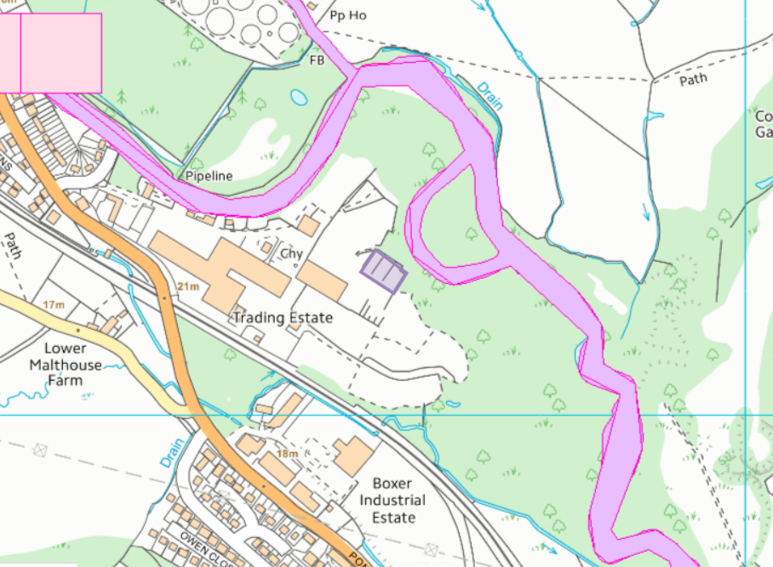
Detailed River Network
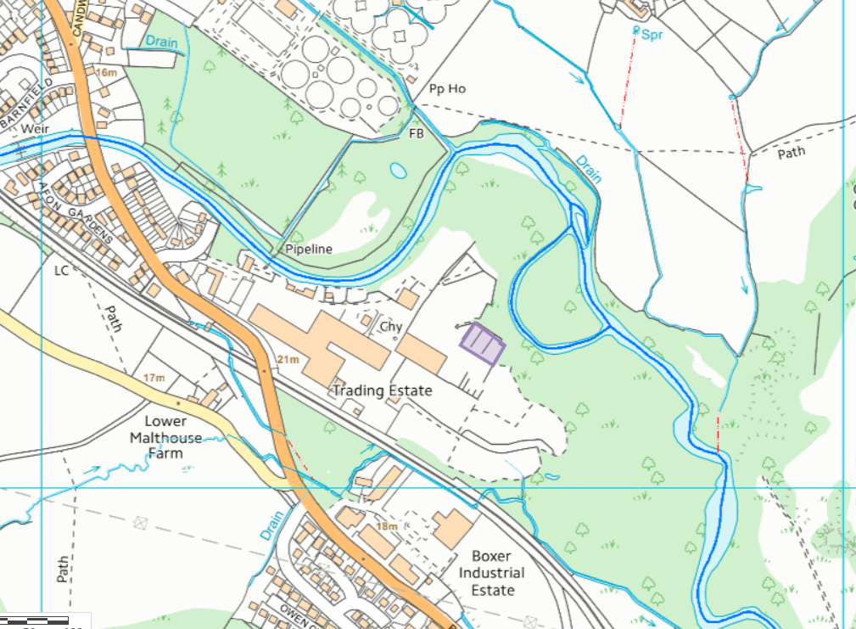
Ancient Woodland Inventory 2011
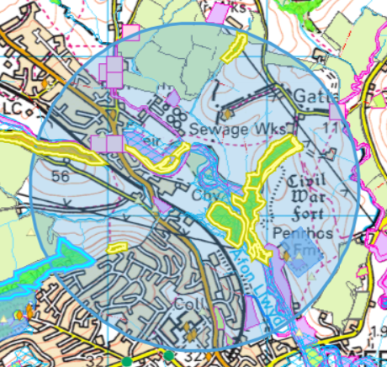
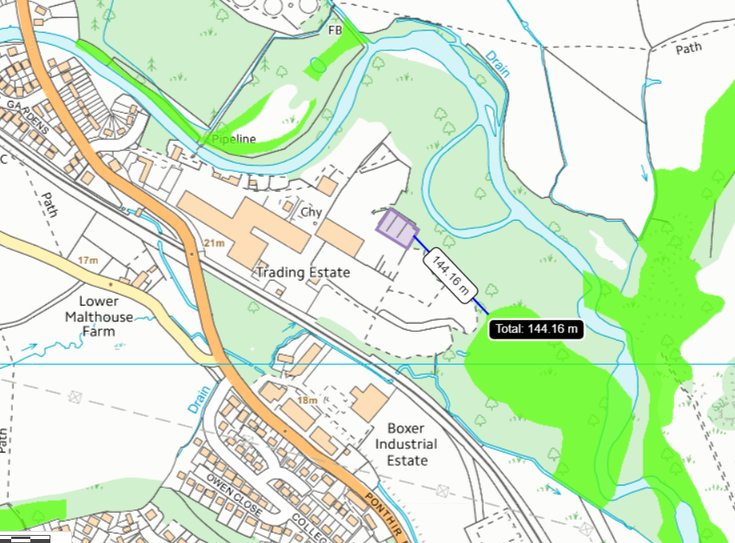
Local Wildlife Sites (SINCs)
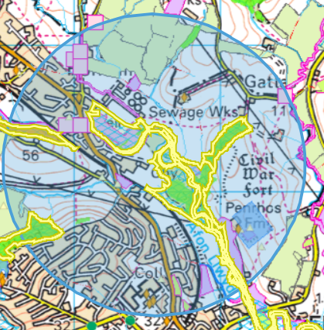
Within 1km:
- Afon Llwyd Grasslands
- Lodge Wood
- Graig Yr Eurych
- Coed y Gatlas
- Afon Llwyd
- Ponthir Sewage Work
Shared boundary with Afon Llwyd Grasslands LWS- Large areas of semi-improved marshy and dry neutral grassland, used by otter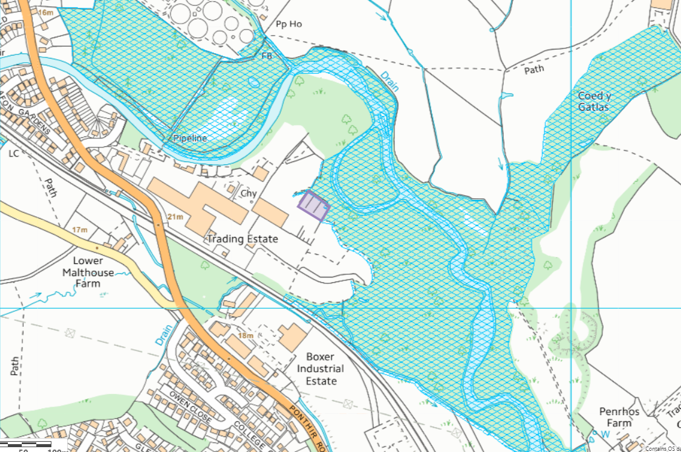

Listed buildings
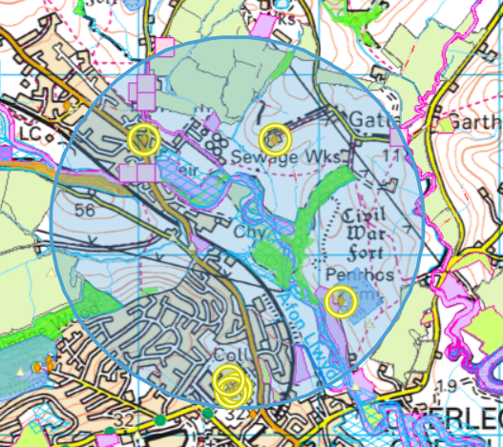
- Ponthir House Inn
- Penrhos Farmhouse
- Barn at Pen-twyn Farm
- Caretaker’s / Gardener’s Lodge at the University of South Wales, Caerleon Campus
- Porthordy Gofalwr / Garddwr ym Mhrifysgol De Cymru, Campws Caerllion
- Preswylfa’r Prifathro ym Mhrifysgol De Cymru, Campws Caerllion
- Former Caerleon Teacher Training College Building

Historic monument
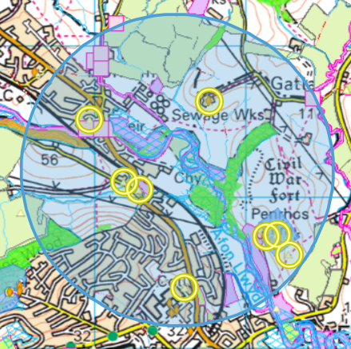
- PONTHIR BRIDGE, PONTHIR, CAERLEON
- PENRHOS, CROPMARK
- MALTHOUSE FARM
- PENTWYTN FARM BARN, USK ROAD
- PENRHOS;PENRHOS FARM
- PENRHOS CAMP (CIVIL WAR EARTHWORKS)
- PONTHIR BARN, LLANFRECHFA
- CAERLEON UNIVERSITY

Schedule monument
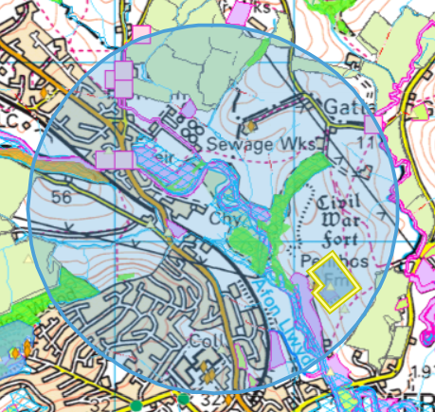
- Penrhos Camp (civil war earthworks)

