CRoW Appendix 4 (140_10_SD02)  CRoW Act 2000: Natural Resources Wales application for permission - Formal Notice |  | 
Natural Resources Wales Formal Notice.
Requirements of Section 28I of the Wildlife & Countryside Act 1981 as amended by the Countryside and Rights of Way Act (CRoW) 2000.
Duty in relation to granting any consent, licence or permit for activities likely to damage Sites of Special Scientific Interest (SSSI).
Guide to filling in this form for Natural Resources Wales staff:
To be completed by Permitting Officers for any applications for a permission which the Natural Resources Wales has considered under S28G duties to protect and enhance SSSIs. This applies to all proposed permissions within a SSSI, and to operations outside the SSSI boundary which are likely to damage its special features.
Refer to OI 140_10 ‘Applying the Countryside and Rights of Way (CRoW) Act 2000 to applications for permits with potential for impact on Sites of Special Scientific Interest (SSSI)’, including the flowchart in Appendix 2.
Pink italic text – drafting notes, to be deleted before completion/consultation.
Blue text – examples, to be replaced with permission-specific information.
Ensure you have completed all sections.
- Natural Resources Wales area/region/NPS hub: | South West
- Name of SSSI: | Cwm Gwrelych and Nant Llyn Fach streams.
- Type of permission: | Environmental Permitting Regulations Mobile Plant activity for the landspreading and field stockpile storage under bespoke permit EB3205CY registered to 4R Recycling Limited.
- Date for Natural Resources Wales permit determination: | 24/11/23
- Predicted 28 day date for response from NRW conservation/ecology (under S28 I(4)): | n/a saved for information only
- Natural Resources Wales reference no: | PAN-023110
- National grid reference: | Fields within 500metres:  4 - SN 88710 05742  5 - SN 88695 05839  6 - SN 88914 05886  10 - SN 88643 06113  11 - SN 80719 06172  There are storage locations and other fields in the landspreading activity but these are in excess of the 500metre screening distance and therefore not relevant to this assessment.
- Description of proposal: | Landspreading and field stockpile storage under bespoke permit to land at Blaengrach, Glyneath, Neath, SA11 5AL.  Total waste to be stored and spread 447 tonnes and is forecast for deployment March to May 2024.  Waste storage locations are within deployment fields.  Waste type – 19 13 06 Sludges from Reedbeds following treatment of Mine Water extracted from Coal Authority/ Severn Trent Glyn Corrweg site. Waste is not high in Readily Available Nitrogen and is stackable.  Wastes will be spread in accordance with the Code of Good Agricultural Practice (COGAP) using conventional rear discharge spreaders.  Crop will be grass only for silage and grazing.  Soil type – medium soils.  No spread zones take into account field slopes, watercourses, wells/springs/boreholes/issues and woodland.  The dredgings contain relatively low concentrations of PTEs.  Application rates capped to ensure no detriment effect on the environment  Delivery and spreading to be undertaken when ground conditions are suitable.  Waste stream has low potential to produce airborne dust and particulate matter due to its high moisture content.  SSSI is circa 300m away from fields due to be treated. Waste is comparatively low nutrient so no risk of leaching  Spreading buffer zones from water courses to minimise chance of indirect impact on SSSI waters.  The storage locations are not within 10m of any ditch, watercourse, or footpath, nor within an SPZ1, and are at least 50m from any well spring or borehole.
- Is the proposed activity within (wholly or partially) the SSSI boundary? | NO approximate distance from nearest deployment field is 235 metres. See map below.
- Has there been any pre-application discussion or correspondence with NRW conservation/ecology | NO
- What aspect(s) of the proposed permission may damage the features which are of special interest for the SSSI?
The following ‘Operations Requiring Consent’ (or other activities associated with the permission) that may cause damage) are relevant to the proposed permission.

7. Dumping, spreading or discharging of any waste materials.

The following SSSI features and mechanisms of impact have been considered to assess the likelihood of damage:

Features: Sequence of Westphalian strata (Carboniferous rocks)

Mechanisms of impact:
- A build of rock debris.
The activity will not add to the building of rock debris.

- Removal of infill material from stream sections.
The activity will not remove infill material.

- Scrub and tree growth.
The controls in place for the activity will prevent run off of the waste material therefore will not add to scrub and tree growth at the SSSI.

- The collection of geological samples.
The activity does not include collection of geological samples.

- Fly tipping.
The activity is restricted to landspreading only within the fields designated in the application.

The proposed activity will not impact these mechanisms given the nature of the waste and the deployment methodology which will be carried out in accordance with the application, permit and Code of Good Agricultural Practice (COGAP).
- Decision
i) The proposed permission is not likely to damage any of the flora, fauna or geological or physiological features which are of special interest.

No mechanism (hazard), the potential pathways have been identified and mitigated in the application Site Specific Risk Assessment and features are not sensitive to this activity. No spread zones take into account field slopes, watercourses, wells/springs/boreholes/issues and woodland.

Natural Resources Wales is minded to:
Issue the permission

- Name and job title of Natural Resources Wales officer: | Bryan Burn  Permitting Officer
- Date form sent to NRW conservation/ecology | n/a
For Natural Resources Wales use only, once NRW conservation/ecology response received
- NRW conservation/ecology comment on assessment: | i) NRW conservation/ecology advise the operation can go ahead  ii) NRW conservation/ecology advise the operation can go ahead with conditions  iii) NRW conservation/ecology advise against permitting the operation  Please ensure that the NRW conservation/ecology response is attached to this Formal Notice.
- Name and job title of NRW conservation/ecology officer: | n/a
- Date of receipt of NRW conservation/ecology response: | n/a

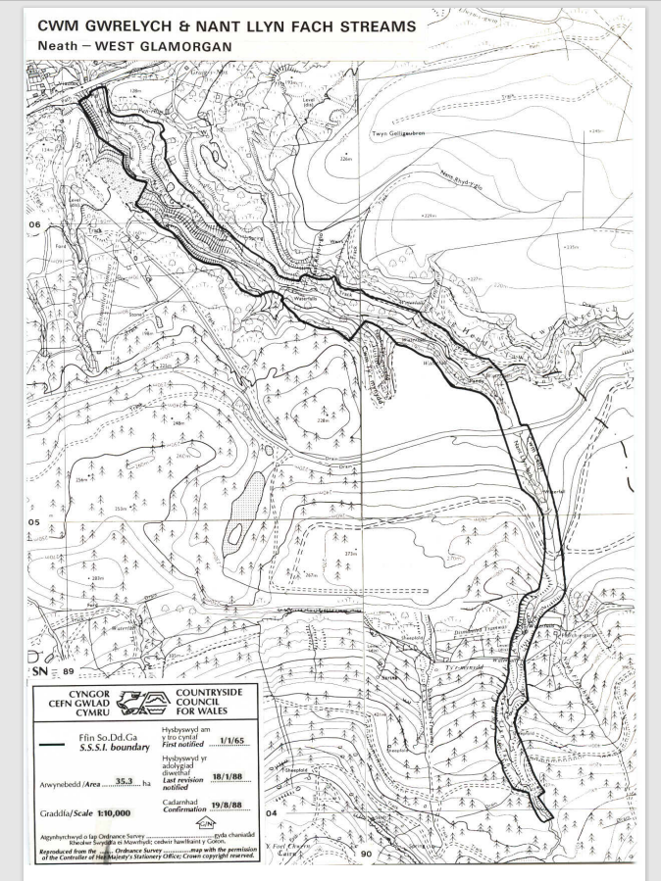
Figure 1

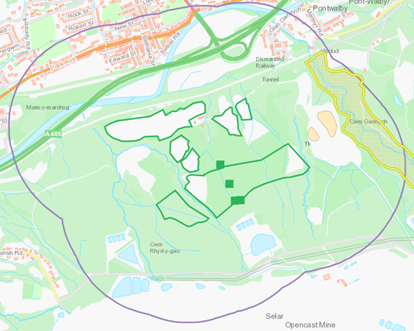
Figure 2

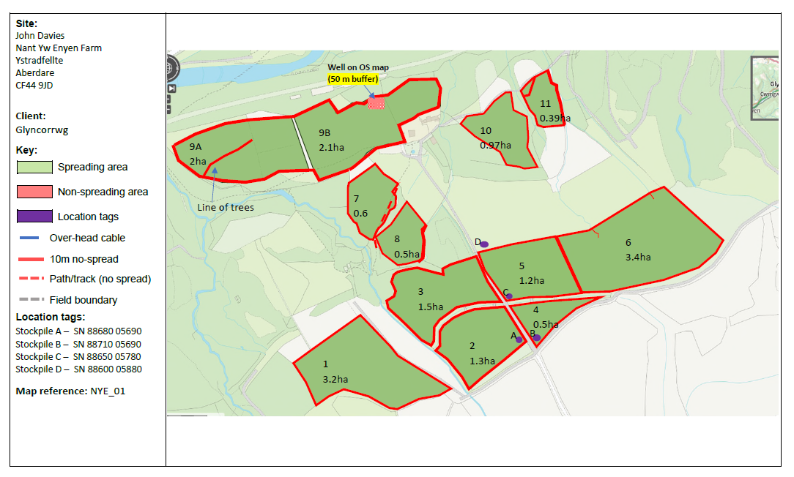
Figure 3

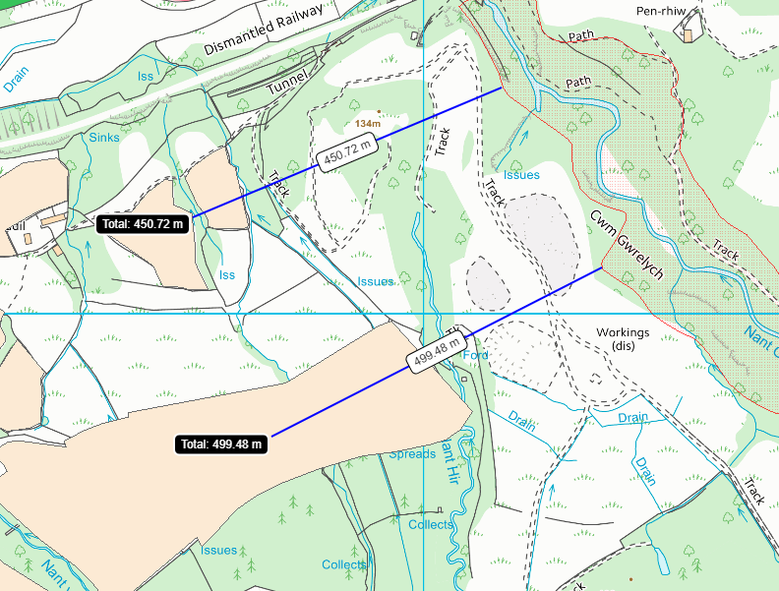
Figure 4

