Bwlchmawr Farm (fields 8161, 9456, 0920M, 0920S, 0920W)
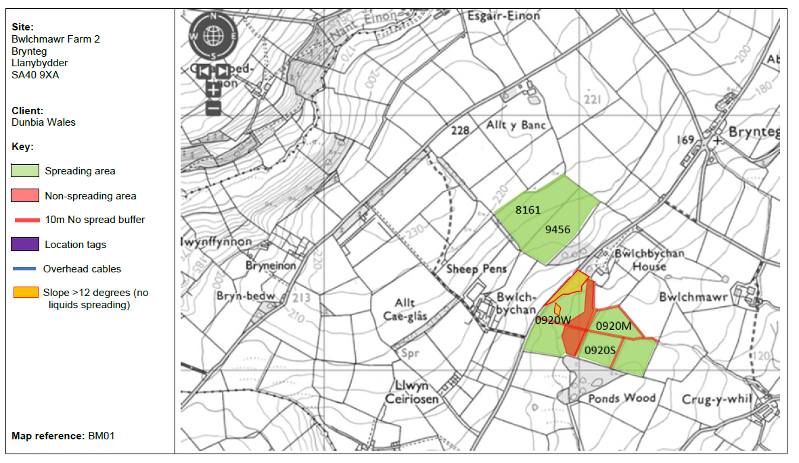
surface water courses
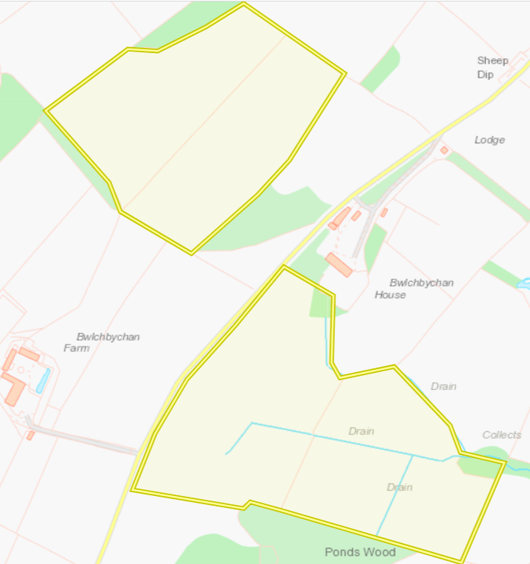
European designated sites- Natura 2000 (SPA, pSPA, SAC or cSAC) or Ramsar- or SSSI within 500m
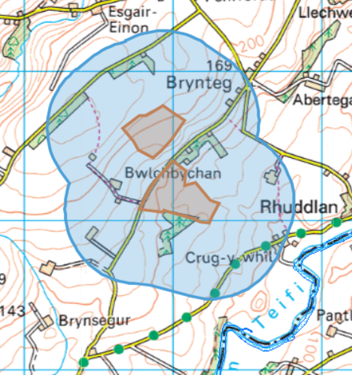 Over 500 meters away

public rights of way
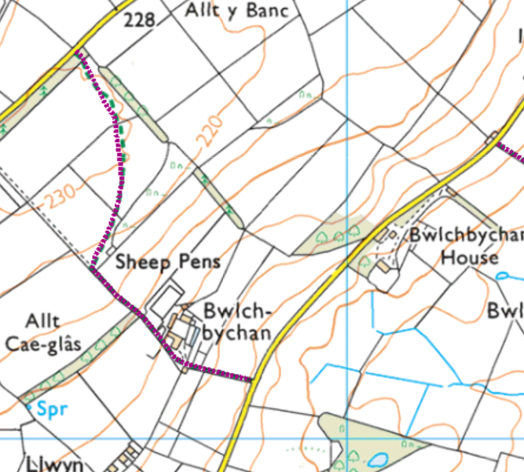
- None within fields or on field boundaries
Field slope
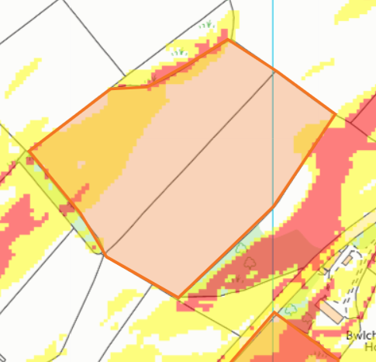
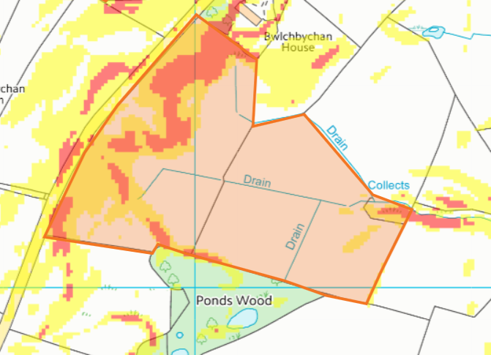

groundwater source protection zones- none
well, spring (or issue) or borehole- none
Groundwater Safeguard Zone- none
Section 7 habitats/species- none
Scheduled Monument- none
Local Nature Reserve- none
National Nature Reserve- none
Ancient Woodlands- none
Local Wildlife Sites (SINC) - none
National Park- none

Tower Hill Farm East fields (7, 8, 9, 10)
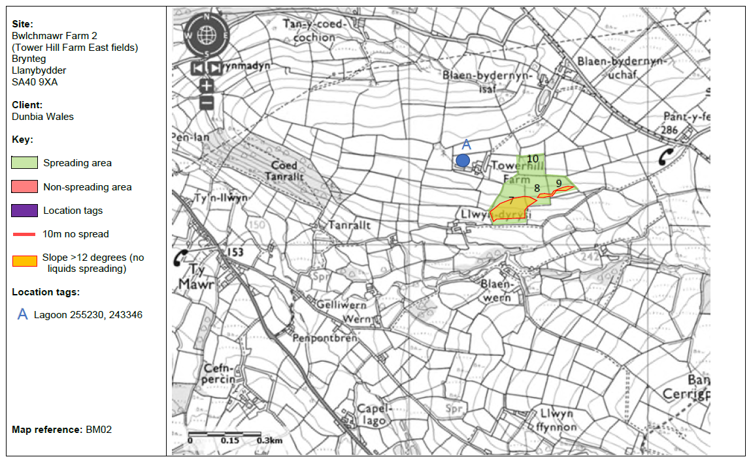

surface water courses
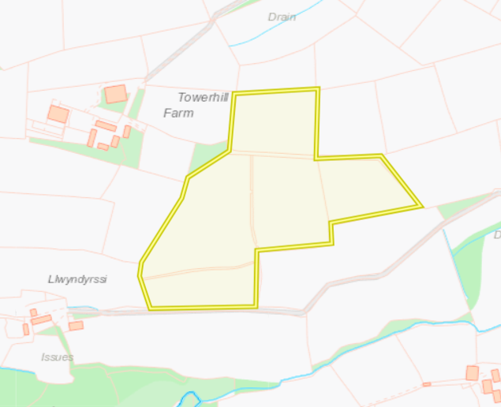

European designated sites- Natura 2000 (SPA, pSPA, SAC or cSAC) or Ramsar- or SSSI within 500m
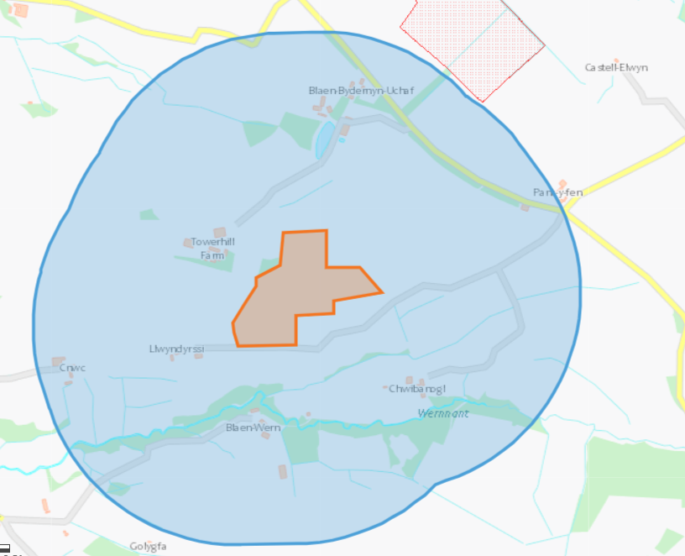
- Outside of 500 meters

Field slope
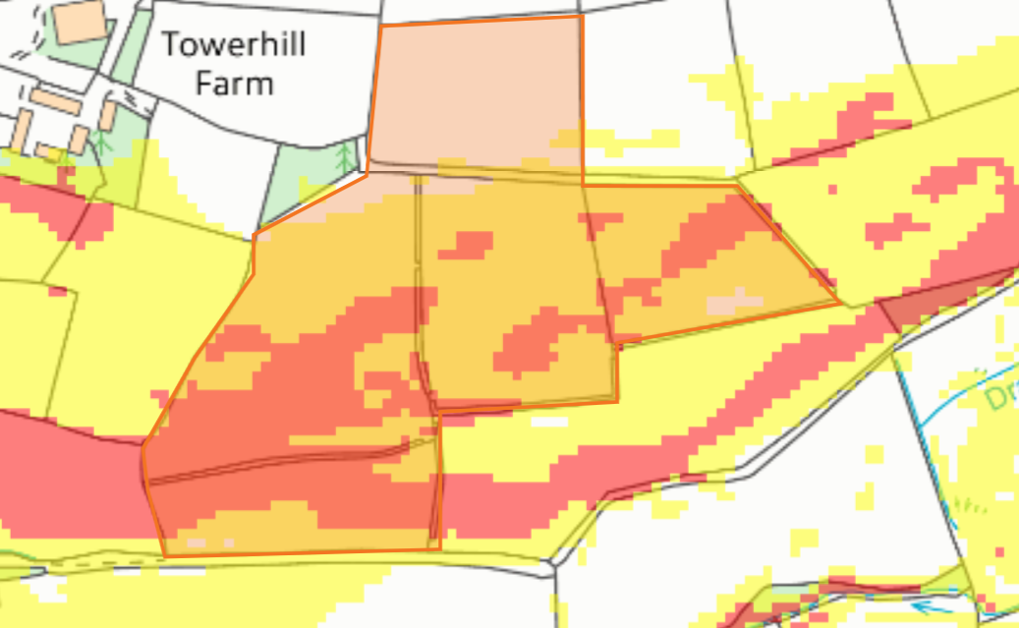

groundwater source protection zones- none
well, spring (or issue) or borehole- none
public rights of way- none
Groundwater Safeguard Zone- none
Section 7 habitats/species- none
Scheduled Monument- none
Local Nature Reserve- none
National Nature Reserve- none
Ancient Woodlands- none
Local Wildlife Sites (SINC) - none
National Park- none

Tower Hill Mountain Store fields (9137, 8042, 7951, 7245, 6552)
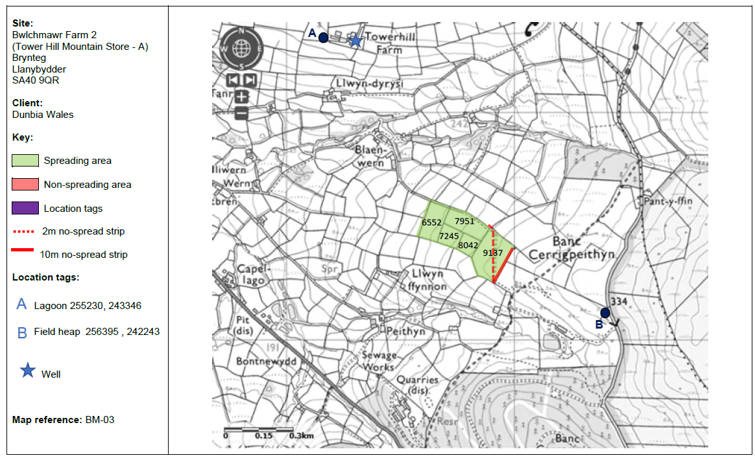
surface water courses
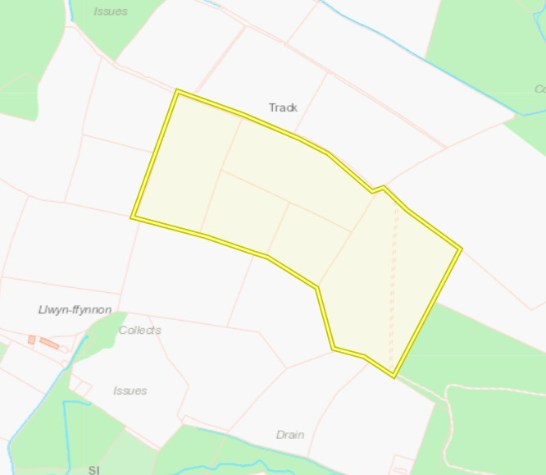

public rights of way
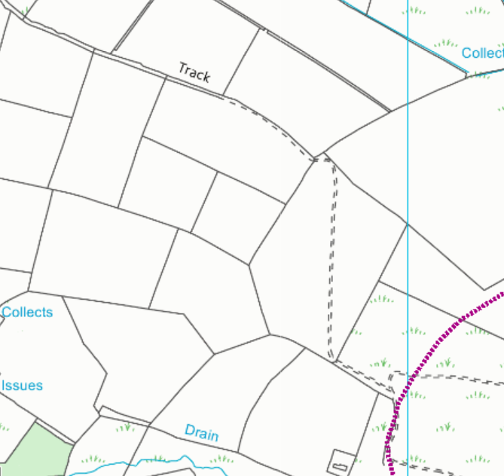
- None within fields or nest to field boundaries, although unprotected tracks have been buffered

Field slope
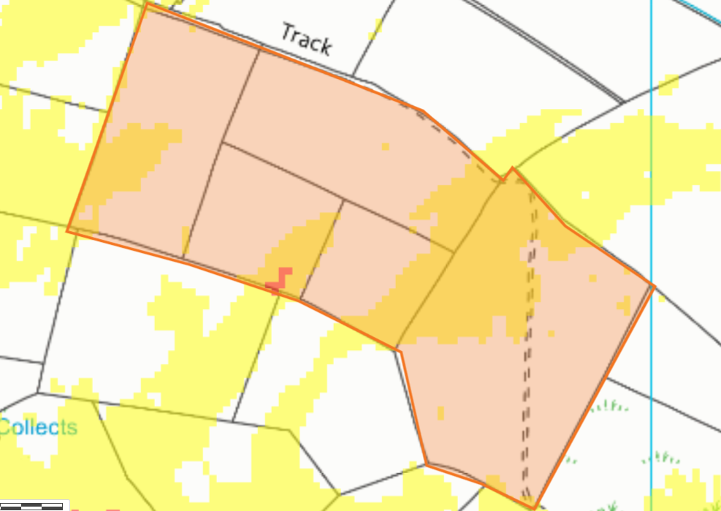

groundwater source protection zones- none
well, spring (or issue) or borehole- none
European designated sites- Natura 2000 (SPA, pSPA, SAC or cSAC) or Ramsar- or SSSI within 500m- none
Groundwater Safeguard Zone- none
Section 7 habitats/Section 7 species- none
Scheduled Monument- none
Local Nature Reserve- none
National Nature Reserve- none
Ancient Woodlands- none
Local Wildlife Sites (SINC)-none
National Park- none

